# Appendix D—Manager and User Requirements and Aspirations

## Background

The NCA Cultural Heritage Manager, NCA Exhibition and Facilities Manager, and NCA Education Officer had several discussions with GML during the preparation of this HMP regarding issues for the management and conservation of the cottage and running of interpretation/education programs at the cottage. These issues are discussed below but not all are within the scope of a HMP in relation to their final resolution.

## Issues Arising from Consultations and Investigations

An additional set of constraints placed upon the management of Blundells Cottage are the requirements of the site managers, the NCA. Consultation to identify issues faced by the NCA in the management of the site and its park setting to understand the day-to-day procedures for site maintenance was undertaken with NCA staff as detailed in Section 1.0 with additional information from consultation sessions in Appendix G.

Particular issues raised for Blundells Cottage are outlined below with discussion about conservation implementation with regard to the identified heritage values as a record of the consultation.

### D.1 Extensions to Slab Shed

The slab shed at Blundells Cottage was initially described in the 1983 Conservation Study Report as being a reconstruction using new and old materials and having only been in its present form over the last few years. The shed retains sufficient ‘original’ fabric, most notably in the roof and the northern corrugated iron gable, to challenge the theory raised in the 1983 CMP that it had been introduced to the site. The varied history of the shed is documented through oral histories as being erected as a slab kitchen, originally in the vicinity of the present tank stand. It is described as a multi-purpose structure with sleeping provision for the three Blundell boys at its southern end; it was later rebuilt on the present site by the Oldfields, who used it as a laundry.[1]

The shed retains sufficient ‘original’ fabric, most notably in the roof and the northern corrugated iron gable, to challenge the theory raised in the 1983 CMP that it had been introduced to the site. The varied history of the shed is documented through oral histories as being erected as a slab kitchen, originally in the vicinity of the present tank stand. It is described as a multi-purpose structure with sleeping provision for the three Blundell boys at its southern end; it was later rebuilt on the present site by the Oldfields, who used it as a laundry.[2]

Photographic evidence shows a shed in this location and oral histories note that that had a fireplace at the northern end and a skillion lean-to on the eastern side under which the buggy was parked. Analysis of the top plate and roof shows that both these elements were previously present before undocumented changes in the 1960s. Observation of the top plate, nails and packing mud all suggest it is the original roof and roof frame. Some of the posts and possibly some of the slabs may also be original or early fabric although there have been various alterations including the introduction of metal strips between the slabs and newspaper lining inside the shed. With vertical slab sheds it is not uncommon for the slabs and base plates to be removed, restored and replaced when the slabs become buried in soil and their bases rot. This has been done in part to both slab buildings at Mugga Mugga. The same process of maintenance may well have occurred at the Blundells Cottage slab shed.

Survey drawings by Jack Percival from 1910, historic accounts and somewhat indistinct photographic evidence indicate that the slab shed at Blundells Cottage was once larger extending beyond the present footprint. There are currently informal proposals circulating to extend the slab shed to its former size, both to restore the early form of the shed and to provide a useable education/interpretation space. The slab shed is believed to have been longer—with a northern portion now demolished—and to have had a large lean to on the eastern side. Survey work is being undertaken in order to mark out the former footprint to inform the feasibility of the proposal.

#### Discussion

There is a risk in the proposed project both in continuing the belief that the slab shed is not original and that substantial alteration may be made based on that assumption. The Burra Charter Article 3 advocates a cautious approach to physical change to a heritage place and advises that changes should not distort the physical or other evidence or be based on conjecture. Article 19 notes that restoration is appropriate only if there is sufficient evidence of an earlier state of the fabric. Article 20 notes reconstruction as appropriate only where there is sufficient evidence to reproduce an earlier state of the fabric which has since been altered. While there is some evidence in the recorded oral history of Blundells Cottage regarding the larger sized slab shed which was used as a kitchen (with a brick hearth and presumably a chimney) and later as a laundry, and the aforementioned Percival survey plan, there is little physical evidence on the site or in the existing fabric, and no known photographic evidence to fully illustrate the form of the fireplace, roof or chimney-to an extent that would support reconstruction.

There are also difficulties in relation to the existing exterior slab walls should an extension of the slab shed be constructed around the existing structure—the existing slab walls should be retained. Procurement of appropriate material for an extension is another issue. Article 22 of the Burra Charter requires new work to be sympathetic to the existing fabric so as to not distort or obscure the cultural significance as well as being readily identifiable. New adzed slabs would be costly to procure whereas new simple slabs date-marked at installation would harmonise with the context. There is also the presently unanswered question of whether the potentially newly enclosed space would be adequate for the desired educational/interpretation space.

In addition to concerns about conservation process and principles, the issue of drainage was raised by the management team during consultations, especially in relation to drainage surrounding the building and the garden and wider setting in the park landscape. Any proposed extension of the slab shed would have to be investigated for effects on surface drainage so that water was not directed towards the walls.

A site mapping exercise based on the 1910 Percival survey should be completed and the results recorded with in ground pegs to determine if the additional space enclosed by new slab walls would be useful. Further research into the form of the larger slab shed should be conducted to determine whether the proposed structure is an appropriate reconstruction or too conjectural to proceed without damaging the heritage values of the place. Even if the reconstruction of the larger slab shed was not undertaken, the survey results could be incorporated into site interpretation.

### D.2 Roofing Cover to Bread Oven

The 1910 Percival survey indicates that the larger slab shed had some form of roofing structure connecting it to the side of the cottage in the vicinity of the bread oven. There is some photographic evidence from 1913 suggesting there was a roof over the bread oven, extending approximately to the line of the slab shed wall. The arrangement of roof lines suggests the two structures were not connected. Remnant limewash on the side of the cottage suggests that this area was formerly covered and used as an extension of the kitchen food preparation area.

There are currently informal proposals to reconstruct the skillion roof in conjunction with the construction of the slab shed extension being discussed, mainly to provide undercover protection for groups of children.

The skillion does not appear in the 1961 Morton Herman plans, even though other structures identified for demolition were shown dotted—presumably the slab shed and roofing over the bread oven area had already been removed by that date. There are no other known references to the skillion and it may have collapsed before the 1960s; however, a 1961 photo of Blundells before work commenced shows part of the bread oven with possibly a fibro sheet covering it as part of the roofing structure support.

Figure D.1  Detail of ‘Federal Capital Views’ (detail), 1910.  View north.  There appears to be a skillion over the bread oven, although this does not appear to connect directly to the slab shed.  Note limewash on the slabs and on foundation plinth of room 1, the current ‘office’.  There is also a large lean-to addition to the east of the slab shed.  (Source:  NLA Picture File detail of panorama photo in album 300, 1910 NLA:PIC8470/8)

**Figure D.1** Detail of ‘Federal Capital Views’ (detail), 1910. View north. There appears to be a skillion over the bread oven, although this does not appear to connect directly to the slab shed. Note limewash on the slabs and on foundation plinth of room 1, the current ‘office’. There is also a large lean-to addition to the east of the slab shed. (Source: NLA Picture File detail of panorama photo in album 300, 1910 NLA:PIC8470/8)

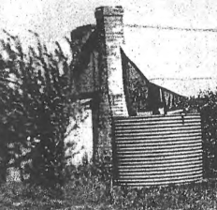

**Figure D.2** Blundells/Oldfields Cottage prior to restoration in 1961, CDHS Picture file reproduced in Beth Knowles, *The Cottage in the Parliamentary Triangle*. The light colour to the bread oven wall may be a sheet of fibro over the end wall of the skillion. Compare this photo with Figure D.9 which clearly shows the brick end wall of the bread oven.

#### Discussion

The bread oven is capped by a robust cement topping and shows no signs of decay. There is some damp in the former kitchen, but it is mainly on the south wall and unlikely to benefit from a skillion on the east wall. The size of the skillion shown in the photo (Figure D.1) is small. It’s reconstruction may also require removal of some of the cypress trees. With the lack of clear evidence fmaythe structure there would also be considerable conjecture associated with any attempt of reconstruction, which is defined in the Burra Charter Article 20 as returning a place to a known earlier state because there is sufficient evidence to reproduce an earlier state of the fabric.

The reconstruction of the skillion roof cannot be supported on heritage conservation grounds, on the basis that it was not a major part the building and there is a lack of evidence for its detail. Ideally, all structures within the immediate Blundells precinct will have high integrity unless there is compelling evidence or reason for an introduction. Visitor management is not considered to be a compelling reason in this context, especially if it can be achieved in another suitable manner, such as a purpose-designed free-standing building located outside the precinct.

### D.3 Limewash Finish to Exterior Walls

Historic investigations of the pre-Federation cottages in the Molonglo River valley report that limewashing was used both as a weather-proofing treatment, and as what is termed a ‘civilising’ detail, to mark out simple wooden dwellings from sheds and animal houses.[3] Traces of limewash exist on most parts of the external walls of the stone and brick building at Blundells Cottage and the evidence suggests that at some stage large expanses of the cottage walls were limewashed white. Some historic photos (see 4.13 and 4.14) indicate that the lower courses of the stonework and the slab shed were once lime washed. However, build-up of limewash, which would indicate repeated applications, is minimal. This suggests it was not a regular activity, or was done a long time ago, or was efficiently mechanically removed during the 1960s conservation phase, as noted in the 1983 Cox report.[4] If that was the case, the removal was not totally effective. There are suggestions that Blundells Cottage could be limewashed on the exterior to recover a former appearance and assist in conservation of the mortar.

#### Discussion

The historic photos seem to confirm that the cottage was not maintained regularly as a limewashed building.

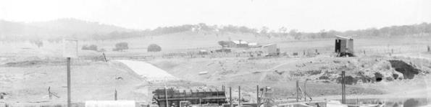

**Figure D.3** Scott’s Crossing 1928 showing Blundells in middle distance. The stone walls do not appear limewashed all over at this date. (Source: NAA A3560, 4970 1929 Scott’s Crossing over the Molonglo River)

This lack of limewash build-up contrasts with Mugga Mugga where there was abundant accumulation of multiple layers on external walls, timber slabs and in the kitchen fireplace. At Mugga Mugga, the decision to apply new limewash was straightforward, as there was clear evidence of its on-going historic use, combined with the realisation that the limewash played a fundamental role in protecting the soft mud-mortar that was used to bed the stonework. The mortars used at Blundells Cottage are surprisingly robust, although those on the western side are weathering from exposure to the strong westerly winds and flooding from overflowing gutters. The issue of mortar loss may be better addressed through conservation action to address water penetration of the building, remove loose material and repoint with a lime-based mortar.

Blundells is a rubble stone building that demonstrates a rich variation of colour and character, from sandy golds, through reds to deep blue/greys. The walls have very high aesthetic value that would be lost if they were re-limewashed. It is likely that the building in its present form is valued partly for these aesthetic qualities and it is apparently a popular place as a backdrop for wedding photos. It is quite likely that many people who appreciate the building on their circuit of the lake have never actually been inside—for them its value may be aesthetic rather than historic.[5]

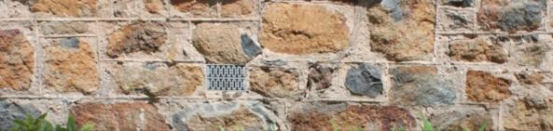

**Figure D.4** Much of the aesthetic appeal of Blundells Cottage lies in the varied colours of its stones. (Source: GML 2012)

The exterior stonework of Blundells Cottage and the slab shed was limewashed at some stage in its history. In particular the eastern side of the cottage between the bread oven and slab shed which was once covered by a roof structure as indicated by the Jack Percival sketch of 1910 would have been limewashed if it were a partly exposed courtyard area associated with food preparation or washing adjacent to the slab shed. There are issues (discussed above) with the reinstatement of the larger sized slab shed and roof covering over the bread oven. Reinstatement of limewash to the exterior of the cottage in the vicinity of the bread oven would provide an alternative interpretative hook to explore and explain the use of the slab shed as a kitchen without resorting to conjectural reconstruction of an enlarged slab shed and skillion roof covering which would be counter to the conservation process outlined in the Burra Charter.

Limewashing the whole of the exterior of Blundells Cottage does not seem a justified approach given the lack of limewash accumulation on the stones and photographic evidence that the cottage was not always limewashed. Oral history references to the cottage being limewashed are insufficient evidence on which to base action. Limewashing the cottage in its isolated park location also risks a significant increase in the likelihood of graffiti vandalism and risk to building fabric when removing such markings.

### D.4 Interior and Exterior Colour Schemes

There are current proposals to re-limewash the cottage interiors and re-paint wooden trims.

#### Discussion

The 2012 Blundells Cottage Paint Analysis by Gillian Mitchel has identified the earliest colour schemes used at the cottage. In conjunction with the limewashing of the exterior walls the external timber trims were dark brown coloured to contrast. Internal walls were originally limewashed white with later colours added to lime based coatings. Internal timbers were originally finished in dark brown. To interpret the heritage values of the cottage at its most important historic phase the limewashing of the interior walls in white with contrasting brown trim in traditional finish is supported. Notable exceptions are to retain the two small portions of coloured wall paper in the parlour and the interior back porch wall which exhibits the range of colour finishes used during the life of the cottage. Both these features can be used in interpretation of the cottage use and development. Externally the current teal paint finish to the woodwork should be replaced with dark brown traditional finish when repainting is due. As noted above full limewashing of the stone walls is not supported.

Care should be taken in choosing the appropriate mix for the limewash to be used. Interiors were historically treated with distempers rather than whitewashes. Distempers provide a softer, deeper colour. It should be a traditional water soluble mix—the addition of modern binders and ‘improvers’ may introduce an impermeable layer which contributes to damp problems in the building.

### D.5 New Museum Services Building

During consultations there was a strongly expressed wish to move office use into a new building to provide adjunct services to Blundells Cottage—and free up Room 1 for interpretation and a temporary exhibition space. This would provide adequately lit and heated office/relaxation space for guides and volunteers with additional provision for collections and education kit storage.

The largest visitor group at the cottage is schools whose visit is often integrated into units of the school curriculum, or as part of a coordinated visit to the National Capital. These groups often come by bus and in groups of up to 40-45 at a time. The cottage cannot easily accommodate groups of that size and it is necessary to hold one smaller group back outside the cottage while the others visit the building’s interior. This is problematic in cold or wet weather and creates a poor visitor experience in such circumstances. Furthermore, there is nowhere to store interpretation material or artefacts not currently on display, or the much needed room heaters in seasonal use. There are inadequate office and recreation facilities for volunteer staff and there are no adequate toilets for staff or visitors. There are no disabled facilities or an easily accessible space in which the cottage’s significance can be interpreted for the mobility impaired.

#### Discussion

An extension to the existing slab shed has been proposed as a solution and is discussed above and is not recommended. There has also been a suggestion of a new building located to the immediate east of the slab shed in the vicinity of the orchard—this being sufficiently close for both staff office use, shelter for student groups and storage of collection items and education material. However this location is in close proximity to the cottage for functional requirements and is also a physical intrusion which would detrimentally impact heritage values. For this reason it cannot be supported on conservation grounds.

Oral history and photographic evidence indicates that there used to be a series of outbuildings associated with the cottage to the southwest, as well as a series of building-sized haystacks to the southeast close to the current day Wendouree Drive, just beyond the present roadside carpark (Figure D.1, D.13 and D.14). These locations may provide preferable opportunities for both gathering school groups, interpretation of the landscape setting of Blundells Cottage (through ‘footprint’ marks of former buildings/haystacks and provision of interpretation facilities for disabled visitors.

A new services building would need to be sited to avoid or minimise any impact on the setting or view lines of Blundells Cottage. The building would need to be appropriately and sympathetically styled and scaled to the cottage and be compatible with the character of the place, while also clearly identifiable as modern.

A service building in the location of former sheds/haystacks adjacent to Wendouree Drive could provide ready access to additional facilities from the cottage without compromising its immediate setting. It could be designed in a form that referenced the historic outbuildings and haystacks (they were similar in form) and could link to the cottage with a multi-ability accessible graded pathway that could lead through the new orchard plantings. Although this location is some distance from the cottage, it can provide a fresh opportunity to interpret the cottage in an appropriate heritage curtilage, without the confusion of museum infrastructure.

Provision of a new building(s) for educational functions, office space and staff/visitor amenities could contribute significant benefits to both operational needs and visitor experience, but the structure would have to be designed and accurately sited with care so as not to have an adverse impact on the heritage values of the cottage and its setting. The commitment to a new building is a medium term project which requires financing and planning for the outcome to achieve success both in terms of conservation, interpretation and operational objectives.

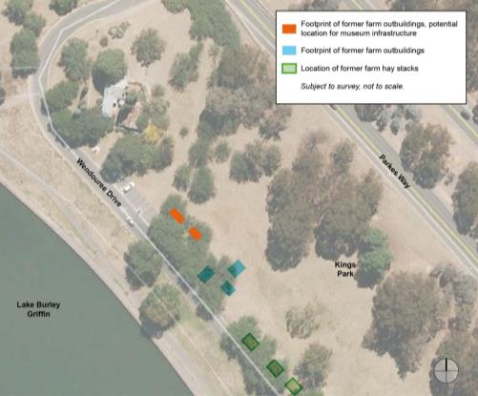

**Figure D.5** Approximate possible proposed location of new service building—sufficiently distant from the cottage not to affect heritage values but sufficiently close to provide staff and visitor services close to carparking. (Source: GML edit to Google Earth base plan.)

### D.6 Heating and Dehumidification

#### Discussion

All cottage managers and guides commented on how cold the cottage is in winter. Given that there were fire places in three rooms, it is probable that at least one was lit at any one time during cold weather and care would have been taken that the fire did not go out. This would have warmed the cottage. In tandem with the issue of cold there is an issue of condensation and humidity in the cottage.

Options to address the lack of heating include:

* clearing and cleaning the chimneys to allow real wood fires in the cottage—but this greatly increases maintenance and fire risk;
* natural flame gas heating inserted into one of the fireplaces, eg the lounge room—the ‘look’ of the flame would add life as well as warmth to the room and contribute to revitalising the cottage interior, but the cottage is not connected to a piped gas supply and gas bottles would be intrusive elements;
* fixed flat panel radiant heaters discretely located on walls with minimal impact on fabric although the limited number of electricity sockets installed in the cottage could present issues;
* heating to the two front rooms could be delivered under the floor—the bedroom has been lifted and re-laid and has generous underfloor space and the subfloor of the parlour would need to be investigated for impacts; and
* overhead ducted heating through the less significant ceilings in the office kitchen and over the front two rooms—but the location of a heat exchange unit would need careful thought out and overhead ducts are not in keeping with the heritage character of the cottage.

The preferred means of heating the cottage is the continued use of electric radiant heaters which do not have either maintenance or fire risk, can be removed during the warmer months and so long as they are of modern and discreet design can be accepted by the visiting public as normal museum infrastructure. Modern programmable heaters which can be set to start automatically prior to opening hours will help to take the chill off the internal cottage temperatures.

Dehumidifiers are also recommended to reduce the damp in the cottage. Both the interior temperature and level of humidity could be monitored to gauge effectiveness.

### D.7 Trees

The 1994 CMP suggests that probably three of the Roman cypress (between the cottage and shed), and group of three Himalayan cypress to the north of the verandah likely to have been planted by Mrs Oldfield in the 1930s. Morton Herman’s 1961 report on the cottage recommended their retention. Since then the trees have since grown hugely to the point where the trees closest to the buildings (a Himalayan cypress trees next to the verandah and the Roman cypress adjacent to the slab shed) overhang the roofs resulting in quantities of dropped needle leaves and into the gutters and the ensuing build up where they are not regularly removed—a maintenance issue with evergreen trees that loose leaves all year round not only in the autumn.

#### Discussion

The trees are important elements of the heritage fabric of the site. They are now mature, their size has been amplified by the provision of reticulated watering that would not have occurred naturally and the effects of which cannot be reversed. A report on the future safe and useful life expectancy of the trees is needed and a plan for their eventual replacement. However, the leaf litter is especially bad for building fabric as it can promote rusting of the galvanised iron roofs, and rapidly fills and clogs gutters and downpipes with the result that water runs down the face of the building. This is what has happened on the western wall of the cottage and is the prime cause of penetrating damp and staining in the kitchen (Room 2) and bedroom (Room 3). Cypress trees most likely contribute to the failure of the gutters over the south wall of room 5, and the consequent damp in that wall. Acidity of run-off may have also exacerbated the rapid rusting of the galvanised iron tank.

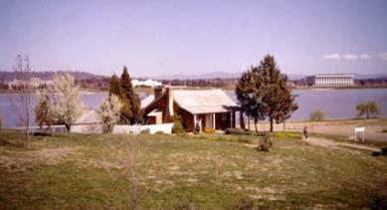

**Figure D.6** Blundells Cottage1968—a photo was taken a year or two after the site was re-landscaped. Note that the canopy of the Himalayan cypress on the right is far smaller than that today, 2013. (Source NAA A1500, K193851968)

The Roman cypress trees between the cottage and slab shed are also problematic as they drop an enormous quantity of plant material on both buildings and the ground. This has resulted in past rotting of base plates and slabs in the shed that has necessitated expensive remedial work. These mature trees have become hazards to both significant buildings.

###### Himalayan cypress

Of the three Himalayan cypresses located at the front of the building it is recommended that the one closest to the verandah be investigated for active management to eliminate most of the foliage overhanging the building. Periodic follow-up pruning may be necessary.

|  |  |
| --- | --- |
| Figure D.7  The Himalayan cypress 2012.  The tree closest to the cottage hangs heavily over the building.  (Source GML 2012)  **Figure D.7** The Himalayan cypress 2012. The tree closest to the cottage hangs heavily over the building. (Source GML 2012) | Figure D.8  Manage the Himalayan cypress closest to the building.  (Source:  GML 2012)  **Figure D.8** Manage the Himalayan cypress closest to the building. (Source: GML 2012) |

###### Roman cypress

For the Roman cypress trees between the cottage and slab shed an assessment should evaluate the effects of planting a replacement specimen (propagated vegetatively from the existing specimens to retain the current variety and form) further from the buildings to reduce crowding and fire danger. This will enable the remaining pines to be managed by removal at a future time when the replacement tree has grown to gain some presence in the landscape.

There are also Roman cypress to the southeast of the cottage which do not appear to be Oldfield era plantings and which obscure the view of the cottage from the lake edge approach path around from Commonwealth Park (Figure D.11 and D.12).

|  |  |
| --- | --- |
| Figure D.9 Roman cypress trees between the stone cottage and the slab shed. | Figure D.10  Roman cypress trees between the stone cottage and the slab shed. |

**Figure D.9-D.10** Roman cypress trees between the stone cottage and the slab shed.

To conserve the landmark qualities and heritage values of the trees and their associations with the Oldfield period of occupation; and to resolve the conservation problems being caused to the building fabric the following is recommended:

* recognise the heritage values of the trees, their mature (overgrown) status and the need for tree management (pruning and replacement strategy);
* a Safe and Useful Life Expectancy (SULE) report on the trees with replacement guidance and advice on how to reduce the amount of foliage overhanging the building;
* maintenance to remove leaf litter from the roof, gutters, downpipes and the ground **on a monthly basis**; and
* an upgrade to gutters and downpipes so that they operate effectively (refer to Maintenance Schedules in Section 8.0).

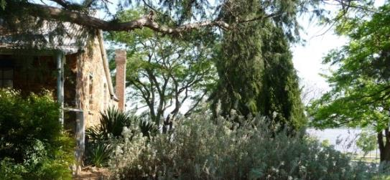

**Figure D.11** Roman cypress trees at southwest of cottage obscure the view of the cottage from the Menzies Walkway along the side of the lake. (Source: GML 2012)

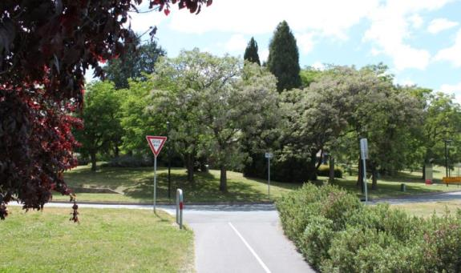

**Figure D.12** View of Blundells from west approach pedestrian/cycle path arriving from Commonwealth Park. (Source: GML 2012)

### D.8 Approach Views, Entry Points and Access Paths

#### Discussion

Historic photos of the cottage show it situated in a relatively bare landscape of grassland devoid of tree or shrub plantings. The current landscape setting of the cottage is in a well treed park with introduced artificial irrigation maximising growth conditions for lush tree development.

All access paths to the cottage are modern, installed from the early 1960s. The garden surrounds of the cottage is a modern installation of a ‘cottage garden’ by the CDHS which is representative of the tastes and understandings of the 1960s rather than of the historic period of the cottage. The picket fence is an introduced feature which never previously existed at the site—fences were farm fences of post and rail or wire as evidenced in historic photographs. It delineates a narrow area immediately around the cottage and isolates it from the surrounding landscape. Consultation indicated that the picket fence was generally disliked by managers and that some fencing adjacent to the Wendouree Drive wall boundary would be welcomed to separate school groups on the front lawn area from the road.

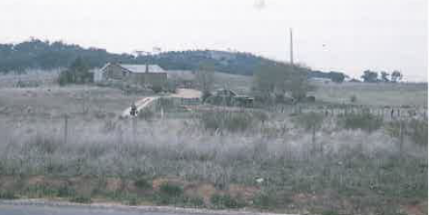

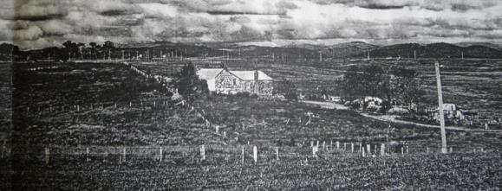

**Figures D13-D.14** Historic view of Blundells from west approach 1957 showing the open landscape with few trees. Post and wire fences in existence. (Source: Photos from Beth Knowles, Canberra)

Historical evidence suggests the cottage was approached from the west at the rear along the dirt drive from Scott’s Crossing road.[6] This unsealed lane approach is shown on more than one historic photo of the cottage before its preservation as a house museum and park landscaping of the surrounds (Figures D.13 and D.14). The large Roman cypress trees to the southwest of the cottage are not present in the photographs and are not plantings associated with Oldfield period of the cottage’s history (Figures D.11-12).

The current curved stone path to the front door is not show on the Morton Herman plan and is part of the CDHS and NCDC landscaping of the cottage surrounds installed in the early 1960s.[7]

|  |  |
| --- | --- |
| Figure D.15-D.16 Morton Herman site plans of Oldfield’s Cottage 1961. | Figure D.15-D.16 Morton Herman site plans of Oldfield’s Cottage 1961. |

**Figure D.15-D.16** Morton Herman site plans of Oldfield’s Cottage 1961.

Generally a path to a simple cottage like Blundells would have been practical and straight, leading directly to the front door, addressing and reinforcing the central axis. This is the case at Mugga Mugga. Herman identifies this axis on his locality plan with an arrow directly off Wendouree Drive. However when approaching from Constitutional Avenue today the pathway is awkward (Figure D.15)

The approaches to the cottage require both opening up and definition. The Roman cypress on the southwest side of the cottage (which does not appear to be part of the pre-1960 planting), could be removed and some of the park’s deciduous trees could be treated with under-pruning to open up the view of the cottage from the southwest. The approach path to the front of the cottage should be redesigned to be more historically accurate in concept; archaeological evidence may assist in confirming the formal cottage approach unless major changes in land level have removed all indications. The picket fence is historically inaccurate and its removal and replacement should be part of the proposed landscape plan for the cottage. The same plan could examine the expressed desire of installing a simple post and wire boundary fence to the edge of the lawn area between the cottage and Wendouree Drive road to contain school groups on the lawn in front of the cottage—for its relative merits in terms of being a safety feature, for lack of true historical accuracy which may confuse visitors about historical fencing patterns and the potential as an interpretative device to define the heritage curtilage at this point.

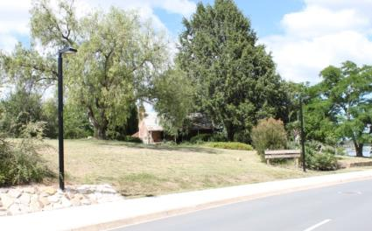

**Figure D.15-D.16** Morton Herman site plans of Oldfield’s Cottage 1961.

### D.9 Disabled Access

#### Discussion

Disabled access to the cottage and its immediate surrounds is problematic given the steep gradient of the setting, uneven nature of the randomly coursed paving paths, historically small entrance doors to the cottage and multiple uneven floor levels inside. Equality access provisions and the opening of the new Boundless playground nearby in Kings Park will increase the number of visitors with disabilities requesting access to the cottage and interpretation. A range of access opportunities is needed.

Given the original door widths of the cottage, steps and internal level changes access to the interior will inevitably be limited. Assisted access to the front door may be possible and would enable close up inspection of parts of the outside and visual access to the front room.

Alternative access methods for interpreting the cottage to visitors who can only approach this area will need to be developed in a full Interpretation Plan and Landscape Masterplan for Blundells Cottage. Alternative and future interpretation could take place in the proposed new service building which should be specifically designed to accommodate disabled access so that the total experience could be satisfactory in achieving educational and experiential goals.

It is anticipated that favourable grades could be obtained from the proposed new service building and the front of Blundells—the stone paths which are introductions to the landscape from the 1960s are less significant than the cottage and do not contribute to an understanding of its heritage values. They could be replaced, noting that the winding style of the paths installed by the NCDC are not stylistically accurate for the historically most important period of cottage development and confuse the interpretation of the heritage curtilage.

### D.10 Screening to Parkes Way

#### Discussion

The busy arterial road of Parkes Way is a modern intrusive element into the atmosphere of Blundells Cottage. The large new ASIO building on the opposite side of Parkes Way is also an intrusive element at the site. While it will never be possible to recapture Blundells 19th and early 20th century ambience, opportunities to reduce the visual and noise impact of the ASIO building and Parkes Way can be implemented.

One way to achieve this is to add an earthen berm (mound) in King’s Park adjacent the highway and to plant dense vegetation in its proximity (Figure D.18). A heritage impact assessment would have to be undertaken to determine effects on both the heritage values of Blundells Cottage and on the heritage values of the King’s Park landscape design.

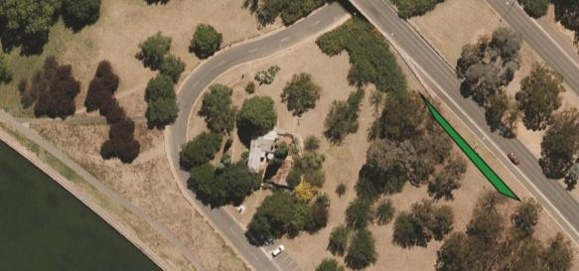

**Figure D.18** Suggested position of earth berm to Parks Way shown.

### D.11 Heritage Curtilage/Setting and Garden

#### Discussion

The establishment of a heritage curtilage for Blundells Cottage is recommended to identify a distinct setting within which the cottage, slab shed and the former associated outbuildings will be maintained, conserved and interpreted. The heritage curtilage is defined as the distinct setting within which the cottage, slab shed and the former associated outbuildings will be maintained, conserved and interpreted. This complex concept is to be decided in consultation with the NCA and after the proposed survey of the landscape in the vicinity of the cottage is completed to assist in understanding how the surrounding landscape has altered, inform decisions regarding provision of desired new educational and office facilities and provide opportunities for interpretation of the wider ‘lost’ agricultural landscape associated with Blundells as a farmhouse cottage.

The development of a landscape plan for the heritage curtilage, including SULE assessments for mature trees, and garden treatment adjacent to the cottage is recommended to inform planting, fencing and support museum interpretation, visitor infrastructure and operational needs.

The garden at Blundells Cottage is largely a creation postdating 1960 and was installed with reference to other regional homestead gardens, but apparently without research regarding the actual garden which may have existed at the cottage. Cuttings and bulbs were obtained from homestead gardens in the region by the CDHS members for planting in the cottage area. All paving in the garden is modern although some stone paths also have associations with old neighbourhood homesteads from where the stones were procured. The garden at Blundells Cottage is a conjectural creation which matched the CDHS aspirations for a suitable setting for their folk museum. The garden is of historic interest as a layer of the history and heritage values at the site and contains plants with associations with historic gardens in the district. However the garden lacks integrity in its present overgrown form and condition, and it confuses the interpretation of the most important heritage values of the place—early European settlement as part of the Duntroon Estate. The ‘cottage garden’ has lower relative heritage significance to other heritage values at the cottage.

The garden is defined by a highly visible white painted picket fence which is neither original nor relevant to the heritage values at Blundells Cottage. The farm and cottage fences of the site were post and rail or post and wire as shown in a number of historic photographs. The picket fence isolates the cottage within a confined space and artificially separates it from the wider landscape.

The strongly expressed interpretation desire for the establishment of a vegetable garden on the northeast slope between the cottage and Parkes Way could also be explored in the landscape plan. It is not known if this area ever had a vegetable garden before. The Blundell family are said to have had vegetable plots near the Molonglo River and Alice Oldfield had a private garden (which may have had vegetables) in an area east of the bread oven. No plans or full descriptions exist for either of these vegetable gardens. The development of a conjectural vegetable garden may not be the best approach for interpretation which could use frankly fake sculptures for interpretation as an alternative. The maintenance costs of a garden to assist in interpretation may also prove prohibitive and a poorly maintained vegetable garden would not enhance the site. Proposed works to extend the CDHS planted orchard should be similarly examined as part of a landscape plan.

The removal of the picket fence and development of a more suitable and historically accurate rural style fence would be of benefit in interpreting heritage values but would have to be erected with reference to identified historic fence patterns and relate to the identified heritage curtilage of the site once it is determined through a landscape plan.

In relation to the curtilage at Blundells Cottage it has to be acknowledged that the historic landscape context has been completely lost and will never be retrieved. The loss of historic landscape context may at first seems a loss, but it is part of what makes Blundells Cottage significant—namely that a classic vernacular cottage, associated with some of the earliest European settlement in the Limestone Plains, has survived to look across the lake at the High Court, arguably the pinnacle function in the Nation. It is this juxtaposition that energises Blundells Cottage. Nineteenth century lifestyles can be told at many places, for example at the house museums of Mugga Mugga and Lanyon, but it is Blundells Cottage that truly demonstrates the breadth of social development in Australia over a short but intense 150 to 200 year timeframe.

This developed understanding supports a wider heritage curtilage to encompass both locations of former outbuildings and haystacks and viewpoints out over the lake to the monumental buildings of the National Triangle.

1. Phillip Cox & Partners Pty Ltd 1983, Blundells Cottage Conservation Study Report p 7.
2. Phillip Cox & Partners Pty Ltd 1983, Blundells Cottage Conservation Study Report p 7.
3. Young L 2007, Lost Houses of the Molonglo Valley, Canberra Before the Federal Capital City, Ginninderra Press, p 44.
4. Phillip Cox 1983, p20 ‘exterior limewash mechanically removed’.
5. An informal straw poll on several weekends in November/December 2012 of people sitting in parked cars near Blundells and admiring the lake views indicated that visitors to the lake shore did not even know that Blundells was a house museum open to the public.
6. Freeman Collett & Partners Pty Ltd 1994, Blundells’ Cottage Precinct Conservation Management Plan, Volume 3.
7. CDHS Newsletter No 46, 1964.