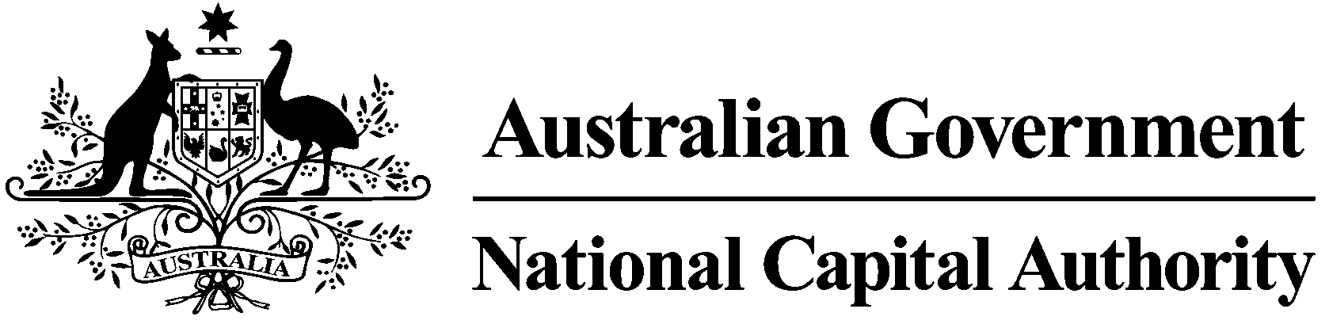

Executive Remuneration 2017-18

As a Commonwealth Entity we provide an annual update on the remuneration paid to the executives in the Agency. Details for the 2017-18 reporting period are outlined in the Tables below.

Table A includes the average annual reportable remuneration paid to substantive executives during the reporting period.

Table B includes details for other staff whose reportable remuneration was $200,001 or more for the reporting period and were not deployed outside of Australia.

Table A: Average annual reportable remuneration paid to substantive executives during 2017-18

Total Remuneration | Number of Executives | Average Reportable Salary | Average Contributed Superannuation | Average Allowances | Average Bonus Paid | Average Total Remuneration
$200,000 and less | 6 | $48,259 | $6,421 | $0 | $0 | $54,680
$200,001 to $250,000 | 1 | $181,342 | $25,765 | $19,936 | $0 | $227,043
$250,0001 to $325,000 | 1 | $223,658 | $36,359 | $19,936 | $0 | $279,953
Total Number of Executives | 8

Table B: Remuneration paid to highly paid staff during 2017-18

The National Capital Authority has no reportable other highly paid staff in 2017-18.

