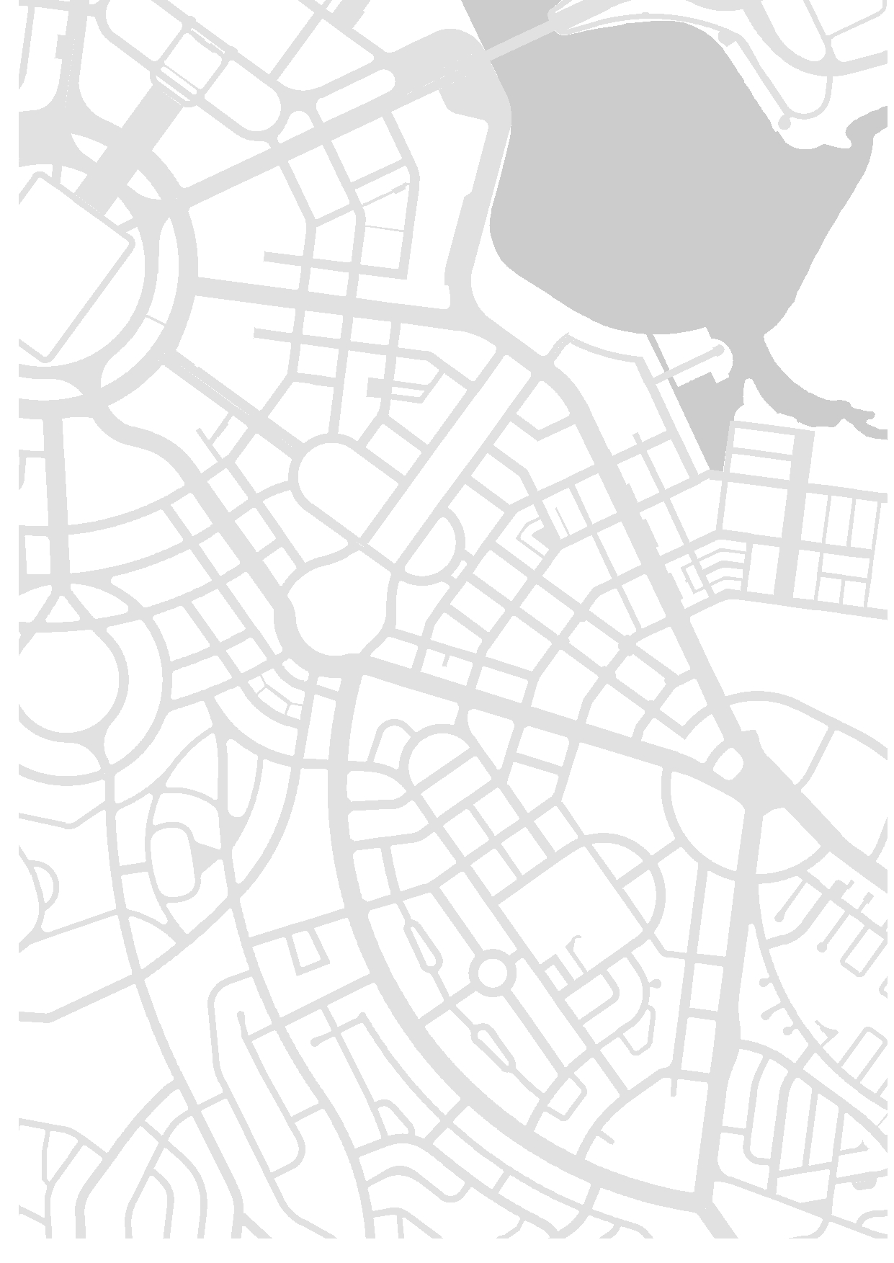



Development Control Plan 17/01

Manuka Circle Precinct, Canberra Avenue

November 2017

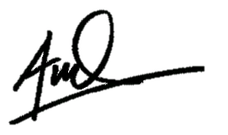

Date: 30/11/2017

Acting Chief Executive

Contents

[Preamble 2](#_Toc487439336)

[Designated Areas (Canberra Avenue Road Reserve) 2](#_Toc487439337)

[Areas subject to Special Requirements (Land Adjacent to Canberra Avenue) 2](#_Toc487439338)

[Application 2](#_Toc487439339)

[Purpose 3](#_Toc487439340)

[Structure 5](#_Toc487439341)

[Definitions 5](#_Toc487439342)

[Further detailed plans and policies 5](#_Toc487439343)

[Planning and urban design objectives 6](#_Toc487439344)

[**General provisions** 8](#_Toc487439345)

[**Site specific provisions** 15](#_Toc487439346)

# Preamble

Canberra Avenue is a Main Avenue as defined in the National Capital Plan (the Plan).

### Designated Areas (Canberra Avenue Road Reserve)

The Plan identifies the road reservations of the Main Avenues as Designated Areas. The National Capital Authority (NCA) is responsible for developing detailed conditions for design and development in these areas. In addition, the NCA is responsible for granting Works Approval within the road reserve. Specifically, the Plan states:

*Main Avenues are the entrance points to the Central National Area (CNA) and are primary organising elements of the National Capital.*

The Plan also outlines the detailed conditions for design and development for the Main Avenues, these state:

*Road pavements, medians, footpaths and verges will be developed to consistently high standards. Signs will generally comprise traffic, directional and visitor information signs, and unnecessary repetition will be avoided. Commercial roadside signs, are not permitted in road reservations, except on bus shelters. Non-commercial signs may be permitted.*

*The Main Avenues … will be developed and maintained as high quality landscaped corridors. In built-up areas, the established design theme of irrigated grass verges and medians and formal tree plantings will be maintained. In areas of intensive pedestrian use, high quality paving is to be used.*

### Areas subject to Special Requirements (Land Adjacent to Canberra Avenue)

The particular blocks or land parcels adjacent to Canberra Avenue are Territory land outside the Designated Area of the Plan. Special Requirements for Main Avenues, under Part 4.23 of the Plan, apply and state:

*Development, except in relation to Northbourne Avenue, is to conform to Development Control Plans (agreed by the Authority) which seek to secure the integrity of the Main Avenues as approaches to the Parliamentary Zone and ensure that the setting, buildings and purposes of development enhance that function.*

The Territory Planning Authority is responsible for assessing development applications relating to these areas. In doing so the Territory Planning Authority is required to ensure any proposal is not inconsistent with this DCP or the Plan.

### Application

This DCP applies to areas identified as part of the Manuka Circle precinct of the Canberra Avenue corridor as described in Figure 1 and 2.

In relation to those sites subject to Special Requirements, these provisions and requirements are additional to the rules and criteria of the Territory Plan. In the absence of a provision in the Plan or the DCP to the contrary, all development should accord with the relevant rules and criteria of the Territory Plan. Where an inconsistency arises between the Territory Plan and the National Capital Plan, the National Capital Plan and any approved instrument under the National Capital Plan prevails. Should an inconsistency arise in a method of quantitative measure (i.e measuring building height as storeys or metres from ground level), the method and measure defined in this DCP shall apply in place of the method outlined in the Territory Plan.

Therefore, this DCP takes precedence before those codes of the Territory Plan (precinct, development and general codes). However, this DCP should be read in conjunction with the applicable codes of the Territory Plan. Additionally, the requirements of ACT Legislation still apply and development proposals should be consistent with both this DCP and the applicable legislation.

### Design Review Panel

Redevelopment proposals must be considered by a joint NCA/ACT Government Design Review Panel prior to being approved by the Territory planning authority.

### Purpose

This DCP contains provisions and requirements for development of land subject to Special Requirements under the Plan. In conjunction with other relevant codes it will be used by the Territory Planning Authority to assess development applications and offer guidance to intending applicants in designing development proposals and preparing development applications.

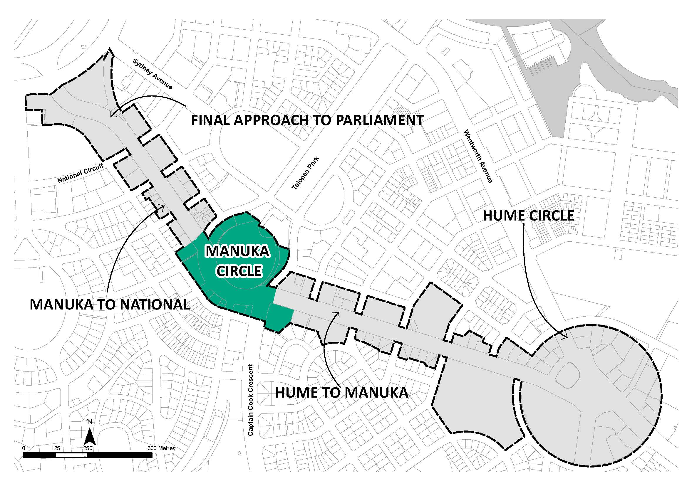

Figure 1 - Manuka Circle Precinct in the context of Canberra Avenue (Main Avenue)

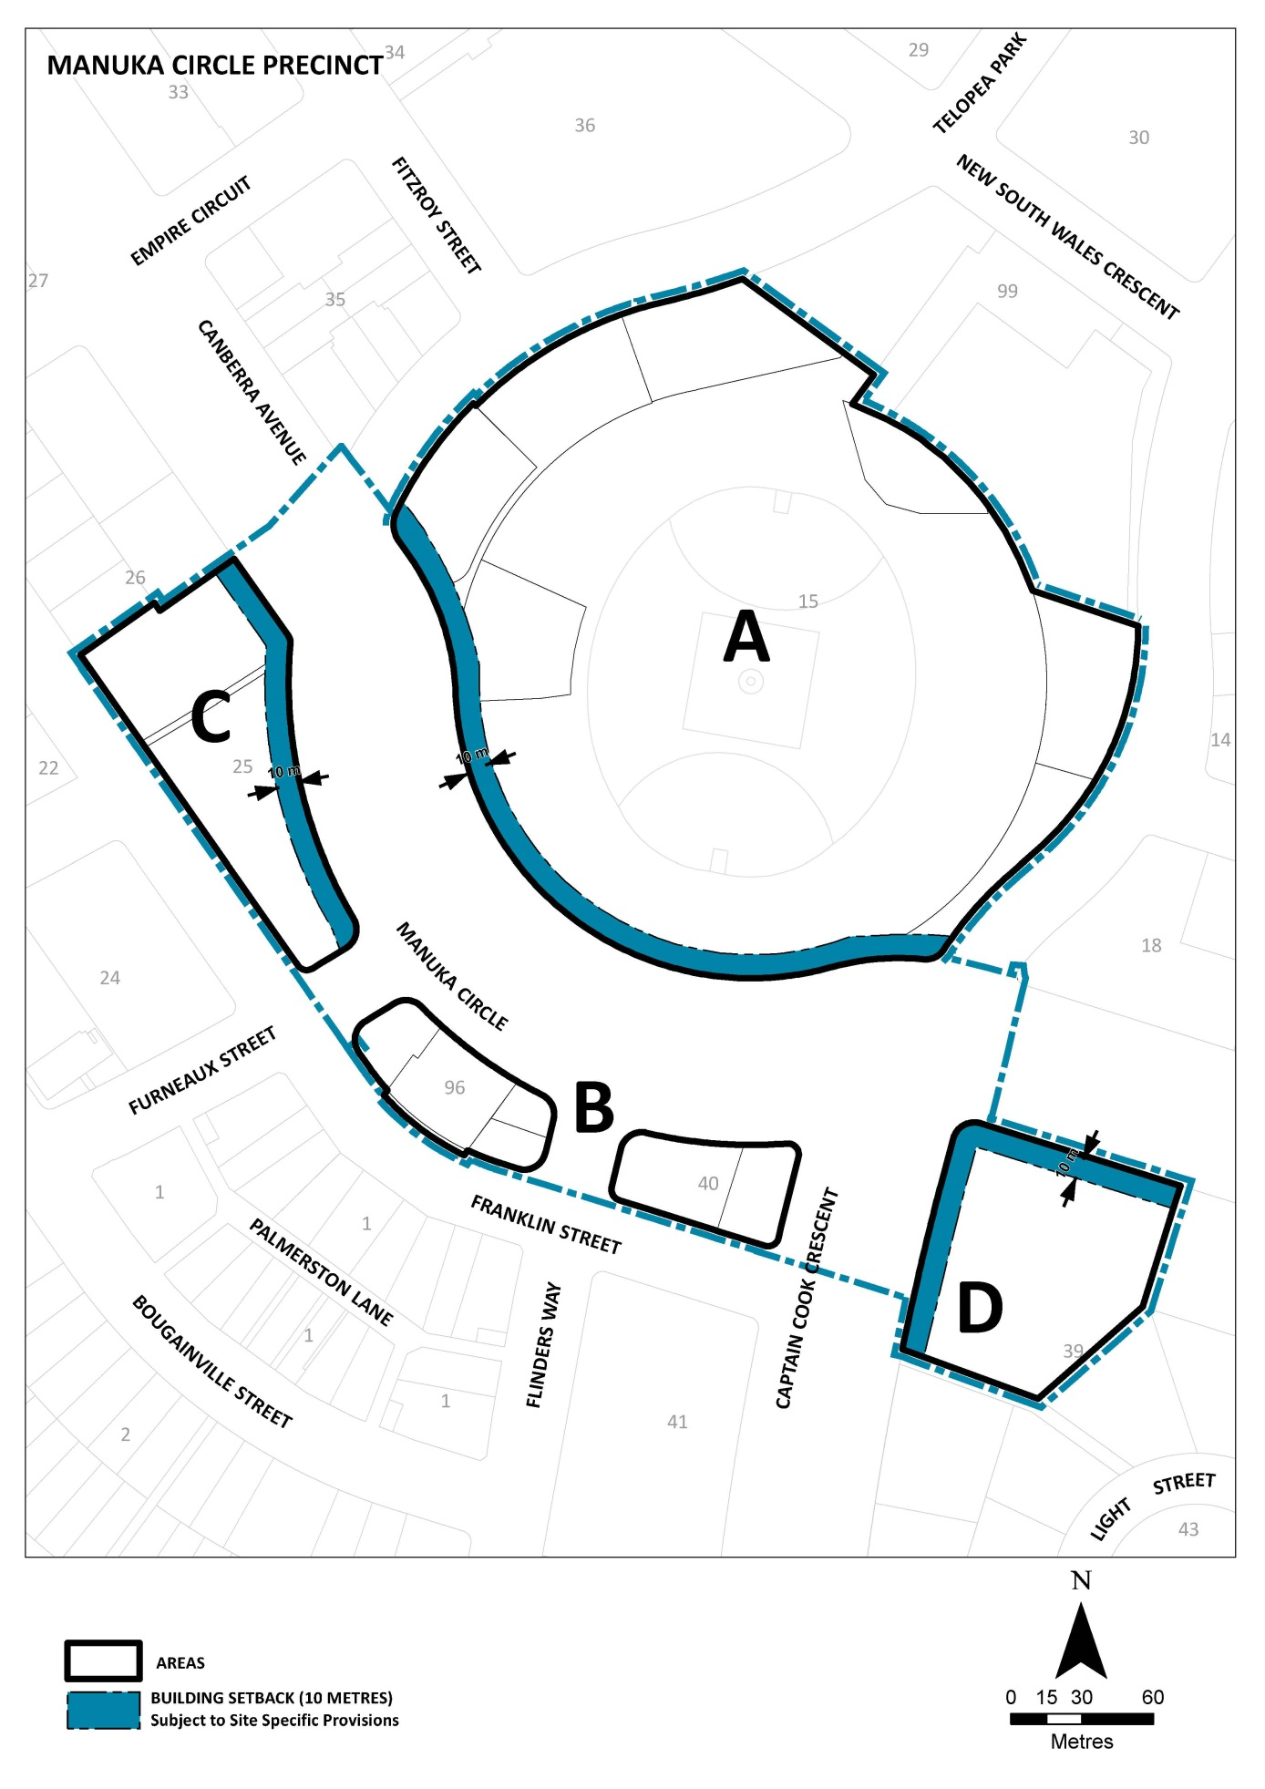

Figure 2 - Manuka Circle Precinct extent and subareas within the precinct

### Structure

This DCP contains general provisions and location specific provisions regarding development of the Manuka Circle precinct (as defined by Figure 1 and 2). If there is any inconsistency in intent or effect of these provisions the location specific provisions should be taken to have precedence.

### Definitions

Defined terms and terms referenced in other legislation are shown in *italics*.

### Further detailed plans and policies

DCPs may require the development of more detailed policies and actions in the form of concept plans, master plans or management plans. Development applications submitted to the Territory planning authority and Works Approval applications submitted to the NCA should be assessed against these documents to ensure the intent of this DCP is upheld. The NCA will work with the relevant authorities to develop these more detailed plans.

# Planning and urban design objectives

The character of both private development and public realm design contributes to the quality and experience of Canberra Avenue as a *Main Avenue* of the National Capital. In this respect, all proposals must respond to the following general objectives for Main Avenues.

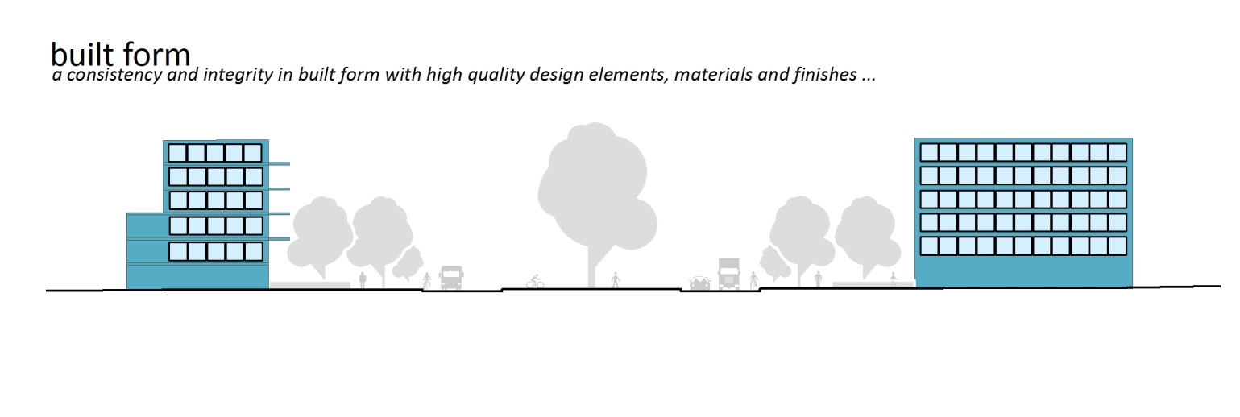

To maintain Canberra Avenue as a setting for prestigious buildings the built form and architectural design of development adjacent to Canberra Avenue shall:

* display a consistency and integrity in height and form with high quality design elements, materials and finishes.
* provide for a character of significance and reinforce an appropriate urban scale relationship to the public realm.
* ensure all new buildings have their main frontage to Canberra Avenue, with clearly articulated pedestrian entries.
* ensure that a high level of amenity is provided in site layout and urban design and that noise impacts are mitigated through appropriate building design, materials and construction.

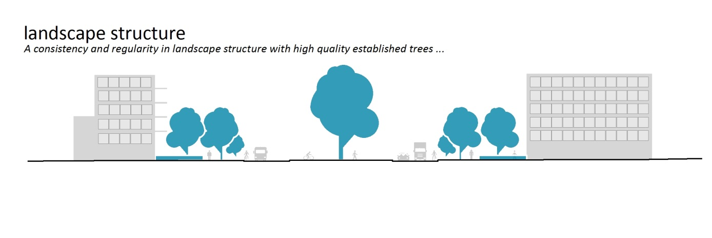

In order to enhance the character of Canberra Avenue as one of the Griffins’ Main Avenues and as one of the main approaches to Parliament House and the Parliamentary Zone, the landscape structure of the road reserve and private landscape areas shall:

* provide a consistency and regularity in landscape structure with high quality established trees.
* be developed and maintained as high quality landscaped corridors.
* continue the established design theme of grass verges and medians and formal tree plantings.
* utlilise high quality paving in areas of intensive pedestrian use.
* select tree species for regularity in landscape character along extended parts of the Avenue.

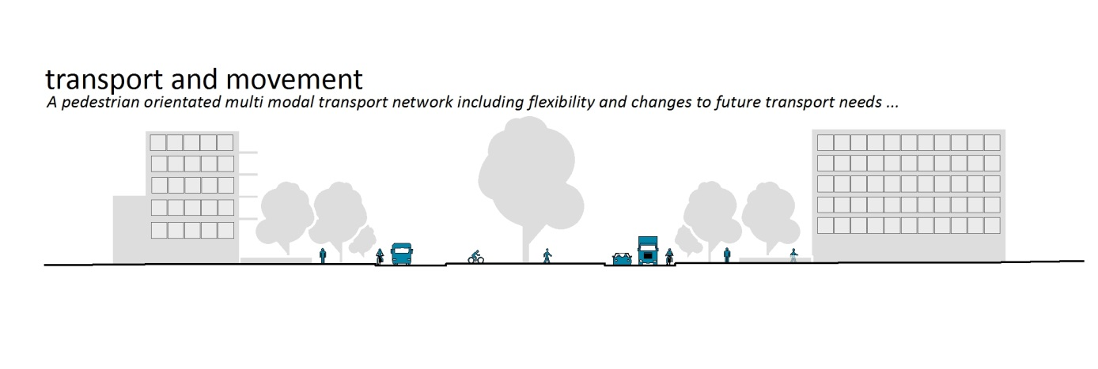Traffic and movement systems shall be managed to ensure the continued effective function of the Main Avenues. This includes but is not limited to:

* reducing the barriers created by major roads to make it easier for people to access the public spaces of the city, particularly in the CNA.
* demonstrate the road user hierarchy by enhancing movement around the city for a diversity of pedestrian, cycle, public transport and private transport modes.
* support efficient and sustainable pedestrian, bicycle and public transport systems that reduce car dependency.
* provide streets that foster a connected and pedestrian-friendly environment.

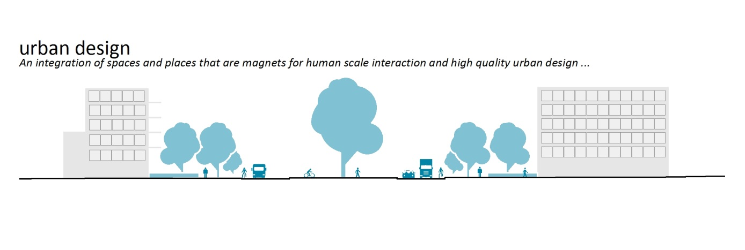

Broadly, the urban design objectives for Canberra Avenue are linked the three previous key themes. In addition to the objectives already defined development should seek to:

* create identifiable places at key points along the Main Avenue.
* ensure the relationship and interface between private development and the public realm fosters human scale interaction
* ensure that existing identified heritage elements of the Avenue are conserved and celebrated as key contributors to the character of the Avenue.

# General provisions

***These provisions apply to the entire Manuka Circle precinct as defined by Figure 1 and 2.***

|  |
| --- |
| Theme 1: Built Form |
| Rule 1.1: Building Height |
| The maximum *building height* permitted for sites, including any rooftop plant, are as follows:   * Area A: RL592 (20 metres from Canberra Avenue kerb). * Area B: RL592 (18 metres from Canberra Avenue kerb) with reduced building height of RL583 to parts of the Franklin Street frontage. * Area C: RL592 (18 metres from Canberra Avenue kerb). * Area D: RL591 (18 metres from Canberra Avenue kerb).   All *development applications* shall include solar analysis to demonstrate that the reasonable solar access to adjacent uses and associated public realm is not unduly impacted. |
| Rule 1.2: Building Design and siting |
| Buildings and other permanent structures must be designed to a high architectural design standard and must ensure an overall consistency in form, massing and detail.  Buildings must be sited parallel to Canberra Avenue unless, in the opinion of the NCA, there is no other suitable alternative. |
| Rule 1.3: Rooftop Plant |
| Rooftop plant and roof mounted equipment must be totally concealed from view from Canberra Avenue and Parliament House.  Rooftop plant, and roof mounted equipment, if required, must be enclosed and the enclosures are to be carefully integrated with the roof form and design of the building. |
| Rule 1.4: Roofscape design |
| Screening, enclosures or roof form used to ensure no visibility of rooftop plant must present to Canberra Avenue as an integral part of the building design with careful consideration given to the roof form and the roofscape of buildings as viewed from the Avenue. |
| Rule 1.5: Building setback from Canberra Avenue |
| The minimum *building setback* to Canberra Avenue are as follows:   * Area A, C and D: Ten metres * Area B: Zero metres. |
| Rule 1.6: Building articulation zone and articulation restriction zone |
| Minor encroachments of building elements into the *building setback* from Canberra Avenue (as defined by Rule 1.5) may be permitted within the *building articulation zone* as described in Figures 3.  Articulation elements shall not occupy more than 25 per cent of this defined articulation zone. Articulation elements permitted are verandas, fin walls, porches, awnings, sunscreen and shade devices, pergolas, bay windows, dwelling entries, and roof elements. |
| *Definition: Building articulation zone*  The articulation zone is a 2.5 metre wide area of the building setback to Canberra Avenue immediately adjacent to the developable area. The articulation zone shall commence no lower than six metres above the adjacent kerb level of Canberra Avenue as described by Figures 3. |

|  |
| --- |
| Rule 1.7: Restrictions on unarticulated building facades |
| Buildings shall have a maximum unarticulated length of 15 metres. Articulation may be provided by:   * changes in wall planes of a minimum one metre in depth and no less than four metres in length and/or * inclusion of balconies and/or * horizontally stepping facades by at least one metre. |
| Rule 1.8: Building Materials and Colours |
| The facades and roofs of buildings are to be constructed of high quality, durable materials. Highly reflective external materials are not permitted. Building materials, construction and finishes are to be responsive to microclimate issues. |
| Rule 1.9: Mechanical Plant, electrical substations, storage and service areas |
| All mechanical plant and equipment (including air conditioning units) is to be contained within buildings or located within service enclosures. Such elements, in addition to electrical substation, storage and service areas (including storage sheds and waste areas), are to be carefully sited and must not be visible from Canberra Avenue, Manuka Circle or Franklin Street. All such plant and equipment shall be totally concealed from view from Canberra Avenue and Parliament House. |

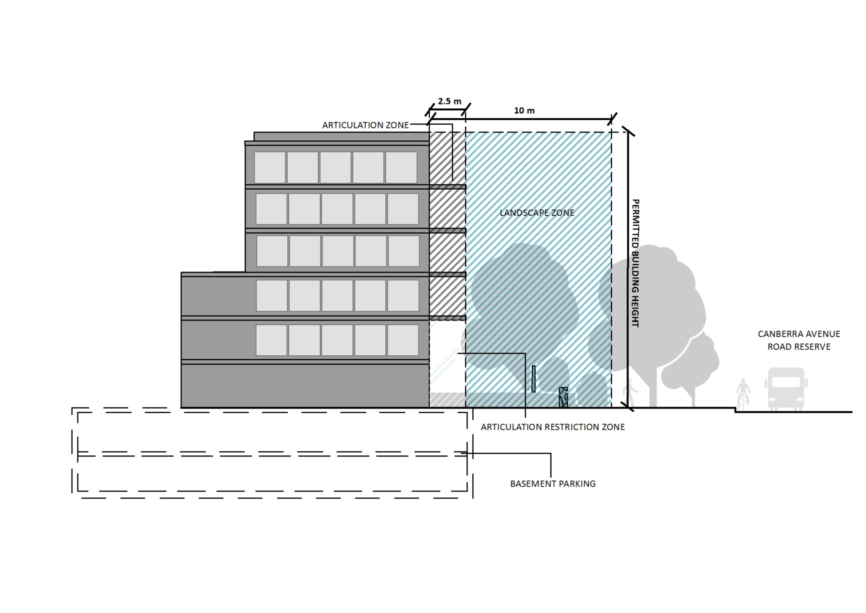

Figure 3 - Building setback to Canberra Avenue and articulation zone

|  |
| --- |
| Theme 2: Landscape Structure |
| Rule 2.1: Landscape Plan |
| A *Landscape Plan* must accompany any development proposal, which achieves the requirements of this DCP and reflects the intent illustrated on Figure 4. The Landscape Plan will need to identify the following:   * Mature trees identified in the tree assessment required at Rule 2.3. Where they are proposed for removal, the Landscape Plan should include provision for replacement with new advanced stock. * Well landscaped setbacks in accordance with Rule 1.5. * Verge works in accordance with Rule 2.4 and 4.2. |
| Rule 2.2: Landscape Design |
| A high standard of landscape design and verge treatment is required for all road frontages. Landscaping should include deep rooted trees wherever possible particularly in the building setback to Canberra Avenue and deep soil zones. |
| Rule 2.3 Tree Assessments |
| An assessment of the adjacent trees within the Canberra Avenue road reserve is mandatory for all redevelopment proposals.  For minor development applications where development involves tree removal or work is proposed in the vicinity of trees, a tree assessment must accompany the development application. |
| Rule 2.4 Offsite Landscape works (Street Trees) |
| Where there are gaps in the street tree planting patterns of Canberra Avenue adjacent to the site OR trees assessed in accordance with Rule 2.3 are identified as requiring replacement, then applications must include replacement trees of the same species and in locations consistent with the current street tree patterns OR other species/locations approved by the NCA. |
| Rule 2.5 Offsite landscape works (Paving and Lawn) |
| In areas of high pedestrian use, high quality paving shall be installed provided trees are planted in accordance with the Land Custodian’s requirements. Elsewhere, lawn is to be installed in the verge and maintained to a high quality by the lessee. |
| Rule 2.6 Courtyard Walls |
| Blank walls to public streets are not permitted. Fences, courtyard or retaining walls are permitted within the *building setback* to Canberra Avenue providing they are appropriately articulated and integrated with soft landscape design treatments and are consistent with the following requirements:   * Walls and fences do not exceed 30 per cent of the length of the Canberra Avenue frontage for a particular block. * Walls or fences are setback a minimum of three metres from the block boundary. * Walls do not exceed a maximum of is 1.5 metres in height. * The use of hedges is used in lieu of (or combined with) fences and walls when forward of the building line. * Courtyard walls and fences shall be comprised of high quality materials in colours and finishes consistent with the principle building. Fences forward of the building line shall be generally transparent in character. |

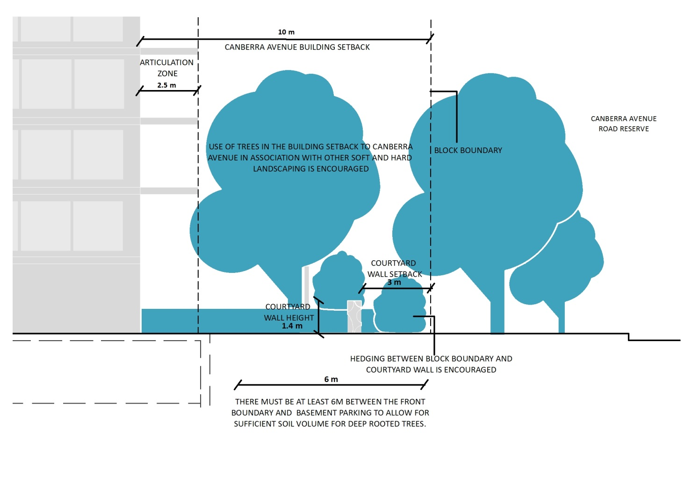

Figure - Landscape intent of building setback to Canberra Avenue

|  |
| --- |
| Theme 3 : Traffic and Movement |
| Rule 3.1 Vehicular Access |
| Vehicular access is generally not permitted from Canberra Avenue. Individual access points from the Avenue to developments will be determined by the relevant authorities. |
| Rule 3.2 Pick-up and Set down areas |
| Pick up and set down areas on Canberra Avenue are only permitted adjacent to Section 96 Griffith. |
| Rule 3.2 Parking in Canberra Avenue setback |
| Surface or on-grade car parking must not be located within the *building setback* to Canberra Avenue. |
| Rule 3.3 Visual impact of parking |
| The visual impact of all surface car parking must be minimised through adequate screening and landscape treatment that appropriately considers view lines and safety. |
| Rule 3.4 Basement parking |
| Encroachment of basement parking into the *building setback* to Canberra Avenue may be considered where it would not detract from the quality of the landscape treatment and would not affect the root zone of existing trees in the road reserve. At minimum setback of six metres must be maintained along the Canberra Avenue frontage for deep rooted planting in accordance with Figure 4. |

|  |
| --- |
| Theme 4: Urban Design |
| Rule 4.1 Pedestrian address |
| The primary pedestrian address frontage for development is to be oriented to Canberra Avenue to reinforce the prestige and visual interest of the avenue. Building frontages must be articulated incorporating modulated form, tactility, silhouette and respond to human scale. Building entries should be appropriate to the scale and character of the avenue. |
| Rule 4.2 Areas of intensive pedestrian use |
| Areas of intensive pedestrian use are to be paved using a high quality durable paver that provides a unique character to the Manuka precinct. |
| Rule 4.3 Pedestrian Access to buildings |
| Multiple entries (including communal building entries and individual ground floor entries) should be provided to activate the street edge on all new developments. Where street frontage is limited and multiple buildings are located internal to the site, a primary street address should be provided with clear sight lines and pathways to secondary building entries. |
| Rule 4.4 Lighting |
| All outdoor lighting, including security and car park lighting shall be designed and sited to minimise light pollution. Outdoor lighting shall use full cut-off light fittings. |
| A full cut-off light fitting allows no light to be directed upward. No light dispersion or direct glare is allowed to shine at or above a 90 degree, horizontal plane from the base of the fixture. The lens/diffuser should not project beyond housing and minimal light should be emitted above 80 degrees as per Figure 5. |

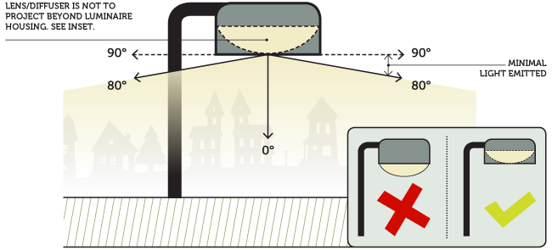

Figure 5 - Full Cut Off Light Fixture

|  |
| --- |
| Theme 5: Design Quality  Development applications must include a statement addressing how a proposal addresses the eight design criteria set out below. The relevant consent authority must consider the criteria when assessing proposals. |
| Criteria 5.1 Context and neighbourhood character |
| Good design responds to and contributes to its context. Context is the key natural and built features of an area, their relationship and the character they create when combined. Well designed buildings respond to and enhance the qualities and identity of the area including the adjacent sites, streetscape and neighbourhood. |
| Criteria 5.2 Built form and scale |
| Good design achieves an appropriate built form for a site and the building’s purpose in terms of building alignments, proportions, articulation, and building elements. Appropriate built form defines the public domain, contributes to the character of the streetscape, and provides internal amenity and outlook. |
| Criteria 5.3 Sustainability |
| Good design combines positive environmental, social and economic outcomes. Good sustainable design includes passive thermal design for ventilation, heating and cooling to reduce reliance on technology and operation costs. In residential development, it includes natural cross ventilation and sunlight for the amenity and liveability of residents. Other elements include recycling and reuse of materials and waste, use of sustainable materials and deep soil zones for groundwater recharge and vegetation. |
| Criteria 5.4 Landscape |
| Good design recognises that together landscape and buildings operate as an integrated and sustainable system, resulting in attractive developments with good amenity. A positive image and contextual fit of well designed developments is achieved by contributing to the landscape character of the streetscape and neighbourhood. |
| Criteria 5.5 Safety |
| Good design optimises safety and security, within the development and the public domain. It provides for quality public and private spaces that are clearly defined and fit for the intended purpose. Opportunities to maximise passive surveillance of public and private areas promote safety. A positive relationship between public and private spaces is achieved through clearly defined secure access points and well lit and visible areas that are easily maintained and appropriate to the location and purpose. |
| Criteria 5.6 Aesthetics |
| Good design achieves a built form that has good proportions and a balanced composition of elements, reflecting the internal layout and structure. Good design uses a variety of materials, colours and textures. |
| Criteria 5.7 Housing diversity and social interaction (for proposals with residential components) |
| Good design achieves a mix of apartment sizes, providing housing choice for different demographics, living needs and household budgets. Well designed apartment developments respond to social context by providing housing and facilities to suit the existing and future social mix. Good design involves practical and flexible features, including different types of communal spaces for a broad range of people, providing opportunities for social interaction amongst residents. |
| Criteria 5.8 Amenity (for proposals with residential components) |
| Good design positively influences internal and external amenity for residents and neighbours. Achieving good amenity contributes to positive living environments and resident well being. Good amenity combines appropriate room dimensions and shapes, access to sunlight, natural ventilation, outlook, visual and acoustic privacy, storage, indoor and outdoor space, efficient layouts and service areas, and ease of access for all age groups and degrees of mobility. |

# Site specific provisions

***These provisions apply to the specific areas described as defined by Figure 2***

|  |
| --- |
| Area A: Manuka Oval (Sections 15 and 99 Griffith) |
| Rule A.1 Broadcast lighting height |
| The height of broadcast light poles, including the lighting frame and any associated equipment erected for broadcast quality lighting, must not exceed RL617. |
| Rule A.2 Broadcast lighting setback |
| Broadcast lighting must not be located within the *building setback* to Canberra Avenue. |
| Rule A.3 Broadcast lighting operation |
| Broadcast lighting towers and frames shall be designed and sited to minimise light pollution, and shall be of a high quality design in detail and execution.  All lighting shall accord with both the following:   * Australian Standard 4842-1997 ‘control of the obtrusive effects of outdoor lighting’ * Civil Aviation Regulations Manual of Operation Standards 139, Section 9.21 ‘Lighting in the vicinity of aerodromes’. |
| Rule A.4 Tree Management and Replacement Master Plan |
| A Tree Management and Replacement Master Plan for the subject site are to be prepared in consultation with and approved by the NCA and relevant ACT Government Agencies. |
| *Further Detailed Plan Required: Tree Management and Replacement Master Plan for Manuka Oval and surrounds* |
| The core objectives of the Tree Management and Replacement Master Plan are:   * Conserve and retain the character of the landscape setting for the Oval, Canberra Avenue and its surrounds. * Ensure that the Canberra Avenue frontage is landscaped with consistent treatments and presents as a unified landscape. * Retain mature trees to the maximum extent practicable whilst allowing for plantings to provide for progressive replacement of these older trees. |
| Rule A.5 Signage and Signage Master Plan |
| All signage is to be of a high design quality, and be consistent in design and detail. Careful consideration is to be given to the integration of signs with landscape and building design to ensure they do not detract from the Canberra Avenue frontage.  Roof signs and large freestanding signs visible from Canberra Avenue not specifically noted in the Signage Master Plan will not be permitted. Permanent signage will not be permitted in the Canberra Avenue road reserve. |
| *Further Detailed Plan Required: Signage Master Plan for Manuka Oval*  All signage located on the site is to be in accordance with a Signage Master Plan approved by the relevant ACT Government land custodian in consultation with the NCA. The Signage Master Plan must be in accordance with the requirements of the Territory Plan and the National Capital Plan. |

|  |
| --- |
| Rule A.6 Building Articulation Zone and articulation restriction zone |
| Buildings may utilize up to 90 per cent of the articulation zone and include minor encroachments into the articulation restriction zone as described by Figure 3 provided applications demonstrate:   * The proposal is to support the continued function of Manuka Oval as a sporting and recreation facility * There is sufficient building setback to ensure emergency access is provided to facilities around Manuka Oval * Implementation of tree planting in accordance with the Tree Management and Replacement Master Plan. |

|  |
| --- |
| Area B: Manuka Group Centre (Sections 40 and 96 Griffith) |
| Rule B.1 Building Setback, Development Footprint and Articulation |
| Buildings may be built to a zero metre *building setback* on all frontages (100 percent site coverage is permitted on these sites). This results in no articulation zone as described in the general conditions of this DCP. A more considered approach to building articulation which achieves appropriate fenestration and creation of shadow lines, by use of over expressed joints, balconies set into the building footprint or similar should be considered. No glass curtain walls are permitted. |
| Rule B.2 Active frontages |
| Active frontages are encouraged for all new development proposals. Active frontages are mandatory for all frontages for any new structured car parks. |
| Rule B.3 Building Height |
| Maximum *building heights* for specific parts of the sites are as described in Figure 6. Building height fronting Franklin Street is reduced and design must be sympathetic and in accordance with the existing streetscape and village character of the Manuka Group Centre. Buildings in this area shall minimise overshadowing of existing buildings. Solar analysis of the impact of buildings on the pedestrian amenity of Franklin Street is to be submitted with any new development proposals. |
| Rule B.4 Pedestrian address |
| Primary pedestrian address may be from Franklin Street on these sites. |

## M:\Projects\Main Avenues\Canberra Avenue\Manuka Circle\output\AreaB_DetailedControls.jpg

Figure 6 - Detailed building height controls for Sections 40 and 96 Griffith (Area B of this DCP)

|  |
| --- |
| Area C: St Christopher’s (Blocks 7 and 12 Section 26, Block 1 Section 25 Forrest) |
| Rule C.1 St Christopher’s Cathedral |
| The cathedral and campanile are to remain a landmark element on this section of Canberra Avenue. New buildings shall be designed to ensure they do not dominate the cathedral. Development of the site shall recognise the heritage values of the St Christopher’s Cathedral Precinct. A minimum of 10 metres separation is required between the cathedral building and any new development. |
| Rule C.2 Pedestrian Access |
| Public pedestrian access through the site from Franklin Street to Canberra Avenue shall be maintained. |
| Rule C.3 Tree Conservation Plans |
| Landscape plans for development applications should incorporate a tree conservation and management plan for trees on the site. Trees removed shall be replaced elsewhere on the site. |
| Rule C.4 Secondary ‘No Build’ Area |
| The secondary ‘No Build’ area forms the immediate landscape setting for the cathedral. Structures need to have careful consideration to the cathedral, its landscape setting, heritage values and address to the Canberra Avenue. |

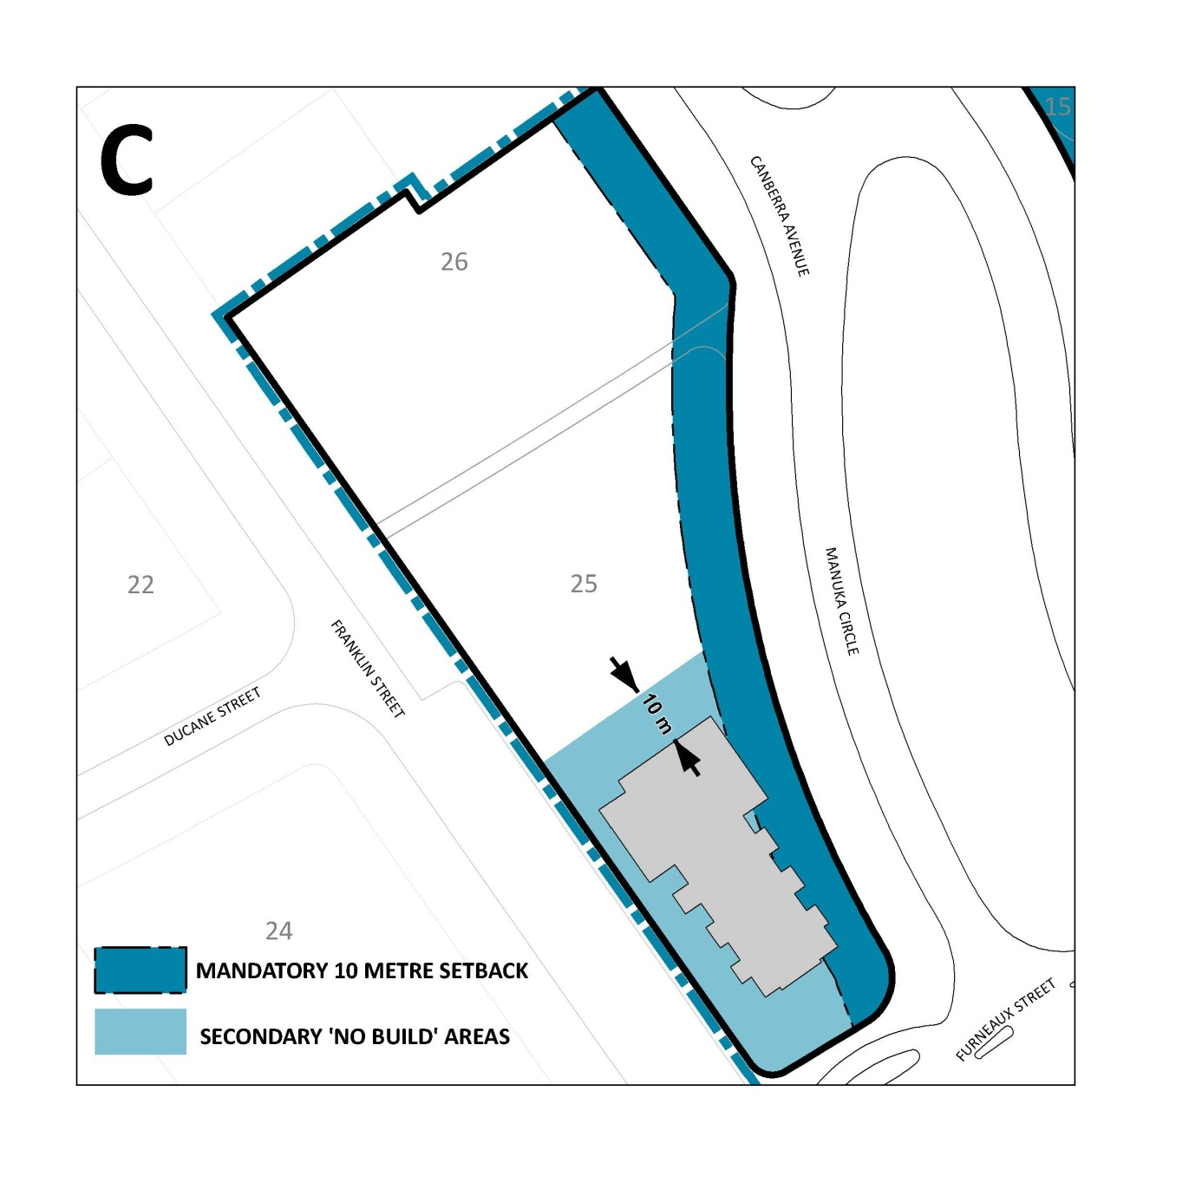

Figure 7 - Detailed building controls for Sections 25 and 26 Forrest (Area C of this DCP)

|  |
| --- |
| Area D: St Paul’s (Block 1 Section 39 Griffith) |
| Rule D.1: St Paul’s Anglican Church |
| St Paul’s Church shall remain a landmark element on this section of Canberra Avenue. New buildings shall be designed to ensure they do not dominate the church building. Development of the site shall recognise the heritage values of the site. A minimum of 12 metres separation is required between the main body of the existing church building and any new development as described in the drawing below. |
| Rule D.2 Secondary ‘No Build Area’ |
| The secondary ‘No Build’ area forms the immediate landscape setting for the church. Structures need to have careful consideration to the church, its landscape setting, heritage values and address to the Canberra Avenue. |

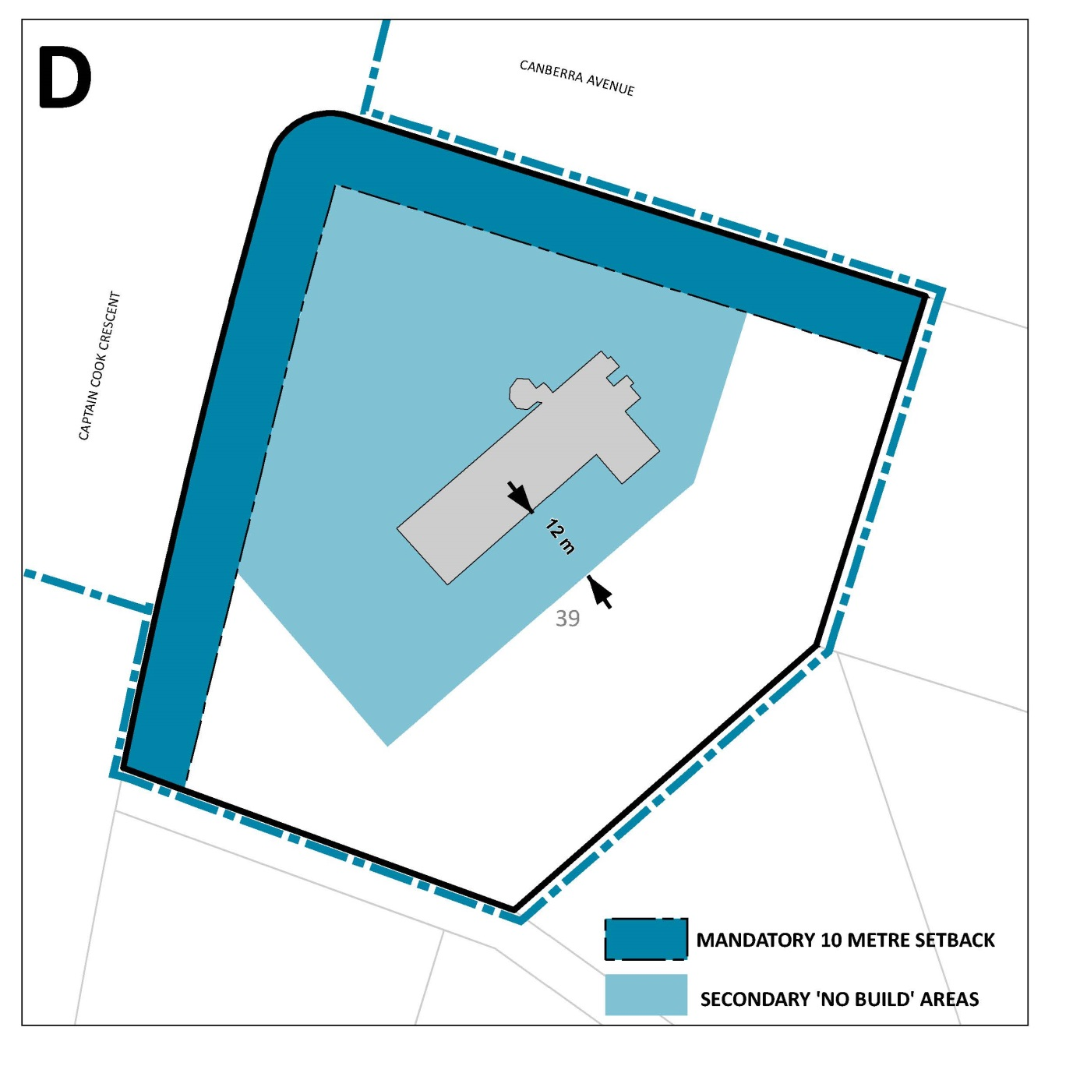

Figure 8 - Detailed building height controls for Sections 39 Griffith (Area D of this DCP)