

**NATIONAL CAPITAL AUTHORITY**

***Australian Capital Territory  
 (Planning and Land Management) Act 1988***

**NATIONAL CAPITAL PLAN**

**AMENDMENT 35   
(JOINT STAFF COLLEGE, WESTON CREEK –   
BOUNDARY ADJUSTMENT)**

**APRIL 2000**

**AMENDMENT 35 OF THE NATIONAL CAPITAL PLAN**

**Amend the National Capital Plan as follows:**

In Figure 1 of the National Capital Plan, change the land use category for a small area of land in the Molonglo River Corridor at Weston Creek, adjacent to the Joint Staff College, from “River Corridor” to “Broadacre Areas”.

The section of Figure 1 as amended, is as follows:

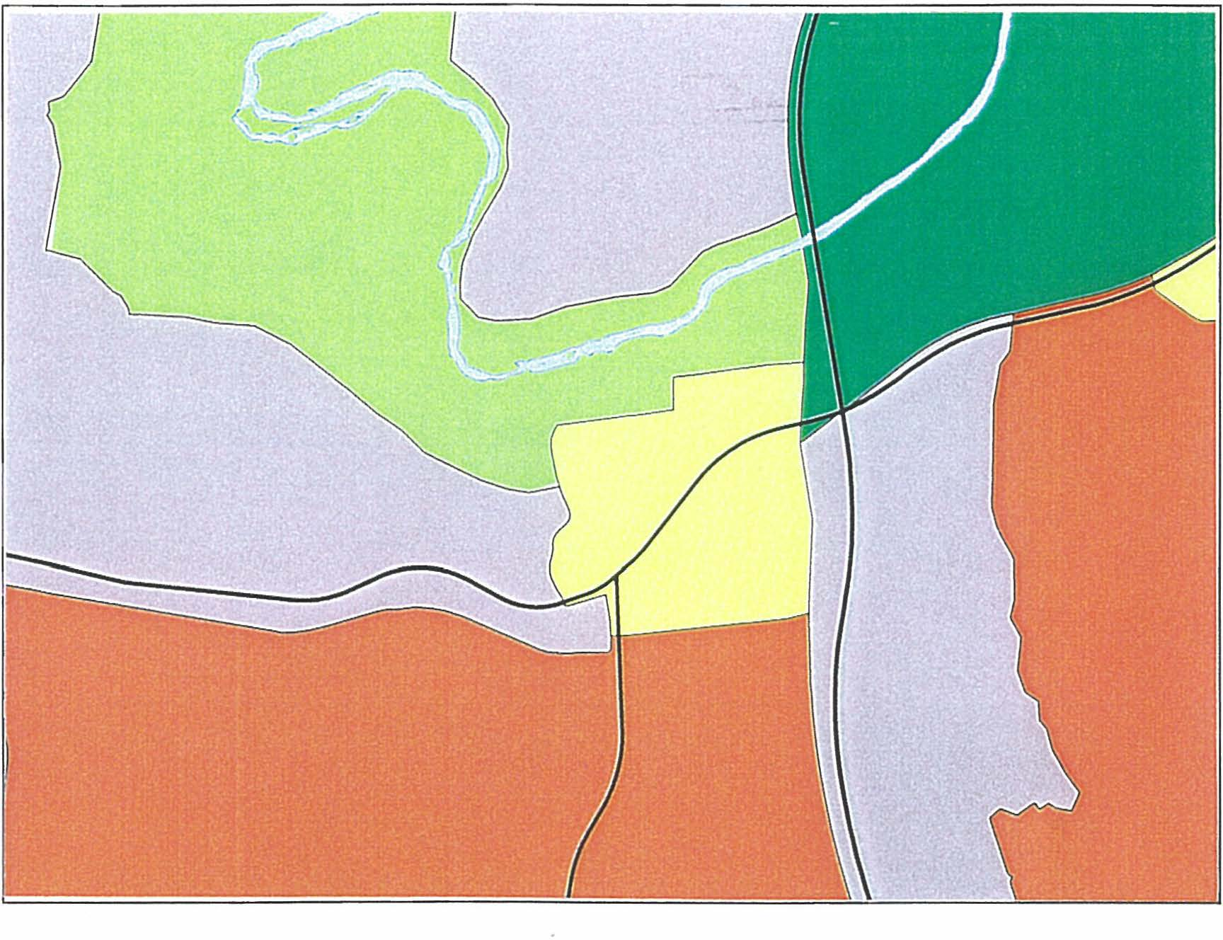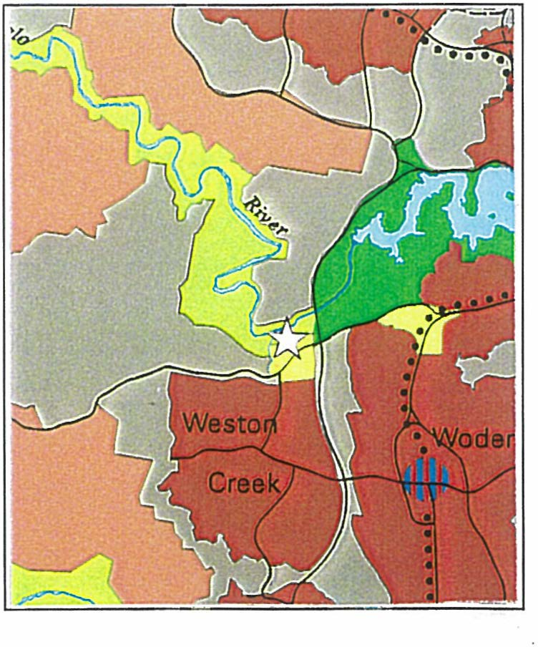

Location Map