NCa Crest

**NATIONAL CAPITAL AUTHORITY**

*Australian Capital Territory   
(Planning and Land Management) Act 1988*

**NATIONAL CAPITAL PLAN**

**AMENDMENT 39**

**(Deakin/Forrest Residential Area)**

**May 2005**

**AMENDMENT 39 TO THE NATIONAL CAPITAL PLAN**

**Amend the National Capital Plan by:**

1) Replacing the existing Figure 7 with the revised Figure 7 at Attachment "A";

2) Inserting new pages following and forming part of Figure 7 as at Attachment "B";

3) Replacing the existing Appendix M — Residential Land Use with the revised

Appendix M at Attachment "C"; and

4) Replacing the existing Appendix N — The Conduct of Business on Residential Land with the

revised Appendix N at Attachment "D".

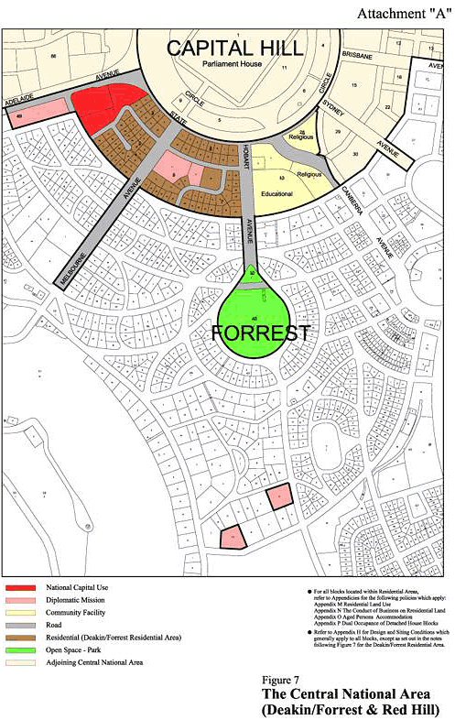

**Attachment "B"**

**Deakin/Forrest**

**Residential Area**

**The land between State Circle**

**and National Circuit**

**Objective:**

To ensure that the residential areas of Deakin and Forrest that lie between State Circle

and National Circuit maintain and enhance the character of the National Capital and are

planned and developed in accordance with its national significance.

**Land Use Policy:**

The primary land use is:

* Residential (refer Appendix M)

Other land use permitted is:

* Home business (refer Appendix N)

Commercial accommodation including serviced apartments is not permitted.

**General Development Conditions:**

To ensure excellent urban design for this important residential precinct adjacent to Parliament House, the quantitative standards, with the exception of building height and plot ratio, may be varied where it can be demonstrated that this would result in excellence in the urban design outcome. All residential development proposed are subject to public notification and consultation with lessees and residents in the Deakin/Forrest Residential Area.

The general development conditions are:

* The principal residential character of the area and the use of the land for residential purposes are to continue.
* Development throughout the area, except for sites fronting State Circle, shall not be more than two storeys in height and generally no more than 8 metres above the natural ground level.
* Development throughout the area, except for sites fronting State Circle shall have a maximum plot ratio of 0.4.
* Design of buildings in proximity to the Prime Minister's Lodge should reflect the dominant urban design character of the locality.
* Roof mounted aerials, masts and satellite dishes should be located to have a low visual impact.

**Development Conditions for sites fronting State Circle:**

***Objectives:***

The objectives of these development conditions are to:

* Provide for high quality residential development of a scale and character appropriate to the setting of Parliament House and the Main Avenue role of State Circle.
* Protect the residential amenity of rear neighbours in terms of privacy, sunlight access and provision of a landscape buffer.
* Reduce traffic access from residences to State Circle.
* Provide for a variety of housing types and sizes.

***Conditions:***

The following conditions apply to residential sites fronting State Circle between Hobart and Adelaide Avenues, being Blocks 1-8 Section 6 Forrest and Blocks 5-9 Section 3 Deakin:

(i) **Block Amalgamation** – block amalgamation may involve more than two blocks.

(ii) **Building height -**any redevelopment of blocks shall result in buildings that address State Circle and shall be two storeys in height. If blocks are amalgamated 3 storeys is permissible. If a block is isolated by amalgamation three storeys may be permissible.

(iii) **Plot Ratio -**the plot ratio for residential redevelopment of existing blocks is 0.4. If sites are amalgamated the plot ratio may be up to 0.8. An exception applies to blocks flanking Melbourne Avenue (Block 1 Section 6 Forrest and Block 9 Section 3 Deakin) which are permitted to develop to a plot ratio of 0.8 without amalgamation. For other blocks, including blocks isolated by amalgamation, a plot ratio higher than 0.4 and up to a maximum of 0.8 may also be permissible (where it can be demonstrated that this would result in excellence in the urban design outcome).

(iv) **Architecture** -Architectural treatment shall be of the highest quality, reflecting the prestigious character of the area. The provision of legible entries, accessible from the street, is encouraged as a means of enriching the streetscape. Buildings should be modulated and provided with articulation elements such as porches, balconies, bay window and shade devices, to provide visual interest to the streetscape. Balconies off living areas should generally have a minimum dimension of 2.5 metres.

Due consideration should be given to the roof form and roofscape of buildings. Roof top plant and equipment, if required, should be carefully integrated with the roof form and design of the building and screened from public view from the street. Internal floor to ceiling dimensions should generally be a minimum of 2.7m to promote natural lighting and cross-ventilation, consistent with energy efficiency objectives and creation of generously scaled facades.

(v) **Vehicle Access -**vehicle access should generally be consistent with the principle shown in Figure A. Blocks, including amalgamated blocks, with a frontage to a road other than State Circle may have access to that road. Site planning should ensure that vehicles are able to enter and leave the site in a forward direction.

The number of vehicular access points to and from State Circle should be minimised in the interests of traffic safety, convenience and streetscape quality.

(vi) **Building Envelopes** - Buildings should generally be contained within the building envelopes depicted in Figure B.

(vii) **Set Backs** -setback from State Circle shall be 10 metres. Building articulation elements such as balconies, entries and shading devices may be permitted forward of the primary set back. r

The minimum setback of buildings from side boundaries for three storey development is 6 metres. For two storey development, the minimum side boundary set back may be less than 6 metres provided it is generally in accordance with the building envelope depicted in Figure B.

The minimum set back for buildings from rear boundaries for three storey development is generally 18 metres. Lower scale development may occur within the rear landscape zone subject to the protection of privacy, the avoidance of overshadowing and the retention of existing substantial trees.

(viii) **Car Parking** - Where the plot ratio exceeds 0.4, car parking other than parking for visitors, should be in a basement. If car parking is in a basement it will not be considered to be part of the gross floor area (GFA) of the building. The basement level is also not considered to be a storey.

The finished floor level of the floor above the basement should not exceed 1 metre above natural ground level. Vent openings are to be integrated with landscape and architectural elements, and generally concealed from public view.

Undercroft parking, carports, and free standing garages are to be avoided.

(ix) **Landscape** - The front landscape zone to State Circle shall be developed to provide a high quality landscape setting with space for planting medium to large trees.

The rear landscape zone is to provide for a substantial landscape buffer that will afford privacy to rear neighbours and maintain winter sunlight to those properties.

The use of hedges is encouraged in lieu of, or combined with, garden walls when forward of the building line. Any front retaining or garden wall should be integrated with the landscape treatments. Garden walls forward of the building line should generally be transparent in character. The maximum average height of fencing shall be 1500mm.

Large expanses of exposed paved surfaces except for necessary vehicle driveways, should be avoided.

(x) **Off-site Works** - Off-site works to be provided by the proponent, may be required as part of the approval for development.

(xi) **Indicative Development Plan, Section and Elevation -**Development of amalgamated blocks is to be guided by the Indicative Development Plan, Section

and Elevation at Figure C.

**Indicative Block Amalgamation & Access Building Envelopes and Setbacks Indicative Plan, Elevation and Cross Section for State Circle**

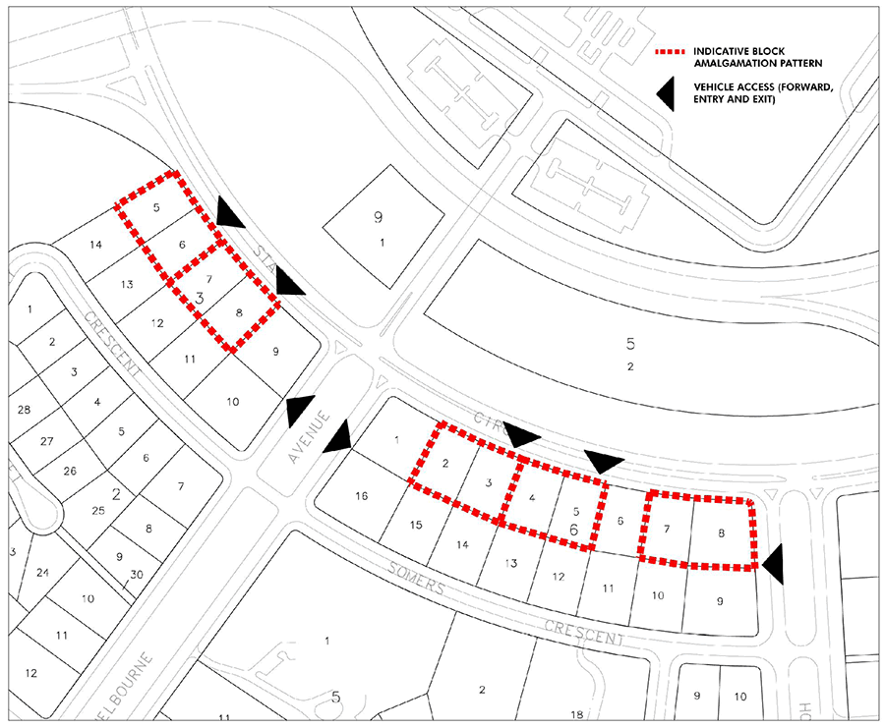

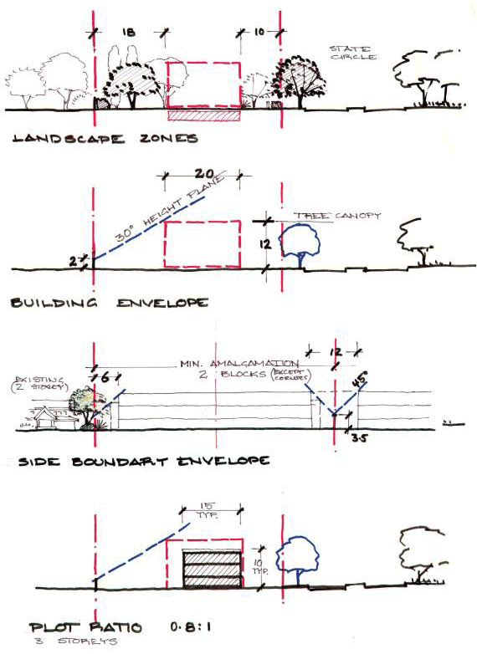

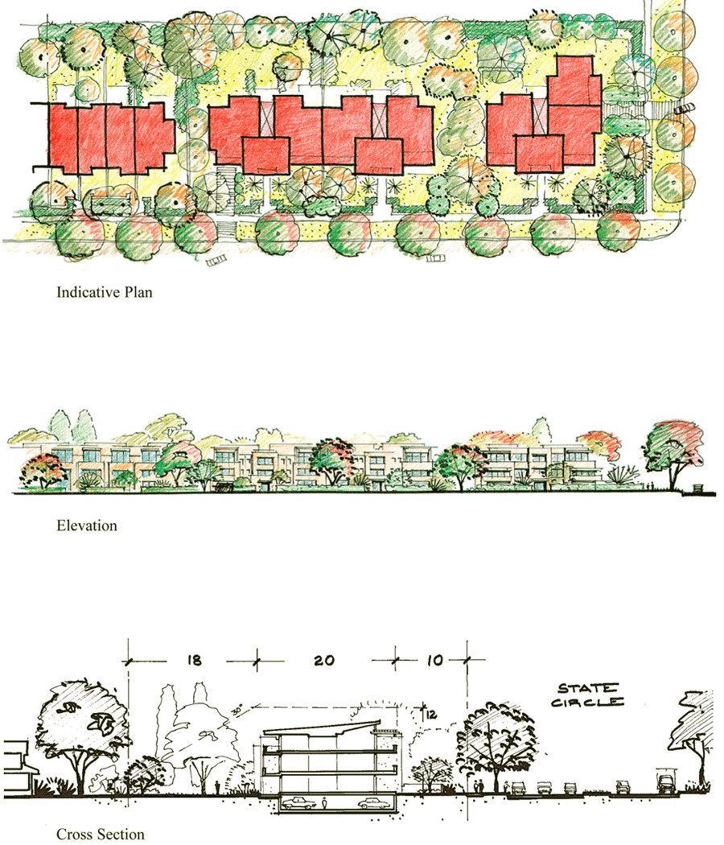

**Attachment "C"**

**Appendix M**

**RESIDENTIAL LAND USE**

1. The National Capital Authority's policy in respect of residential land use is that it may only be used for the purpose of erecting a dwelling, a residential flat building or a medium density dwelling where that building or dwelling complies with the covenants set out in the lease except that Dual Occupancy may be approved in accordance with Appendix P of this Plan and other residential buildings may be approved that comply with conditions in Appendix H or with other specific conditions for residential development specified elsewhere in the Plan.
2. A residential flat building or medium density dwelling may be erected on those Crown Lease lands where a covenant has been made between the Commonwealth and the lessee permitting such erection.
3. All buildings are required to comply with the relevant Design and Siting Conditions of the National Capital Authority.
4. As part of the consideration of an application for any residential development or redevelopment, other than for a single dwelling house, the National Capital Authority will require the applicant to notify the proposal in the principal daily newspaper circulating throughout Canberra inviting comments within two weeks of that notice appearing and for the comments to be provided to the National Capital Authority. The National Capital Authority will take into consideration such comments received before approving the application. The National Capital Authority will also require written assurance from the applicant that neighbours have been separately informed in writing of the proposal and have been made aware of the intention to invite comments on the proposal by way of a notice appearing in the local newspaper and by a sign describing the proposal being prominently displayed at the front boundary of the site. When comments are received they will be used to assist the National Capital Authority delegates to determine whether or not the stated performance criteria are satisfied and to establish if the intentions of the policy applying to the site regarding residential amenity can be met.

For single dwelling house applications the National Capital Authority will require the applicant to notify the adjoining neighbours of the proposal in writing and by a sign describing the proposal being prominently displayed at the front boundary of the site. Comments received will need to be provided to the National Capital Authority and will be taken into consideration when assessing such applications.

1. For the purposes of residential land use the following definitions will apply:

**Dwelling** means a room or suite of rooms occupied or used or so constructed or adapted as to be capable of being occupied or used as a separate domicile and includes outbuildings, if any, that are normal to the enjoyment and exclusive use of the dwelling.

**Residential Flat Building** means a building or group of buildings containing two or more dwellings.

**Medium Density Dwelling** means a building designed, constructed or adapted for and used as a private dwelling for a single household which forms part of a group of two or more dwellings and includes group houses, villa homes, cottage houses, courtyard houses, town houses and semi-detached or terrace buildings and the like.

**Amenity** means in relation to an area, a planning area or a locality, includes such quality or condition in the area, planning area or locality as contributes to its pleasantness and harmony and to its better enjoyment.

**Attachment "D"**

**Appendix** N

**THE CONDUCT OF BUSINESS ON RESIDENTIAL LAND**

**Preamble**

The National Capital Authority's planning policies are intended to provide inter alia, a high level of amenity in residential areas and to prevent the erosion of this amenity through the introduction of unsuitable commercial uses. Approval may be given to residents to carry out a home business provided that the use is not offensive, dangerous or a nuisance or it is not contrary to the public interest to do so. Home business means the use of residential land for carrying on a profession, trade, occupation or calling on the land.

The National Capital Authority's policies establish, in planning terms, the necessary criteria to determine whether a proposed user of land meets the requirements for consent to conduct a business on land leased for residential purposes.

**Policy**

The National Capital Authority may consent to a home business that is incidental to the residential use of the site provided that:

1. at least one worker is a bona fide resident of the land;
2. the operation of the home business does not cause unreasonable annoyance, offence, nuisance or danger to any tenant or occupant of adjoining land;
3. goods related to the home business are not displayed in windows or outside the building;
4. provision is made for the parking of all customer/client vehicles on existing driveways on the land or in a suitably screened location on the land;
5. the home business does not, or is unlikely to cause, pollution, create a health hazard or present a danger which is prohibited under any relevant Territory legislation and/or Code of Practice (as may vary from time to time);
6. traffic generated by the home business does not unacceptably affect the flow of local traffic;
7. the use does not result in the storage on the land of materials obtained for or generated by the home business other than within the confines of approved structures; and
8. retailing associated with home business does not, or is unlikely to generate an increase in traffic, parking demand or noise, which is unreasonably deleterious to the amenity of the surrounding area:

Where a home business had previously been regularly approved under Section 10 of the *City*

*Area Leases Act 1936,* variation from the above controls may be permitted provided they are

consistent with the conditions under which previous approval was granted.

**Standards**

In order to restrict the agglomeration of non-residential activities and ensure that the scale of home business is compatible with the residential character of the locality, the following performance standards apply:

1. there shall be a maximum of two home business per section;
2. the maximum gross floor area of business (including storage) shall not exceed 40 m2;
3. there shall be a maximum of three persons (including resident workers) employed on the site; and
4. there shall be a maximum of one commercial vehicle operating from or parked within the site.

**Definitions**

In this policy:

**Amenity** in relation to an area, a planning area or a locality, includes such quality or condition in the area, planning area or locality as contributes to its pleasantness and harmony and to its better enjoyment.

**Home Business** means the use of residential land for carrying on a profession, trade, occupation or calling on the land.