  
  
 **NATIONAL CAPITAL AUTHORITY**

*Australian Capital Territory   
(Planning and Land Management) Act 1988*

**NATIONAL CAPITAL PLAN**

**AMENDMENT 44   
(Office Employment Location Policies)**

**March 2005**

**THE NATIONAL CAPITAL PLAN   
AMENDMENT 44   
(Office Employment Location Policies)**

**The National Capital Plan is to be amended by:**

1. Deleting the words at page 7 of the Plan under *Employment and Offices* and inserting instead the following words:

“Office employment is to be encouraged in Civic, in the Town Centres and in other Defined Office Employment Centres within the two transport corridors as indicated in Figure 19 of the Plan.

In terms of broad land use policy, the Plan envisages Civic as being the dominant centre for business activity, retailing, commerce, culture, entertainment and recreation. Residential development in and around Civic is also encouraged.”

1. Deleting Chapter 3. Employment Location (at pages 77 to 80 of the Plan) and relacing it by a revised Chapter 3. Office Employment Location as set out in **Attachment 1**.
2. Amending Chapter 4. Urban Areas (at page 90 of the Plan) by deleting the second dot point and replacing it by the following:
   * • “particular interest in ensuring that Civic’s future development conforms with the metropolitan strategies for a decentralised distribution of employment to Defined Office Employment Centres as set out in the Office Employment Location policies in Chapter 3 of the Plan.”
3. Amending Chapter 5. Broadacre Areas (at page 97 of the Plan) by deleting the fifth dot point under “Other Uses” in 5.2(h) Canberra International Airport and inserting at the end of the paragraph words as set out below:

*Office Use*

* + Office is a permitted use at Canberra International Airport.
  + There is no gross floor area limit for any office use, or for any particular office building, at the Airport where the office use is permitted as ‘Primary Uses’ or ‘Other Uses’.
  + The total gross floor area of all offices permitted as ‘Office Use’ shall not exceed 120,000 m2. This gross floor area limit applies to offices which are permitted only as ‘Office Use’. The limit does not include offices which are permitted as ‘Primary Uses’ or ‘Other Uses’.
  + Subject to the gross floor area limitation, and subject to any other relevant provisions of the Plan, there is no gross floor area limit on any individual office building at the Airport.

and

1. Amending PART THREE Background Notes to the Plan (pages 161 and 162 – Employment Projections) to include the data and commentary on office employment since 1990 as set out in **Attachment 2**.

**Attachment 1**

3. Office Employment Location

**3.1 Background**

**Urban Development and Office Employment**

Canberra’s urban development has, to date, taken place in a series of separate towns created by providing new suburban housing areas in the city’s several major valleys, and by keeping development off the intervening hills and ridges.

In the early 1980s an examination of options for the location of major employment and retailing activities in Canberra took place. Following on the recommendations of the earlier Y-Plan outlined in *Tomorrow’s Canberra*, the 1984 Metropolitan *Canberra Policy Plan* examined a number of options for future urban settlement.

One option was to direct growth in employment opportunities and retail floor space into the “Central Area” – extending from Acton across Civic to Duntroon and including Parkes and Barton – and into the Woden and Belconnen Town Centres. This option did not include Tuggeranong and Gungahlin Town Centres. At an ACT population of about 400,000, this option envisaged Civic growing in employment to 35,000, out of a total “Central Area” employment level of 78,000. Woden and Belconnen Town Centres would each reach about 18,000.

The second option assumed Town Centres for Tuggeranong and Gungahlin, each with significant levels of employment and retailing. Under this option, at an ACT population of about 400,000, Civic would have 25,000 employees, out of a total “Central Area” figure of 64,000. Employment in Woden and Belconnen Town Centres would be of the order of 12,000 and 14,000 respectively.

The *1984 Metropolitan Canberra Policy Plan* concluded that the latter option would confer a number of benefits. The National Capital Development Commission identified these benefits in a submission to the Commonwealth Government Joint Parliamentary Committee on the ACT dated May 1986. The benefits are paraphrased as follows:

* *It would have less physical impact, as it would not require the construction of a third crossing of Lake Burley Griffin and as a lower level of road capacity would be required*
* *Lower concentrations of air pollutants, a lower incidence of noise pollution and lower traffic volumes in residential streets would occur*
* *A more efficient use of the road system. The reverse loading on roads would be higher and there would be fewer congested traffic links*
* *There would be a 12 per cent saving in fuel costs*
* *A saving of at least $120 million on the investment required for urban arterials and parkways*
* *Fewer structured car parks would be required, producing a saving of $80 million to $100 million*
* *A lower public transport deficit, as peak hour demand would be lower… (with) …more evenly balanced directional flows*
* *(reduced) … length and cost of journeys by residents of all towns, in particular those of Gungahlin and Tuggeranong.*

A 1987 review of Canberra’s metropolitan development by the Commonwealth Government Joint Parliamentary Committee on the ACT concluded that the Commonwealth should limit the further expansion of Commonwealth employment in Civic and should take steps to locate additional offices in the city’s Town Centres.

In 1988 in response to this issue, and partly as a result of major departmental restructuring and a desire for co­location of the functions of new and large departments, the Commonwealth Government developed a long term strategy for Commonwealth office location. The strategy recognised that while there may be little growth in total employment, there was a need to replace substantial accommodation, to ease overcrowding and to provide additional space in response to the impact of technological change on office space requirements.

The Strategy:

* limited further growth of Commonwealth offices in Civic
* gave priority to the development of additional office space in Town Centres, particularly Tuggeranong and Belconnen
* limited office accommodation in Parkes and Barton to Commonwealth Departments and agencies requiring close working relationships with the Executive and the Parliament.

In response to this strategy the Commonwealth in 1989 commenced a major new office development in Tuggeranong for the Department of Social Security.

**Impact of Changes since 1990**

By 1989, with a Canberra population of just 274,000, Civic had almost reached 25,000 employees and the total “Central Area” figure stood at some 59,000. By the early 1990s, public sector employment, which had long been the engine of growth in Canberra, had begun to noticeably slow. A broad reform of the Commonwealth Public Service in 1996 resulted in policies of outsourcing, downsizing, increased competition, and a Commonwealth property divestment programme. These initiatives, combined with managerial principles in the Commonwealth of greater freedom in choice of office location, contributed to a more open market and generally less interventionist Government approach – in this case influencing the location of offices.

By the end of 2002 the ACT population was 322,680 people. The employment level at November 2002 was 174,300. In trend terms a total of 74,800 people were employed in the public sector in the February quarter of 2003 (77% Commonwealth and 23% Territory Government employment). This represents a level of public sector employment of 43% - down from 55.4% in 1986.

Due to the diminishing importance of the Commonwealth Government as a property owner, policies dealing with Commonwealth office employment location are now of lessening importance. The policy of divestment of property also included Federal Airports. In 1998 the Commonwealth Government granted a long term lease to the Canberra International Airport Pty Ltd.

**Office Employment Location**

In the light of changing circumstances and factors affecting decisions about office employment there is a need to adopt new policies that ensure Canberra’s continuing economic growth in the office employment sector while maintaining the fundamental objectives that are of importance to the quality and significance of the National Capital. These are to:

* avoid traffic congestion in the “Central National Area”
* avoid deterioration of the environmental and visual quality of the Central National Area of Canberra
* maintain the option of further employment in the Town Centres
* preserve the setting and significance of the Central National Area as a location for major national institutions
* ensure the dominant role of Civic is maintained in the hierarchy of centres*.*

For these reasons, and in the context of broad land use policies relating to national and arterial roads, the Authority’s principles and policies with respect to office employment location are as follows:

**3.2 Principles for Office Employment Location**

Canberra’s distinctive urban structure that builds on the legacy of Griffin and Voorhees is of national significance.

Within the broad land use policies and other Commonwealth policies, decisions on the location of employment in Canberra and the Territory should enhance rather than detract from the City’s role as the national capital.

Decisions should have regard to the transportation and environmental impacts of all major office employment location proposals. They should also recognise the market demand for small and medium scale offices for the private sector in the commercial areas of Town, Group and Local Centres and in other defined office locations.

**3.3 Policies for the Location of Office Employment**

(a) Major office employment should be located within Defined Office Employment Centres located within the two transport corridors developed from Belconnen Town Centre to Queanbeyan and from Gungahlin Town Centre to Tuggeranong Town Centre as indicated in Figure 19.

(b) Defined Office Employment Centres within the East-West Corridor comprise:

* + - Belconnen Town Centre (as defined* in Part B2B of the Territory Plan)
    - Bruce [as shown in Figure 7 (Office Sites-Bruce) in Part B2E of the Territory Plan]
    - Civic Centre (as defined in Part B2A of the Territory Plan and also the Designated Areas shown in Figure 10 of the National Capital Plan)
    - Russell (the Designated Areas shown in Figure 12 of the National Capital Plan)
    - Canberra International Airport (the Designated Areas shown in Figure 14 of the National Capital Plan)
    - (c) Defined Office Employment Centres within the North-South Corridor comprise:
    - Gungahlin Town Centre (as defined* in Part B2B of the Territory Plan)
    - Parkes (the Designated Areas shown in Figures 5 and 11 of the National Capital Plan)
    - Barton and Forrest (the Designated Areas shown in Figure 8 of the National Capital Plan)
    - West Deakin [as shown in Figure 6 (Office Sites-Deakin) in Part B2E of the Territory Plan]
    - Woden Town Centre (as defined in Part B2B of the Territory Plan)
    - Tuggeranong Town Centre (as defined in Part B2B of the Territory Plan)
    - (d) Offices are permitted at Group and Local Centres but should be of a scale appropriate to the particular centre. As a general guide, offices should not exceed the total retail floor space in a Local or Group Centre.
    - (e) Private sector offices may be located in any Defined Office Employment Centre.
    - (f) Public sector office employment should be encouraged to locate in Civic and the Town Centres.
    - (g) Public sector office employment established in the Town Centres should be encouraged to remain in that Town Centre or, where relocation is proposed, to locate in another Town Centre.
    - (h) The location of office employment outside Defined Office Employment Centres should generally be discouraged and only permitted when considered to be in the public interest after the full transport and environmental effects of such decisions have been considered.
* The precise boundaries of each Defined Office Employment Centre may change over time. Any such changes will be made through the statutory processes of amending the National Capital Plan and/or varying the Territory Plan.

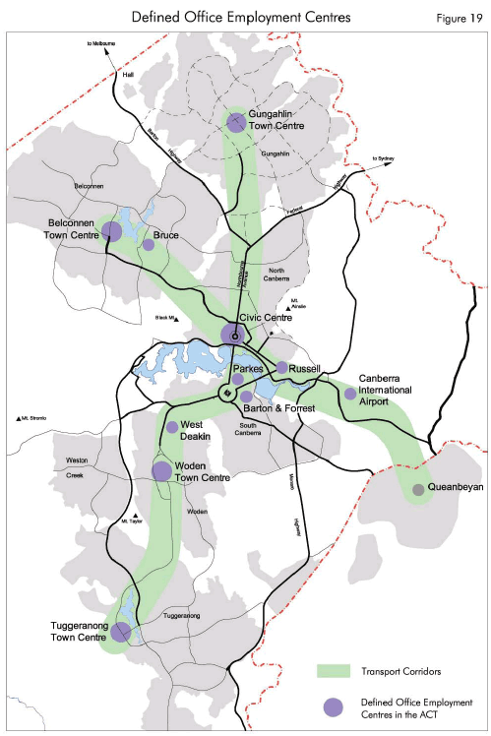

**Attachment 2**

**Employment Projections**

**Employment levels**

At the end of 2002 the ACT’s population was 322,680. The employment level at November 2002 was 174,300 with a labour force participation rate of 73%. Compared to the national average of 64%, the ACT has a significantly higher labour force participation rate.

In trend terms a total of 74,800 people were employed in the public sector in the ACT in the February quarter of 2003 (or 43% of employees). This public sector component comprised 57,500 Commonwealth employees (77%) and 17,300 Territory employees (23%). The remaining 99,500 (57% of total employees) were from the private sector (ABS 1367.8 Dec/June 2003).

This trend shows the shift from the situation in 1986 when the public sector employment was 55.4% and the private sector comprised 44.6 %.

**Office Space**

Historically the ACT has experienced low office vacancy rates of between 1% and 3%. In 1997 office vacancy rates peaked at 10% or more, then dropped continuously until 2001 when the vacancy rate was 4.1%. The vacancy rate then increased to 5.3% in 2002. At January 2004, the ACT had the lowest office vacancy rate (5.5%) of all Australian capital cities.

The main location of office employment remains Civic with 28% of the total ACT office floor space. The Town Centres follow with a combined share of 21%. See Figure 1.

**Figure 1 – Location of Office Space in the ACT January 2004**

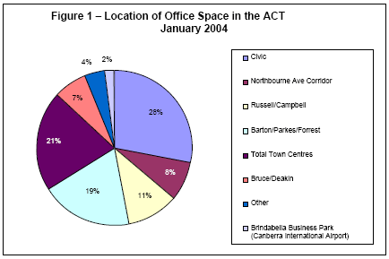

(Source: Australian Office Market Report January 2004, Property Council of Australia)

In the period between 1981 and 2002, office distribution in the Central Area (Civic, Northbourne Avenue Corridor, Russell, Campbell, Barton, Parkes and Forrest), the Town Centres and the remaining ‘Other Locations’ (Bruce, Deakin, Canberra Airport and Other areas) has changed. The proportion of offices in the Central Area decreased from 69% in 1981 to 66% in 2002. During the same period, office floor space in Town Centres decreased from 25% to 21% and it increased from 5% to 12% in ‘Other Locations’. See Figure 2.

**Figure 2 -Change in Office Floorspace Distribution from 1981-2002**

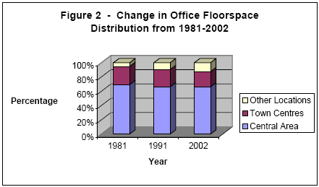

(Source: Working Paper No.3 PALM, ACT Government)

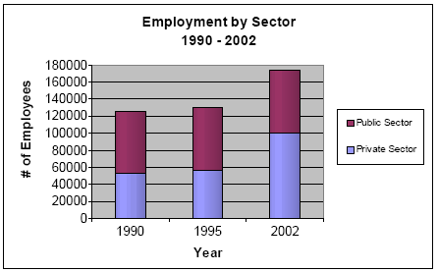

(Source: ABS)

**Projected Office Space Availability**

Several different estimates are given for future office space requirements and are generally estimated on a 10 year basis. The following estimate of office space demand and availability is based on Working Paper No. 3 developed by the Planning Policy Section of PALM in October 2002.

For the purpose of estimating the amount of future land required for offices, the assumption is that existing office space in 2002 is occupied by employment in the Government and Administration & Defence and the Property & Business Services sectors only. Assuming an average 22 sq m of office space per employee in predicting future office space, there will be a requirement for additional floorspace in the order of 202,400 sq m by 2010.

The withdrawal of stock, particularly in Civic has played a significant role in reducing the amount of vacant space. Between 1997 and 2002, approximately 50,000 sq m of office floor space has been withdrawn from Civic. This has been partially accelerated by the Civic re-vitalisation policy which provided financial incentives to convert vacant office buildings to other uses, mainly residential. Over the same period approximately 25,000 sq m of new office floor-space entered the Civic office market.

Policy changes to office employment location have been necessary to take account of the significant changes that have occurred over the last 10 to 15 years. Policies such as out-sourcing, down-sizing, competition policy and more particularly the Commonwealth’s property divestment programme have all contributed to a more open market and less intervention by the Commonwealth Government in market decisions – in this case the location of offices. The policies in relation to office employment location are set out in Chapter 3 of the National Capital Plan.