Australian Government Crest

National Capital Plan – Amendment 75 – Australian Defence Force Academy and Royal Military College Duntroon Master Plan

*Australian Capital Territory (Planning and Land Management) Act 1988*

I, SIMON CREAN, Minister for Regional Australia, Regional Development and Local Government, approve this amendment of the National Capital Plan under section 19(1)(a) of the *Australian Capital Territory (Planning and Land Management) Act 1988.*

Dated 23 July 2012

SIMON CREAN

Minister for Regional Australia, Regional Development and Local Government

1 Name of instrument

This instrument is the *National Capital Plan – Amendment 75 – Australian Defence Force Academy and Royal Military College Duntroon Master Plan*.

2 Commencement

This instrument commences on the date of its registration.

3 Amendment of National Capital Plan

Schedule 1 amends the National Capital Plan.

Schedule 1 Amendment

(section 3)

The National Capital Plan is amended by the following:

Introduction

1. Amend Figure 3 *Designated Areas* with the following:

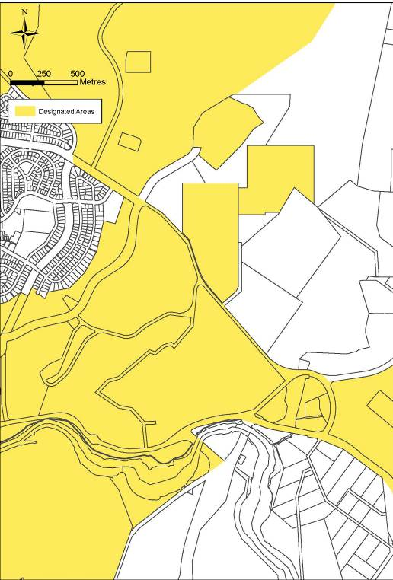

Part One – Principles, Policies and Standards, Designated Areas, Special Requirements

Chapter 1 The Central National Area

1. Delete Figure 13 *The Central National Area (Duntroon, ADFA & Campbell Park)* and replace with the following:

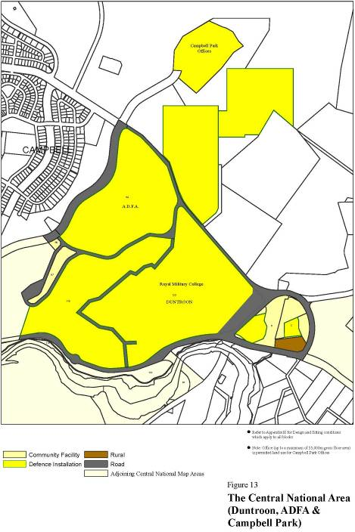

Administration and Implementation

1. Amend the Plan to recognise consequential changes of Amendment 75 to page numbers, section titles and contents page.

Appendix T1: Royal Military College Duntroon Master Plan

1. Amend the title of the Appendix to read ‘Australian Defence Force Academy and Royal Military College Duntroon Master Plan’.
2. Delete the existing Appendix T1 and replace with the following:

### Detailed Conditions of Planning, Design and Development

### Purpose

This Master Plan has been prepared to guide the future planning, design and development of the Royal Military College (RMC) and the Australian Defence Force Academy (ADFA) as military training establishments.

### The Site

RMC and ADFA are located approximately 3.5 kilometres south-east of the Canberra city centre. The two facilities share a common boundary and together occupy a total area of approximately 231 hectares.

The site is surrounded by Mount Pleasant to the north-east and separated from the suburbs of Campbell and the Russell offices to the west by a bushland ridge which forms a physical barrier. To the north-east is open land used for grazing. Canberra Airport is located to the east and the Molonglo River and Jerrabomberra Wetlands are located to the south of the site.

The ADFA campus occupies approximately 52 hectares of land, with a further 54 hectares located north-east of Fairbairn Avenue comprised of playing fields and grazing land. The current ADFA campus was designed and planned in the early 1980s, as the primary tertiary institution for the Australian Defence Force and was officially opened on 11 December 1986.

RMC comprises a site area of approximately 125 hectares. RMC provides military training for all potential Army General Service Officers (GSO). RMC also undertakes the military component of training for army cadets at ADFA. The original homestead was constructed on site in 1833 and the College, Duntroon, as it was then known, was established in 1911.

### Vision and objectives

RMC and ADFA will continue to provide premier academic and military facilities and meet the academic and military training needs for the Australian Defence Force for the foreseeable future.

Both Institutions represent a vital element of Canberra’s role as the national capital and are included as Designated Areas of the National Capital Plan. RMC is the only Army officer training facility in Australia, and, given its historical significance, sense of tradition and heritage character, is an important representation of Army presence in the national capital. ADFA is the centre for tertiary education for the Australian Defence Force (ADF) and educates approximately 30% of all Officer cadets within the tri-services of the ADF.

Objectives in achieving the Master Plan vision are:

* To encourage shared use facilities, located centrally to both ADFA and RMC;
* To achieve greater efficiency and increased flexibility in buildings and infrastructure to reflect changing uses;
* To consolidate housing within existing residential areas;
* To maintain and enhance sporting and recreational facilities to meet ADFA and RMC needs; and
* To conserve and manage significant natural, cultural and Indigenous heritage values.

### Guiding Principles

The site is located within the Central National Area and a high quality of planning and development should be achieved within a design context appropriate to its location.

Planning for RMC and ADFA is to be based on an integrated and sustainable approach to future use and development of both sites. Improved integration between the two sites and greater opportunities for shared use of facilities are expected outcomes.

The Master Plan is to facilitate upgrading domestic, academic and recreational facilities to ensure that they meet contemporary military and academic training needs and comply with current access, health and safety standards.

The urban design values of RMC and ADFA are to be recognised, protected and enhanced as an integral component of future development. In particular, the urban composition that incorporates the Headquarters Building, Morshead Drive and the Fairbairn Avenue Entry (the ‘Gun Gates’) is to be recognised for its significance to the urban character of RMC.

Development is intended to occur in a manner consistent with the principles of water sensitive urban design incorporating integration of stormwater treatment into the landscape, protection of water quality (particularly in relation to the Molonglo River and its tributaries), and reduction of run-off and peak flows.

### Constraints

The Constraints Map (Figure 1) provides a context for the Master Plan and describes the primary planning issues to be considered with respect to development of the site. Significant constraints are illustrated on the Constraints Map (Figure 1) and are described below.

**Environmental constraints**

Several areas of vegetation and potential fauna habitats listed under Australian Government environment legislation occur on site. These include:

* White Box – Yellow Box – Blakely’s Red Gum Grassy Woodland and Derived Native Grassland (including *Leucochrysum albicans* var. *tricolor* (Hoary Sunray);
* Natural temperate Grassland of the Southern Tablelands of NSW and the Australian Capital Territory, including habitat for several threatened fauna species).

**Heritage**

The RMC Duntroon Conservation Area is listed on the Commonwealth Heritage List. Individual buildings or locations within the RMC Duntroon Conservation Area are also listed individually on the Commonwealth Heritage List. These include Duntroon House and Garden, Changi Chapel and the ANZAC Chapel of St Paul, Parade Ground and Associated Buildings Group, and individual residences and sheds.

**Airport generated constraints**

The northern portion of ADFA is affected by constraints generated by its proximity to Canberra International Airport, including:

* Areas of high aircraft generated noise (High Noise Corridor) – residential development and other noise sensitive land uses would be restricted in this area; and
* The Airport Obstacle Limitation Surface (AOLS) – height limitations apply to all forms of development within areas affected by this constraint.

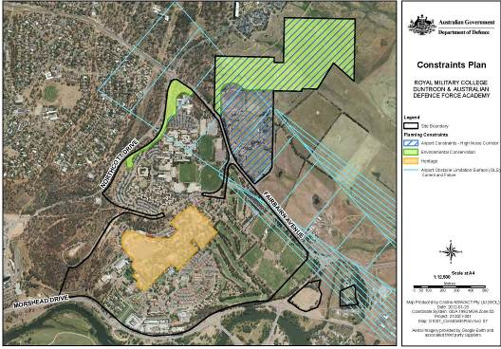

**Figure 1:** Constraints Plan

## Development guidelines

### 1. Land use

1.1 The Master Plan drawing (Figure 2) divides the site into zones that correspond to primary purposes within the overall function of the facility as a military training and academic institution. Likely land uses which are permissible within each zone are listed in Table 1.

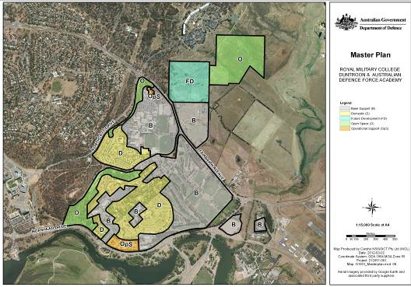

**Figure 2:** Zone map

**Table 1:** Permissible likely uses within Precincts

|  |  |  |
| --- | --- | --- |
| **Precinct** | **Primary purpose** | **Permissible likely uses** |
| Operational Support Precinct | The provide areas for buildings or infrastructure for personnel supporting key capability functions. | This precinct is intended to provide facilities for a Defence Installation and Scientific Research Establishment. |
| Base Support Precinct | To provide areas for activities associated with the general occupation and function of an establishment or facility, without adversely affecting operational or operational support activities. | This precinct is intended to provide facilities for a Defence Installation. Support activities that would be appropriate for this precinct would include Community Facility, Community Protection Facility, Child Care Centre, Indoor Recreation Facility, Outdoor Recreation Facility and Personal Services Establishment. |
| Domestic Precinct | To provide areas for activities associated with the domestic functions of an establishment or facility, without adversely affecting operational, operational support or base support activities. | This precinct is intended to provide Residential and Social/Community Facilities. |
| Open Space Precinct | To provide buffers between incompatible internal and external activities; to enable conservation and/or enhancement of land with significant environmental values; and to avoid land being targeted for future development on land that is unsuitable for such purposes. | This precinct is intended to provide facilities for a Defence Installation (training and recreation equipment), Landscape Buffer and Open Space. |
| Future Development Precinct | To identify larger parcels of developable land that can facilitate the future expansion of activities within the base or establishment. | This precinct applies to uncommitted land and is to be retained for the future uses of the Defence Installation. |

1.2 New developments with potential to provide services, recreational or community facilities to both ADFA and RMC should generally be located within the vicinity of General Bridges Drive.

1.3 Priority should be given to land uses which strongly relate to the academic and military training functions of the sites.

### 2. Urban design, building height and setback

2.1 New buildings, site works and landscape treatment shall complement and enhance the existing facilities with special emphasis on three areas:

* The RMC Duntroon Conservation Area;
* The Main Entry to RMC Duntroon from Morshead Drive (“The Badge Gates”); and
* The Entry from Fairbairn Avenue (“The Gun Gates”).

2.2 All new work in the RMC Duntroon Conservation Area is to be consistent with the existing character in scale and by use of materials, treatment of facades and landscape works.

2.3 A limit of three storeys applies to all new buildings at RMC and four storeys at ADFA to maintain consistent scale of built form and protect the amenity of neighbouring buildings.

2.4 New residential buildings (excluding Live In Accommodation (LIA)) shall be a maximum of two storeys in height. New residential buildings should generally be consistent with the height of existing residential development and be designed to protect the amenity of neighbouring buildings.

2.5 Where the development site abuts an existing dwelling or LIA, sufficient spatial separation should be provided to ensure the development does not adversely impact on residential amenity.

2.6 The siting and location of new development should be compatible with external land uses and set back 20 metres from arterial roads (Morshead Drive and Fairbairn Avenue) to provide a landscape buffer.

### 3. Landscape

3.1 A landscape structure is to be devised which adds to the legibility of the site by reinforcing the identity of each precinct, establishing pedestrian links and a hierarchy of vehicle circulation.

3.2 The open area of land along the ridgeline adjacent to General Bridges Drive will remain as a landscape buffer between RMC and ADFA. No buildings shall be constructed within this zone.

3.3 Strong vegetative screening is to be maintained along Morshead Drive adjacent to the Operational Support Zone.

3.4 Landscape treatment of the perimeter areas is to be compatible with the adjacent land use, the adjacent road and the quality and character of the existing landscape. The perimeter landscape treatment must be a minimum of 20 metres wide, measured from the road verge (except where constrained by existing conditions).

3.5 The landscape treatment and the urban design elements (portals, etc) of the Main Entry (‘The Badge Gates’) to RMC should reflect the formal, prestigious role of the College. The planting of the entry avenue is to be of a formal, deciduous character, similar to the RMC Duntroon Conservation Area.

3.6 The Fairbairn Avenue (‘The Gun Gates’) entry, from Fairbairn Avenue to the RMC Duntroon Conservation Area (Robert Campbell Road) shall be planted with Eucalypts to create a link to the rural surrounds and to retain views beneath the canopy to ADFA.

3.7 At the junction of the entry avenue and the RMC Duntroon Conservation Area emphasis is to be given to the change in landscape character. Beyond this point the road verge planting is to be continued in deciduous trees and the character of the spaces formalised.

### 4. Car parking, access and movement

4.1 All car parking demand generated by day to day activities shall be accommodated within the confines of RMC and ADFA. Any parking that is displaced by new development is to be replaced elsewhere on the site.

4.2 Car parking should be designed and sited to ensure the safe and efficient movement of vehicles, including buses.

4.3 Developments should be integrated with the internal pedestrian network and provide safe and convenient access for pedestrians.

4.4 Development should ensure access is maintained to key sites along General Bridges Drive including the Duntroon Health Centre and General Bridges’ Grave.

4.5 Car parking is to be provided in small lots, well screened and landscaped.

### 5. Architectural character

5.1 The architectural character and quality of all buildings should be of a consistently high standard and should seek consistency in terms of scale, materials, colours, finishes and detail.

5.2 Perimeter development shall be of a consistent architectural character and quality, befitting the national significance of the site and the Approach Routes to the national capital.

5.3 Within the Operational Support Precinct, large stores and workshop buildings should be designed so as to limit their bulk and visual intrusion by, for example, articulation with recessed elements and varied setbacks.

5.4 The articulation, material and colour of buildings shall be sympathetic to the heritage values of any adjacent heritage listed place.

### 6. Royal Military College Duntroon main entrance

6.1 Portal entry structures (“Badge Gates”) shall be retained to mark formal entry to the college from Morshead Drive.

6.2 New buildings shall be located symmetrically of the avenue axis. Building character, materials and massing should be consistent with the character of the Parade Ground buildings.

6.3 Strong formal avenue planting shall be established with a visual link to the round-about. Screening of residential and logistics complex from avenues is required.

### 7. Lighting

7.1 All outdoor lighting, including security and car park lighting, shall be designed and sited to minimise light pollution. Outdoor lighting shall use full cut-off light fittings. New building façade lighting installations shall use full cutoff fittings that are carefully integrated into the building’s structure.

**Note**

1. All legislative instruments and compilations are registered on the Federal Register of Legislative Instruments kept under the *Legislative Instruments Act 2003*.See http://www.frli.gov.au.