

# REPORT ON CONSULTATION

# DRAFT AMENDMENT 82

# AMTECH ESTATE

# October 2013

Contents

Contents 2

1 Introduction 3

1.1 Purpose and background 3

1.2 Existing National Capital Plan provisions 3

1.3 Effect of the Draft Amendment to the National Capital Plan 3

2 Consultation 4

3 Key issues 5

3.1 Natural temperate grasslands 5

Comments Received 5

NCA response 5

3.2 Current leases for the estate 5

Comments received 5

NCA response 5

4 Recommended changes 6

5 Conclusion 6

6 Attachments 6

Attachment 1 – Canberra Times notice 7  
Attachment 2 – Commonwealth Gazette Notice 8

Attachment 3 – Summary of submissions 9

# 1 Introduction

## Purpose and background

This report summarises the issues raised during the public consultation process undertaken by the National Capital Authority (NCA) on Draft Amendment 82– Amtech Estate (DA82) to the National Capital Plan (the Plan).

The purpose of DA82 is to broaden the range of industrial uses permitted for Amtech Estate. This will enable the ACT Government to determine detailed land use policies for Amtech Estate.

Amtech Estate was developed by the ACT Government in the 1990s in response to a perceived demand for a high tech industrial ‘campus’. The estate was intended to cater exclusively for advanced technology manufacturing industries and provide an opportunity for such industries to co-locate with similar businesses.

Amendment 13 to the Plan (gazetted in March 1995) introduced specific requirements for Amtech Estate. These requirements include restricting land use to ‘Advanced Technology Park’, ‘Public Utility’ and ‘Open Space’ only. Special Requirements were also introduced into the Plan, which state that development of the estate is to conform to a Development Control Plan (DCP).

Land in the estate was released to the market in the mid-1990s, however the estate has not achieved full occupancy and the ACT Government’s ambition of creating an ‘Advanced Technology Park’ has not been realised. Existing uses in the estate include Australian Government offices and storage facilities, health facilities (such as Canberra Eye Hospital), and telecommunications facilities. A number of blocks remain undeveloped

On 14 June 2013, the Authority agreed to draft an amendment removing the land use restrictions applying to the Amtech Estate from the Plan.

## Existing National Capital Plan provisions

Amtech Estate is located within Urban Areas under the General Policy Plan – Metropolitan Canberra. The Plan further identifies that the range of uses permitted for the site are ‘Advanced Technology Park’, ‘Public Utility’ and ‘Open Space’. The provisions of the Plan effectively limit land uses primarily to those involved in the research, development, manufacture, processing, assembly and marketing of advanced technology and scientific products, as well as public utilities and open space.

Section 4.5.5 of the Plan contains Special Requirements specifically for Amtech Estate, which requires that development conforms to a DCP. The Plan outlines a series of matters to be addressed in the DCP, including staging of development, access arrangements, built form, landscaping and environmental protection measures.

## Effect of the Draft Amendment to the National Capital Plan

The amendment will better recognise the role of the ACT in planning at a local level by allowing the ACT Government to determine the detailed land use policies for Amtech Estate. This will make the location more desirable for development by amending the provisions in the Plan and existing DCP to broaden the range of industrial uses while controlling obvious conflicts and adverse impacts within the estate, such as hazardous industry.

If DA82 is approved, the current provisions of section 4.5.5 can largely be reflected by a new DCP for the Canberra Avenue and Monaro Highway frontages of the site. Through the DCP, the NCA may mandate such matters as landscaping, the intended built form addressing the Approach Routes and access arrangements.

The process to create a new DCP to supersede the current DCP for Amtech Estate is underway and a draft DCP will be released for public comment in due course.

# Consultation

On Saturday 4 July 2013, the NCA released DA82 for public comment and a notice was published in *The Canberra Times* on that day (Attachment 1). On Friday 5 July 2013, a notice was published in the *Commonwealth Notices Gazette* (Attachment 2). A media release was provided to national media outlets advising DA82 was open for public comment.

In accordance with the NCA’s Commitment to Community Engagement (August 2011) the period for public comment ran for 30 business days, concluding on 14 August 2013. Hard copies of DA82 were made available to the public at the National Capital Exhibition, as well as the NCA offices. In addition, DA82 and supporting documentation was available on the NCA’s ‘Have Your Say’ website.

Key activities during the consultation period of DA82 included:

* On 8 July 2013, the NCA referred DA82 to the following stakeholders:
  + ACT Government Environment and Sustainable Development Directorate
  + ACT Government Territory and Municipal Services Directorate
  + ACT Government Economic Development Directorate
  + Griffith / Narrabundah Residents Association
  + Walter Burley Griffin Society Inc.
  + Inner South Community Council
  + Canberra Business Council
  + affected Lessees within the Amtech Estate.
* On 10 July 2013, a request for an exemption to undertake a Regulation Impact Statement was sought from the Office of Best Practice Regulation.
* On 12 July 2013, the Office of Best Practice Regulation advised no Regulation Impact Statement would be required for DA82.
* On 17 July 2013, the NCA held a public information session at the NCA offices. In addition to one representative of the NCA, two members of the public attended the session.
* On 7 August 2013, the Environment and Sustainable Development Directorate of the ACT Government provided a response to the draft amendment. There was no objection to DA82 proceeding.

# Key issues

The NCA received two written submissions in response to DA82. All submissions were acknowledged by the NCA.

A summary of the key issues raised during the public consultation process (both in written submissions and verbally at the public information session) and the NCA’s response is outlined below. Each submission is included in Attachment 3 together with a detailed NCA response.

## Natural temperate grasslands

### Comments received

A member of the public raised questions as to the association of DA82 with a recent referral made to the former Department of Sustainability, Environment, Water, Populations and Communities regarding the potential impact of development of the eastern section of the Amtech Estate. Current ecological surveys have determined this area to consist of a natural temperate grassland ecological community with recent siting of the critically endangered Golden Sun Moth. It was noted that this referral was withdrawn shortly following public notification on the Department of the Environment website.

### NCA response

DA82 will have no impacts on the developable area of the site. The range of possible uses on the site will be broadened to encompass most uses permitted under the Mixed Use Industrial zoning (IZ2) of the Territory Plan. The potential impact of development on endangered ecological communities is regulated through the *Environmental Protection and Biodiversity Conservation Act 1999* (Cth) referral system currently administered by Department of the Environment.

Any development of the eastern side of the estate would require further discussions and a referral to the Department of the Environment.

## Current leases for the estate

### Comments received

One submission raised a query regarding the effect of DA82 on current leases and the costs associated with lease variations. It was noted that current leases within the estate are quite restrictive. This submission also noted that most current leases within the estate do not restrict ‘office use’ gross floor area (GFA) whereas the proposed Territory Plan zoning for the site restricts ‘office use’ GFA to 2000m2.

### NCA response

If approved, DA82 will allow current lessees to vary their leases to allow for more uses, consistent with the Mixed Use Industrial zoning (IZ2) of the Territory Plan. The Environment and Sustainable Development Directorate advised that normal lease variation costs will apply.

Leasing on Territory Land is an issue for the Planning and Land Authority within the Environment and Sustainable Development Directorate. The intention of DA82 is to reduce the influence the NCA has over the detailed planning of the Amtech Estate. A draft variation to the Territory Plan is required to give effect to the changes described in this Draft Amendment. This will require public consultation under ACT legislation.

# Recommended changes

No changes to DA82, as released for public consultation, are recommended.

# Conclusion

On 4 July 2013, DA82 was released for public consultation. The public consultation period ran for six weeks in accordance with the NCA’s Commitment to Community Engagement (August 2011), concluding on 14 August 2013.

Two written submissions were received in response to DA82. In response to these submissions, no changes have been recommended to DA82.

# Attachments

1. Notice of release of Draft Amendment 82 for public comment published in *The Canberra Times*.
2. Notice of release of Draft Amendment 82 for public comment published in the *Commonwealth Notices Gazette*.
3. Summary of submissions and NCA response.

## Attachment 1 – Canberra Times notice

## Attachment 1 – Canberra Times notice Attachment 2 – Commonwealth Notices Gazette notice

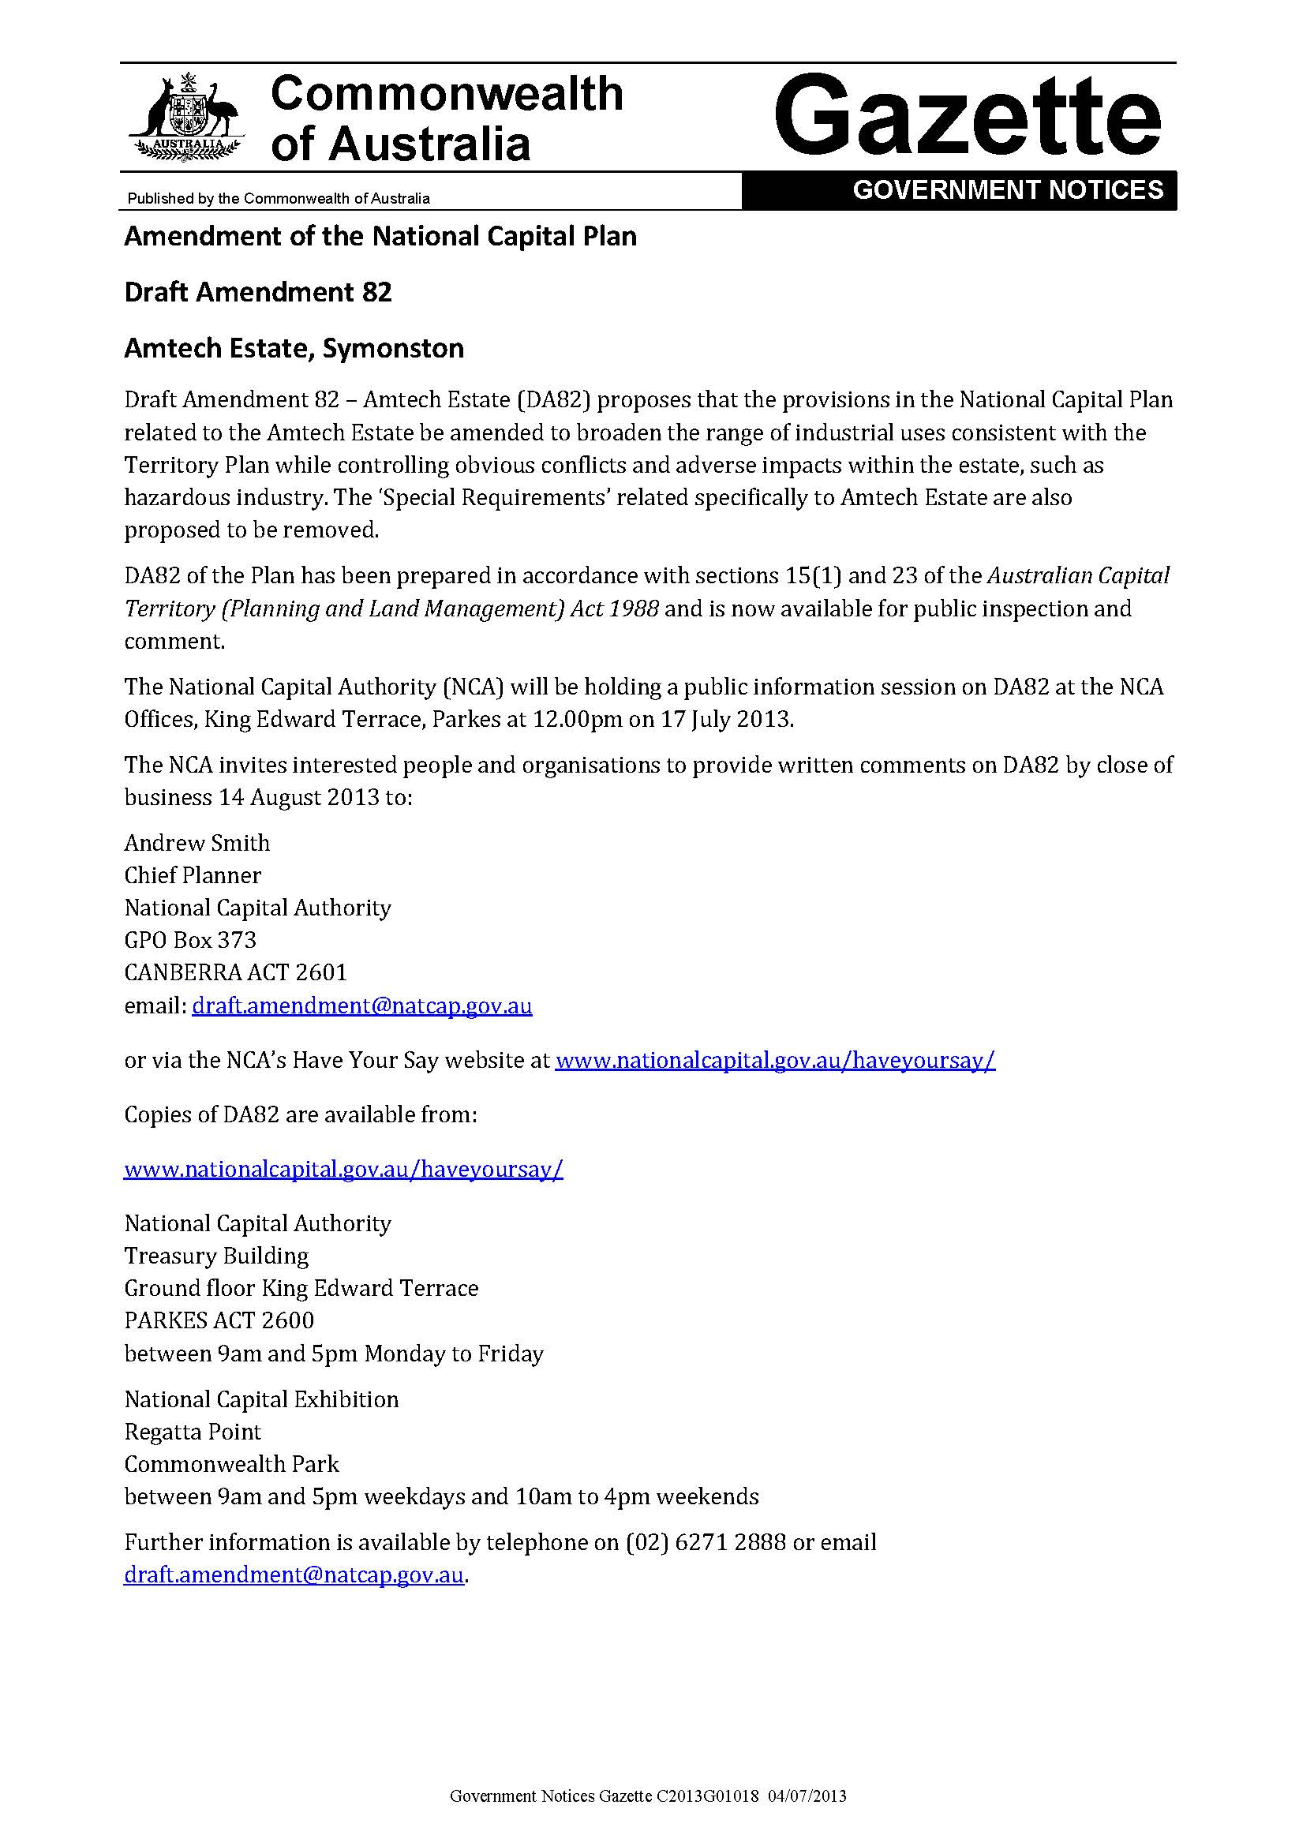

### Attachment 3 – Summary of submissions

Note: The National Capital Authority (NCA) undertakes an open and transparent Draft Amendment process. Draft Amendment documentation advised that the NCA would prepare a Consultation Report for publication on the NCA website, and that this Consultation Report would include a summary of each submission, along with the name of each person making the submission. Names of submitters have been omitted where a submitter requested confidentiality.

| **No.** | **Details of submitter** | **Key points raised in submission** | **NCA consideration** |
| --- | --- | --- | --- |
| **1** | Environment and Sustainable Development Directorate (ESDD) on behalf of ACT Government. | The Environment and Sustainable Development Directorate (ESDD) advised that it supports DA82 and has no comments to make. | Noted. |
| **2** | MMJ Canberra | [It is understood] the proposed amendments will broaden the range of allowable uses within the Estate to more adequately meet the market while not having an impact on existing development rights contained within a current Crown Lease - the changes proposed appear to be of benefit to current and potential leaseholders in the Amtech Estate. | Noted. |
| Of concern however is the limitation on GFA for ‘Office Use’ should the Estate move to an IZ2 zoning. [It is understood] that the Territory Plan allows a total GFA of 2,000m2 per lease for Office Use in all Industrial Zones. The current provisions for the majority (if not all) of current Crown Leases within the Amtech Estate allow for office GFA to exceed the permitted restriction on total GFA (Office) under the existing general development controls for Industrial Zones. | Noted. |
| In consideration of the foregoing, I submit that any changes approved to the existing land use restrictions and DCP take into account the current allowable Use under existing Crown Leases (including approved GFA) , and that there should be no future limitation imposed on Office GFA for the existing Estate or any future expansion of Amtech Estate. | Leasing on Territory Land is an issue for the Planning and Land Authority within the Environment and Sustainable Development Directorate. The intention of DA82 is to reduce the influence the NCA has over the detailed planning of the Amtech Estate.  A Draft Variation to the Territory Plan will be required in order to change the zoning of the site to IZ2 – Mixed Use Industrial. |