Australian Government Crest

National Capital Plan – Amendment 74 – Section 5 Campbell1

*Australian Capital Territory (Planning and Land Management) Act 1988*

I, SIMON CREAN, Minister for Regional Australia, Regional Development and Local Government, approve this amendment of the National Capital Plan under section 19(1)(a) of the *Australian Capital Territory (Planning and Land Management) Act 1988.*

Dated 15 November 2012

SIMON CREAN

Minister for Regional Australia, Regional Development and Local Government

1 Name of instrument

This instrument is the *National Capital Plan – Amendment 74 – Section 5 Campbell*.

2 Commencement

This instrument commences on the date of its registration.

3 Amendment of National Capital Plan

Schedule 1 amends the National Capital Plan.

Schedule 1 Amendment

(section 3)

The National Capital Plan is amended by the following:

## Part One Principles, Policies and Standards, Designated Areas, Special Requirements

### Chapter 1 The Central National Area

1. Amend clause 1.5.3(i) to read as follows:

*Ensure conveniently located parking in a manner that does not dominate the public domain. All basement and service vehicle entries are to be located from secondary street frontages.*

1. Delete the existing Figure 12 *The Central National Area (Constitution Avenue and Anzac Parade)* and replace with the following:

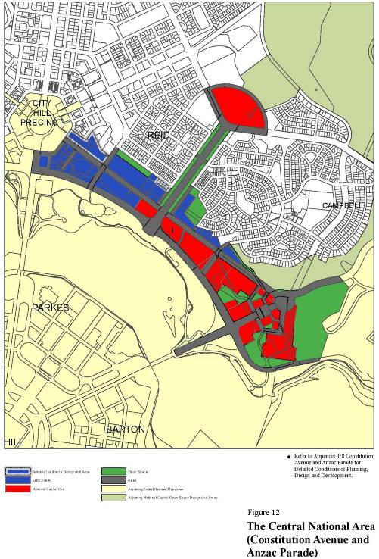

## Part Two Administration and Implementation

1. Amend the Plan to recognize consequential changes of Amendment 74 to page numbers, section titles and contents page.

## Appendix T8: Constitution Avenue and Anzac Parade

1. Delete the existing figure titled ‘Indicative Urban Structure’ and replace with the following:

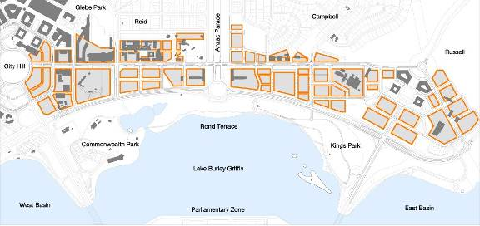

1. Delete the existing figure titled ‘Indicative Main Pedestrian Connections’ and replace with the following:

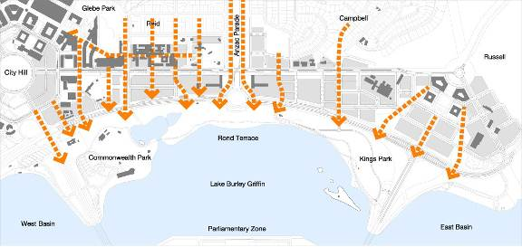

1. Delete the existing figure titled ‘Indicative Landscape Structure’ and replace with the following:

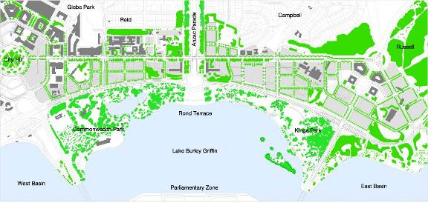

1. Delete the existing figure titled ‘Indicative Public Transport, Access and Circulation’ and replace with the following:

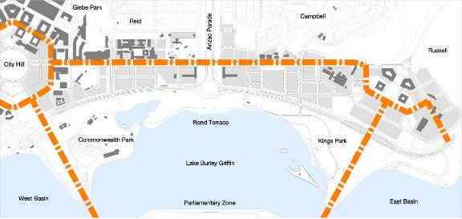

1. Delete the existing figure titled ‘Indicative Road Structure’ and replace with the following:

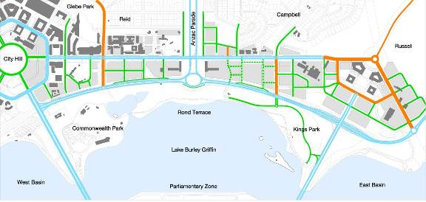

Diagram showing the indicative road hierarchy (Main Avenues, indicative Local Streets, Major Streets and indicative Lanes) for Constitution Avenue and the surrounding road network.

1. Delete the existing figure titled ‘Indicative Cycleways’ and replace with the following:

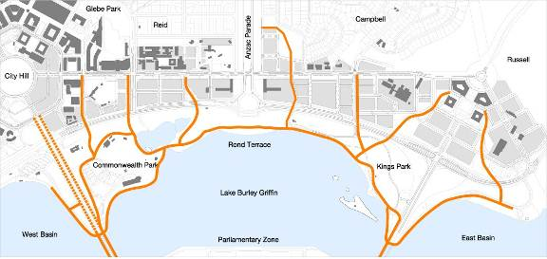

1. Amend paragraph four under section titled ‘Active Frontage’ to read as follows:

*Ground level frontages will present an attractive pedestrian-oriented frontage providing active uses for a minimum of 30 percent of the street frontage. Key active frontages are to have a minimum of 75 percent active uses.*

1. Amend paragraph five under section titled ‘Active Frontage’ to read as follows:

*Residential uses, except for home offices, should be avoided at street level at those locations identified as having an active frontage in the figure above.*

1. Delete the existing figure titled ‘Indicative Active Frontage’ and replace with the following:

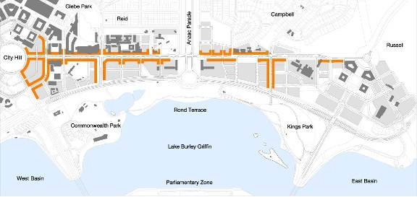

1. Delete the existing figure titled ‘Indicative Building Height and Form’ and replace with the following:

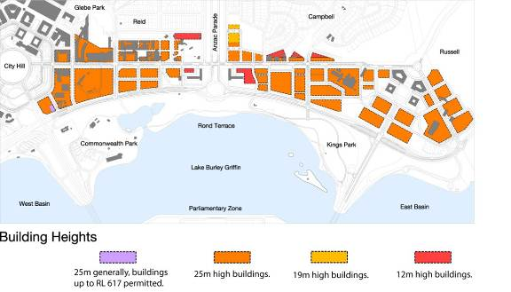

1. Amend paragraph seven under section titled ‘Building Height and Form’ to read as follows:

*Development should generally be constructed to the street boundary to define and enclose streets and create continuous street frontage while allowing variations in individual buildings and uses. Development on the northern side of Constitution Avenue shall be set back a minimum of 6.5 metres from the block boundary.*

1. Insert a new paragraph and drawing under section titled ‘Building Height and Form’ as follows:

*Building height is to be measured from and between the finish footpath level at each corner of a development block.*

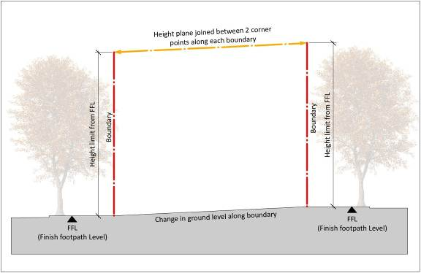

1. Insert a new paragraph under section titled ‘Building Height and Form’ as follows:

*Minimum floor-to-ceiling heights within buildings are to be as follows:*

|  |  |
| --- | --- |
| ***Location*** | ***Min. floor height*** |
| ***Ground Floor facing Constitution Avenue and roads where ‘Indicative Active Frontages’ are located*** | ***6.5 metres floor to ceiling (mezzanine level permitted over 30% of ground floor)*** |
| ***Ground Floor (Residential)*** | ***3.3 metres floor-to-ceiling*** |
| ***Ground Floor (other uses, including commercial/office use)*** | ***3.6 metres floor-to-ceiling*** |
| ***Residential (general)*** | ***2.7metres floor-to-ceiling minimum for all habitable rooms, 2.4 metres is the preferred minimum for all non-habitable rooms however 2.25 metres is permitted.***  ***For two-storey units, 2.4 metres minimum for second storey if 50 percent or more of the apartment has 2.7 metre minimum ceiling heights.***  ***For two-storey units with a two-storey void space, 2.4 metre minimum ceiling heights.***  ***Attic spaces are permitted, with a 1.5 metre minimum wall height at edge of room with a 30 degree minimum ceiling slope.*** |

1. Delete the existing figure titled ‘Indicative Stormwater (proposed)’ and replace with the following:

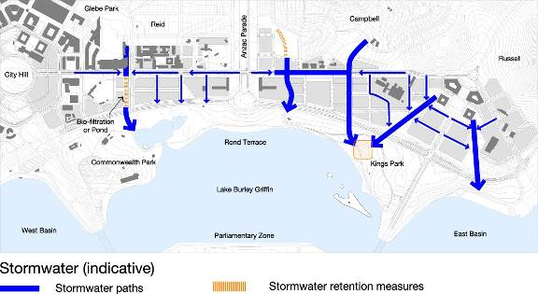

1. Replace the section titled ‘Car Parking’ with the following:

**Parking**

*Provide on-street car parking and conveniently-located bicycle parking to support retail uses, pedestrian amenity and after-hours activity.*

*Large off-street permanent surface car parks are to be avoided; car parking is to be accommodated in basements or in above-ground structures concealed from public areas by habitable building facades.*

*Development of existing surface car parks will need to demonstrate that an adequate public car parking provision (on-street or in appropriately designed structures) will meet the needs of Constitution Avenue.*

*Car parking for new development shall accord with the following rates:*

|  |  |  |
| --- | --- | --- |
| **Land use(s)** | **Car parking rate** | **Locational requirements** |
| Residential | One space per dwelling and one visitor space per four dwellings or part thereof. | Long-stay resident parking: on-site  Short stay/visitor parking: on-site or off-site immediately adjacent to the site. |
| Office | One space per 100 square metres of gross floor area. | On-site or off-site immediately adjacent to the site. |
| Administrative use; Bank; Child Care Centre; Consulting Rooms; Co-operative Society; Health Centre; Personal Services Establishment | Two spaces per 100 square metres of gross floor area. | On-site or off-site immediately adjacent to the site, with the exception of Child Care Centre where parking must be provided on-site. |
| Bar, Café, Restaurant, Retail | Two and a half spaces per 100 square metres of gross floor area. | On-site or off-site immediately adjacent to the site. |
| Hotel, Motel | One space per employee, plus one space per guest room or unit for establishments up to 36 units; or  25 spaces plus 0.3 spaces per guest room for establishments of more than 36 units. | On-site. |

*Land uses for which car parking rates are not prescribed above will be subject to individual assessment.*

*Proponents must demonstrate the access and parking capacity of the proposed development, and its impacts on the transport network and surrounding area. A higher on-site and/or off-site parking provision for any use may be required by the Authority after taking into account the relationship between on-site parking, off-site parking opportunities, the capacity of public transport in the area at the time of development, and anticipated future levels of public transport.*

*Additional parking shall be provided for bicycles, motorcycles and vehicles owned and operated under car-sharing schemes.*

1. Delete the existing figure titled ‘Indicative Development’ and replace with the following:

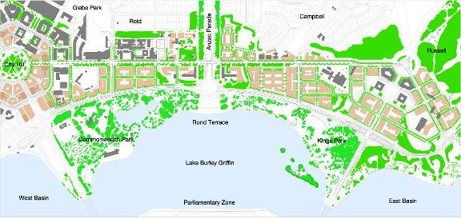

1. At the end of Appendix T8, add the following:

## Detailed Conditions of Planning, Design and Development for Section 5 Campbell

*The detailed conditions in this section ensure that the planning, design and development of Section 5 Campbell integrates with the established residential suburb of Campbell and contributes to the character of Constitution Avenue.*

*All residential and commercial development proposed for Section 5 Campbell is subject to public notification and consultation.*

*Where an inconsistency arises between these detailed conditions and Appendix T8, these detailed conditions prevail.*

### Illustrative Development Plan

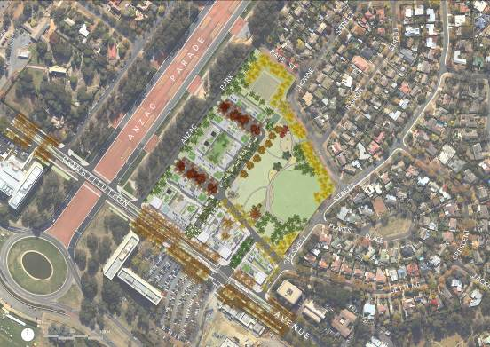

### Public Space

*The overall structure of public space is to respond to the established network of streets, parks and public spaces, and enhance the connectivity, accessibility and legibility of this network. At a finer scale, public spaces are to respond to site topography through designs that resolve access and drainage.*

*The design of public space is to provide increased amenity for residents within and adjacent to the site, through improvements to passive surveillance and visual permeability.*

*The general arrangement of streets and sections is shown in Figure 1.*

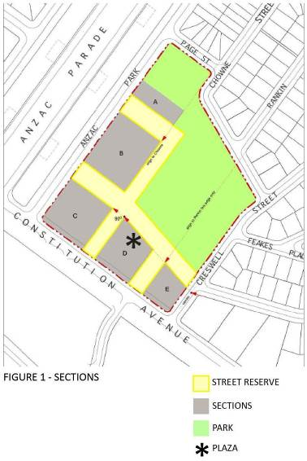

### Building Form

*Building forms are to respond to the scale and pattern of development on Constitution Avenue, the proposed network of public space and achieve a transition that responds to the established residential urban form.*

*Building designs are to provide controlled solar gain and cross-ventilation, to reduce energy consumption and improve the amenity for building occupants. The maximum permissible building depths for residential buildings as measured across the floorplate are shown in Figure 2. Minor departures are permitted where it can be demonstrated that optimum solar gain and cross ventilation is achieved and where it can be demonstrated to improve the public domain.*

*Amalgamation of sections will not be permitted where building forms adversely impact pedestrian movement or visual access. Building elements (other than awnings) are not to be built over roads.*

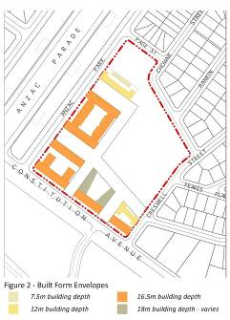

### Site Access and Set-backs

*Primary vehicle access to Section 5 Campbell is to be from Constitution Avenue, with the exception of basement car parks. Service entries must not face Constitution Avenue, Anzac Park East and new roads bordering Open Space. All service entries are to be located and designed to minimise their impact on the streetscape. Access to service rooms and areas should be achieved within buildings to minimise adverse impacts on public space.*

*Pedestrian access to each building is to be provided at adjacent ground level, whilst maintaining privacy for private residences and passive surveillance.*

*Direct pedestrian access from the public domain is to be provided to each ground floor unit or tenancy where they have a clear relationship to the public domain. The level of ground floor entries shall be:*

* *Not less than the finished level of the footpath; and*
* *Not more than 450mm above the footpath level.*

*The required building setbacks are shown in Figure 3. Balconies and other articulation elements may encroach into the setback zone. Any such encroachments must not exceed 30% of the setback area and are not permissible on the ground floor. Encroachments within the setback area must not include internal habitable space.*

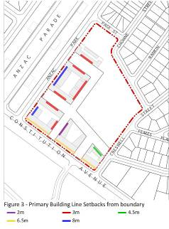

### Building Height

*Overall building heights are to comply with those shown in Figure 4. Minor departures from heights shown in Figure 4 will only be considered where it can be demonstrated that the mass and bulk of buildings is not significantly increased, and where it enhances the architectural quality of the building, and fosters energy efficiency, indoor amenity, appropriate urban scale, and adds visual interest to the skyline. Building design is to take advantage of natural light and orientation for occupants and visitors.*

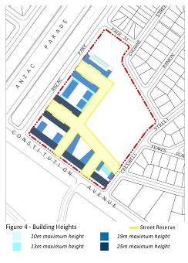

### *Building Facades*

*Street corners are to be expressed by giving visual prominence to parts of the building façade such as a change in articulation, material or colour, roof expression and/or increased height.*

*Building articulation, material and colour must be sympathetic to the heritage values of the adjacent National and Commonwealth Heritage listed places.Building entries are to be clearly identified through building form, material and colour.*

*The use of built form elements such as balconies, projections, awnings and hoods are encouraged to provide shelter and ameliorate wind and downdraft in public spaces.*

### *Parking*

*A minimum of 150 on-street visitor parking spaces shall be provided above ground.*

*Ground level or above ground parking structures are not permitted.*

### *Materials*

*Materials shall be selected for their permanence and durability. Materials shall not be highly reflective, to avoid glare and focused transfer of heat. Materials shall have potential for recycling.*

### *Landscape*

*Trees planted within the road reserve should be consistent with the existing landscape character of Campbell and provide continuous canopy to shade roads and footpaths in summer. Trees planted within road reserves must be capable of achieving the heights and canopy spread indicated in Sections 1 to 6 of these detailed conditions at maturity.*

*The landscape zone within blocks is consolidated to provide for substantial mature plantings that will afford privacy to neighbours and maintain winter sunlight to properties where available. Landscape plantings within each block must include a selection of large scale trees, capable of reaching a minimum 15 metres in height with a broad canopy and that are consistent with the landscape character of Campbell when mature. Deep soil space to be provided is shown in Figure 5.*

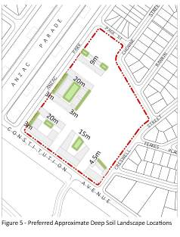

### *Heritage*

Development of Section 5 Campbell shall respect the cultural heritage values of the National and Commonwealth Heritage listed places in the vicinity of the site.

Anzac Park East

Off-site landscaping is required to assist in reducing the visibility of building form from Anzac Parade, and in providing a green backdrop to memorials.

Existing *Arbutus unedo* in the southern verge of Anzac Park East shall be retained to provide a dense evergreen screen. Trees may be removed to allow construction of new streets. Existing *Arbutus unedo* are to be interplanted with *Eucalyptus cinerea* to add a second canopy layer.

Where gaps exist in the rows of *Eucalyptus bicostata* on Anzac Parade, new plantings are required to match the plantings on the western side of Anzac Parade.

The landscape treatment at the corner of Constitution Avenue and Anzac Parade/Anzac Parade East shall generally be in accordance with Figure 6.

Works Approval will not be granted for residential and commercial development on Section 5 Campbell until such time as off-site landscape works on Anzac Park East and Anzac Parade have been completed.

Section 5

Particular attention shall be given to the building form/façade at the corner of Anzac Parade East and Constitution Avenue. The design of buildings should be articulated using a variety of messing; solids and voids; and materials and colours to ameliorate any impacts on the adjacent National and Commonwealth Heritage listed places.

Buildings should not intrude on the public appreciation of the eastern handle of the New Zealand Memorial as the gateway to the Memorial Parade or interrupt the symmetrical characteristics of the East and West portal buildings in framing the Parliament House Vista.

The architectural design of the buildings on Site C must be sympathetic to the heritage values of the adjacent National and Commonwealth Heritage listed places.

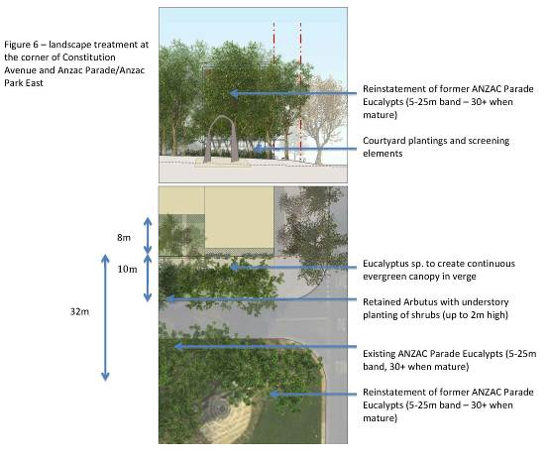

### *Lighting*

The impact of outdoor lighting in proximity to Anzac Parade and the memorials shall be minimised.

Heritage Management Plans for National and Commonwealth Heritage listed places shall be considered in developing external lighting designs. The colour and finish of light poles and other light fittings shall be sympathetic to the heritage values of the adjacent National and Commonwealth Heritage listed places.

New building façade lighting installations shall use full cutoff light fittings that are carefully integrated into the building’s structure. External lighting to building entrances, window displays and signage shall be restricted to assist in providing a dramatic backdrop. Consideration will be given to building lighting where it contributes to identity, legibility, silhouette, architectural expression, and façade articulation.

All street and footpath lighting is to be full cutoff.

### Indicative Development – Streetscape

*The following indicative development streetscape sections are provided to illustrate the proposed relationship between public space, landscape and transport uses (see legend provided at Figure 7 for locations):*

1. *Wendouree Drive*
2. *Park Edge Street (Getting extension)*
3. *Park Edge Street (Chowne Street Alignment)*
4. *Shared-way (Chowne Street Alignment)*
5. *Streets adjoining Anzac Park East*
6. *Anzac Park East*



Section plan illustrating what development may look like along Wendouree Drive.

Section plan illustrating what development may look like along the new park edge street (Getting Street extension).

Section plan illustrating what development may look like along the Park Edge Street (Chowne Street Alignment).

Section plan illustrating what development may look like in the shared-way on the Chowne Street alignment.

Section plan illustrating what development may look like on the new memorial streets

Section plan illustrating what development may look like on Anzac park East.

**Note**

1. All legislative instruments and compilations are registered on the Federal Register of Legislative Instruments kept under the *Legislative Instruments Act 2003*.See http://www.frli.gov.au.