

***The Australian Capital Territory***

***(Planning and Land Management) Act 1988***

**National Capital Plan**

**Amendment 55**

**(Office, Retail and Community Facility Uses)**

**Block 16 Section 28 City**

**Australian National University**

**September 2006**

NATIONAL CAPITAL PLAN DRAFT AMENDMENT 55

National Capital Plan Amendment 55   
Block 16 Section 28 City (Australian National University)

The National Capital Plan is amended by:

1. Adding the letter “A” on Block 16 Section _8 City at Figure 9.

The effect of this is shown in the Amended Figure 9 at Attachment B; and

1. Adding a new page following Figure 9 and inserting the following:

**A City   
Block 16 Section 28**

**Objectives**

The objectives of the land use policy are to:

* enable a mix of Office, Retail and Community Facility uses;
* present a formal address to University Avenue and to Marcus Clarke Street;
* maximise active street frontages; and
* present a seamless transition between the premises and University Avenue by having consistent paving, planting and street furniture.

**Land Use Policy**

The permitted land uses, subject to a Community Facility (being an educational establishment for Australian National University being part of any development) are:

* Community Facility;
* Office;
* Retail. Other land uses are permitted, ancillary to and in association with the permitted uses.



Figure 9 Attachment B

The Central National Area (Acton and Central Canberra (part))

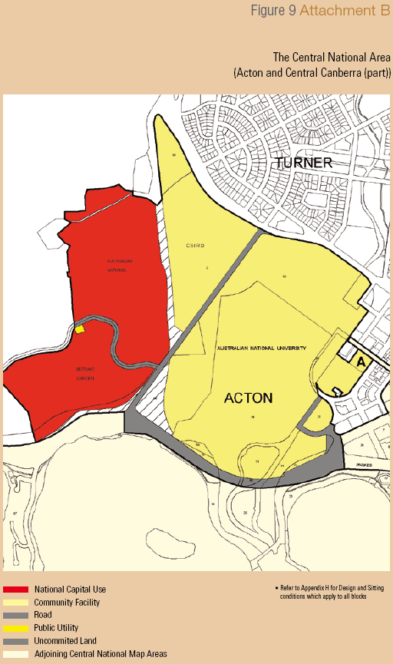

*Refer to Appendix H for Design and Sitting conditions which apply to all blocks