Schedule 1 Amendment

(section 3)

The National Capital Plan is amended by the following:

## Introduction

### Part One - Principles, Policies and Standards, Designated Areas, Special Requirements

1. The Central National Area

a) Delete the existing Figure 8 The Central National Area (Barton) and substitute the following Figure 8 The Central National Area (Barton).

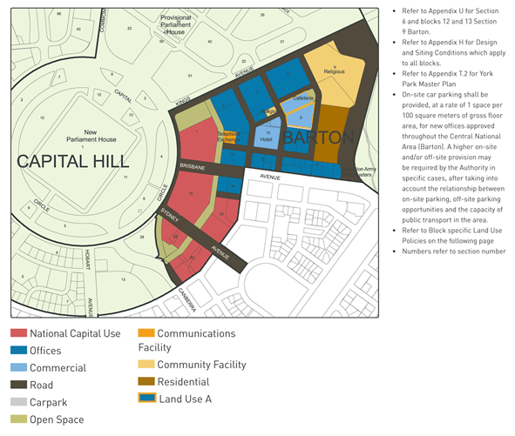

b) Delete Schedule B – Block 13 Section 9 Barton, and substitute the following Schedule B:

**Blocks 12 & 13 Section 9 Barton**

**Objective**

The objective of the land use policy for the sites is to provide an opportunity for the development of mixed use facilities, including office, retail and residential, incorporating a car parking structure and active street frontages.

**Principles and Policies**

Promote a range of land uses including Office, Residential, Retail, Café and Restaurant which contribute to the vibrancy, amenity and convenience of Barton as an attractive place in which to work and live.

Provide a prestigious development reflecting the national significance of Barton in the Central National Area.

Provide a scale of development commensurate with the location’s accessibility to nearby infrastructure, cultural attractions and parklands and its location within the Central National Area.

Provide a scale of development that increases private investment in the precinct to deliver public infrastructure including local retail and professional services, café/restaurant establishments, and a parking structure.

Promote environmentally sustainable development including increased pedestrian accessibility and public transport use while reducing dependency on private vehicles.

**Land Use Policy**

Development and redevelopment shall accord with the Detailed Conditions of Planning, Design and Development as set out in Appendix U (Section 6 and Blocks 12 & 13 Section 9 Barton).

Permitted land uses are:

* Bank;
* Car Park;
* Child Care Centre;
* Commercial Accommodation (Serviced Apartment only);
* Consulting Rooms;
* Co-operative Society;
* Office;
* Open Space;
* Personal Service Establishment;
* Residential;
* Restaurant, Bar, Café;
* Retail; and
* Road.

c) Amend Appendix U to read Section 6 and Blocks 12 & 13 Section 9 Barton - Detailed Conditions of Planning, Design and Development.

d) After the last paragraph under ‘Appendix U – Sections 6 and Blocks 12 & 13 Section 9 Barton – Detailed Conditions of Planning, Design and Development’, add the following:

### BLOCKS 12 & 13 SECTION 9 BARTON

DETAILED CONDITIONS OF PLANNING, DESIGN AND DEVELOPMENT

**Building Height and Form**

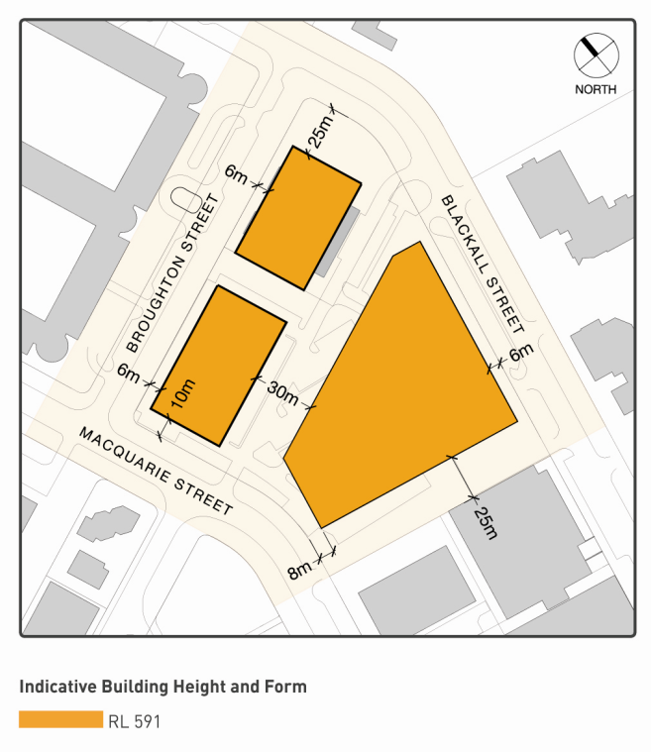

To protect the integrity of views to and from Parliament House, development is generally limited to a height of RL591. Minor building elements (such as lift overruns and roof plant) that extend building height above RL591 will be considered where this enhances the architectural quality of the building, and fosters energy efficiency, indoor amenity, appropriate urban scale, and adds visual interest to the skyline. Minor building elements should be carefully integrated within the form of buildings.

Building and landscaping will need to exhibit design excellence and be designed to ensure protection of the amenity of surrounding buildings and public spaces, including privacy, overlooking and overshadowing.

Individual buildings are to contribute to the coherent definition of blocks and streets generally in accordance with the layout and setbacks. A hierarchy of public spaces and street frontages should be created, with the greatest amount of public activity and building entrances being encouraged on principal streets and at public spaces.

Blank facades to public spaces and streets are not permitted especially at ground level, to create interest in the streetscape and to enhance passive surveillance and public safety.

**Active Frontages**

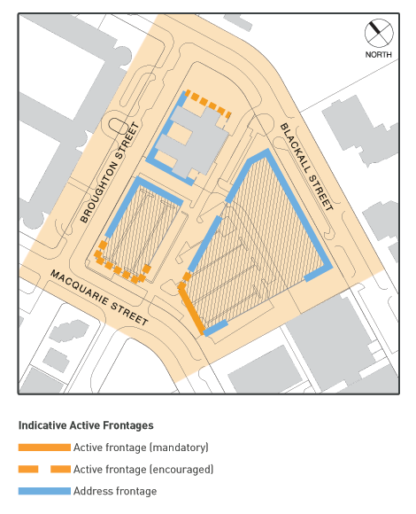Active frontages should include shops and entries to buildings. Address frontages will generally be free of service functions and blank walls, with residential and minor commercial addresses encouraged.

High standards of architecture are sought for the precinct. Modulation of facades, entrances, window bays, sun shading and balconies, and clear articulation of building elements, textures and materials, should provide interest and variety to the streetscape.

Residential frontages may be set-back from street boundaries to provide entry porches and a garden interface with the public domain to protect the amenity of residents and contribute to the interest and landscape qualities to the street.

Balconies should be of an appropriate size and design to optimise their use and privacy. A minimum dimension of 2.5m for at least one balcony per dwelling should be provided and balustrades should be opaque up to at least 4 storeys from street level.

**Parking and Access**

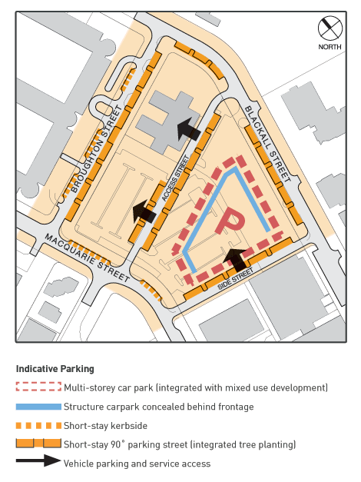Large off-street permanent surface car parks are to be avoided. Car parking is to be accommodated in basements and/or in above ground structures concealed from public view. Blank facades to public spaces or streets are not permitted, and sculptural elements and urban scale public art is encouraged. The inclusion of these elements can assist in ascribing different meanings to buildings, and provides the opportunity to characterise not only shelter and functionality, but to interact with our daily lives.

Some short stay on-street shall be provided to support retail uses, pedestrian amenity and after hours activity.

Car parking for new development shall accord with the following rates:

Residential; Commercial Accommodation (Serviced Apartment only): 1.5 spaces per 100 square metres of gross floor area.

Bank; Child Care Centre; Consulting Rooms; Co-operative Society; Office; Personal Service Establishment: 2 spaces per 100 square metres of gross floor area.

Restaurant, Bar, Café; Retail: 2.5 spaces per 100 metres of gross floor area.

A higher on-site and/or off-site parking provision may be required by the Authority after taking into account the relationship between on-site parking, off-site parking opportunities and the capacity of public transport in the area at the time of development.

The proponent must provide the NCA a long term parking strategy for construction staging which minimises disruption to parking. The parking strategy must be adopted in the first stage of development to accommodate a minimum of 470 displaced car parking spaces.

Access to the site (for parking and site servicing) should be from the side and access street generally.

Additional parking shall be provided for vehicles associated with less consumption of energy. These include bicycles, motorcycles, small cars and car-sharing vehicles.

Car parking structures should provide secure storage and related facilities for bicycle users. This would position the development as a local centre for commuting and recreational cyclists, as well as providing the opportunity for an alternative mode of transport between the many office buildings in the locale.

**Landscape/Streetscape**

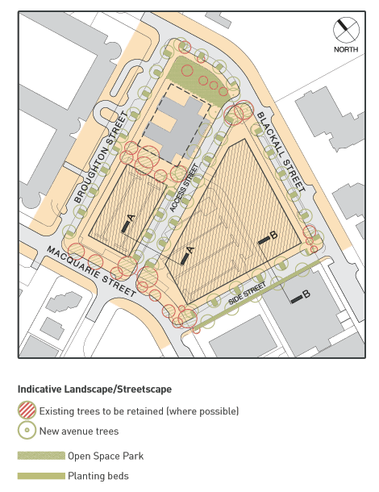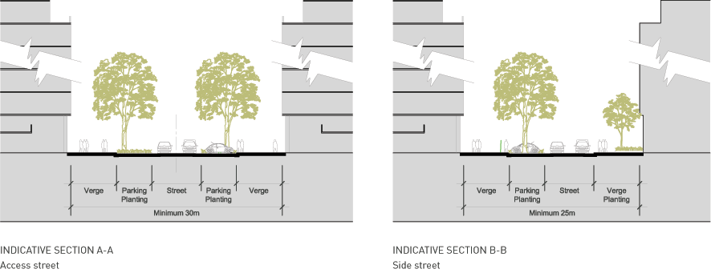

Paving, lighting, street trees and planting beds shall be of high quality and should reinforce the amenity and visual quality of the pedestrian environment. Street trees and other large trees are to be planted in deep-root soil conditions. Existing large trees are to be retained (where possible).

**Public Domain and Off-Site Works**

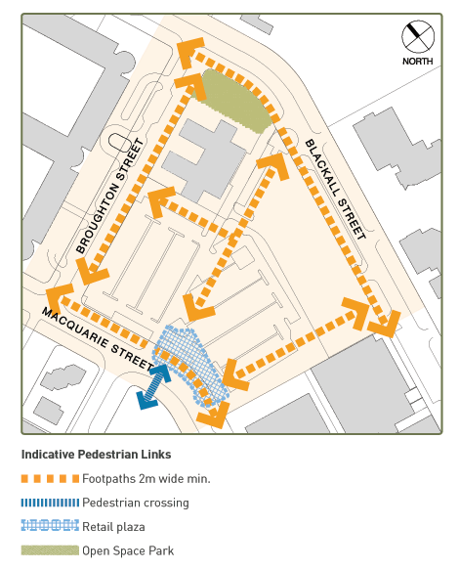A retail plaza is to be provided on the corner of Macquarie Street and the side street and furnished with lighting, seating and paving to provide an attractive public area for outdoor cafés and restaurants.

The developer is to carry out off-site works to create a high quality public domain commensurate with a vibrant and attractive mixed use precinct.

On-street parking, verge landscaping, paving, lighting and furniture shall be provided using high quality durable materials.

**Sustainable Development**

Development proposals will demonstrate a high level of performance in terms of environmental design including energy efficiency, climate management and water sensitive urban design.

**Public Notification**

All applications for Works Approval for major development are subject to public notification and consultation. The determination of those applications that constitute major works is at the discretion of the National Capital Authority.

### Part Two Administration and Implementation

e) Amend the Plan to recognise consequential changes of Amendment 57 to page numbers, section titles and contents page.

**Note**

1. All legislative instruments and compilations are registered on the Federal Register of Legislative Instruments kept under the *Legislative Instruments Act 2003*.See http://www.frli.gov.au.