

Barton Block 13 Section 9 Redevelopment
Traffic Assessment

Final Report
Department of Finance and Deregulation

18 December 2008
Traffic Assessment

Prepared for
Department of Finance and Deregulation

Prepared by
Maunsell Australia Pty Ltd
Level 2, 60 Marcus Clarke Street, Canberra ACT 2600, Australia
T +61 2 6201 3000 F +61 2 6201 3099 www.maunsell.com
ABN 20 093 846 925

18 December 2008

6005 1531

© Maunsell Australia Pty Ltd 2008

The information contained in this document produced by Maunsell Australia Pty Ltd is solely for the use of the Client identified
on the cover sheet for the purpose for which it has been prepared and Maunsell Australia Pty Ltd undertakes no duty to or accepts any responsibility to any third party who may rely upon this document.
All rights reserved. No section or element of this document may be removed from this document, reproduced, electronically stored or transmitted in any form without the written permission of Maunsell Australia Pty Ltd.

Quality Information
Document Traffic Assessment
Ref 6005 1531
Date 18 December 2008
Prepared by Neil Graham
Reviewed by Tim Rampton

Revision History
Revision | Revision Date | Details | Authorised
Revision | Revision Date | Details | Name/Position | Signature
0 | 18/12/2008 | Draft report | Rod Williams  ACT Operations Manager
1 | 18/12/2008 | Final report | Rod Williams  ACT Operations Manager

Table of Contents
Executive Summary 6
1.0 Introduction 7
1.1 Background 7
1.2 Study Objectives 7
1.3 Site Location 7
1.4 Report Structure 7
2.0 Strategic Context 9
2.1 Planning Responsibility and Parking 9
2.2 Strategic Plans and Policies and Recent Studies 9
2.2.1 The National Capital Plan 9
2.2.2 The Canberra Spatial Plan 10
2.2.3 The Sustainable Transport Plan 12
2.3 Recent Studies 12
2.3.1 Parliamentary Zone Review 12
2.3.2 ACT Parking Strategy Study 12
2.3.3 ACT: A Capital Future 13
3.0 Existing Conditions 14
3.1 Land Use 14
3.2 Parking Supply and Demand 14
3.2.1 Parking Management 14
3.2.2 Total Supply and Demand in the Barton Area 14
3.2.3 Block 13 Section 9 15
3.2.4 York Park Site 17
3.3 Pedestrian and Bicycle Access 17
3.3.1 Pedestrian Access 18
3.3.2 Bicycle Access 19
3.4 Public Transport 19
3.5 Road Network 20
3.5.1 Introduction 20
3.5.2 Intersection Operation 22
3.6 Journey to Work Data 23
3.7 Commercial Development 24
3.7.1 Completed Development 24
3.7.2 Approved and Likely Future Development 24
3.8 Summary 24
4.0 Development of the Site 26
4.1 Description 26
4.1.1 Indicative Uses 26
4.1.2 Vehicular and Pedestrian Access 26
4.1.3 Public Transport Access 26
4.2 Parking 26
4.2.1 Permanent Parking 26
4.2.2 Temporary Parking 27
4.3 Road Network 28
4.3.1 Traffic Generation 28
4.3.2 Intersection Operation 28
4.3.3 Site Access 29
4.3.4 Road Network Summary 29
4.4 Pedestrians and Cyclists 29
4.5 Public Transport 29
5.0 Conclusion 30
5.1 Parking 30
5.2 Traffic and Access 30
5.3 Public Transport 30
5.4 Pedestrian and Bicycle Access 30
Appendix A aaSIDRA Results 31
2005 Existing performance 31
2011 FUTURE PERFORMANCE – AM Peak only 34

Executive Summary
Maunsell AECOM were previously commissioned by Capital Planners Pty Ltd in 2005 to provide an assessment of the potential traffic impacts resulting from the proposed development of Block 13 Section 9, Barton, Canberra. At the request of the National Capital Authority (NCA) Maunsell AECOM have updated their original report dated 18 January 2006.
Block 13 Section 9 is one of the two remaining surface car parking sites in Barton, the other being the York Park site. Other open surface car parking sites in the Barton area tend to be barrier controlled, however the larger of these also advertise long-stay parking (at a cost).
Future parking demand is dependant on the following factors:
- Development in the surrounding area;
- Decreased demand from greater provision of on-site parking from developments throughout Barton; and
- Greater public transport usage in future.

An assessment of likely future traffic conditions in the area found that traffic generated traffic has a relatively minor impact on the operation of the three key intersections. Site design can ensure that peak flows can be distributed to the surrounding road network and to areas with spare capacity. Additional green time for increased volumes on key turning movements is considered to mitigate any adverse impacts and establish a more efficient road network.
Pedestrian and cyclist trips will be encouraged through the provision of a high standard of pathways and connectivity through the site and to surrounding established networks. The commercial components of the site will provide cycle storage facilities.
In conclusion, the development of the site is expected to have only temporary impacts on long-stay parking supply during construction and minimal impacts on permanent long-stay parking supply. The design and layout of the site will encourage greater trips made by public transport, walking and cycling modes and contribute to government policy to decrease car dependency over time.

1.0 Introduction

1.1 Background
Maunsell AECOM were previously commissioned by Capital Planners Pty Ltd in 2005 to provide an assessment of the potential traffic impacts resulting from the proposed development of Block 13 Section 9, Barton, Canberra. At the request of the National Capital Authority (NCA) Maunsell AECOM have updated their original report dated 18 January 2006.
Block 13 Section 9 is one of the two remaining surface car sites facilities in Barton, the other being the York Park site. Other open surface car parking sites in the area tend to be barrier controlled, however the larger of these also advertise long-stay parking (at a cost).

1.2 Study Objectives
The primary objective of this study is to investigate the development of the Block 13 Section 9 site. It is intended that the outcomes of this study would support government policy objectives in both the short and long terms.

1.3 Site Location
The suburb of Barton is located between Capital Hill and Lake Burley Griffin, on the southern side of Kings Avenue (as shown in Figure 1-1). Barton is generally bounded by State Circle, Sydney Avenue, New South Wales Crescent, Telopea Park, Bowen Drive and Kings Avenue. The main land uses in the suburb are commercial and medium to high density residential development.
Block 13 (the site) is located within Section 9 Barton, which is bordered by Broughton Street to the north, Blackall Street to the east and south, and Macquarie Street to the west. Block 13 is bounded by:
- Broughton Street and the Edmond Barton Building to the north;
- A café in Section 12 to the north;
- Blackall Street and the Landmark apartment complex to the east;
- Tourism House and the AMA Building to the south; and
- Macquarie Street, a small park and a church to the west.

1.4 Report Structure
The remainder of the report is divided into the following sections:
- Chapter 2 describes the strategic context of the site in terms of current and future land uses, parking strategies and infrastructure operation and maintenance;
- Chapter 3 describes the existing land use and traffic conditions of the road network including car use, parking supply and demand, public transport, pedestrian and cycle facilities;
- Chapter 4 describes vehicle access and traffic generation for development of the site; and
- Chapter 5 provides the conclusions to the study.
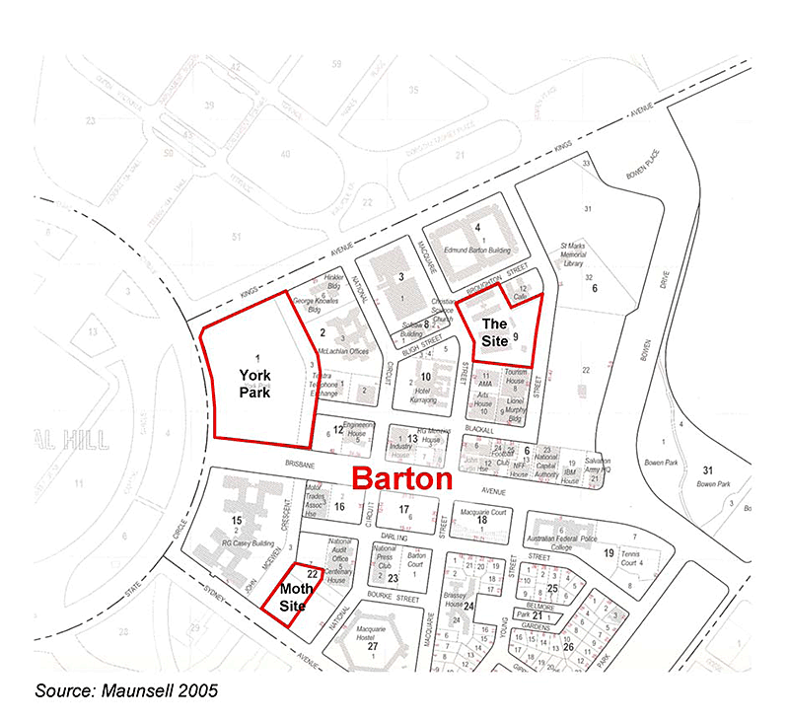

Figure 1-1: Location of Barton and the Site

2.0 Strategic Context

2.1 Planning Responsibility and Parking
The planning and development of Barton falls under the responsibility of both Commonwealth and ACT governments. The Commonwealth administers the National Capital Plan through the National Capital Authority (NCA) while the ACT government is responsible for the administration of the Territory Plan.
The Canberra Spatial Plan is the Territory’s key strategic planning document for directing and managing urban growth and change. It provides strategic directions for the development of Canberra over the next 30 years and beyond. The Spatial Plan integrates with The Sustainable Transport Plan, which seeks to achieve a more sustainable transport system for Canberra over the next 30 years.
A summary of key traffic and transport aspects of these documents follows.

2.2 Strategic Plans and Policies and Recent Studies

2.2.1 The National Capital Plan
The National Capital Plan provides a general policy framework for land use and planning in the Territory, and more specifically guides the planning, design and development of areas of the Territory that have been identified as having national capital importance (Designated Areas). It is the overarching strategic plan for the Australian Capital Territory - a land use policy plan that reflects the national significance of Canberra and the Territory.
Matters of national significance in the planning and development of Canberra to be protected as identified in the National Capital Plan include:
- maintaining high quality design for entry points and along approach routes to the Central National Area;
- maintaining a legible and functional hierarchy of roads in the Territory;
- providing for a system of inter-town public transport; and
- minimising traffic congestion in the Central National Area.
General transport related planning, design and development conditions that apply to the Central National Area include:
- Traffic capacity and traffic arrangements on major routes in the Designated Area will be planned to ensure safe and dignified access for all ceremonial occasions, and for residents, staff, tourists and visitors.
- The transport system within the Designated Area will be planned and managed for volumes of traffic and parking consistent with the significance and use of the Area. Transport infrastructure should foster the use of transport systems which minimise adverse effects from vehicular traffic.
- Direct access to and from major roads will be permitted where practicable and not inconsistent with traffic safety requirements. The design and maintenance of all roadways and parking areas, including their associated landscaping, signs and lighting, will be of a consistently high quality.
- Commonwealth, Kings and Constitution Avenues, the avenues connecting the nodal points of the National Triangle, are of critical significance in delineating the geometric form of Griffin's plan. They are not only the primary movement routes, but they are powerful generators of structure and urban form.
- Building, road and landscape maintenance is to conform with Management Plans prepared by the Authority in consultation the ACT Government, which will consider traffic and parking operations, temporary uses and ceremonial events. The Management Plans will also establish levels of maintenance for land, water and infrastructure appropriate to the principles and policies for the Area.
In terms of car parking the NCA’s policy decisions are considered to play a primary role in the supply and availability of tenant, off-street and on-street parking throughout Barton and the adjoining areas of Parkes and Forrest. The proximity of Barton to the Parliamentary Triangle and national institutions means that the NCA holds particular interest in redevelopment of existing sites and development of vacant sites with regard to traffic and transport policy.
In granting works approvals, the NCA have an objective of ultimately being able to meet reasonable demand for off-site parking in Parkes/ Barton through the erection of public car parking structures. This is largely in recognition of the need to replace public parking cars displaced from existing temporary car parks that become development sites.
A recent internal report by the NCA (February 2006) indicated that there may be a need for building a public structured car park on the Project site, depending on how much parking is provided in public parking structures elsewhere in the Parkes/ Barton area. Note that the structured car park is not an additional requirement for the developer of the site. It is largely recognition of the need to replace public parking for cars displaced from existing temporary car parks that become development sites, including sites elsewhere in Barton.

2.2.2 The Canberra Spatial Plan
One of the goals of the Canberra Spatial Plan is to retain ease of movement and facilitate good travel connections. This goal responds to the very high value that Canberran’s place on the ease within which they can get around the city. A closer relationship between jobs, services and homes will enable more people to use walking and cycling as an alternative method of transport that supports a healthy lifestyle.
The relevant key principles underpinning the Spatial Plan include:
- Contain growth within 15km to reduce sprawl;
- Increase the number of homes within 7.5km of the City Centre to provide a wider range of housing close to employment and services;
- Locate new residential areas close to town centres and transport routes;
- Locate employment close to residential areas and transport routes; and
- Provide good travel connections to minimise journey times and trip lengths.

The future major transport connections that form a key part of this Plan are illustrated in Figure 2-1. It shows a trunk public transport route within the Kings Avenue corridor, which is likely to be bus-based initially and light rail in the long-term. This route accommodates direct and frequent public transport movement between Barton (feeding areas to the south and east such as Woden, Fyshwick and Queanbeyan) and Civic (feeding areas to the north and west). These routes are used to service key employment corridors running both north-south and east-west through Central Canberra.
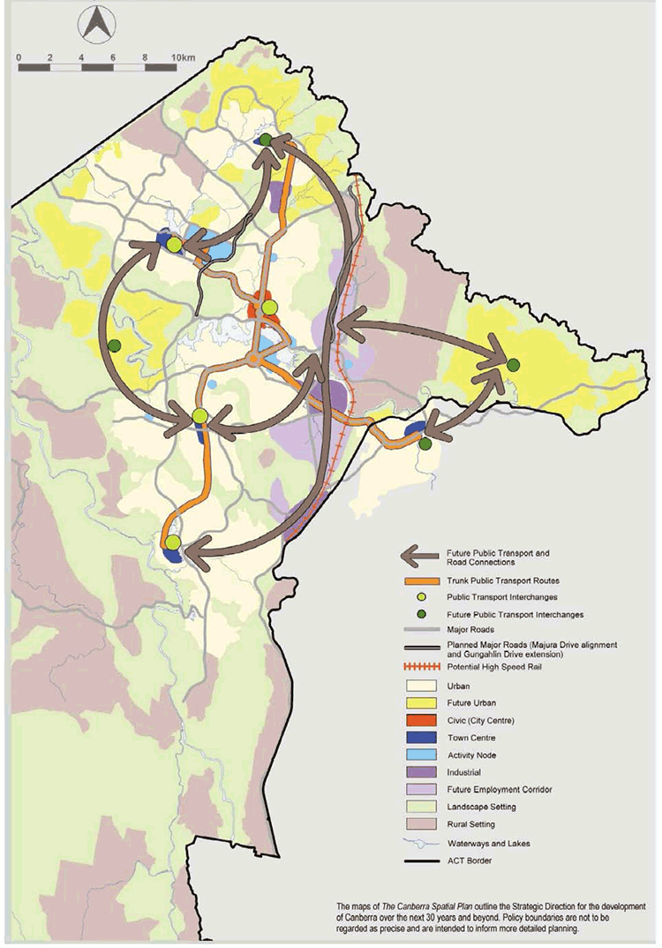
Figure 2-1: Canberra Spatial Plan – Future Transport Connections

2.2.3 The Sustainable Transport Plan
The Sustainable Transport Plan is a 25 year implementation plan which was developed to sit under The Territory Plan and be directly associated with the recommendations made in The Canberra Spatial Plan. The Sustainable Transport Plan will move Canberra to a transport system that retains Canberra’s high levels of accessibility, but with lower per capita costs and less negative impacts. It will also facilitate a shift of travel from cars towards a greater reliance on walking, cycling and public transport. The transport sector is a major contributor to ACT greenhouse gas emission profile and successful implementation of The Sustainable Transport Plan is a critical element of the ACT Greenhouse Strategy 2000.
A key to achieving The Sustainable Transport Plan is the progressive shift towards an urban form that supports shorter trips and encourages people to walk or cycle. The Spatial Plan provides this urban form. The Sustainable Transport Plan encourages improvement of public transport services at activity nodes along key transport corridors. This will support intensification of development along these corridors in line with the urban containment principle of the Spatial Plan.
The Sustainable Transport Plan proposes the progressive development of a corridor transit system, building onto the existing bus system. Investment in busways will help to reduce public transport travel times on trunk routes and make them more reliable. A range of complementary measures is proposed to support increased public transport patronage. These include the introduction of effective management of parking, real time information for bus passengers, TravelSmart programs, improved interchanges, park and ride facilities and increased services.
The ACT Sustainable Transport Plan (ACT Government, 2005) provides targets for reduced car commuting from 87% (ACT average) in 2001 to 80% in 2011 and 70% in 2026. The contribution of public transport is targeted to increase from 6.7% in 2001 to 16% in 2026.
The introduction of pay parking will allow for the application of the “user pays” principle for commuter parking in major employment centres, consistent with the ACT Sustainable Transport Plan.

2.3 Recent Studies

2.3.1 Parliamentary Zone Review
The Parliamentary Zone Review is a strategic planning document that provides the structure for a major review of buildings, car parking spaces and open space in the Zone. The review proposes an increase of up to 8,000 employees in up to 28 redeveloped or new buildings. Car parking needs should be met by underground car parks in each of the new buildings and two new multi-level parking buildings within the Zone. Up to 3,000 publicly accessible spaces could replace the need for the existing surface car parks in the area.

2.3.2 ACT Parking Strategy Study
The Draft ACT Parking Strategy (ACT Government, March 2007) makes recommendations for more restrictive parking controls being applied to new commercial development. The study makes the following relevant recommendations for the future management of the Parliamentary Zone and adjoining areas:
The Draft ACT Parking Strategy proposes that, within the Parliamentary Zone:
- Agreement is reached with the National Capital Authority on responsibility for the strategic planning and administrative control of parking in Barton and Parkes (including the Parliamentary Zone) so that there is consistency in the strategic approach to parking supply, pricing and management across the ACT’s major employment and commercial centres;
- Parking time restrictions and appropriate enforcement are introduced to manage on-street parking in Barton and Parkes (including the Parliamentary Zone), to ensure that on-street parking space is used primarily for “high priority”, short-stay parking needs and for essential servicing of the precinct;
- Pay-parking is introduced at fee levels that:
- -promote high turnover, short-stay use of on-street parking;
- encourage longer-stay parking needs to be accommodated in off-street parking facilities; and
- encourage constraint in Single Occupant Vehicle car travel to the precinct;
- Introduction of high-quality shuttle services between Barton and Parkes (including the Parliamentary Zone) and City and Russell is explored to reduce needs for car-commuting to work in Barton and Parkes, and for car use during the day for business and social trips, with the costs to be incorporated into parking fees;
- Introduction of a similar strategy of precinct based, shared-use public parking stations in Barton and Parkes (including the Parliamentary Zone) be considered, as is proposed for City and the town centres);
- Consolidated parking options that would offer key nodes for a prospective shuttle bus service and for an enhanced pedestrian/ cycle network to reduce the need for car travel within the precinct and between the precinct and surrounding nodes such as City, Kingston and Manuka be explored; and
- Additional surface car parks should not be considered in Barton and Parkes (including the Parliamentary Zone), with existing ground-level car parks to be replaced by consolidated, shared-use parking structures.

2.3.3 ACT: A Capital Future
"Canberra: A Capital Future -Managing Transport Development" states that Canberra's past reliance on road systems is no longer appropriate and aimed simply at satisfying an ever increasing demand for private travel. It further states that a better approach is to aim for an affordable balance between the provision of new roads and the creation of a more effective public transport system as a genuine alternative to private car use.

3.0 Existing Conditions

3.1 Land Use
Land use in Barton is primarily government or private office buildings with supporting uses including churches, clubs and accommodation. Residential development, including low density housing and medium density apartments are also evident, mainly on the eastern side of the area. Ownership is mostly a mixture of Commonwealth Government land and long-term leases that offer “private ownership”.
Block 12 Section 9 Barton has a land use policy of part commercial and part open space. Existing commercial use on the site includes the Ottoman Restaurant. The remainder of the site is surface car parking.
Key land uses adjoining the site include:
- A café within the north-eastern corner of the site;
- The Edmund Barton Building on the northern side of Broughton Street;
- The Landmark residential apartment complex on the eastern side of Blackall Street;
- Tourism House and the AMA Building to the south;
- A small park and church to the west; and
- A hotel complex to the south west.

3.2 Parking Supply and Demand

3.2.1 Parking Management
The ACT Government administers parking restrictions in Parkes and Barton. It is responsible for the enforcement of parking restrictions and the issuing and processing of infringement notices.
Enforcement is limited to public parking areas that display time and/or vehicle (e.g. ‘government vehicle only’) restrictions. Off-street tenant parking cannot be enforced by parking officers while public parking on private sites (e.g. Section 9 Block 13) can be enforced.

3.2.2 Total Supply and Demand in the Barton Area
About 8,100 employees are located in Barton and 5,500 in Parkes. There are also a number of major visitor attractions in Parkes.
An analysis of 2001 floor space and journey to work data in Barton indicates that the current demand for commuter parking in the study area is likely to be in the order of 2.4 spaces per 100m². This level of demand for parking is higher than for other major employment centres (e.g., Civic). Parking demand in the study area is currently affected by the public transport service to the area and the proximity of residential accommodation within a reasonable walking distance of the area.
Table 3-1 provides a summary of the results of a recent survey of parking in Barton and Forrest by Integral Services Group. It includes the area bounded by Kings Ave, State Circle, Canberra Ave, Telopea Park and the lake. The overall parking utilisation was 87% on the day and at the times surveyed in September 2007. The off-street parking was more highly utilised. The greatest demand is for long-stay off-street parking (90% utilisation).

Table 3-1: Parking Supply and Demand in Barton/Forrest

Location | Type | Supply | Demand | Utilisation
On-street | Short-stay | 346 | 286 | 83%
On-street | Long-stay | 518 | 361 | 70%
On-street | Sub-total | 864 | 647 | 75%
Off-street | Short-stay | 167 | 122 | 73%
Off-street | Long-stay | 4,693 | 4,045 | 90%
Off-street | Sub-total | 4,660 | 4,167 | 89%
Total |  | 5,524 | 4,814 | 87%

Note: 1. Excludes residential parking and some parking underneath buildings which were inaccessible.
- The supply of parking for gravel car parks was based on an estimate using observed data.
- No supply data was recorded for illegal parking on grass verges, but demand was recorded.

Much of the public parking in Barton is on-street or in temporary car parks. The two primary off-street public parking areas in Barton are on Australian Government land ear-marked for development:
- Block 5 Section 1 Barton; and
- Block 13 Section 9 Barton (the Project site).

A deficiency in the supply of long stay public car parking in Barton/ Forrest is counteracted by a corresponding over supply in Parkes. Surveys of peak hour pedestrian movements across Kings Av indicate that a large number of Barton workers park in Parkes and walk across Kings Ave. Based on the results of this survey it is estimated that Parkes/ Barton operates with a parking deficit of approximately 500 public parking spaces. Conversely, it would appear from the results of surveys shown in Table 6 that tenant parking is underutilised, somewhat addressing the overall imbalance in supply and demand.

3.2.3 Block 13 Section 9
The site is primarily used as an at-grade public parking facility. The formalised paved parking area contains about 470 car parking spaces comprising the following areas:
- Broughton Street (northwest area): 147 marked spaces;
- AMA (southwest area): 193 marked spaces; and
- Blackall Street (eastern area): 130 marked spaces.
Recent counts (Maunsell, November 2005) identified about 630 cars parked within the site, including about 100 cars in the unmarked unpaved areas along the southern perimeter of the site. Counts of the different areas identified the following number of parked cars.
- Broughton Street (northwest area): 170 cars;
- AMA (southwest area): 280 cars, including 50 in the unpaved area; and
- Blackall Street (eastern area): 180 cars (including 50 in the unpaved area).

These counts were done when the Edmund Barton Building was occupied.
Site observations undertaken as part of Maunsell’s 2005 study indicated that long stay car parks in the vicinity of the site are operating at full or above capacity (100-110% peak utilisation). These observations also show that there is a significant overflow of parking from the suburb or Barton into the long stay parking facilities in the Parliamentary Triangle. The long stay parking in the Parliamentary Triangle is currently free for use.
Typical parking conditions at the time of the survey are shown in Photograph 3.1 to Photograph 3.4.
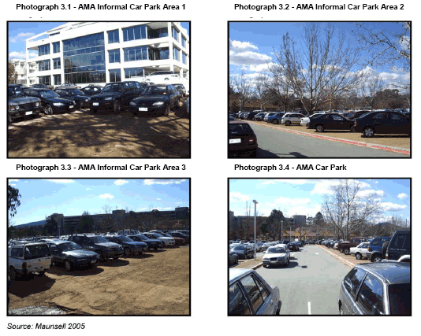
Photograph 3.1 - AMA Informal Car Park Area 1
Photograph 3.2 - AMA Informal Car Park Area 2
Photograph 3.3 - AMA Informal Car Park Area 3
Photograph 3.4 - AMA Car Park

Vehicle Access
Vehicle access to the site from the surrounding road network is via Macquarie Street and Blackall Street. There are three vehicle accesses along Macquarie Street (Photographs 3.5 to 3.7), although two of these accesses are generally blocked by parked vehicles. The remaining access serves the various parking aisles located in the western component of the car parking area. Blackall Street has three vehicle access points (Photographs 3.8 to 3.10), two of which access the unpaved car parking area.
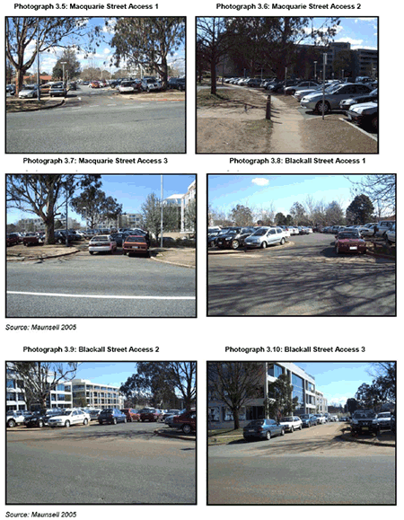
Photograph 3.5: Macquarie Street Access 1 Photograph 3.6: Macquarie Street Access 2
Photograph 3.7: Macquarie Street Access 3 Photograph 3.8: Blackall Street Access 1
Photograph 3.9: Blackall Street Access 2 Photograph 3.10: Blackall Street Access 3

3.2.4 York Park Site
The York Park or One State Circle site comprises a paved parking area leased to DFAT by Finance on the southern part of the site and an unpaved public parking area on the northern part of the site. Currently there is formal parking for about 710 vehicles on this site, although vehicles are also informally parked around the site. Vehicle access to the main car park is via Brisbane Avenue while access to the unpaved area is via the access road to Blackall Street and National Circuit. Additional parking could be provided within Windsor Walk.

3.3 Pedestrian and Bicycle Access
Key pedestrian and cycle routes in Barton are shown in Figure 3-1. The majority of bicycle and pedestrian paths are located alongside the lake whilst the majority of primary footpaths are alongside the public roads.
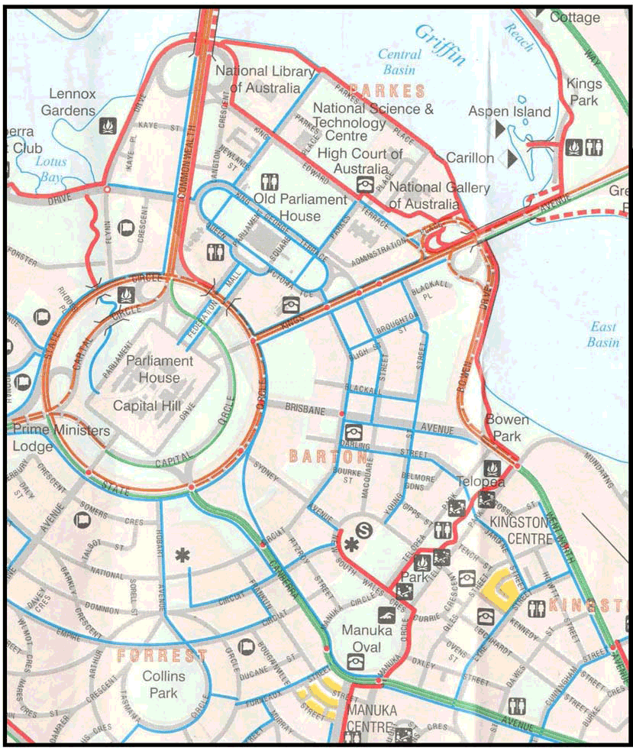
Figure 3-1: Bicycle and Pedestrian Routes in Barton

3.3.1 Pedestrian Access
Pedestrian access around the site and to a variety of destinations is catered for by pedestrian pathways alongside public roads. Pedestrian links to the lake and its surrounding pedestrian network is via several pathways through the Landmark Apartment complex, situated between Blackall Street and Bowen Drive.
Kings Avenue and Brisbane Avenue both present significant pedestrian barriers. However, a signalised pedestrian crossing is provided on Kings Avenue between Macquarie Street and Blackall Street. Brisbane Avenue has three sets of signals along its length which provide pedestrian phases.

3.3.2 Bicycle Access
Access to the ACT bicycle network is provided via Kings Avenue to the north, Brisbane Avenue to the south and the lakeside to the east. The bicycle network is shown on Figure 3-1, including both on-road and off-road facilities.

3.4 Public Transport
The ACT Government operates the ACTION bus network which provides bus services through the area, including along routes close to the subject site. A map showing bus routes and stops in the vicinity of the site is given in Figure 3-2. There are a number of public bus services operating in the vicinity of One State Circle, including along Kings Avenue, National Circuit, State Circle and Commonwealth Avenue.
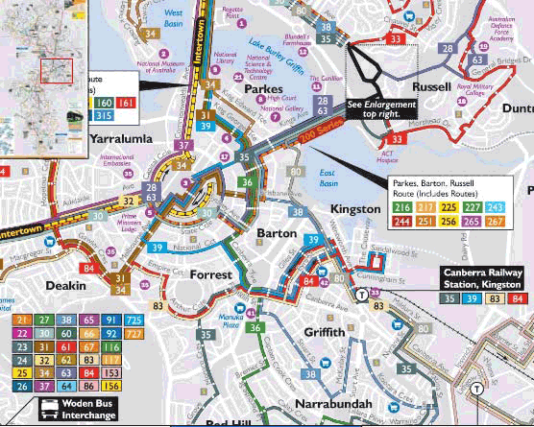
Figure 3-2: ACTION Bus Network in Area
Barton is relatively well accessed by public bus services. There are thirty five routes that pass through Barton, including three express services. The majority of these routes use either National Circuit or Kings Avenue with about six bus stops located within 10 minutes walk of the site. Typical routes and locations of bus stops are shown in Figure 3-3.
Recent consultation with ACTION indicates that they are going to substantially increase bus travel frequencies in the Parkes and Barton/ Forrest areas, as well as other Government office areas. Frequencies of 15minutes throughout the day are expected, compared with current frequencies of 30 to 60 minutes for some services. In addition, the number of services between town centres will be increased (to 5minute intervals). Such increases in service frequency will facilitate more sustainable transport outcomes for the area in the future.
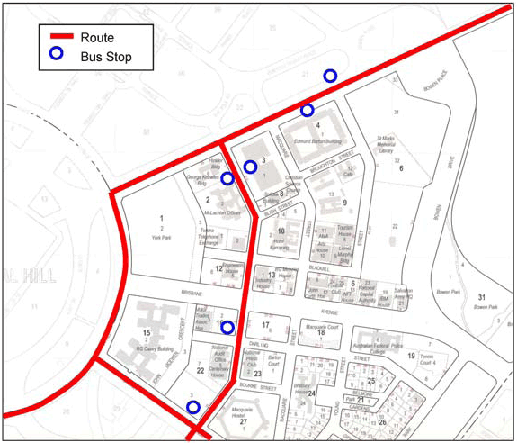
Figure 3-3: Bus Routes and Bus Stops in the Vicinity of the Site

3.5 Road Network

3.5.1 Introduction
The network immediately surrounding the site provide the majority of access to the site. These are Macquarie Street/ Kings Avenue (signalised), Blackall Street/ Kings Avenue (priority controlled), and National Circuit/ Brisbane Avenue (signalised). The intersections are shown in Figure 3-4.
Traffic volumes on surrounding roads generally reflect the classification of the roads, either as arterial routes or local roads providing site access. Both Kings Avenue and Brisbane Avenue are arterial roads. Figure 3-5 shows the surrounding network and recent estimates of daily traffic volumes. Kings Avenue plays a major role in distribution to the regional network while volumes on Brisbane Avenue are significantly lower.
Macquarie Street and Blackall Street are both local roads with a 50km/hr speed limit. Macquarie Street is access controlled with limited on-street parking and carries about 4,000-6,500 vehicles per day. A pedestrian crossing in Macquarie Street between Bligh Street and Blackall Street helps to facilitate pedestrian access across the road.
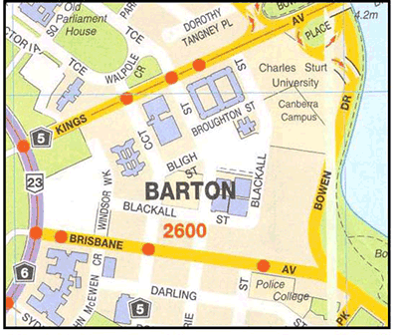
Figure 3-4: Surrounding Road Network

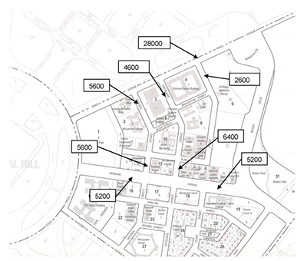
Source: Maunsell (2005)

Figure 3-5: Existing Road Network and Traffic Volumes (vpd)

Blackall Street operates as a local road currently carrying approximately 2,500 vehicles per day. It services St Marks Church, the on site car park, some access to the Landmark apartment complex and some office buildings. It has adequate mid-block capacity and its main capacity constraint is at the Kings Avenue intersection which is not signalised (Photographs 3.11 and 3.12). Adjoined by less intensive land uses and some open space Blackall Street is considered to offer significant spare capacity to proposed or future land uses.
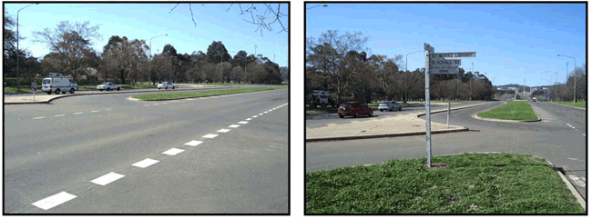
Photograph 3.11: Blackall St & Kings Ave Intersection 1 Photograph 3.12: Blackall St & Kings Ave Intersection 2

3.5.2 Intersection Operation

Turning Movements
Turning volumes offer a good indication of intersection operation and spare capacity. A qualitative assessment of the turning movements suggests that the AM peak is the critical peak period with a number of significant turning movements. The critical movement is the right turn from Brisbane Avenue into Macquarie Street with 434 vehicles. High volume turns also include the left turns from Kings Avenue into Blackall Street (366 vehicles) and Macquarie Street (324 vehicles). Intersection operation is not critically affected by these movements and significant spare capacity in the intersections is considered to exist.

Network Performance Indicators
The capacity of an urban road network, where intersections are frequent, is controlled by the capacity of the intersections within that network. Average delay is commonly used to assess intersections performance, with ‘level of service’ (LoS) used as indicator; ‘LoS A’ representing a good level of operation and ‘LoS F’ representing oversaturated conditions, where improvements are required. A summary of the level of service criteria is shown in Table 3-2.
Table 3-2: Performance Criteria for Intersections
Level of Service | Average Delay / Vehicle (secs/veh) | Traffic Signals, Roundabout | Give Way and Stop Signs
A | Less than 14 | Good operation | Good operation
B | 15 to 28 | Good with acceptable delays and spare capacity | Acceptable delays and spare capacity
C | 29 to 42 | Satisfactory | Satisfactory, but accident study required
D | 43 to 56 | Operating near capacity | Near capacity and accident study required
sE | 57 to 70 | At capacity; at signals incidents will cause excessive delays | At capacity; requires other control mode
F | >70 | Roundabouts require other control mode | At capacity; requires other control mode
Source: Guide to Traffic Generating Developments, NSW Roads and Traffic Authority, 1993
A quantitative assessment of intersection operation was undertaken using the traffic counts and SCATS data. Analysis of the existing operation of the intersections was undertaken using aaSidra 2.0. The results of this analysis are presented below.
Kings Ave / Blackall St AM – LoS A, with average delay for right turners out of Blackall St of around 42 seconds. PM -LoS A, with average delay for right turners out of Blackall St around 47 seconds
Kings Ave / Macquarie St AM – LoS C, with 95% back of queue lengths over 100m for all approaches PM – LoS C, with 95% back of queue lengths over 100m on King’s Ave approaches only
Brisbane Ave / Macquarie St AM – LoS B, with minimal delays to all movements PM – LoS B, with minimal delays to all movements.
The SIDRA results suggest significant capacity in the current network and that any reasonable future increases in traffic at the intersections can be accommodated through appropriate phasing. More detailed results are included in Appendix A.

3.6 Journey to Work Data
Journey to Work (JTW) data for ACT from the 2001 Census showed the following travel patterns for the journey to work trip to Barton and Parkes.

Table 3-3: 2001 ABS Journey to Work Summary Table
Mode | Barton |  | Parkes
 | Number | Percentage | Number | Percentage
Bus | 383 | 5.2% | 291 | 5.8%
Car Driver | 5746 | 77.8% | 3877 | 77.2%
Car Passenger | 674 | 9.1% | 508 | 10.1%
Walk | 211 | 2.9% | 66 | 1.3%
Cycle | 180 | 2.4% | 141 | 2.8%
Other | 191 | 2.6% | 139 | 2.8%
Non Trips* | 728 |  | 510
TOTAL | 8113 |  | 5532
* Includes work from home / did not go to work / not stated
The JTW data shows over 8,000 full-time or part-time staff working in Barton. About 87% of journeys to work are undertaken by private car (as car driver / car passenger). Only 10.5% of trips use public transport, walking or cycling. On any given day the staff absentee rate is about 9%.
The targets for increased usage of walking, cycling and public transport for the journey to work are an important outcome of the Sustainable Transport Plan and are shown in Table 3-4. These targets represent a more than doubling of the current proportion of trips used by environmentally-friendly modes. City will attract the most growth in these modes, because of it’s continual growing attraction for job opportunities and it’s importance as a focal point in Canberra’s road and public transport system.
Table 3-4: ACT Journey to Work Mode Split targets

MODE | 2001 | 2011 | 2025
Walking | 4.1% | 6% | 7%
Cycling | 2.3% | 5% | 7%
Public Transport | 6.7% | 9% | 16%
Total | 13.1% | 20% | 30%
Source: ACTPLA (2004)

3.7 Commercial Development

3.7.1 Completed Development
Commercial development recently completed is likely to reduce demand for surface car parking facilities in Barton / Forrest. Table 3-5 identifies recently completed development, floor area and parking supply. By providing two parking spaces per 100m² GFA on site these developments should cater for long-term parking demand.
Table 3-5: Completed Development
Development* | Complete | GFA (m²) |  | Car Parking
Development* | Complete | was | now | was | now
Engineering House | 2005 | 2,900 | 6,500 | 57 | 123
Dept IT & Arts | 2005 | 0 | 11,000 | 0 | 220
Minter Ellison | 2005 | 0 | 14,000 | 0 | 280
1 National | 2007 | 3,611 | 17,000 | 64 | 340
* The Realm Hotel was also completed in recent years.
New developments also provide barrier controlled tenant parking. Any excess in parking supply could lead to the availability of long-term non-tenant parking (for a cost). The future acceptance of pay parking will enhance the viability of these car parking spaces. However, this is not likely to reduce demand for parking until pay parking becomes accepted, and even then only a minimal number of spaces may become available.

3.7.2 Approved and Likely Future Development
Future commercial development may affect parking demand as additional spaces are provided on-site. Table 3-6 identifies approved developments and the proposed increase in parking supply.
Table 3-6: Approved and Likely Future Development
Development | Construction |  | GFA (m²⁾ |  | On-Site Parking Provision
Development | Start | Finish | current | proposed | current | proposed
McLachlan Offices* | 2007 | 2009 | 15,000 | 22,500 | 60 | 450
Softlaw Building | 2007 | 2009 | 2,200 | 4,600 | 25 | 80
Robert Garran Offices | 2009 | 2011 | 17,000 | 17,000 | 90 | 210
* Approved and currently under construction.
Table 3-6 identifies about 565 additional on-site parking spaces to be constructed by 2011. While many of these spaces will be utilised through the provision of additional employment space, off-site parking demand is expected to decrease significantly. For example the redevelopment of the McLachlan Offices will provide an additional 7,500m² GFA of floor space with 390 parking spaces. Taking the net increase in supply against likely increases in demand, the actual decrease in demand for off-site surface parking throughout Barton/Forrest could reduce by at least 500 spaces by 2009, as result of planned developments.

3.8 Summary
Current traffic conditions suggest that the AM peak period is the critical peak, with relatively high volumes turning right from Brisbane Avenue into Macquarie Street and left turners from Kings Avenue into Blackall and Macquarie Streets (although not critical movements). Qualitative and quantitative assessments indicate that significant spare capacity exists in the network and that any reasonable increase in future volumes should be catered for within the existing network layout. Longer green time for higher volume movements may be considered to improve network efficiency.
Emphasis on the provision of on-site parking has resulted in many of the above developments providing car parking rates of two per 100m² GFA, rather than the previous standard of one space per 100m² GFA. This is more in line with employment density and therefore limits demand for off-site parking. Demand could be reduced by at least 500 parking spaces by 2009 throughout Barton/ Forrest.

4.0 Development of the Site

4.1 Description

4.1.1 Indicative Uses
A number of indicative options for the development of Block 13 Section 9 were created and assessed as part of site investigations done in 2005. These included a mixed use development containing offices, apartments, retail and parking.
A preferred option was selected in consultation with NCA, as a basis for the traffic analyses in this report. This option included the following assumed land use and parking:
- 15,000 m² of office space;
- 1,000 m² of retail space;
- 120 apartment units; and
- 830 parking spaces on-site and an additional 40 on-street parking spaces on Blackall Street.

4.1.2 Vehicular and Pedestrian Access
The development of the site will consider adequate vehicular and pedestrian access through the provision of laneways connecting between Macquarie Street and Blackall Street. These could be used for one-way or two-way vehicular access.
Pedestrian access would be provided through the provision of pedestrian footpaths alongside public roads and laneways plus additional pathways through open space. Pedestrian crossings can be provided at all major desire lines.

4.1.3 Public Transport Access
A similar level of access to the public transport network will be provided to that which currently exists.

4.2 Parking

4.2.1 Permanent Parking
In terms of the long-term use of the site all surrounding on-street parking spaces will revert to short-term parking, consistent with government policy. Commercial development sites will generally cater for the employment rates they support and there will be a decreasing demand for off-site long stay parking.
There are two key elements to the provision of permanent parking on the Project site:
- The parking to be provided as part of the development; and
- • Replacement parking.
Parking to be provided as part of the new office development needs to be at a rate of 1 space per 100m² GFA in basement parking on-site. Parking for retail uses will be provided at 4 spaces per 100 m² GFA. This parking requirement can be offset by:
- The provision of on-site bicycle storage (maximum of 5% reduction in parking requirement)
- The provision of on-street visitor parking as part of the development
The NCA’s latest draft parking policy document for Barton/ Forrest (NCA, February 2006) suggests a requirement for 2,060 additional spaces, fundamentally to replace parking in temporary car parks lost due to development on those car parks, as well as to address the overflow of parking from Barton to Parkes (about 500 cars). A reduction in the shortfall will be achieved with the provision of additional parking as part of the Edmund Barton offices refurbishment. The amount of additional parking is not yet known.
It is suggested that these additional replacement car parking spaces be provided in 3 structured car parks in Barton, as follows:
- Barton Block 7 Section 22 (Territory land) – 900 spaces;
- Barton Block 13 Section 9 (National land) – 460 spaces; and
- Basement parking in the median of Sydney Avenue – 700 spaces.
The alternative to these sites is to consider a structured car park in Parkes, where there are considerably more options for structured car park locations. It is reasonable to consider Parkes/ Barton together, rather than specifying that the parking requirement in Barton should be met within Barton. Importantly, such a car park could incorporate the existing demand for overspill parking from Barton into Parkes (about 500 spaces).
There is strong potential for the ACT Government to initiate the construction of a 900 space structured car park on Section 22, which could cater for parking displaced from the Project site when it becomes a construction site. This would equate to a net increase of about 750 spaces on the Section 22 site after taking account of existing on-site parking.
The ACT Government is also considering the construction of basement car parking in the Sydney Avenue median. This could accommodate an additional 700 cars, resulting in a net increase of 1,450 new spaces in structures.
Initial discussions with staff at the ACT Chief Ministers Department indicate a relatively strong interest in pursuing the option of building structured car parks on Section 22 and in the median of Sydney Avenue. Potential advantages include:
- They are likely to give substantial impetus to the initiation of pay parking in Parkes / Barton;
- They will satisfy a short-term need to replace parking when construction commences on the Project site;
- They will help satisfy a long-term need for additional parking in the area; and
- They are centrally located in the precinct, offering excellent access to workers who would be a major user of the car park.

4.2.2 Temporary Parking
The loss of the existing on-site temporary parking needs to be addressed as part of development on the site. There needs to be an agreement between stakeholders on the minimum acceptable replacement numbers of parking spaces during the construction period, and realistic projected parking demand by construction workers during the construction period. Another fundamental strategy for reducing the parking demand in the Barton / Parkes precinct (both temporarily and permanently), will be to encourage the use of public transport.
Analyses undertaken by Maunsell in 2005 indicated that off-site parking demand from displaced parking spaces during the development of the site is likely to be in the range of 200 to 250 spaces, depending on the sequence of development and the timing of provision of new permanent on-site parking.
The options for temporary long-stay parking locations are plentiful within the precinct. These need to be investigated as part of the future detailed planning and design for the site.
There are additional car parking opportunities along the eastern side of Blackall Street. Current parking restrictions prevent car parking along the eastern side of Blackall Street. Analysis shows that up to 40 parallel parking spaces could temporarily be provided on Blackall Street for short-stay parking, to address a short-fall in short-stay parking in the area.

4.3 Road Network
Potential traffic generated from the development of Block 13 Section 9 may affect the operation of the surrounding road network. This section assesses those potential impacts and provides mitigation measures where necessary.

4.3.1 Traffic Generation
The development of Block 13 Section 9 will only marginally increase the volume of traffic generated. Counts undertaken by Maunsell in 2005 indicated that about 550 vehicles were generated by the site during the peak hour. This reflects a very high arrival rate (about 87% of vehicles parked at the site arrived in the peak hour); in Russell the peak hour arrival rate is about 65% of parking demand and in City 55%. A lower arrival rate can be expected in future, with the occurrence of peak spreading in the wider network.
The indicative plan for the site indicated that a total of 590 long-stay spaces are to be provided for commercial uses on the site. In addition, there will be 120 residential units and some short-stay spaces for the retail development. Assuming a peak trip generation rate of 80% of parking spaces for the commercial car parking and 0.6 veh/hr/unit for residential uses, the site could generate up to 544veh/hr (ie, little change from existing traffic). However, there will be a redistribution of traffic, largely due to the change in use on the site.
The newly generated traffic (544 vehicles) was distributed to the network using current desire patterns (reflected in turn movements at the car park accesses). Account was taken of the changed access arrangements on MacQuarie St and changed traffic patterns on Blackall St (with more residential). In addition, allowance was made for additional traffic on MacQuarie St generated by the possible redevelopment of part of Robert Garran Offices. It indicated that there will be very little change in traffic on MacQuarie Street, but a small increase on Blackall Street.

4.3.2 Intersection Operation
A qualitative assessment of future traffic generation on the road network suggests that the additional traffic can be accommodated within the existing road network and intersection configuration. The results of a more detailed quantitative assessment are included below.
A quantitative assessment of intersection operation in 2011 was undertaken using current distribution and the following assumptions:
- Background growth of 2% pa;
- Full occupation of approved future developments by 2011;
- Reoccupation of the Edmund Barton Building by 2011; and
- 65% occupation of short-term parking on the site and immediately adjoining streets (to take into account visitor parking).

Analysis of the critical AM peak operation of the intersections with the development was undertaken using aaSidra 2.0. The results of the analysis are presented below.
Kings Ave / Blackall St LoS A, with average delay for right turners out of Blackall St of around 66 seconds.
Kings Ave / Macquarie St LoS C, with 95% back of queue lengths over 100m for all approaches
Brisbane Ave / Macquarie St LoS B, with minimal delays to all movements
The SIDRA results suggest that there will be very little change in intersection operation with the development. More detailed results are included in Appendix B.

4.3.3 Site Access

Temporary Access During Construction
Initial development of the site should facilitate the formalisation of an access laneway between Macquarie Street and Blackall Street. This laneway can be used for construction access until completion of the site. The access points to both streets are not likely to cause conflict with other road users, however safety and priority at Macquarie Street should be clearly indicated due to its proximity with Bligh Street. Consideration should be given to one-way in-bound movement into the laneway at this location.
The development of the car park, commercial and residential buildings will also involve the establishment of laneways that can be used as construction access.

Permanent Access
All laneways and accessways should have the necessary separation distance from proposed pedestrian crossings and have adequate sight distance. Delays and queueing from accesses will be minimal (1-2 cars 95% of the time)

Surrounding Network
The minor redistribution of traffic generated from the site in future is not likely to have an adverse impact on other intersections within the surrounding network.

4.3.4 Road Network Summary
The existing road network in the area of Block 13 Section 9 Barton readily services traffic generated by the site and adjoining developments. Redevelopment of the site will not cause much change in traffic generated in the area, but there will be some redistribution of traffic accessing the site. There is sufficient spare capacity in the nearby existing intersections to support the changes.

4.4 Pedestrians and Cyclists
Pedestrians and cyclists are well catered for in the area through a network of existing pedestrian and cycle paths. Pedestrian and cyclist access through the site will be enhanced through the provision of new laneways and open space. One of the proposed laneways will provide continuous access along the key pedestrian desire lines between Blackall Street and Bligh Street.
On-site cycle storage and facilities including change-rooms and showers will be provided as part of the commercial developments. This is expected to encourage journey to work trips by bicycle and reduce parking requirements.
The development of the site is expected to enhance to pedestrian and cyclist movement around the site and surrounding area, and contribute to lower demand in car parking spaces in the future.

4.5 Public Transport
There are a number of easily accessible bus stops within 400 metres walk of the development site with numerous bus services, encouraging the use of public transport. These are located on Kings Avenue and National Circuit as shown in Figure 3-3.
A shift in public transport usage from 6.9% in 2001 to 16% in 2016 has been targeted in the ACT Sustainable Transport Plan and the introduction of pay parking in Parkes/Barton would help to achieve this mode shift. Future pressure on the provision of off-site parking spaces will also help to encourage a shift towards higher public transport patronage over time.

5.0 Conclusion

5.1 Parking

Permanent Parking
- The provision of parking will be consistent with ACT Government’s parking strategy.
- Commercial development sites will generally cater for the employment rates they support and there will be a decreasing demand for off-site long stay parking.
- Initial discussions with staff at the ACT Chief Ministers Department indicate a relatively strong interest in pursuing the option of building structured car parks on Section 22 and in the median of Sydney Avenue.

Temporary Parking
- Off-site parking demand from displaced parking spaces during the development of the site is likely to be in the range of 200 to 250 spaces, depending on the sequence of development and the timing of provision of new permanent on-site parking.
- The options for temporary parking locations are plentiful within the precinct.
- Parking conditions in Parkes/Barton should be regularly monitored and the need for temporary parking options.

5.2 Traffic and Access
- The development of the site will consider adequate vehicular and pedestrian access through the provision of laneways connecting between Macquarie Street and Blackall Street. These could be used for one-way or two-way vehicular access.
- There is significant spare capacity in the adjacent road network.
- There will be very little change in traffic on Macquarie Street, but a small increase on Blackall Street.

5.3 Public Transport
- The site is well serviced by public transport and is close to a major trunk service route on Kings Avenue.
- A similar level of access to the public transport network will be provided to that which currently exists.

5.4 Pedestrian and Bicycle Access
- Pedestrian and Cyclist trips will be encouraged through the provision of a high standard of pathways and connectivity through the site and to surrounding established networks.
- The commercial components of the site will provide cycle storage facilities.

Appendix A aaSIDRA Results

2005 Existing performance

Intersection of Kings Ave and Blackall St (existing AM peak)
Movement | Degree of Saturation (v/c) | 95% back of queue length (m) | Average Delay (sec) | Level of Service
Blackall St – south approach
Left | 0.220 | 6 (1 car) | 26 | B
Right | 0.565 | 19 (3 cars) | 42 | C
Kings Ave – east approach
Left | 0.372 | 0 (0 cars) | 8 | A
Through | 0.372 | 0 (0 cars) | 0 | A
Kings Ave – west approach
Through | 0.284 | 9 (2 cars) | 0 | A
Right | 0.586 | 22 (4 cars) | 36 | C
Overall Level of Service ‘A’, with an average delay to all vehicles of 5 seconds.

Intersection of Kings Ave and Blackall St (existing PM peak)
Movement | Degree of Saturation (v/c) | 95% back of queue length (m) | Average Delay (sec) | Level of Service
Blackall St – south approach
Left | 0.301 | 10 (2 cars) | 20 | B
Right | 0.890 | 77 (11 cars) | 47 | D
Kings Ave – east approach
Left | 0.276 | 0 (0 cars) | 8 | A
Through | 0.275 | 0 (0 cars) | 0 | A
Kings Ave – west approach
Through | 0.280 | 0 (0 cars) | 0 | A
Right | 0.080 | 2 (0 cars) | 16 | B
Overall Level of Service ‘A’, with an average delay of 7 seconds.

Intersection of Kings Ave and Macquarie St (existing AM peak)
Movement | Degree of Saturation (v/c) | 95% back of queue length (m) | Average Delay (sec) | Level of Service
Macquarie St – south approach
Left | 0.231 | 44 (7 cars) | 55 | D
Through | 0.231 | 44 (7 cars) | 47 | D
Right | 0.788 | 136 (23 cars) | 65 | E
Kings Ave – east approach
Left | 0.661 | 118 (20 cars) | 31 | C
Through | 0.662 | 121 (20 cars) | 22 | B
Right | 0.624 | 63 (10 cars) | 71 | F
King George Tce – north approach
Left | 0.787 | 139 (23 cars) | 65 | E
Through | 0.787 | 139 (23 cars) | 57 | E
Right | 0.022 | 4 (1 car) | 52 | D
Kings Ave – west approach
Left | 0.804 | 166 (27 cars) | 33 | C
Through | 0.803 | 168 (27 cars) | 24 | B
Right | 0.742 | 75 (13 cars) | 73 | F
Overall LoS ‘C’, with an average delay to all vehicles of 39 seconds.

Intersection of Kings Ave and Macquarie St (existing PM peak)
Movement | Degree of Saturation (v/c) | 95% back of queue length (m) | Average Delay (sec) | Level of Service
Macquarie St – south approach
Left | 0.355 | 62 (10 cars) | 46 | D
Through | 0.355 | 62 (10 cars) | 38 | C
Right | 0.414 | 70 (12 cars) | 46 | D
Kings Ave – east approach
Left | 0.761 | 121 (20 cars) | 36 | C
Through | 0.762 | 123 (20 cars) | 28 | B
Right | 0.670 | 37 (6 cars) | 68 | E
King George Tce – north approach
Left | 0.336 | 59 (10 cars) | 46 | D
Through | 0.336 | 59 (10 cars) | 38 | C
Right | 0.048 | 9 (2 cars) | 42 | C
Kings Ave – west approach
Left | 0.659 | 100 (17 cars) | 35 | C
Through | 0.659 | 101 (17 cars) | 26 | B
Right | 0.187 | 11 (2 cars) | 65 | E
Overall LoS ‘C’, with an average delay to all vehicles of 34 seconds.

Intersection of Brisbane Ave and Macquarie St (existing AM peak)
Movement | Degree of Saturation (v/c) | 95% back of queue length (m) | Average Delay (sec) | Level of Service
Macquarie St – south approach
Left | 0.062 | 1 (1 cars) | 9 | A
Through | 0.340 | 15 (2 cars) | 21 | B
Right | 0.340 | 15 (2 cars) | 23 | B
Brisbane Ave – east approach
Left | 0.154 | 0 (0 cars) | 8 | A
Through | 0.153 | 0 (0 cars) | 0 | A
Right | 0.234 | 20 (3 cars) | 21 | B
Macquarie St – north approach
Left | 0.112 | 3 (1 cars) | 9 | A
Through | 0.126 | 8 (2 cars) | 22 | B
Right | 0.126 | 8 (2 cars) | 23 | B
Brisbane Ave – west approach
Left | 0.094 | 0 (0 cars) | 8 | A
Through | 0.094 | 0 (0 cars) | 0 | A
Right | 0.393 | 18 (3 cars) | 23 | B
Overall LoS ‘B’ with an average delay to all vehicles of 17 seconds.

Intersection of Brisbane Ave and Macquarie St (existing PM peak)
Movement | Degree of Saturation (v/c) | 95% back of queue length (m) | Average Delay (sec) | Level of Service
Macquarie St – south approach
Left | 0.018 | 0 (0 cars) | 9 | A
Through | 0.122 | 5 (1 car) | 18 | B
Right | 0.122 | 5 (1 car) | 19 | B
Brisbane Ave – east approach
Left | 0.041 | 0 (0 cars) | 8 | A
Through | 0.041 | 0 (0 cars) | 0 | A
Right | 0.246 | 9 (2 cars) | 19 | B
Macquarie St – north approach
Left | 0.230 | 7 (1 cars) | 9 | A
Through | 0.316 | 14 (2 cars) | 16 | B
Right | 0.316 | 14 (2 cars) | 18 | B
Brisbane Ave – west approach
Left | 0.058 | 0 (0 cars) | 8 | A
Through | 0.058 | 0 (0 cars) | 0 | A
Right | 0.339 | 16 (3 cars) | 16 | B
Overall LoS ‘B’ with an average delay to all vehicles of 15 seconds.

2011 FUTURE PERFORMANCE – AM Peak only

Intersection of Kings Ave and Blackall St (existing AM peak)
Movement | Degree of Saturation (v/c) | 95% back of queue length (m) | Average Delay (sec) | Level of Service
Blackall St – south approach
Left | 0.322 | 10 (2 cars) | 28 | B
Right | 0.828 | 38 (6 cars) | 66 | E
Kings Ave – east approach
Left | 0.369 | 0 (0 cars) | 8 | A
Through | 0.369 | 0 (0 cars) | 0 | A
Kings Ave – west approach
Through | 0.295 | 10 (2 cars) | 0 | A
Right | 0.572 | 21 (4 cars) | 35 | C
Overall Level of Service ‘A’, with an average delay to all vehicles of 6 seconds.

Intersection of Kings Ave and Macquarie St (existing AM peak)
Movement | Degree of Saturation (v/c) | 95% back of queue length (m) | Average Delay (sec) | Level of Service
Macquarie St – south approach
Left | 0.247 | 46 (7 cars) | 55 | D
Through | 0.247 | 46 (7 cars) | 47 | D
Right | 0.815 | 143 (24 cars) | 66 | E
Kings Ave – east approach
Left | 0.728 | 136 (23 cars) | 31 | C
Through | 0.728 | 141 (23 cars) | 23 | B
Right | 0.624 | 63 (10 cars) | 71 | F
King George Tce – north approach
Left | 0.838 | 153 (25 cars) | 69 | E
Through | 0.838 | 153 (25 cars) | 61 | E
Right | 0.022 | 4 (1 car) | 52 | D
Kings Ave – west approach
Left | 0.837 | 180 (30 cars) | 33 | C
Through | 0.836 | 183 (30 cars) | 25 | B
Right | 0.796 | 81 (13 cars) | 76 | F
Overall LoS ‘C’, with an average delay to all vehicles of 40 seconds.

Intersection of Brisbane Ave and Macquarie St (existing AM peak)
Movement | Degree of Saturation (v/c) | 95% back of queue length (m) | Average Delay (sec) | Level of Service
Macquarie St – south approach
Left | 0.062 | 1 (1 cars) | 9 | A
Through | 0.388 | 17 (3 cars) | 25 | B
Right | 0.388 | 17 (3 cars) | 28 | B
Brisbane Ave – east approach
Left | 0.160 | 0 (0 cars) | 8 | A
Through | 0.160 | 0 (0 cars) | 0 | A
Right | 0.263 | 20 (3 cars) | 21 | B
Macquarie St – north approach
Left | 0.125 | 3 (1 cars) | 9 | A
Through | 0.153 | 6 (2 cars) | 24 | B
Right | 0.153 | 6 (1 car) | 25 | B
Brisbane Ave – west approach
Left | 0.102 | 0 (0 cars) | 8 | A
Through | 0.102 | 0 (0 cars) | 0 | A
Right | 0.477 | 20 (3 cars) | 24 | B
Overall LoS ‘B’ with an average delay to all vehicles of 19 seconds.

