NCA Crest

Canberra Central Logo

The Australian Capital Territory   
(Planning and Land Management) Act 1988

## National Capital Plan

# Amendment 59 – City Hill Precinct

December 2006Part 2: National Capital Plan   
Draft Amendment 59

### National Capital Plan

## Draft Amendment 59 – City Hill Precinct

The National Capital Plan is amended by the following:

# Introduction

## Part One Principles, Policies And Standards, Designated Areas, Special Requirements

## 1. Central National Area

a) Delete the twelfth paragraph under ‘1.1.1 Background’ below,

‘Of particular importance in the near future will be the resolution of future development in and around City Hill in Civic.’

and substitute the following section:

‘Of particular importance in the near future will be the resolution of future development in and around City Hill Precinct. This has been addressed in The Griffin Legacy which proposes City Centre – City Hill as the symbolic heart of City.’

b) Renumber section ‘1.3 Remaining Parts of the Central National Area as 1.6 Remaining Parts of the Central National Area’.

c) Renumber section ‘1.4 Detailed Conditions of Planning, Design and Development’ as ‘1.7 Detailed Conditions of Planning, Design and Development’.

d) After the last paragraph under section ‘1.2.3 Policies for Lake Burley Griffin and Foreshores’ add the following section:

### 1.3 City Hill Precinct

#### 1.3.1 Background

#### City Hill Precinct

City Hill Precinct is central to the implementation of The Griffin Legacy. The precinct should take its rightful place as the municipal heart of central Canberra. City Hill Precinct will be reclaimed as Griffin’s symbolic and geographical centre for City – a corner completing the National Triangle as a gateway to the Central National Area and a hub connecting significant main avenues and vistas.

The objectives of the Canberra Central Taskforce are set out below. The objectives of the Canberra Central Taskforce form the background to principles and policies set out in Appendix T7.

#### Objectives for City Hill Precinct

1. Vitalise City so that it becomes first amongst equals in the hierarchy of town centres within Canberra – with the City Hill Precinct as the pre-eminent heart of City.

2. Recognition that vitalisation will make City a genuine City Centre; attracting people to live, work, play and stay – with City Hill Precinct self-evidently the focus of public and private life and activity.

3. The planning and development of the City Hill Precinct must stimulate high levels of human activity, including accessibility, density and variety of use.

4. Development must command the highest standards of urban design, sustainability, exemplary architecture and social inclusion reflecting the character of the National Capital and providing a model for city development in Australia in the 21st century.

5. The development of the City Hill Precinct must complement and actively relate to and integrate with the existing and committed structure of the rest of City.

6. The planning of the City Hill Precinct must be primarily directed to those demographics of the population most likely to be attracted to city living – the purpose being to maximise population and diversity of activity in City.

7. The planning approach to the City Hill Precinct should be guided by and extend the legacy of the Griffin Plan for a vital and urban city heart by embracing contemporary realities.

8. The development of the City Hill Precinct and City must produce an asset for the community, not a burden for taxpayers – this requires economic viability and the creation of a positive climate for private sector investment and appropriate public sector investment.

9. Flexibility to allow for future social and technological change must be a basic tenet of planning for the future development of the City Hill Precinct and City.

#### 1.3.2 Land Use for City Hill Precinct

Development and redevelopment shall accord with the Detailed Conditions of Planning Design and Development set out in Appendix T.7 City Hill Precinct.

Primary land uses permitted for City Hill Park are:

• Park and limited ancilliary uses

Permitted land uses for City Centre are:

• Administrative use

• Car park

• Café, bar restaurant

• Casino

• Community protection facility

• Cultural facility

• Education establishment

• Hotel

• Health centre

• Motel

• Indoor recreation facility

• Park

• Office

• Place of assembly

• Personal service

• Public utility

• Residential

• Retail

• Scientific research establishment

• Social/Community facility

• Tourist facility

### Maps – Central National Area

1. Delete existing Figure 10 The Central National Area (City) of ‘Maps – Central National Area’ and substitute the following Figure 10 The Central National Area (City Hill Precinct)

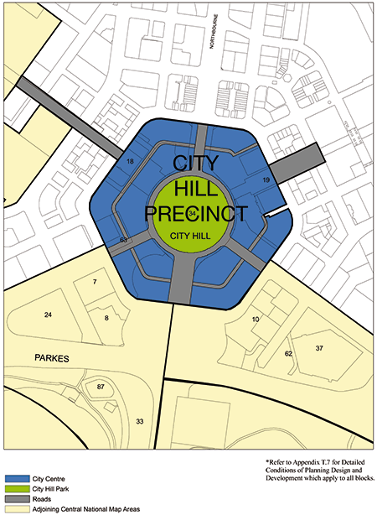

### Part Two Administration And Implementation

f) Amend the Plan to recognise the consequential changes of Draft Amendment 59   
to page numbers, section titles and the contents page.

## Appendices

g) Delete Appendix S - City Sections 10(Part), 37 and 62 DETAILED CONDITIONS OF PLANNING DESIGN AND DEVELOPMENT.

### Appendix T – MASTER PLANS – DETAILED CONDITIONS OF PLANNING DESIGN AND DEVELOPMENT

h) After Appendix T.6 add the following Appendix:

## Appendix T.7: City Hill Precinct

T.7 City Hill Precinct – Detailed Conditions of Planning, Design and Development and associated Urban Design Guidelines. These are the principles agreed to by Canberra Central Taskforce.

### City Hill Park as a central open space

City Hill Park should be retained and enhanced as an enclosed central park serving a functional role within an urban built form.

The topography of City Hill Park may need to be modified to create an urban park, accommodate pedestrian desire lines and integrate with Vernon Circle.

City Hill Park is the primary public space for the Precinct. Any buildings located on City Hill Park must be ancillary to this purpose and be designed, sited and of a scale that complements the landscape character.

New public spaces created within the Precinct must complement and not diminish the pre-eminence of City Hill Park.

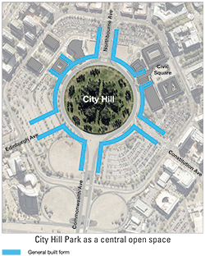

### Land Use

Mixed land uses should be encouraged throughout the City Hill Precinct while allowing flexibility to respond to market demand.

Prime sites within the City Hill Precinct should be identified for the Legislative Assembly and Supreme Court buildings and other municipal and cultural uses. If the Supreme Court and Legislative Assembly buildings are to be located adjacent to City Hill Park, they should have their main address in and active frontages to Vernon Circle.

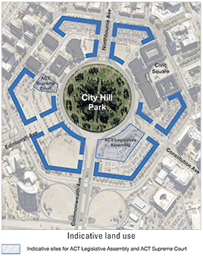

### Avenue Connections and Vistas

Southbound traffic should be discouraged from using Northbourne Avenue along its length to reduce reliance on Northbourne and Commonwealth Avenues as the main north-south arterial route.

The intersection of Commonwealth Avenue and London Circuit should be redesigned to encourage the diversion of northbound traffic onto London Circuit and improve pedestrian access and safety.

New road connections to Vernon Circle should be created from Constitution and Edinburgh Avenues, providing access for local traffic and pedestrians, with arterial traffic discouraged at the existing London Circuit intersections.

View corridors must be retained from radiating avenues to City Hill Park. No buildings should bridge these avenues.

Buildings on the avenues must have predominantly active frontages at ground floor.

Use a limited palette of high-quality pedestrian pavement materials, street furniture and lighting. Pavement and landscape design should have an elegant, simple and bold design emphasising the geometry and formality of the main avenues.

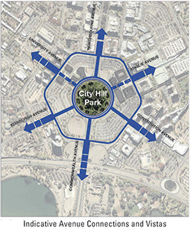

### Vernon Circle

Vernon Circle should be a low-speed urban street with a careful blend of through and local traffic, giving priority to pedestrians and providing access to City Hill Park.

Vernon Circle should be redesigned as an urban ‘circle’ rather than a through route.

Vernon Circle must continue to serve as a ceremonial road to Parliament House and for public events for the city of Canberra.

New buildings should address Vernon Circle, have zero setbacks and must have active frontages.

Over time, the existing major cultural and municipal buildings adjacent to City Hill Park (and extensions to them) could be reconfigured to address Vernon Circle.

Landscape and streetscape treatments are to be of a high quality and scale commensurate with a low-speed urban street.

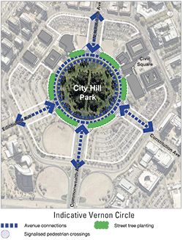

### London Circuit

London Circuit should be an urban boulevard operating as the main public transport circuit for Canberra Central.

Buildings must be set back from London Circuit a sufficient distance to establish a tree-lined boulevard character (two rows of trees and wide pavements).

New buildings fronting London Circuit must have active frontages.

London Circuit should serve as the main connector between Northbourne and Commonwealth Avenues, but should be discouraged as a through route.

London Circuit should serve as a gateway, providing a transition between the grand scale boulevard character of the avenues and the intimate local urban scale of the inner City Hill Precinct. The transition should be achieved through the use of urban design and traffic engineering treatments that serve to physically and psychologically divert traffic from the avenues onto London Circuit, thereby limiting access to the inner City Hill Precinct to predominantly local traffic.

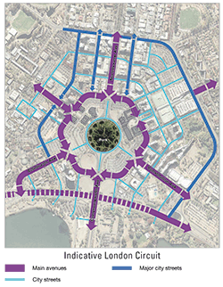

### Building Form, Height and Landmark Buildings

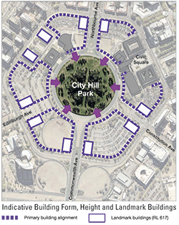Tall landmark buildings up to RL 617 (generally 14–18 storeys) are restricted to the corners of the main avenues intersecting with London Circuit.

Buildings above 25 metres in height are to be the subject of wind testing, including down draught conditions and turbulence, to ensure development does not have adverse impacts on building entrances and the public domain.

Building heights up to 25 metres (generally six to eight storeys) above adjacent kerb levels of London Circuit, Vernon Circle and Northbourne, Edinburgh, Constitution and Commonwealth Avenues are permissible in all areas of City Hill Precinct with a minimum of 16 metres (equivalent to four storeys) desirable fronting Vernon Circle to create a sense of enclosure around City Hill Park.

Minor building elements that extend building height above 25 metres will be considered where this enhances the architectural quality of the building and fosters energy efficiency, indoor amenity and appropriate urban scale.

Height controls will be determined on a site-by-site basis to achieve performance objects such as:

• Maintaining sunlight access to City Hill Park and major pedestrian areas;

• Achieving landmark public buildings, whether through height, siting, form or setting; and

• Addressing the heritage values of the Sydney and Melbourne Buildings.

Streetscape design guidelines must encourage modulation, tactility, silhouette and human scale in relation to the built form.

Subdivision patterns should be designed to minimise amalgamation of land, achieving a mix of development scales including fine urban grain.

New buildings are encouraged to be delivered through design competitions in order to encourage innovation and design excellence.

Indicative development plans are to be prepared for land between each main avenue, Vernon Circle and London Circuit as part of a development application.

New development should exemplify sustainability principles and demonstrate excellence in urban design, landscape and architecture.

Building design, layout and construction should take account of the impacts of noise on surrounding uses.

Unique paving and public place treatments should be introduced into Vernon Circle to provide City Hill Precinct with an appropriate identity for ceremonial and municipal connections with the Parliamentary Zone.

Public art and art spaces in new development should be encouraged.

### Indicative TrafficTraffic

Major modifications to the existing traffic management are dependent upon the continuing implementation of peripheral parkways and city bypass routes including Gungahlin Drive, Majura Parkway, Clunies Ross Street, Fairbairn Avenue, Marcus Clarke Street and Cooyong/Ballumbir Streets and the removal of the Parkes Way cloverleaves.

Traffic engineering devices (e.g. slip lanes) should be designed to promote pedestrian amenity, safety and access and bicycle movements.

### Indicative ParkingParking

Public car parking that is available at all hours must be provided on street as well as in appropriately designed structures that do not dominate the public domain.

Replacement of existing surface car parks and public car parking shall be provided for as identified in the ACT Government Parking Strategy.

Development of existing surface car parks will need to demonstrate that an adequate public car parking provision (on street or in appropriately designed structures) will meet the needs of City Hill Precinct.

Car parking for new development is to be accommodated in basements or in above ground structures that do not dominate the public domain.

### Public Transport

Redevelopment of the City Hill Precinct should take place in the context of an integrated public transport plan.

Mechanisms should be introduced to give priority to public transport.

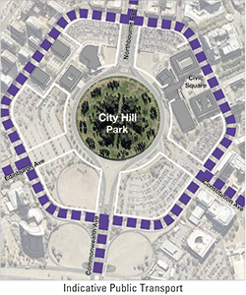

### Laneways

Existing laneways should be retained and new laneways created to provide permeability and create service access.

Opportunities should be identified to create laneways with active frontages, particularly in relation to heritage and public buildings and at intersections.

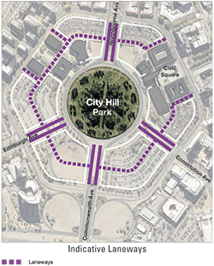

### Pedestrian and Bicycle links

New development, including public spaces, should facilitate pedestrian connectivity within the City Hill Precinct and between the City Hill Precinct and Canberra Central.

New development should facilitate bicycle movements between the City Hill Precinct and Canberra Central.

Indicative development: an aerial perspective looking northwest towards the Australian National University.

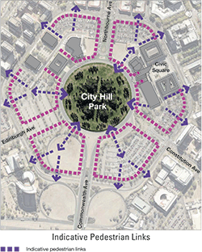

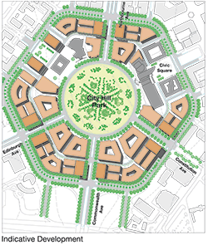

### Indicative Street Cross Section: Constitution Avenue to City Hill Park

### Indicative Street Cross Section: Constitution Avenu to City Hill Park

### Indicative Street Cross Section

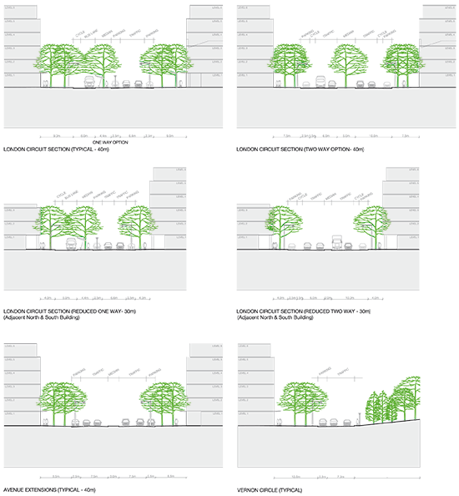

### Artist’s Impression of Vernon Circle

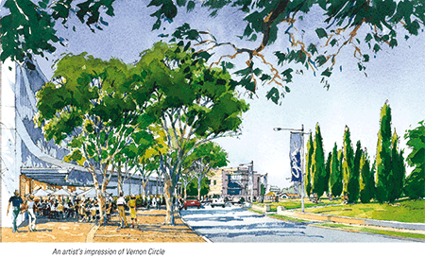

### Indicative development: an aerial perspective looking northwest towards the Australian National University

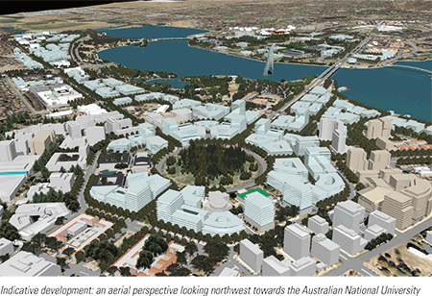

### An artist’s impression of City Hill Park looking towards the National Triangle

