

The Australian Capital Territory   
(Planning and Land Management) Act 1988

## National Capital Plan

Amendment 63 –

Molonglo and North Weston

September 2008

## NATIONAL CAPITAL PLAN AMENDMENT 63 –

Molonglo and North Weston

The National Capital Plan is amended by the following:

Introduction

Urban Development

a Delete paragraph four and replace with the following:

“The National Capital Plan provides for the continuation of urban development in the form of separate and distinct townships set in broad landscaped valleys, with the immediate hills and ridges providing separation between towns, and the distant mountains providing a natural landscape backdrop.”

General Policy Plan

b Amend Figure 1 the General Policy Plan with the following:

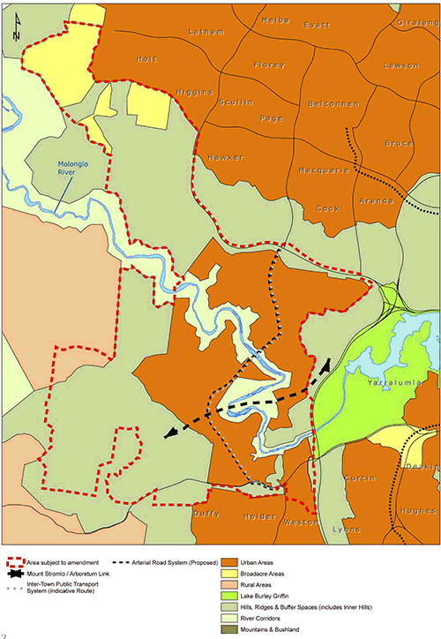

Designated Areas

c Amend Figure 3 Designated Areas with the following:

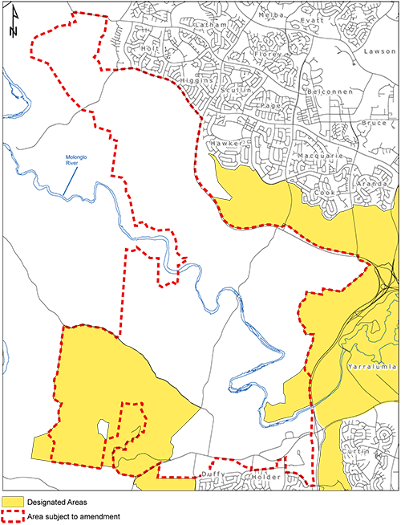

4 Urban Areas

Chapter 4 Urban Areas

d Delete paragraph three and replace with the following:

“The National Capital Plan therefore provides for the continuation of urban development in the Territory as separate and distinct towns set in broad landscaped valleys, with the immediate hills, ridges and other major open space providing separation between towns and the distant mountains providing a natural landscape backdrop.”

e Add to 4.1 Background a new dot point following the second dot point ‘the new town of Gungahlin’

Molonglo and North Weston

f Add to 4.4 Policies for Urban Areas a new dot point following the third dot point ‘the new town of Gungahlin’

Molonglo and North Weston

g Add to 4.4 Policies for Urban Areas a new clause (j) as follows:

“Any areas potentially affected by Scrivener Dam flood inundation may only be developed where it is demonstrated that Scrivener Dam meets flood safety and operational requirements, based on the applicable Australian National Committee on Large Dams (ANCOLD) guidelines.”

h Add to 4.4 Policies for Urban Areas a new clause (k) as follows:

“Planning of urban areas in Molonglo should make provision for a distinct, accessible and legible link, of a minimum width of seventy (70) metres between Stromlo Forest Park and Canberra International Arboretum and Gardens.”

8 National Capital Open Space System

Chapter 8 National Capital Open Space System

i Amend the existing Figures 24 and 25 Inner Hills with the following:

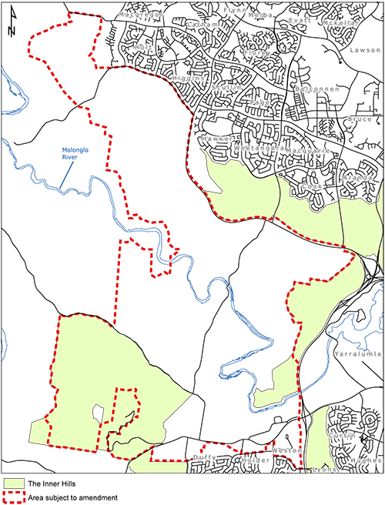

j Amend clause 8.5.3 (h) by adding the following:

Overnight Camping (Stromlo Forest Park only); and

Tourist Facility (Stromlo Forest Park only)

k Add to 8.6.3 Policies for River Corridors a new clause (i) as follows:

Development within the Molonglo River Corridor is to comply with all relevant principles and policies of Appendix F and any other relevant principle or policy of the Plan.

l Delete clause 8.6.4 Special Requirements for Murrumbidgee and Molonglo River Corridors (iii).

m Amend the existing Figure 27 Special Requirements with the following:

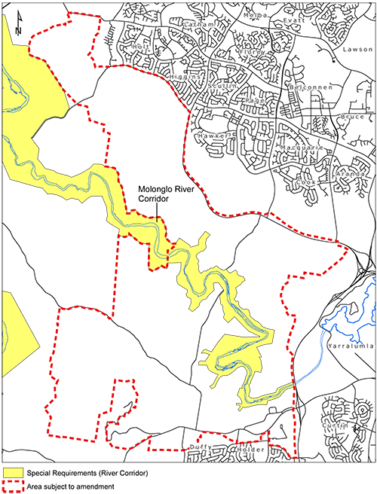

Appendix A: LAND USE DEFINITIONS

n Delete the land use definition of ‘Overnight Camping’ and replace with the following:

Overnight Camping

Land which is open to public use for holiday and recreational use of tents for overnight accommodation; the term includes any land together with any amenity building erected thereon which is used or intended for use in conjunction with such land.

o Delete the land use definition of ‘Tourist Facility’ and replace with the following:

Tourist Facility

The use of land for the purpose of providing entertainment, recreation, cultural or similar facilities for use mainly by the general touring or holidaying public. This may include a restaurant, café, bar, service station, tourist accommodation (including motel) and the retail sale of crafts, souvenirs, antiques and the like.

Appendix F:   
REQUIREMENTS FOR MURRUMBIDGEE RIVER CORRIDOR

p Amend Appendix F Requirements for Murrumbidgee River Corridor with Appendix F Requirements for Murrumbidgee and Molonglo River Corridors.

Part Two  
Administration and Implementation

q Amend the Plan to recognise consequential changes ofAmendment 63 to page numbers, section titles and contents page.