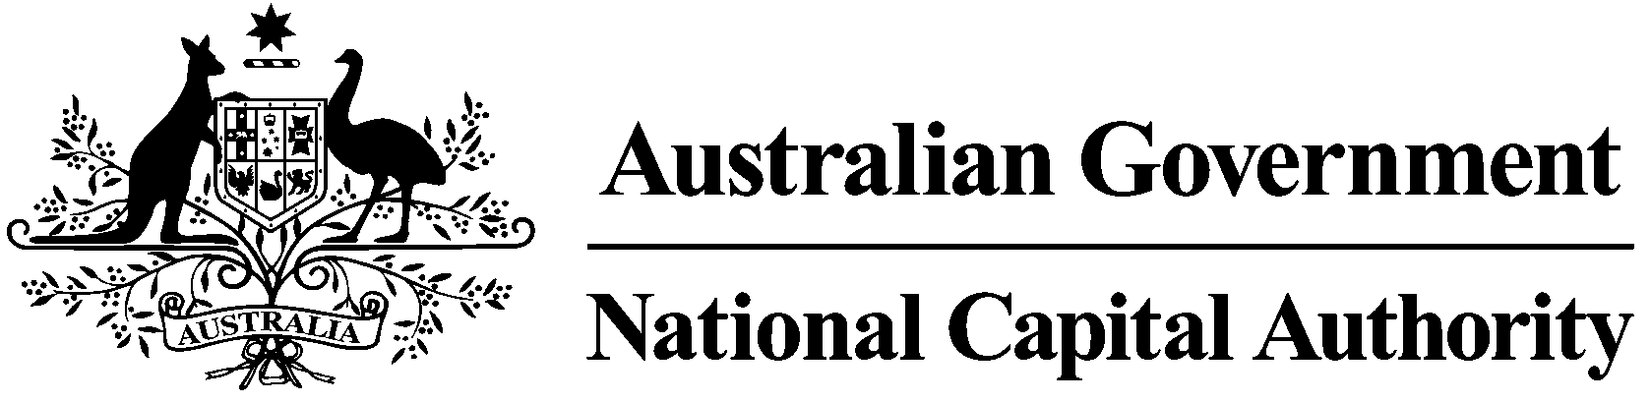

# REPORT ON CONSULTATION

# DRAFT AMENDMENT 79 REMOVAL OF WEST BASIN PEDESTRIAN BRIDGE

## FEBRUARY 2013

Contents

Contents 2

1 Introduction 3

1.1 Purpose and background 3

1.2 Existing National Capital Plan provisions 3

1.3 Effect of the Draft Amendment to the National Capital Plan 3

2 Consultation 3

3 Key issues 3

3.1 Bridge removal 3

3.2 Bridge retention 3

4 Recommended changes 3

5 Conclusion 3

6 Attachments 3

Attachment 1 – *Canberra Times* notice 3

Attachment 2 – Commonwealth Notices Gazette notice 3

Attachment 3 – Summary of submissions 3

# 1 Introduction

## Purpose and background

This report summarises the issues raised during the public consultation process undertaken by the National Capital Authority (NCA) on Draft Amendment 79 – Removal of West Basin Pedestrian Bridge (DA79) to the National Capital Plan (the Plan).

The purpose of DA79 is to remove references to a pedestrian bridge connecting the Acton Peninsula to Lennox Gardens, Yarralumla across the West Basin of Lake Burley Griffin.

DA79 is in response to Immigration Bridge Australia’s (IBA) decision to use an alternate site for commemorative purposes.

In 2004, the NCA released *The Griffin Legacy: Canberra the Nation’s Capital in the 21st Century* (The Griffin Legacy). The Griffin Legacy included reference to a pedestrian bridge linking Acton Peninsula to Lennox Gardens, Yarralumla. The purpose of the bridge was to link the lakeside promenades and improve pedestrian access between attractions such as the National Museum of Australia (NMA) and national institutions located within the Parliamentary Zone.

In 2006, a number of amendments to the Plan were proposed through The Griffin Legacy. On 5 December 2006, the Plan was amended to include reference to the pedestrian bridge, together with design guidance for the West Basin of Lake Burley Griffin.

On 26 February 2009, the Joint Standing Committee on the National Capital and External Territories (JSCNCET) resolved to inquire into, and report on the IBA proposal. On 29 May 2009, the JSCNET tabled its inquiry report. The report included recommendation that IBA seek to reconcile competing issues relating to Lake users, vista and heritage value of the lake and its foreshores. Further to this, if these issues could not be resolved the IBA consider changing the location of the proposed bridge, or proposing an alternative memorial to migration.

On 9 December 2009, bridge proponents advised the NCA that they no longer wished to pursue the construction of a bridge, and were seeking an alternative site for an immigration monument.

On 10 August 2012, the Authority agreed to draft an amendment removing provision for a pedestrian bridge from Acton to Lennox Gardens from the Plan.

## Existing National Capital Plan provisions

Appendix T9 of the Plan currently refers to the pedestrian bridge and states that national attractions are to be linked:

*… with a continuous pedestrian network, including a high-span pedestrian bridge connecting the National Museum and the Parliamentary Zone.*

The pedestrian bridge is also depicted in the diagrams on the following pages:

* T7:16 Indicative Development: an aerial perspective looking northwest towards the National Triangle
* T7:17 An artist’s impression of City Hill Park looking towards the National Triangle
* T9:7 Indicative Waterfront Promenade
* T9:8 Indicative Cycleways and Ferry
* T9:14 Indicative Development
* T9:15 West Basin – Extending the city to the lake and waterfront promenade’ West Basin 'artist's impression

## Effect of the Draft Amendment to the National Capital Plan

The proposed amendments to the Plan will:

* Remove references to a pedestrian bridge crossing West Basin from Acton Peninsula to the Parliamentary Zone.
* Require any future proposals for a pedestrian bridge across Lake Burley Griffin to be subject to detailed consideration.

# Consultation

On Saturday 3 November 2012, the NCA released DA79 for public comment and a notice was published in *The Canberra Times* on that day (Attachment 1). On Wednesday 7 November 2012, a notice was published in the *Commonwealth Notices Gazette* (Attachment 2). A media release was provided to national media outlets advising DA79 was open for public comment.

In accordance with the NCA’s ‘Commitment to Community Engagement (August 2011)’ the period for public comment ran for 30 business days, concluding on 14 December 2012. Hard copies of DA79 were made available to the public at the National Capital Exhibition, as well as the NCA offices. In addition, DA79 and supporting documentation was available on the NCA’s ‘Have Your Say’ website.

Key activities during the consultation period of DA79 included:

* On 1 November 2012, a request for an exemption to undertake a Regulation Impact Statement was sought from the Office of Best Practice Regulation.
* On 7 November 2012, the NCA held a public information session at the NCA offices. In addition to one representative of the NCA, two people attended the session.
* On 14 November 2012, the NCA referred DA79 to the following stakeholders:
  + ACT Government Environment and Sustainable Development Directorate.
* On 29 November 2012, the Office of Best Practice Regulation advised no Regulation Impact Statement would be required for DA79.
* On 30 November 2012, the Environment and Sustainable Development Directorate provided a response to the draft amendment. There was no objection to DA79 proceeding.

# Key issues

The NCA received seven written submissions in response to DA79. All submissions were acknowledged by the NCA.

A summary of the key issues raised during the public consultation process (both in written submissions, and verbally at the public information session) and the NCA’s response is outlined below. A summary of each submission is included in Attachment 3 together with a detailed NCA response.

## Bridge removal

**Issues**

Four submissions supported references to the bridge being removed for the following reasons:

* support removal due to the adverse visual impact on Lake Burley Griffin and impact on water activities
* removal is positive due to findings of the JSCNCET 2009 Inquiry into Immigration Bridge and due to opposition expressed by the community.

**NCA response**

The above comments have been acknowledged. No change to DA79 is recommended.

## Bridge retention

**Issues**

Three submissions did not support the removal of bridge references for the following reasons:

* would have been a useful link for cyclists riding on the Belconnen-Parkes axis and provide a shorter alternative to using Commonwealth Avenue Bridge
* would assist with parking issues at the National Museum of Australia
* would provide a useful connection between the National Museum and other national institutions in the Parliamentary Zone. An improved design could have potentially alleviated lake users’ concerns.

**NCA response**

The above comments have been acknowledged, however given the history, JSCNCET Inquiry findings and public opposition to a pedestrian bridge in this location, no changes to DA79 are recommended.

# Recommended changes

No changes to DA79, as released for public consultation, are recommended.

# Conclusion

On 3 November 2012, DA79 was released for public consultation. The public consultation period ran for six weeks in accordance with the NCA’s ‘Commitment to Community Engagement (August 2011)’, concluding on 14 December 2012.

Seven written submissions were received in response to DA79. In response to these submissions, no changes have been recommended to DA79.

# Attachments

1. Notice of release of Draft Amendment 79 for public comment published in *The Canberra Times*.
2. Notice of release of Draft Amendment 79 for public comment published in the *Commonwealth Notices Gazette*.
3. Summary of submissions and NCA response.

### Attachment 1 – Canberra Times notice

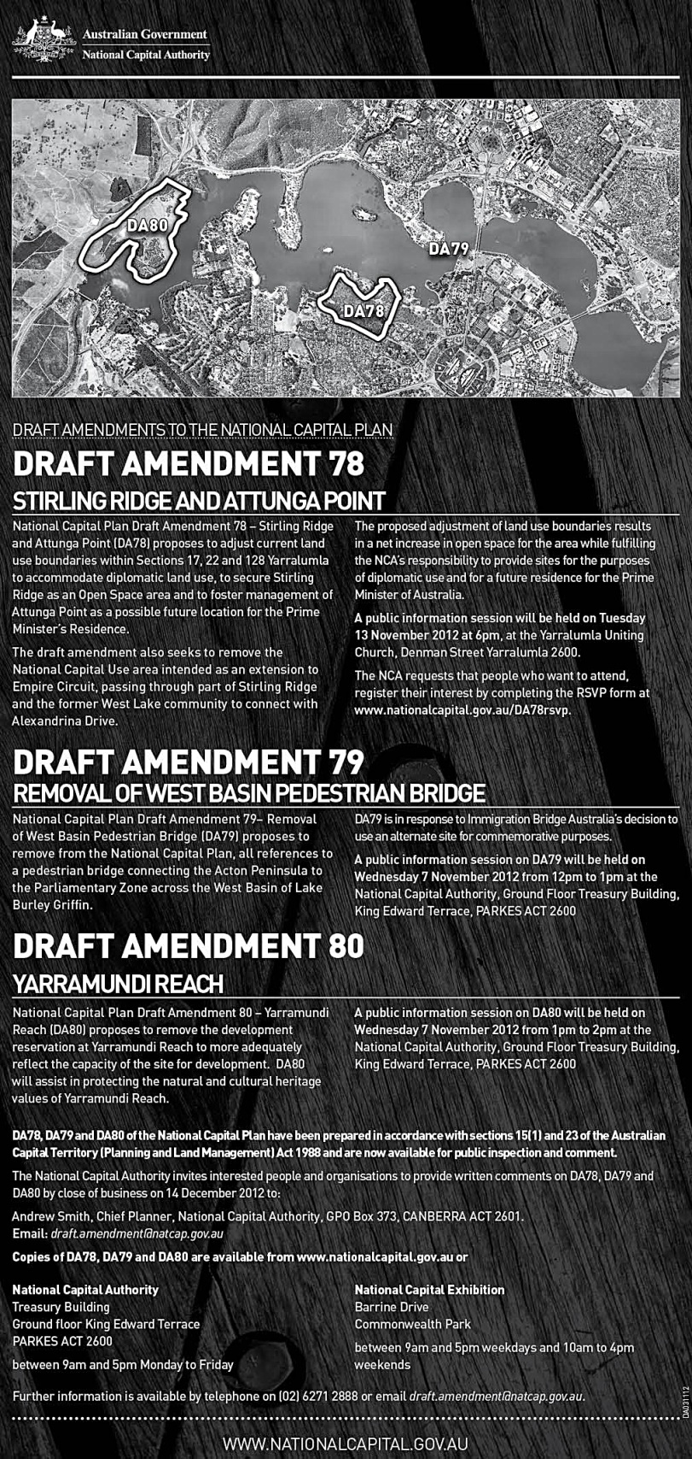Attachment 2 – Commonwealth Notices Gazette notice

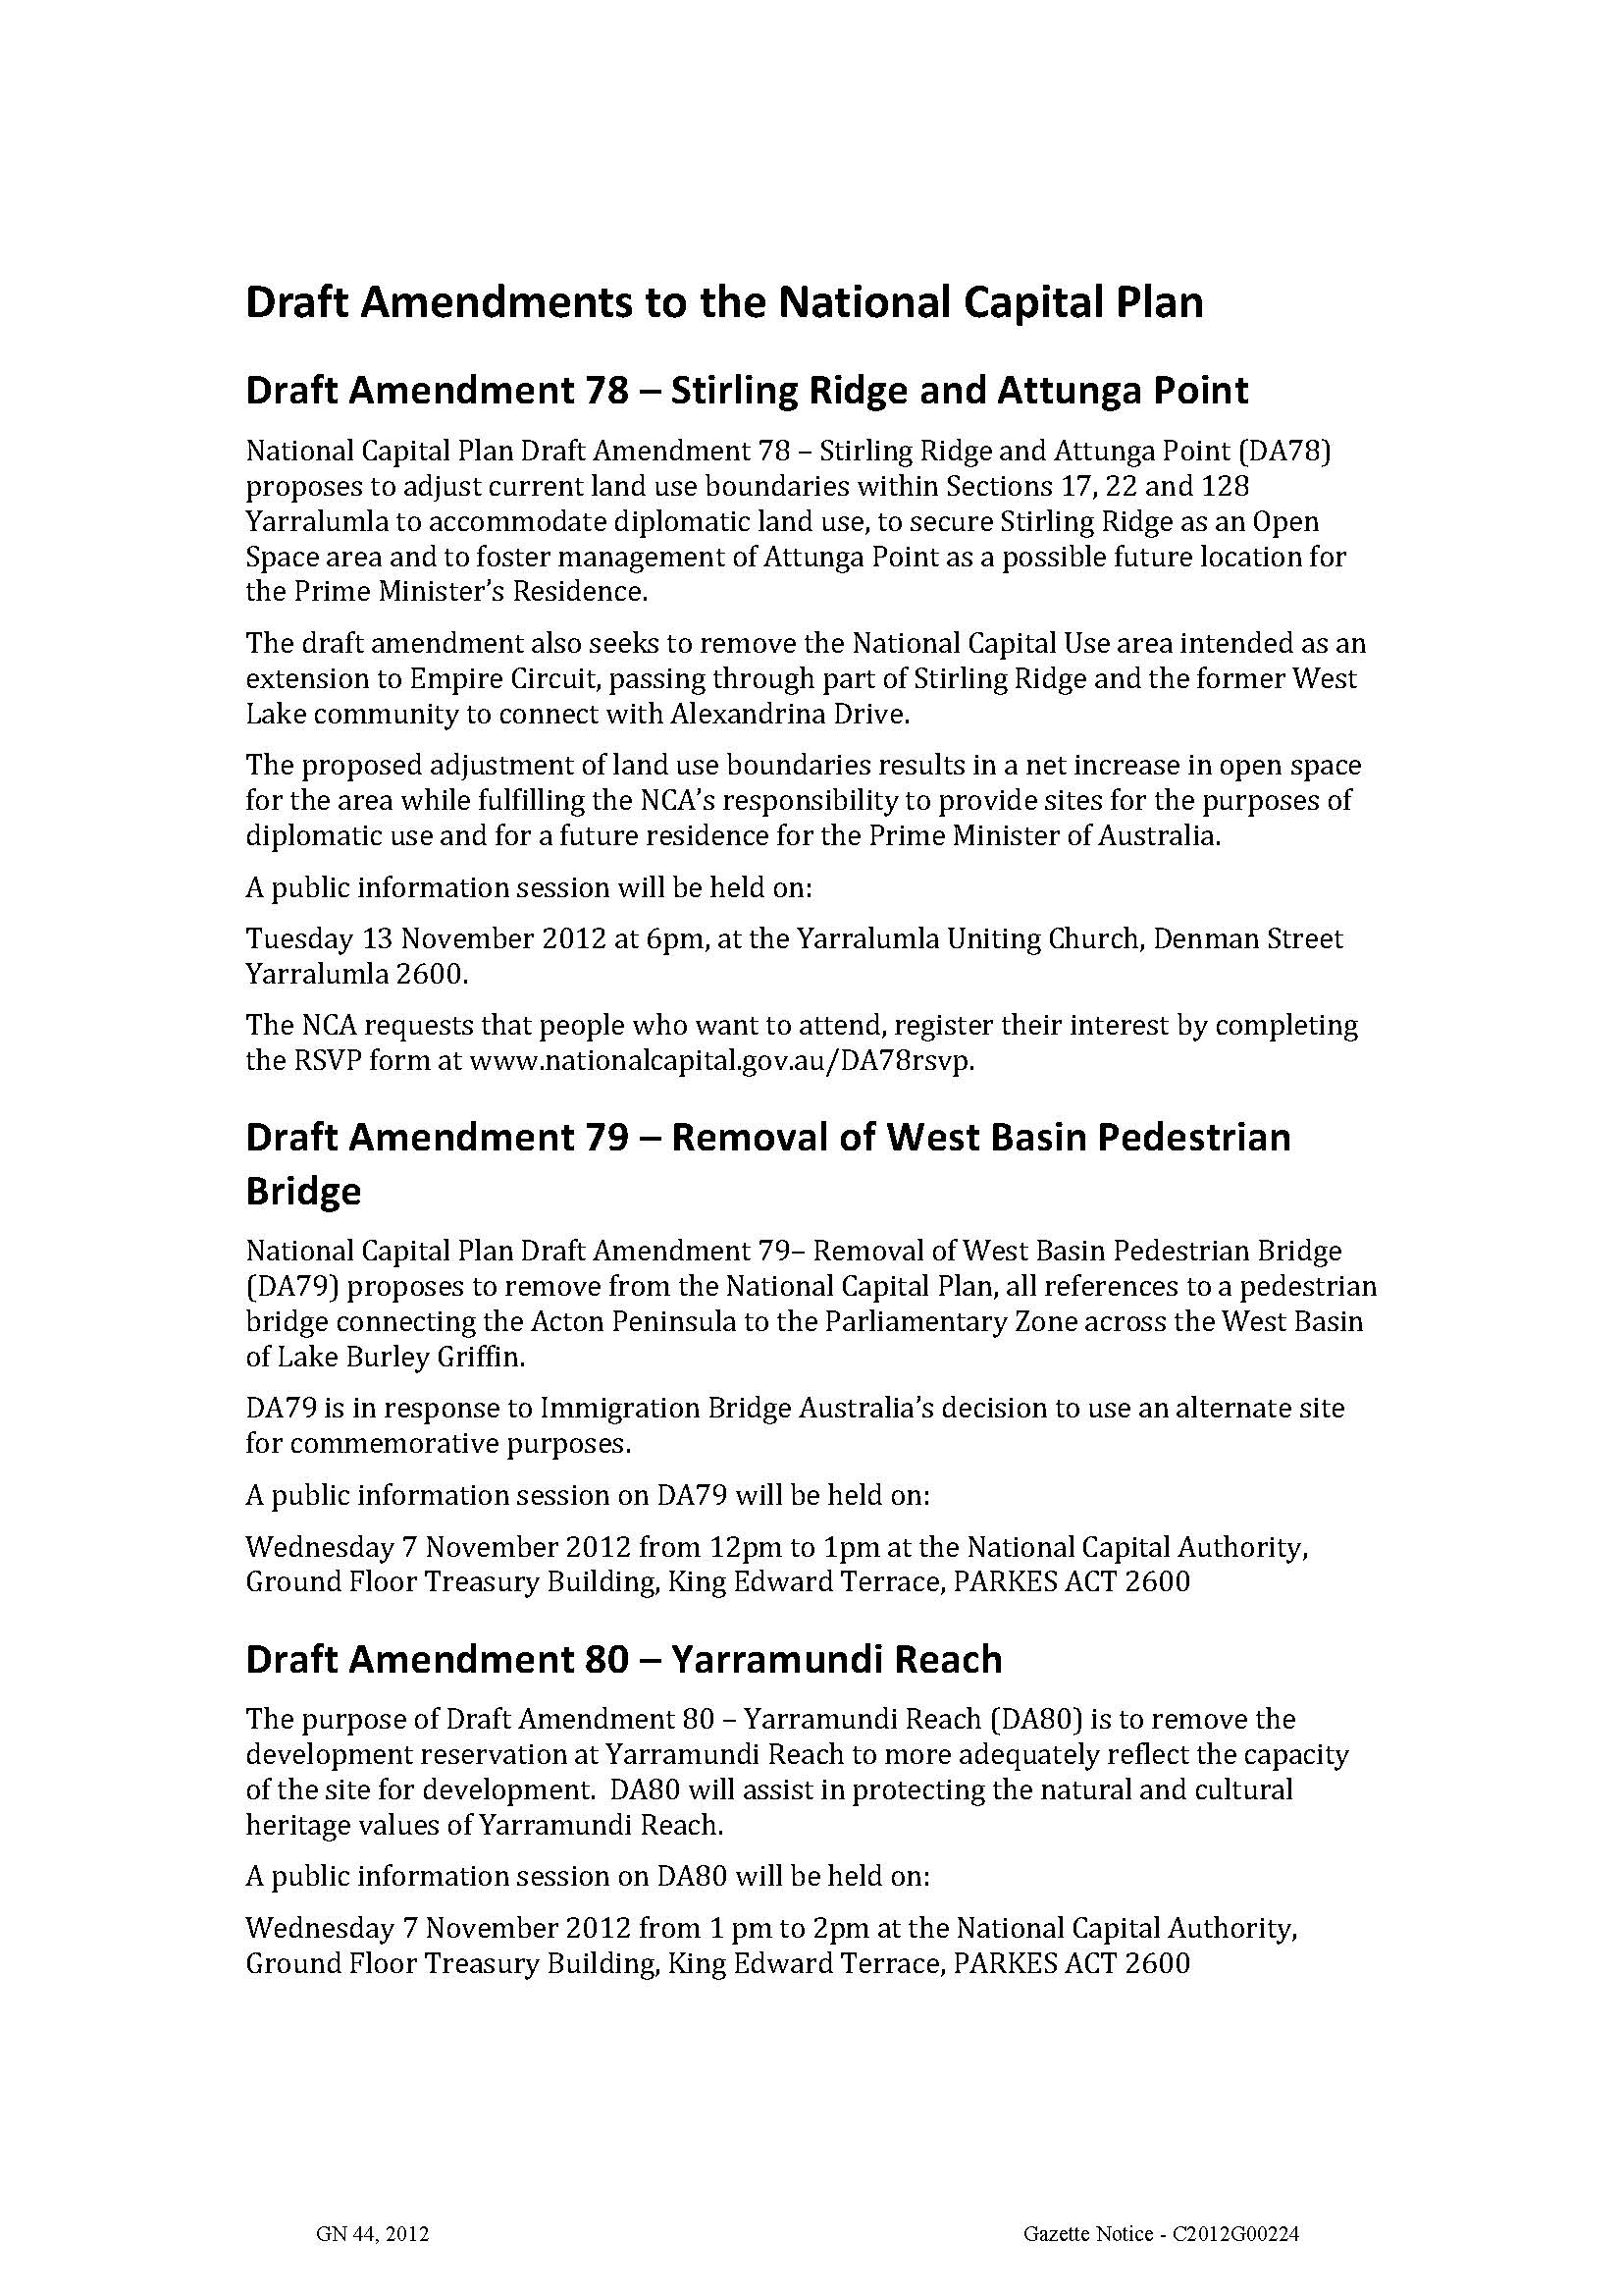

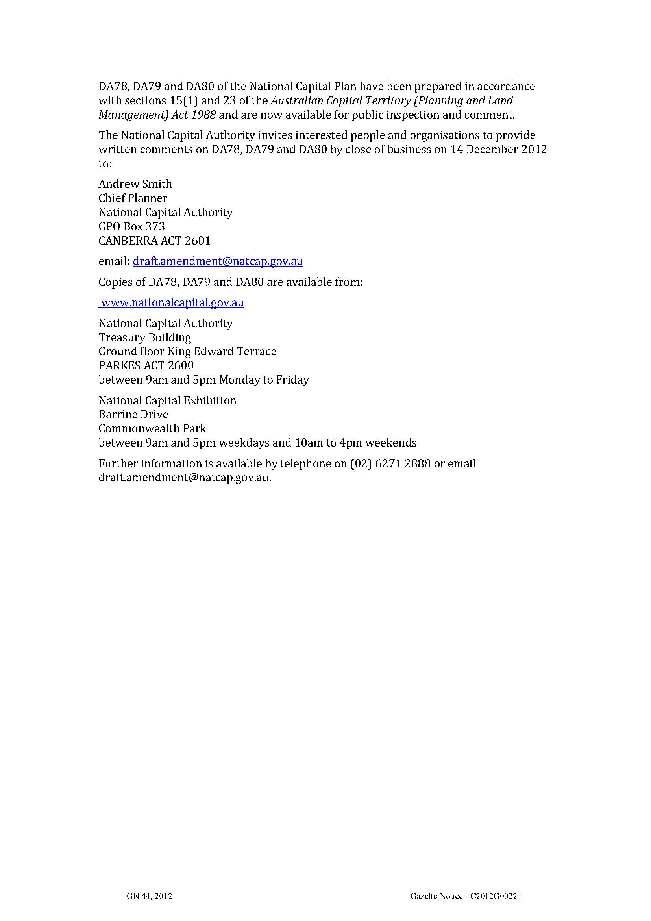

### Attachment 3 – Summary of submissions

Note: Details of each submitter have only been reproduced in this table where a submitter has granted permission for their name and/or address to be used by the National Capital Authority for the purposes of the Report on Consultation for Draft Amendment 79.

|  |  |  |  |
| --- | --- | --- | --- |
| **No.** | **Details of submitter** | **Key points raised in submission** | **NCA consideration** |
| **1** | Environment and Sustainable Development Directorate (ESDD) on behalf of ACT Government. | The Environment and Sustainable Development Directorate (ESDD) advised that it supports DA79 and has no comments to make. | Noted. |
| **2** | Miller (Twitter) | Pedestrian/cycle bridge should still be considered given the parking issues at the National Museum of Australia. | Noted. |
| **3** | Undisclosed | Against removal of bridge in principle as it would have provided a useful connection between the National Museum and other national institutions in the Parliamentary Zone. An improved design could have potentially alleviated lake users’ concerns. | Noted. |
| **4** | Undisclosed | Against removal as would have provided a useful link for cyclists riding on the Belconnen-Parkes axis, as a shorter alternative to Commonwealth Avenue. | Noted. |
| **5** | Undisclosed | Supports references to bridge being removed, given the adverse impacts any bridge would have on the visual amenity of Lake Burley Griffin and on water activities. | Noted. |
| **6** | Friends of Albert Hall | Deletion of references to pedestrian bridge a positive response to the 2009 Inquiry by JSCNCET. Supportive of DA79. | Noted. |
| **7** | Undisclosed | Supports removal of all references to a pedestrian bridge across Lake Burley Griffin. | Noted. |