

**REPORT ON CONSULTATION**

**DRAFT AMENDMENT 76 – POLICY 4.4(d) FOR URBAN AREAS**

# AUGUST 2012 Contents

Introduction 3

1.1 Purpose and background 3

1.2 Existing National Capital Plan provisions 4

1.3 Effect of the Draft Amendment to the National Capital Plan 4

2 Consultation 4

3 Key issues 5

3.1 Protection of Urban Open Spaces 5

3.2 National Capital Open Space System 5

4 Recommended changes 6

5 Conclusion 6

6 Attachments 6

Attachment 1 – Canberra Times notice Attachment 2 – Commonwealth Notices Gazette notice 7

Attachment 2 – Commonwealth Notices Gazette notice 8

Attachment 3 – Summary of submissions 9

# Introduction

## Purpose and background

This report summarises the issues raised during the public consultation process undertaken by the National Capital Authority (NCA) on Draft Amendment 76 – Policy 4.4(d) for Urban Areas (DA76) to the National Capital Plan (the Plan).

The purpose of DA76 is to clarify the intent of Policy 4.4(d) for Urban Areas.

DA76 proposes to introduce a clear policy into the Plan to permit minor adjustments at the boundary of Urban Areas and other land use policy areas based on detailed design conducted by the ACT Government. The policy will continue to recognise the NCA’s interest and role in these matters, and the Territory will need to seek certification that their proposals are not inconsistent with the broader principles and policies of the Plan.

Policy 4.4(d) relates to the establishment of the boundary between Urban Areas and other land use categories in the General Policy Plan (**Figures 1 and 2 of the Plan**). The policy currently states:

*Except where boundaries are already* ***computed****, the detailed planning of urban development by the Territory planning authority will determine the boundary between Urban Areas and other land use categories. Before detailed plans are approved, certification shall be obtained from the National Capital Planning Authority that the proposals are not inconsistent with the National Capital Plan.*

The policy has been in effect since the formation of the Plan. It suggests that at the time of drafting, some boundaries had been ‘computed’ whilst others had not.

The policy appears to have been used during the early 1990’s as part of reviews of development and / or subdivision proposals in the Gungahlin district at the northern periphery of the city. The Gungahlin urban area was identified in the original General Policy Plan (Metropolitan Plan) for the National Capital.

The policy clearly offers some flexibility in regard to the establishment of the urban land boundary, however this flexibility is restrained by the statement ‘*Except where boundaries are already* ***computed***’. The determination of whether a boundary is computed is not described. The term ‘computed boundary’ is not defined in the Plan, the *Australian Capital Territory Planning and Land Management Act 1988 (Cth)*,nor the Territory Plan.

In April 2012, the ACT Government approached the NCA to amend the Plan to clarify the intent of Policy 4.4(d). The ACT Government proposed that the policy be amended using language that provides flexibility at a design detail level whilst still ensuring NCA engagement. In June 2012, the Authority agreed to prepare the amendment.

An amendment to Policy 4.4(d) for Urban Areas of the Plan will permit the ACT Government to determine the final boundary between Urban Areas and other land use categories whilst still ensuring NCA engagement.

## Existing National Capital Plan provisions

Policy 4.4(d) for Urban Areas currently states:

*Except where boundaries are already computed, the detailed planning of urban development by the Territory planning authority will determine the boundary between Urban Areas and other land use categories. Before detailed plans are approved, certification shall be obtained from the National Capital Planning Authority that the proposals are not inconsistent with the National Capital Plan.*

The Plan does not define the term ‘computed’ nor is there an agreed definition of the term. Therefore the point at which a boundary has been ‘computed’ is unclear.

## Effect of the Draft Amendment to the National Capital Plan

Amending Policy 4.4(d) is intended to:

* Reinstate the original intent of the policy by introducing language agreed by the NCA and ACT Government.
* Permit minor adjustments at the boundary of Urban Areas and other land use policy areas based on detailed design conducted by the ACT Government.
* Reduce the need to prepare minor amendments for land use policy changes between Urban Areas and other areas (where such a boundary variation is agreed by the NCA and where matters of National Significance are not of concern).

If approved, DA76 would not change or diminish the role of the Authority in finalising the boundaries of the Urban Areas. The Authority will continue to have an interest and role in these matters.

# Consultation

On Thursday 21 June 2012, the NCA released DA76 for public comment and a notice was published in *The Canberra Times* on that day (Attachment 1). On Wednesday 20 June 2012, a notice was published in the *Commonwealth Notices Gazette* (Attachment 2). A media release was provided to national media outlets advising DA76 was open for public comment.

In accordance with the NCA’s Commitment to Community Engagement (August 2011) the period for public comment ran for 30 business days, concluding on 2 August 2012. Hard copies of DA76 were made available to the public at the National Capital Exhibition, as well as the NCA offices. In addition, DA76 and supporting documentation was available on the NCA’s Have Your Say website.

Key activities during the consultation period of DA76 included:

* On 25 June 2012, the NCA referred DA76 to the following stakeholders:
  + ACT Government Environment and Sustainable Development Directorate
  + Friends of Grasslands (ACT)
  + Conservation Council - ACT Region
  + Walter Burley Griffin Society Inc:
  + Various community councils around Canberra.
* On 27 June 2012, a request for an exemption to undertake a Regulation Impact Statement was sought from the Office of Best Practice Regulation.
* On 29 June 2012, the Office of Best Practice Regulation advised no Regulation Impact Statement would be required for DA76.
* On 27 June 2012, the NCA held a public information session at the NCA offices. One member of the public attended the session, in addition to two representatives of the NCA.
* On 31 July 2012, the Environment and Sustainable Development Directorate provided a response to the draft amendment. There was no objection to DA76 proceeding.

# Key issues

The NCA received two written submissions in response to DA76. All submissions were acknowledged by the NCA.

A summary of the key issues raised during the public consultation process (both in written submissions, and verbally at the public information session) and the NCA’s response is outlined below. A summary of each submission is included in Attachment 3, together with a detailed NCA response.

## Protection of Urban Open Spaces

### Issues

At the public information session, a member of the public criticised DA76 for not protecting the open spaces already within the ‘Urban Areas’ of the General Policy Plan.

### NCA response

The General Policy Plan is a broad strategic planning framework for the entire ACT. The detailed land use for urban open spaces is set out in the Plan (Designated Areas) and the Territory Plan (Non-Designated Territory Land). DA76 will not alter the relationship between the current suburban areas and current urban park systems.

No changes are DA76 is recommended.

## National Capital Open Space System

### Issues

At the public information session, a member of the public suggested that the integrity of the National Capital Open Space System could be compromised by allowing the ACT Government, as developer, to pick the urban boundary. They claim could cause overall loss and degradation of the quality of open spaces in the ACT.

### NCA response

The NCA will still be required to be engaged by the ACT Government prior to any change in boundary can occur. The ACT Government will need to provide sufficient evidence that the proposed change is not inconsistent with the Plan or undermine matters of National Significance.

No changes to DA76 are recommended.

# Recommended changes

No changes to DA76, as released for public consultation, are recommended.

# Conclusion

On 21 June 2012, DA76 was released for public consultation. The public consultation period ran for 30 business days in accordance with the NCA’s Commitment to Community Engagement (August 2011) and concluded on 2 August 2012.

Two written submissions were received in response to DA76. In response to submissions, no changes have been recommended to DA76.

# Attachments

1. Notice of release of Draft Amendment 76 for public comment published in *The Canberra Times*.
2. Notice of release of Draft Amendment 76 for public comment published in the *Commonwealth Notices Gazette*.
3. Summary of submissions and NCA response.

### Attachment 1 – Canberra Times notice Attachment 1 – Canberra Times notice Attachment 2 – Commonwealth Notices Gazette notice

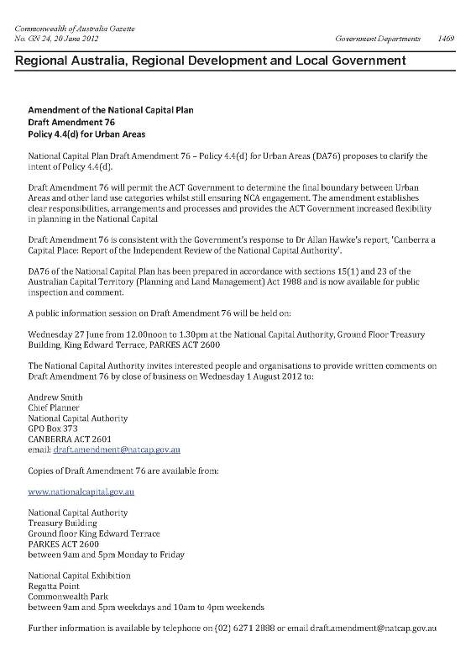

### Attachment 3 – Summary of submissions

Note: Details of each submitter have only been reproduced in this table where a submitter has granted permission for their name and/or address to be used by the National Capital Authority for the purposes of the Report on Consultation for Draft Amendment 76.

|  |  |  |  |
| --- | --- | --- | --- |
| **No.** | **Details of submitter** | **Key points raised in submission** | **NCA consideration** |
| **1** | Surveyor-General of the ACT  PO Box 1908  Canberra ACT 2601 | Agrees that the approach to remove the term ‘computed boundary’ is appropriate. | Noted. |
| Considers the reference to boundaries aligned to ‘existing leasehold’ is unambiguous and these boundaries are certainly ‘computed’ as understood by the surveying profession.  The proposed changes proposed are consistent with earlier advice provided to the NCA. | Agreed and noted. |
| **2** | Environment and Sustainable Development Directorate (ESDD) on behalf of ACT Government. | The Environment and Sustainable Development Directorate (ESDD) advised that it supports DA76 and has no comments to make. | Noted. |