

**CONSULTATION REPORT**

**DRAFT AMENDMENT 87**

**Relocation of Indicative Sites for Landmark Buildings (Knowles Place)**

December 2016

**Table of** Contents

1 Introduction 3

1.1 Purpose and background 3

1.2 Existing National Capital Plan provisions 3

1.3 Effect of the Draft Amendment to the National Capital Plan 3

2 Consultation 4

3 Key issue 5

4 Recommended changes 5

5 Conclusion 5

6 Attachments 5

Attachment 1 – Canberra Times notice 6

Attachment 3 – Media Release 8

Attachment 4 – Summary of submissions 9

# 1 Introduction

## Purpose and background

The National Capital Plan (the Plan) sets out general planning policies and principles for overall development of the Australian Capital Territory. One of the functions of the National Capital Authority (NCA) is to keep the Plan under constant review and propose amendments to it when necessary.

This report summarises the issues raised during the public consultation process undertaken by the NCA on Draft Amendment 87 – Relocation of Indicative Sites for Landmark Buildings (Knowles place) (DA87) to the Plan.

DA87 proposes to relocate the areas identified for landmark buildings adjacent to Knowles Place, from Blocks 1 and 4 Section 18 City, to Blocks 9 and 13 Section 63 City, and Block 21 Section 63 City respectively.

Agreement to the preparation of a draft amendment was in recognition that the sites currently identified for landmark buildings form part of the ACT Law Courts Precinct and have been nominated for Provisional Registration to the ACT Heritage Register. Heritage registration will restrict development capacity on these sites and therefore the potential to achieve the desired outcomes for the City Hill Precinct.

## Existing National Capital Plan provisions

Figure 40 in the Plan shows the location of indicative sites for landmark buildings around the City Hill Precinct. These sites are located at the corners of the main avenues intersecting with London Circuit and buildings on these sites may be built to a height of RL617 (generally 14 to 18 storeys). Indicative landmark building sites include the blocks that the Reserve Bank of Australia and City Police Station sit on (Blocks 1 and 4 Section 18 City).

## Effect of the Draft Amendment to the National Capital Plan

The proposed amendment to the Plan will relocate the areas identified for landmark buildings adjacent to Knowles Place, from Blocks 1 and 4 Section 18 City, to Blocks 9 and 13 Section 63 City, and Block 21 Section 63 City respectively.The new sites are currently surface carparks.

# Consultation

On 15 October 2016, DA87 was released for public comment. A public notice was published in *The Canberra Times* on this day (Attachment 1). On 18 October 2016, a notice was published in the *Commonwealth Notices Gazette* (Attachment 2).

In accordance with the NCA’s ‘Commitment to Community Engagement (August 2015)’ the period for public comment ran for 30 business days, concluding on 25 November 2016. DA87 was available on the NCA’s website, and hard copies were available on request.

Key activities during the consultation period for DA87 included:

* On 24 October 2016, the NCA referred DA87 to the following stakeholders:
  + ACT Government Environment and Sustainable Development Directorate (ESDD)
  + North Canberra Community Council
  + Lake Burley Griffin Guardians
  + Planning Institute of Australia
  + Local businesses.
* On 24 October 2016, the NCA held a joint public information session with the ACT at the NCA offices. One member of the public attended the session.
* On 24 October 2016, a request for an exemption to undertake a Regulation Impact Statement was sought from the Office of Best Practice Regulation (OBPR).
* On 27 October 2016, the OBPR advised no Regulation Impact Statement would be required for DA87.
* On 17 November 2016, the ACT Government’s Environment, Planning and Sustainable Development Directorate (EPSDD) provided a response to the draft amendment. There was no objection to DA87 proceeding.

# Key issues

The NCA received one written submissions in response to DA87, from the ACT Government’s Environment, Planning and Sustainable Development Directorate. No major issues were raised, however the submission noted that:

*‘… the proposed locations for the landmark buildings are in high demand parking locations which requires further resolution as part of development on these sites’.*

Parking matters will be dealt with as the Estate Development Plan progresses and at the Works Approval stage.

The full submission is included in Attachment 4.

# Recommended changes

No changes to DA87, as released for public consultation, are recommended.

# Conclusion

On 15 October 2016, DA87 was released for public consultation. The public consultation period ran for six weeks in accordance with the NCA’s ‘Commitment to Community Engagement (August 2015)’, concluding on 25 November 2016.

One written submissions were received in response to DA87. No changes have been recommended to DA87.

# Attachments

1. Notice of release of Draft Amendment 87 for public comment published in *The Canberra Times*.
2. Notice of release of Draft Amendment 87 for public comment published in the *Commonwealth Notices Gazette*.
3. Summary of submissions and NCA response.

### Attachment 1 – Canberra Times notice

Attachment 2 – Commonwealth Notices Gazette notice

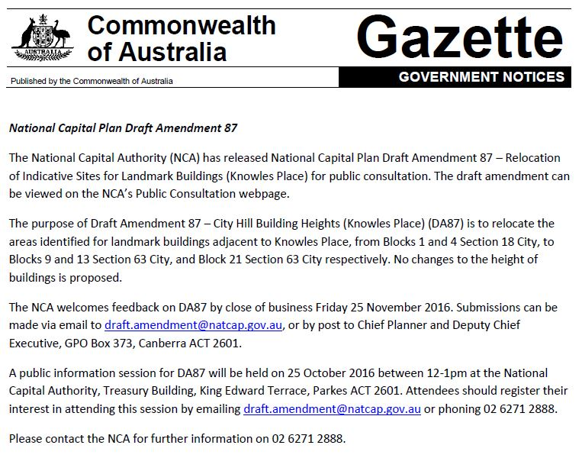

### Attachment 3 – Summary of submissions

Note: The National Capital Authority (NCA) undertakes an open and transparent process for amending the National Capital Plan. Draft Amendment documentation advised that the NCA would prepare a Consultation Report for publication on the NCA website, and that this Consultation Report would include a summary of each submission, along with the name of each person making the submission. Names of submitters have been omitted where a submitter requested confidentiality.

|  |  |  |  |
| --- | --- | --- | --- |
| **No.** | **Details of submitter** | **Key points raised in submission** | **NCA consideration** |
| **2** | 2nd submission  Environment and Sustainable Development Directorate (EPSDD) | * EPSDD supports the relocation of the indicative sites for landmark buildings proposed in the draft amendment and notes that this is consistent with the City Plan (2014) and preliminary directions of the draft City and Gateway Urban Renewal Strategy. * The sites identified for landmark building are generally unencumbered surface parking areas. These new locations are considered to provide significant development opportunity, suitable for landmark buildings that could positively contribute towards the city centre’s urban structure and desired high quality sustainable development outcomes. * EPSDD notes that the proposed location for the landmark buildings are in high demand parking locations which requires further resolution as part of development on these sites. | Noted. |