

**CONSULTATION REPORT**

**DRAFT AMENDMENT 75 – AUSTRALIAN DEFENCE FORCE ACADEMY AND ROYAL MILITARY COLLEGE DUNTROON MASTER PLAN**

June 2012

1.0 Introduction 3

1.1 Purpose and background 3

1.2 Existing National Capital Plan provisions 3

1.3 Effect of the Draft Amendment to the National Capital Plan 4

2.0 Consultation 4

3.0 Key issues 5

3.1 Environment 5

3.2 Heritage 6

4.0 Recommended changes 7

5.0 Conclusion 8

6.0 Attachments 8

# 1.0 Introduction

## 1.1 Purpose and background

This report summarises the issues raised during the public consultation process undertaken by the National Capital Authority (NCA) on Draft Amendment 75 – Australian Defence Force Academy and Royal Military College Duntroon Master Plan (DA75) to the National Capital Plan (the Plan).

The purpose of the draft Amendment is to replace the existing Master Plan for the Royal Military College Duntroon (RMC) with a Master Plan for both RMC and the Australian Defence Force Academy (ADFA). A new Master Plan for both sites will guide the future planning, design and development of RMC and ADFA as military training establishments.

The Plan requires the preparation of Master Plans for a number of major sites within the Central National Area, including RMC and ADFA. These Master Plans are incorporated into the Plan as detailed conditions of planning, design and development.

The RMC Master Plan, which forms Appendix T1 of the Plan, was incorporated into the Plan through Amendment 3 (approved on 6 July 1993). This Master Plan has guided the planning, design and development of RMC as a military training establishment. Although a Master Plan was prepared for ADFA in 1997, it was never incorporated into the Plan.

In response to an identified need to provide new facilities common to both institutions, and to explore opportunities for integrated use of resources, the Department of Defence (Defence) has prepared an integrated land use and development framework for both RMC and ADFA. The creation of one Master Plan for both sites is intended to facilitate an integrated and sustainable approach to their future use and development.

In November 2010 Defence requested that the NCA prepare an Amendment to the Plan to replace the existing RMC Master Plan at Appendix T1 of the Plan with an updated Master Plan for both RMC and ADFA. In December 2010 the NCA agreed to prepare the necessary amendment.

An amendment to T1 of the Plan offers an opportunity to secure a planning and design framework that will guide and provide a consistent approach to the development of both RMC and ADFA.

## Existing National Capital Plan provisions

RMC and ADFA are located within the Central National Area, as identified in Figure 13 The Central National Area (Duntroon, ADFA & Campbell Park) of the Plan. Figure 13 identifies the land use policy for the site as ‘Community Facility’.

The Plan requires the preparation of Master Plans for a number of major sites within the Central National Area, including both RMC and ADFA. The existing RMC Master Plan, which forms Appendix T1 of the Plan, was incorporated into the Plan through Amendment 3 (approved on 6 July 1993). Although a Master Plan was prepared for ADFA in 1997, it was never incorporated into the Plan.

The majority of the RMC and ADFA site is located within the Designated Areas of the Plan, and therefore the NCA has the detailed planning responsibility, including the approval of any works, for the site. The most north-eastern portion of the site is not currently within Designated Areas.

## Effect of the Draft Amendment to the National Capital Plan

The current land use policy of ADFA and RMC, identified as ‘Community Facility’ in Figure 13 The Central National Area (Duntroon, ADFA & Campbell Park) of the Plan, will be amended to more accurately reflect the use of the sites.

Designated Areas will be extended to cover the entirety of the RMC and ADFA sites. The NCA will then have the detailed planning responsibility (including the approval of works) for both sites.

The existing Master Plan for RMC at Appendix T1 of the Plan will be replaced with a Master Plan for both RMC and ADFA.

# Consultation

On Saturday 31 March 2012, the NCA released DA75 for public comment. A notice was published in *The Canberra Times* (Attachment 1) on that day. On Wednesday 4 April 2012, the same notice was published in the *Commonwealth Notices Gazette* (Attachment 2). A media release was provided to national media outlets, and a ‘tweet’ to NCA Twitter followers was sent advising the draft amendment was open for public consultation.

In accordance with the NCA’s Commitment to Community Engagement (August 2011) the period for public comment ran for 30 business days, concluding on 17 May 2012. Hard copies of DA75 were made available to the public at the National Capital Exhibition, as well as the NCA offices. In addition, DA75 and supporting documentation was available on the NCA’s Have Your Say website.

Key activities during the consultation period of DA75 included:

* On 23 April 2012, a request for an exemption to undertake a Regulation Impact Statement was sought from the Office of Best Practice Regulation.
* On 2 April 2012, the NCA referred DA75 to the following stakeholders:
  + ACT Government Environment and Sustainable Development Directorate
  + North Canberra Community Council
  + National Trust (ACT)
  + Campbell Neighbourhood Watch
  + Friends of Grasslands
  + Conservation Council ACT Region
  + Walter Burley Griffin Society Inc:
  + Campbell Residents’ Group.
* On 27 April 2012, the Office of Best Practice Regulation advised no Regulation Impact Statement would be required for DA75.
* On 11 April 2012, the NCA held a public information session at the NCA offices. Two members of public attended the session, in addition to representatives of the NCA and Defence.
* On 7 May 2012, the Environment and Sustainable Development Directorate provided a response to the draft amendment. While a number of further clarifications were raised, there was no objection to DA74 proceeding.

# Key issues

The NCA received four written submissions in response to DA75. All submissions were acknowledged by the NCA, together with an undertaking to inform the submitters of how the NCA considered their submissions.

A summary of the key issues raised during the public consultation process (both in written submissions, and verbally at the public information session and other meetings) and the NCA’s response is outlined below. A summary of each submission is included in Attachment 3, together with a detailed NCA response.

## 3.1 Environment

**Issues**

The ‘Future Development’ area identified on the Zone Map of the draft master plan contains an area of box-gum woodland and natural temperate grassland. Both the woodland and grassland are endangered ecosystems. The box-gum woodland is relatively small, however is contiguous to a larger area of woodland on Territory Land adjacent to the Defence site. The woodland area is important bird habitat, while the grassland provides important habitat for endangered species such as the southern lined earless dragon.

In addition to nationally listed threatened species, the natural temperate grassland is known habitat of the Perunga grasshopper. This species is listed as Vulnerable under the ACT’s *Nature Conservation Act 1980*.

It was suggested that the land use zoning of the Master Plan is inconsistent with the presence of significant grassland, woodland and habitat areas in the northern part of Block 550 (the ‘Future Development’ area). Figure 1 of the Master Plan identifies that this area is significantly constrained because of existing environmental values, however Figure 2 of the Master Plan identifies the area for ‘Future Development’. It was suggested that the area could be more appropriately identified for conservation purposes only or that the area be added to the adjoining ‘Open Space’ area.

**NCA response**

Endangered ecological communities are listed as a matter of national environmental significance under the *Environment Protection and Biodiversity Conservation Act* 1999 (EPBC Act). Under the EPBC Act, actions that have, or are likely to have, a significant impact on a matter of national environmental significance require approval from the Minister for Sustainability, Environment, Water, Population and Communities.

The draft amendment does not constitute a development application, and is not considered an action under the EPBC Act. Depending on the nature of future proposals in this area, Defence may be required to refer the proposed action to the Minister under the EPBC Act for assessment.

## Heritage

**Issues**

Four indigenous heritage sites have been identified on RMC. While these sites are not listed on the Commonwealth Heritage List, it was suggested that they should be assessed to determine whether they should be.

It was also suggested that the Master Plan should not be approved until such time as a heritage assessment of ADFA has been completed to determine if there are any places of heritage significance worthy of listing on the Commonwealth Heritage List. The constraints map within the Master Plan, and the list of heritage places under the ‘Heritage’ constraints section, would subsequently need to reflect anything arising from the ADFA heritage assessment.

It was recommended that General Bridges Grave (listed on the Commonwealth Heritage List) be included in the inventory of places in the ‘Heritage’ constraints section.

The detailed conditions of planning, design and development state that one of the objectives of the Master Plan is to conserve and manage significant natural and cultural heritage values. It was recommended that this objective be amended to acknowledge the need to conserve and manage indigenous heritage, in addition to natural and cultural heritage.

One submission advocated for additional controls in regard to the architectural character of development in proximity to heritage listed places.

**NCA response**

The assessment of sites for listing on the Commonwealth Heritage List is beyond the scope of the draft Amendment. Heritage places have protection through other mechanisms, and places that are included in the Commonwealth Heritage List are protected under the provisions of the EPBC Act. Should an assessment of ADFA, or any other place within RMC result in a listing in the CHL (or National Heritage List), adequate protections are in place. Depending on the nature and extent of any listing, an amendment to the Master Plan may be required to reflect the listing.

The constraints section identifies significant constraints to development. The RMC Duntroon Conservation Area has been included in this section as it covers a reasonably large area within RMC, and planning and development within an area of this size requires significant consideration and can be complex. The composition and size of General Bridges Grave is not considered to represent a significant constraint to development.

As noted above, heritage places also have protection through other mechanisms, and places that are included in the Commonwealth Heritage List (such as General Bridges Grave) are protected under the provisions of the EPBC Act.

It is considered that the importance of conserving and managing Indigenous heritage should be recognised, in additional to natural and cultural heritage. It is therefore recommended that the relevant objective of the detailed conditions of planning, design and development be amended to read as follows:

*To conserve and manage significant natural, cultural and Indigenous heritage.*

It is considered that the Master Plan could recognise the need for new development adjacent to heritage listed places to be sympathetic to the heritage values of that place.   
It is therefore recommended that an additional clause be added to the ‘Architectural Character’ section as follows:

*The articulation, material and colour of buildings shall be sympathetic to the heritage values of any adjacent heritage listed place.*

The proposed clause does not expressly require, nor prohibit, the use of particular materials or colours, but recognises that these building elements need to be sympathetic to the heritage values of adjacent heritage places.

## Lighting

**Issues**

Paragraph 7.1 of the draft amendment provides that *‘all outdoor lighting, including security and car park lighting, shall be designed and sited to minimise light pollution. Outdoor lighting shall use full cut-off light fitiings. Any uplighting of buildings should be carefully designed to keep night time overspill and glare to a minimum.’*

It was submitted that the subdued lighting which prevails in Canberra is critically important to the night-time amenity of the national capital, to night-time views and vistas, and to the sense of a city cradled in the natural landscape. It was considered that the NCA’s draft Outdoor Lighting Policy recognises this, and contains measures designed to limit night pollution.

It was considered that up-lighting will project light into the surrounding atmosphere no matter how carefully it is designed. It was suggested that DA75 should therefore prohibit all new up-lighting on the site, and instead should specify that building facades, if lit up at all, should be down-lit, not up-lit.

**NCA response**

The NCA’s draft Outdoor Lighting Policy contains the following design requirement: *‘use full cutoff light fittings for new building façade lighting installations, that are carefully integrated into the building’s structure.’*

It is recommended that this design requirement be replicated in the Master Plan to provide clarity on the intention for lighting of buildings, and to maintain consistency between the National Capital Plan and the Outdoor Lighting Policy. It is therefore recommended that clause 7.1 of the draft Amendment be amended to read as follows:

*All outdoor lighting, including security and car park lighting, shall be designed and sited to minimise light pollution. Outdoor lighting shall use full cutoff light fittings. New building façade lighting installations shall use full cutoff light fittings that are carefully integrated into the building’s structure.*

As ADFA and RMC are within Designated Areas under the National Capital Plan, other relevant policies, strategies and design requirements of the Outdoor Lighting Policy will be considered when assessing applications for works approval.

# Recommended changes

A total of three changes to DA75 as released for public consultation are proposed. These changes are in response to issues raised by interested parties during the public consultation process. The recommended changes are described in section 3.0 of this report.

# Conclusion

On 31 March 2012, DA75 was released for public consultation. The period for public comment ran for 30 business days in accordance with the NCA’s Commitment to Community Engagement (August 2011) and concluded on 17 May 2012.

Four written submissions were received in response to DA75. In response to submissions, three changes have been recommended to DA75. These changes provide greater recognition of the importance of the role of lighting, and of the range of heritage matters that will be considered as part of future planning and development of the site.

# Attachments

1. Notice of release of Draft Amendment 75 for public comment published in *The Canberra Times*.
2. Notice of release of Draft Amendment 75 for public comment published in the *Commonwealth Notices Gazette*.
3. Summary of submissions and NCA response.

### Attachment 1 – Canberra Times notice

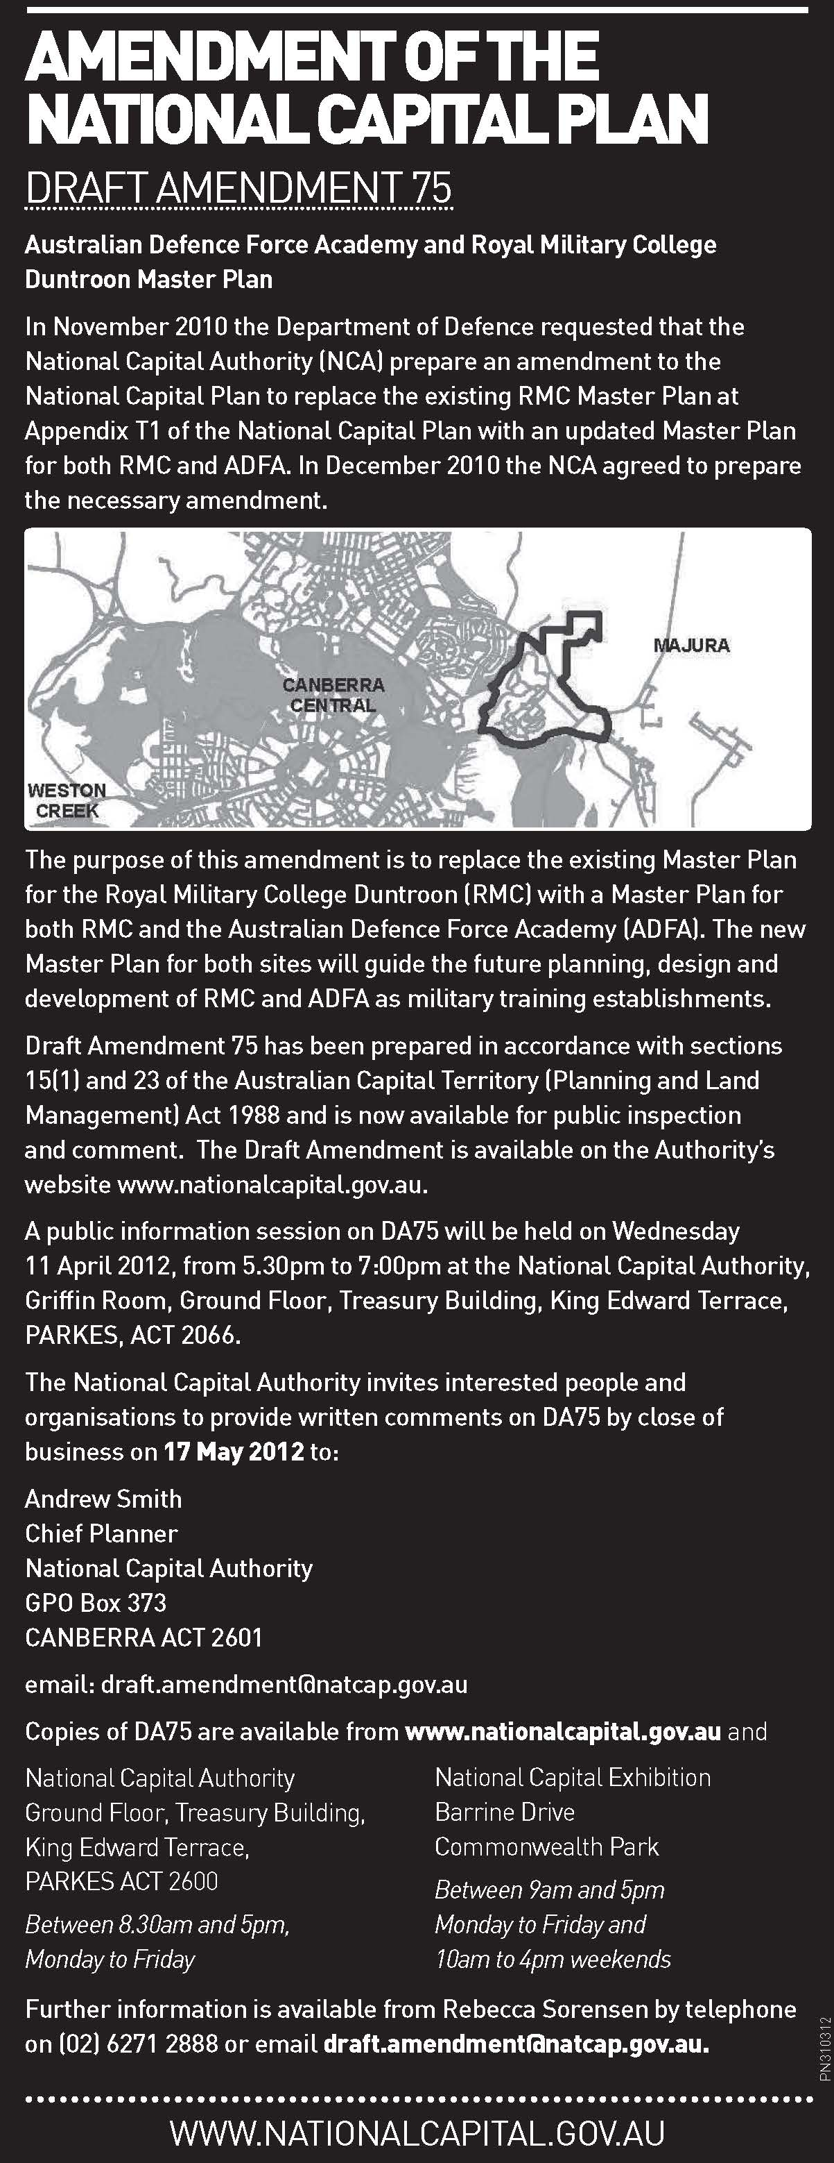Attachment 2 – Commonwealth Notices Gazette notice

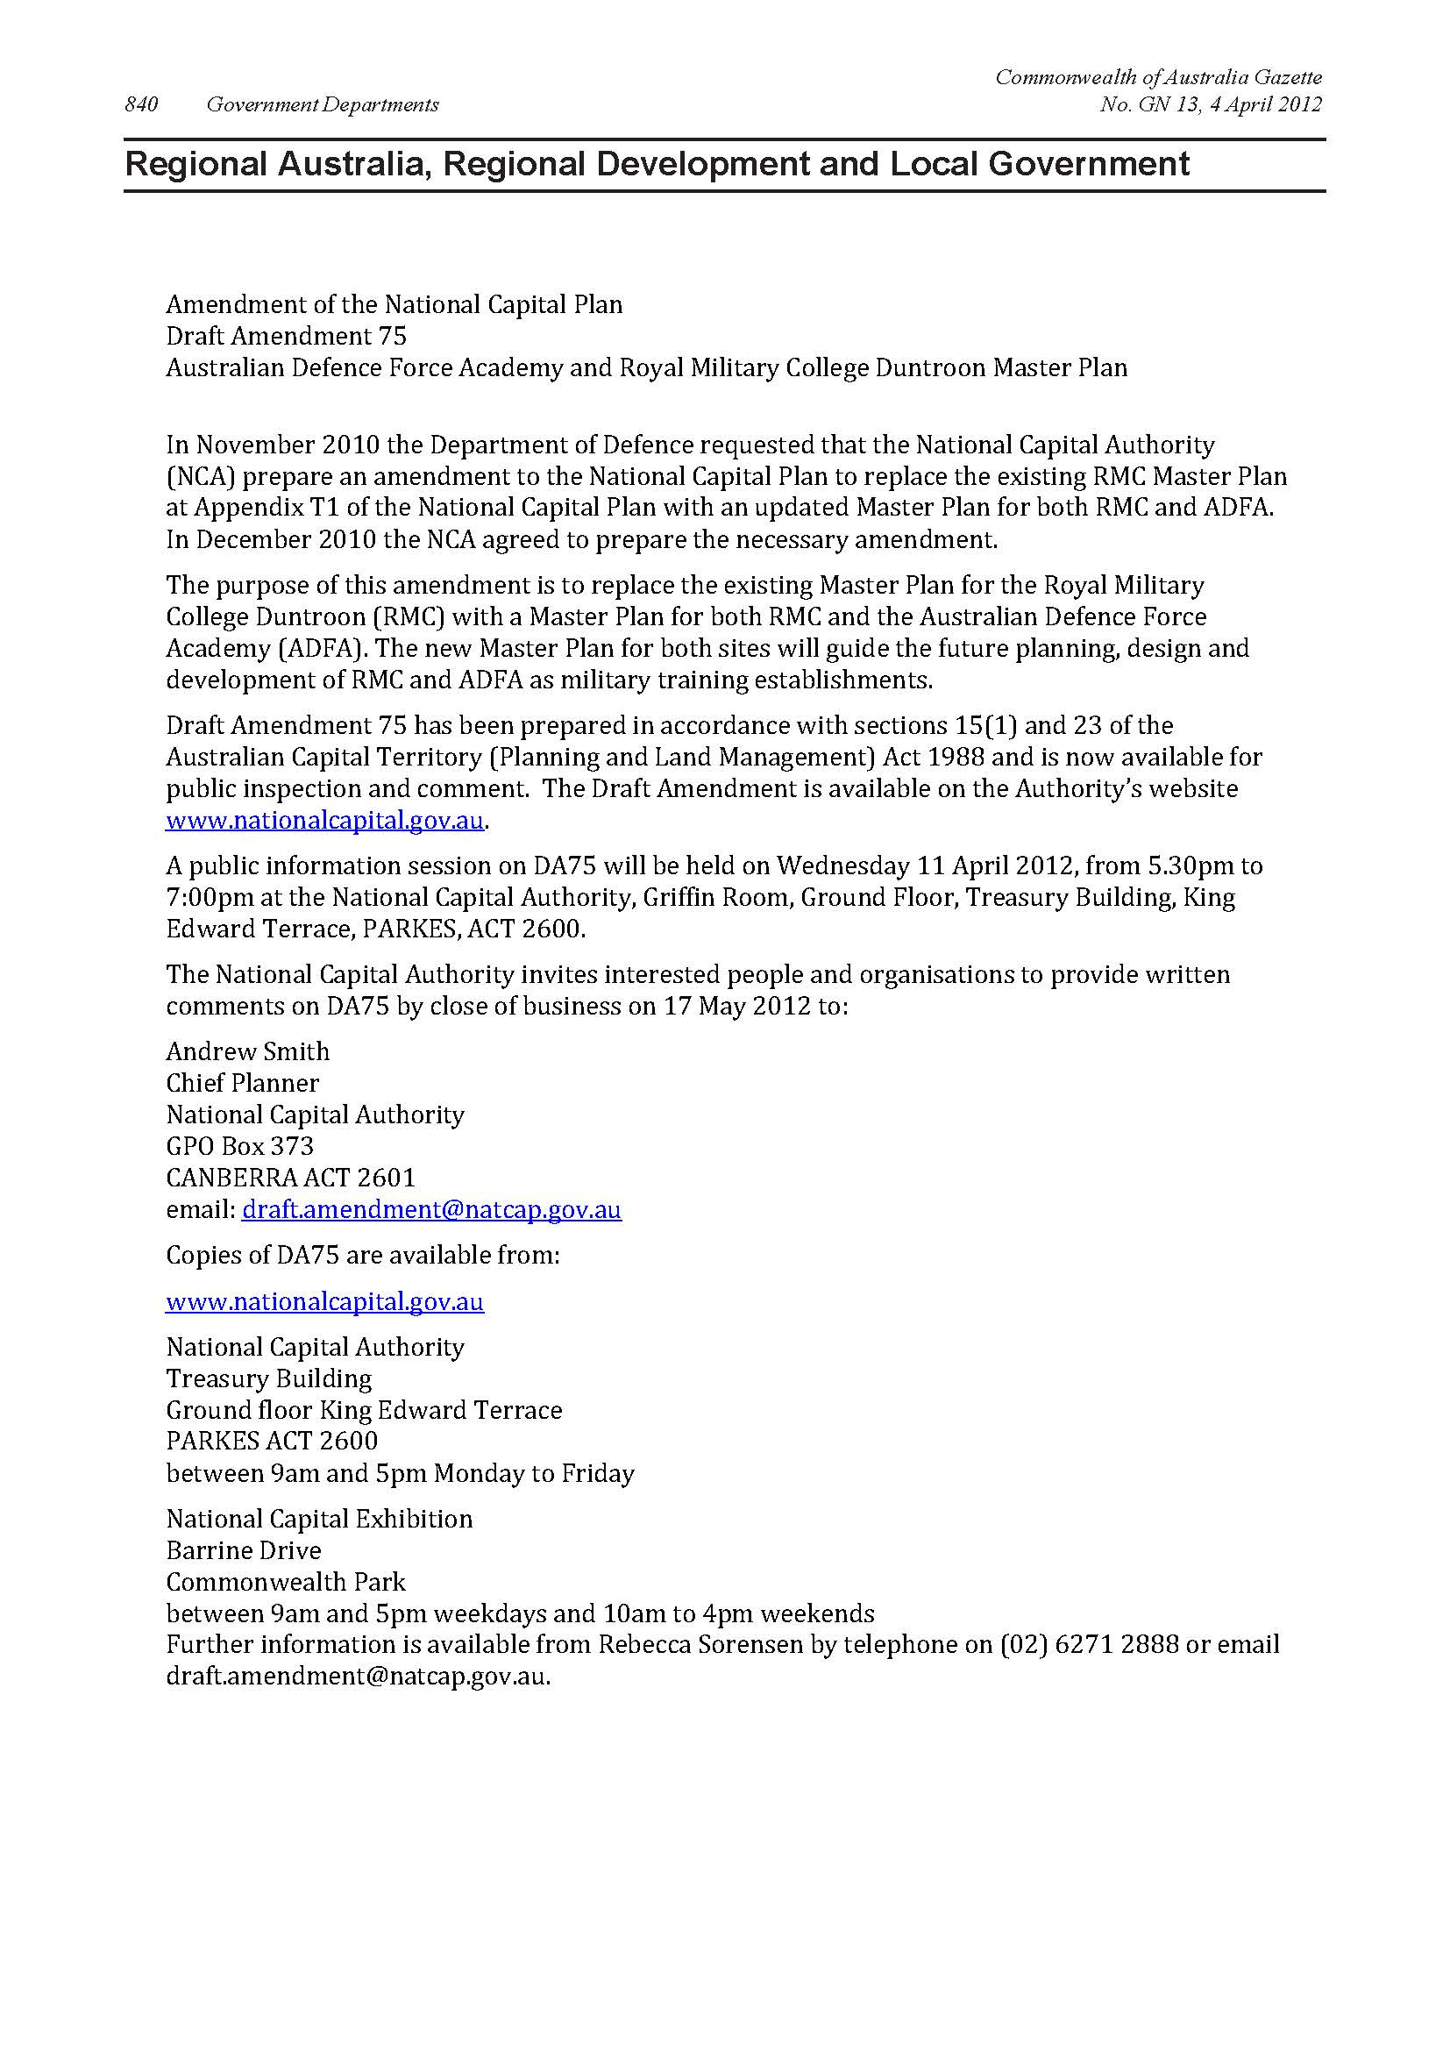

### Attachment 3 – Summary of submissions

Note: Details of each submitter have only been reproduced in this table where a submitter has granted permission for their name and/or address to be used by the National Capital Authority for the purposes of the Report on Consultation for Draft Amendment 75.

| **No.** | **Details of submitter** | **Key points raised in submission** | **NCA consideration** |
| --- | --- | --- | --- |
| 1 | Friends of Grasslands  PO Box 987, CIVIC SQUARE ACT 2608 | Friends of Grasslands (FOG) is pleased to note that the objectives of the Master Plan include conservation of significant natural heritage values, and that an area of box-gum woodland and natural temperate grassland has been marked as a constraint.  It is disappointing to see that some of this endangered grassy ecosystem area has been zoned for future development. The northern half of the future development area contains both box-gum woodland and natural temperate grassland, both endangered ecosystems. The box-gum woodland portion is relatively small but is contiguous with a significant patch of box-gum woodland on ACT land adjoining the Defence site. The entire woodland patch is very important bird habitat. The natural temperate grassland area is important habitat for several endangered species, in particular the southern lined earless dragon.  FOG asks that the northern half of the area marked for future development be added to the adjoining open space area and be managed for conservation in perpetuity. This area and the open space area should be zoned to ensure the retention of this site in the longer term. | Endangered ecological communities are listed as a matter of national environmental significance under the *Environment Protection and Biodiversity Conservation Act* 1999 (EPBC Act). Under the EPBC Act, actions that have, or are likely to have, a significant impact on a matter of national environmental significance require approval from the Minister for Sustainability, Environment, Water, Population and Communities.  The draft amendment does not constitute a development application, and is not considered an action under the EPBC Act. Depending on the nature of future proposals in this area, Defence may be required to refer the proposed action to the responsible Minister under the EPBC Act for assessment. |
| 2 | ACT Government  Environment and Sustainable Development Directorate | **Flora and fauna**  Part 1 of the draft amendment states that a number of threatened flora and fauna species exist in the area, but these are not listed in Part 2 – it is therefore suggested that Part 2 be amended to include such a list and an appraisal of the importance of the site for these species.  Block 564 and the northern part of Block 550 contain natural temperate grassland which is a nationally endangered ecological community. This threatened grassland supports a number of component threatened species as listed in Part 1 of the draft amendment. The site is one the few known habitats of the endangered grassland earless dragon which is one of the most highly threatened species, nationally and in the ACT, and has a highly restricted and fragmented distribution. In addition to the nationally threatened entities, the natural temperate grassland is also known habitat of the Perunga grasshopper listed as vulnerable under the ACT’s *Nature Conservation Act 1980*. The conservation values of the Block 564, and the northern part of Block 550, are such that the area has high conservation value.  The land use zoning proposed by the Master Plan appears to be inconsistent with the presence of significant grassland, woodland and habitat in the northern part of Block 550. Figure 1 of the Master Plan identifies that the northern part of Block 550 is significantly environmentally constrained, but Figure 2 includes this area within a Future Development zoning, which ‘identifies larger parcels of developable land that can facilitate the future expansion of activities’. It is suggested that the environmental values of the northern part of Block 550 would be more consistent with a land use zoning for conservation purposes only.  It is not clear from the Master Plan that Block 564 will be set aside for conservation purposes. The Master Plan Land Use Zone map proposes that Block 564, and other strips of woodland areas to the west of the existing facility, will be zoned as Open Space Precincts with the intention of providing facilities for a defence installation (training and recreation equipment), landscape buffer and open space. This proposed zoning seems at odds with the high conservation value of the block. It appears to be unsuitable for a defence installation.  Please also note that any future development of Block 564, or the northern part of Block 550, would require consideration under Commonwealth and/or Territory environmental legislation.  It is recommended that DA75 be amended to reflect the above comments.  **Heritage**  It is unlikely that the provisions of DA75 will detrimentally affect the heritage values of the place. However, there are known Aboriginal sites within the affected area. It is therefore recommended that the NCA consider the report for the RMC prepared in 2008 by Navin Officer Heritage Consultants. Please also note that all Aboriginal sites should be reported to the Heritage Council and these sites are protected from disturbance under the *Heritage Act 2004*.  **Noise**  The NCA may wish to consider the design and proximity of noise generating premises to residential facilities. This is likely to be of most concern where *Base Support Precinct* is adjacent to *Domestic Precinct*. It is suggested that appropriate planning, design and noise mitigation measures and practices be implemented where these mixed uses occur in close proximity.  **Water resources**  The NCA may wish to consider amending the draft Master Plan to include intent about the environmental footprint and the effect of the site on its surrounds. For example, ‘a commitment to Water Sensitive Urban Design (WSUD) and ensuring that the activities/development of the site does not create additional, and attempts to reduce, the discharge of pollutants and hydrological alteration to Woolshed Creek and Lake Burley Griffin.’  **Contaminated sites**  It is suggested that the draft Master Plan includes comments on constraints associated with potential contamination of the site. Environment Protection Authority records indicate the presence of site impacts associated with fuel storage, asbestos impacts to soil, lead paint, unexploded ordinance and effluent reuse.  **Mapping**  It is suggested that the figures/maps contained in DA75 be amended to show the future Majura Parkway more prominently.  **Territory and Municipal Services (TaMS)**  TaMS supports DA75.  **Economic Development Directorate (EDD)**  EDD has no comments in relation to DA75.  **ActewAGL**  The following infrastructure, which is located on the site, needs to be considered in the preparation of any development proposal for the site:   * The Googong Bulk Supply Water Main – this very large (1200mm diameter) is a critical asset within the water supply system. Traditionally the main is contained in an easement of a minimum of ten metres width. The main passes south to north through the western portion of RMC and ADFA. * A 450mm diameter trunk sewer running west to east from Plant Road to Morsehead Drive – this sewer drains the majority of the RMC site in addition to public open space to the south of Morsehead Drive. * A 300mm diameter trunk sewer passing through the eastern portion of the ADFA site and thence north to south throught the RMC gold course – this sewer drains the entire ADFA site in addition to a small portion of RMC and land to the north of ADFA. * Effluent reuse mains located in Hopkins Drive RMC, General Bridges Drive, the eastern portion of ADFA and the playing fields to the north of Fairbairn Avenue – these mains supply non-potable water to RMC, ADFA and other ACTEW customers. * Other minor ACTEW or privately owned sewer and water assets. | **Flora and fauna**  Part 2 of the draft Amendment document is the proposed planning framework for ADFA and RMC. It is not necessary to list endangered species or ecological communities within the planning framework.  Endangered ecological communities and species are listed as a matter of national environmental significance under the EPBC Act. Under the EPBC Act, actions that have, or are likely to have, a significant impact on a matter of national environmental significance require approval from the Minister for Sustainability, Environment, Water, Population and Communities.  The ‘Future Development’ zoning of the northern part of Block 550 does not expressly prohibit or permit development of the site. The NCA is aware that, depending on the nature of future proposals in this area, Defence may be required to refer the proposed action to the responsible Minister under the EPBC Act for assessment. Development that will not have a significant adverse impact on the environmental values of the area may be permitted.  Similarly, Block 564 and other areas with high conservation value and zoned as ‘Open Space’ do not expressly prohibit or permit development. The ‘primary purpose’ for these areas includes the use of the land for ‘conservation and/or enhancement of land with significant environmental values’. Again, depending on the nature of future proposals in these areas, Defence may be required to refer the proposed action to the responsible Minister under the EPBC Act for assessment. Development that will not have a significant adverse impact on the environmental values of the area may be permitted.  The draft Amendment proposes that the entire ADFA and RMC sites be zoned ‘Defence Installation’ as the current land use policy of ‘Community Facillity’ does not adequately reflect the use of the site. The term ‘Defence Installation’ is defined in the National Capital Plan as ‘a building or place operated by the Department of Defence or the armed forces of Australia and includes Department of Defence offices, offices associated with national security and defence communication facilities, but does not include facilities associated with military aviation.’  The Master Plan provides greater detail on the likely use of the land for Defence purposes within the ‘Defence Installation’. Development is also subject to the provisions of other legislation, including the EPBC Act.  **Heritage**  ADFA and RMC are located on National Land, managed by the Department of Defence. By virtue of the *Australian Capital Territory (Self-Government) Act 1988*, obligations imposed by the *Heritage Act 2004* are not binding on the Crown in right of the Commonwealth (refer also Regulation 3B of the *Australian Capital Territory (Self-Government) Regulations 1999* and section 121 of the *Legislation Act 2001*).  Objects (artifacts and Aboriginal remains) and areas which are of particular significance to Aboriginal peoples and traditions can have protection from injury or desecration under the *Aboriginal and Torres Strait Islander Heritage Protection Act 1984* (Cth).  Provisions of this legislation do not need to be replicated in the draft Amendment.  **Noise**  Noise and compatibility between uses will need to be considered by Defence when planning future additions or alterations to ADFA and RMC.  **Water resources**  The Master Plan will form part of the National Capital Plan. Other parts of the National Capital Plan (for example, Chapter 10) contain relevant requirements pertaining to the environment. These provisions include using nationally recognised guidelines and standards as a basis for assessing environmental quality, and requiring ecological resources to be managed having regard to such matters as soil conservation, nutrient recycling, water balance regulation, and protection of water quality.  **Contaminated sites**  The presence, or potential presence, of contaminated land needs to be taken into account when planning construction and other activities, but does not necessarily need to be included in the planning framework. Site remediation will need to be considered as part of future proposals on contaminated land.  **Mapping**  The maps forming part of DA75 relate to the ADFA and RMC sites only. Off-site works or projects are not identified. In regard to Majura Parkway, the spatial dimensions of the road reserve have been considered and adequate space has been left to ensure the road can be constructed wholly outside of Defence land.  **Territory and Municipal Services (TaMS)**  Noted.  **Economic Development Directorate (EDD)**  Noted.  **ActewAGL**  Infrastructure requirements, including the impact of future proposals on existing infrastructure, will be considered as necessary as part of the Works Approval process. |
| 3 | National Trust of Australia (ACT)  PO Box 1144 CIVIC SQUARE ACT 2608 | Generally supports the proposal, but makes the following comments:   * Clause 1.3.2 mentions that the four indigenous heritage sites on RMC are not listed on the Commonwealth Heritage List. There should be a recommendation that they are included or at least fully assessed to ascertain whether they should be. * Before the master plan is confirmed there needs to be a heritage assessment of ADFA completed to determine if there are any places of heritage significance worthy of listing on the CHL. A number of buildings have won architectural awards and may be suitable. A heritage assessment may affect the outcomes of the Master Plan and so needs to be done before the final plan is passed.   In regard to the detailed conditions of planning, design and development:   * The objectives should also include conservation of significant Indigenous sites as well as natural and cultural. * There needs to be a clearer statement about the existing road system and to what extent the landscape is of significance. * The constraints map would need to consider anything that will arise from the heritage assessment of ADFA suggested above. * The White Box, Yellow Box, Woodlands and Grasslands need to have their areas precisely located and the specific environmental constraints for each species defined. * The list of heritage places in the Heritage Constraints section will need to include any items that arise from an ADFA heritage assessment and should also include General Bridges Grave.   In regard to the Development Guidelines:   * Car parking, access and movement – reference to the current road system and layout is needed along with appropriate guidelines for future use and development. * Architectural character – needs to make a particular guideline or reference to sympathetic design when near heritage listed places and note that special approval is required for any work in these area which includes a statement of heritage impact. | ***Heritage***  The assessment of sites for listing on the Commonwealth Heritage List is beyond the scope of the draft Amendment. Heritage places have protection through other mechanisms, and places that are included in the Commonwealth Heritage List are protected under the provisions of the EPBC Act. Should an assessment of ADFA, or any other place within RMC result in a listing in the Commonwealth Heritage List (or National Heritage List), adequate protections are in place. Depending on the nature and extent of any listing, an amendment to the Master Plan may be required to reflect the listing.  The constraints section identifies significant constraints to development. The RMC Duntroon Conservation Area has been included in this section as it covers a reasonably large area within RMC, and planning and development within an area of this size requires significant consideration and can be complex. The composition and size of General Bridges Grave is not considered to represent a significant constraint to development.  As noted above, heritage places also have protection through other mechanisms, and places that are included in the Commonwealth Heritage List (such as General Bridges Grave) are protected under the provisions of the EPBC Act.  It is considered that the importance of conserving and managing Indigenous heritage should be recognised, in additional to natural and cultural heritage. It is therefore recommended that the relevant objective of the detailed conditions of planning, design and development be amended to read as follows:  *To conserve and manage significant natural, cultural and Indigenous heritage.*  It is considered that the Master Plan could recognise the need for new development adjacent to heritage listed places to be sympathetic to the heritage values of that place. It is therefore recommended that an additional clause be added to the ‘Architectural Character’ section as follows:  *The articulation, material and colour of buildings shall be sympathetic to the heritage values of any adjacent heritage listed place.*  ***Car parking, access and movement***  The Master Plan provides guidance for future use and development of RMC and ADFA. Provisions relating to both landscape, and car parking, access and movement are included within the Master Plan. Where particular landscape or transport network features are to be retained, these are identified in the Master Plan (for example, maintaining the open area adjacent to General Bridges Drive as a landscape buffer between RMC and ADFA). |
| 4 | Leslie Kelety, CAMPBELL | The objectives and contents of DA75 are overall very commendable. However, the draft amendment should be strengthened in three respects.  ***Need to protect the bushland along the western edge of the ADFA site***  Currently, there is a wide strip of bushland on the western edge of the ADFA site alongside Northcott Drive, some 80 to 100 metres wide. (It is bounded by Northcott Drive to the west and Milne Bay Road/Tobruk Road/Kapyong Street to the east).  This strip of bushland is a very important component of the landscape. It rises steeply above the rest of the ADFA site to meet Northcott Drive, and is an integral part of the prominent bushland ridge on Mount Pleasant, on the other side of Northcott Drive. It is effectively a continuation of the Mount Pleasant bushland.  This land needs to be protected. Its preservation will enhance the environmental amenity and natural beauty of ADFA and Duntroon, and will ensure that these national institutions sit within Canberra’s beautiful natural landscape, rather than dominate or wreck it. (This land presently contains two open-air car parks (in Milne Bay Road), but these are planted with native trees and do not have a significant deleterious impact on its environmental and landscape values.)  DA75 rightly accords protection to the ridgeline adjacent to General Bridges Drive (paragraph 3.2). Similar protection should be accorded to the strip of bushland on the western edge of the ADFA site, which is of comparable environmental and aesthetic value.  At present, there is only one provision in DA75 which gives this strip of bushland a modicum of protection, namely paragraph 3.4.  Paragraph 3.4 is quite inadequate to provide the necessary protection, for two reasons. First, it deals only with ‘landscape treatment’, not preservation – it does not actually rule out development, it just specifies the kind of landscaping that needs to accompany the development. Secondly, it only applies to a 20 metre strip – which is one-quarter or one-fifth of the width of the strip of bushland in question.  Full preservation, in similar terms to paragraph 3.2 which applies to the ridgeline next to General Bridges Drive, needs to be accorded to the strip of bushland on the western edge of the ADFA site, across its full width (ie between Northcott Drive to the west and Milne Bay Road/Tobruk Road/Kapyong Road to the east).  ***Need to give explicit recognition to the landscape values of the site***  The foregoing draws attention to the potential higher-level shortcoming in DA75: the *Vision and Objectives* and *Guiding Principles* enumerated in the draft amendment refer to landscape-related issues of a ‘micro’ nature which pertain to the immediate site, but do not give explicit recognition to the role of the site as part of the wider landscape on the eastern side of the central area.  The objectives should include an additional objective of preserving and enhancing the natural landscape values of the site, and ensuring that the built forms of ADFA and the RMC take their place respectfully within that landscape.  This objective should inform the specific planning and building requirements and restrictions in the master plan (including a provision preserving the bushland on the western edge of the ADFA site, as suggested above).  ***Need to prevent light pollution***  Paragraph 7.1 of the draft amendment provides that *‘all outdoor lighting, including security and car park lighting, shall be designed and sited to minimise light pollution. Outdoor lighting shall use full cut-off light fitiings. Any uplighting of buildings should be carefully designed to keep night time overspill and glare to a minimum.’*  The subdued lighting which prevails in Canberra is critically important to the night-time amenity of our national capital, to night-time views and vistas, and to the sense of a city cradled in the natural landscape. The NCA’s draft Outdoor Lighting Policy recognises this, and contains measures designed to limit night pollution.  Be definition, up-lighting projects light into the surrounding atmosphere no matter how carefully it is designed. DA75 should therefore prohibit all new up-lighting on the site. It should specify that building facades, if lit up at all, should be down-lit, not up-lit. | Noted.  ***Need to protect the bushland along the western edge of the ADFA site***  The land between Northcott Drive and Milne Bay Road/Tobruk Road/Kapyong Street is identified on the Constraints Plan of the Master Plan as ‘Environmental Conservation’. Having regard to this constraint, the Zone Map within the Master Plan identifies the area as ‘Open Space’. The Master Plan states that the primary purpose of the open space zoning is *‘to provide buffers between incompatible internal and external activities; to enable conservation and/or enhancement of land with significant environmental values; and to avoid land being targeted for future development on land that is unsuitable for such purposes.’*  Likely uses within the open space area are training and recreation equipment, landscape buffer and open space. Depending on the nature of any proposal in the area between Northcott Drive and Milne Bay Road/Tobruk Road/Kapyong Street, a referral under the *Environment Protection and Biodiversity Conservation Act 1999* may be required.  It is considered that the Master Plan (and other relevant legislation) provides adequate protections to ensure that uses incompatible with the conservation and landscape value of this area are not permitted.  ***Need to give explicit recognition to the landscape values of the site***  The ‘Guiding Principles’ of the Master Plan state that *‘a high quality of planning and development should be achieved within a design context appropriate to its location.’* This provision recognises the importance of the design of ADFA and RMC in the broader context.  The nature of uses on the ADFA and RMC sites, and the historical development of the facilities, has resulted in some distinct landscape characteristics across the site. This includes areas of more formal, exotic plantings. The Master Plan appropriately recognises these variations in landscape, and requires that the landscape structure reinforce the identity of each precinct.  ***Need to prevent light pollution***  The NCA’s draft Outdoor Lighting Policy contains the following design requirement: *‘use full cutoff light fittings for new building façade lighting installations, that are carefully integrated into the building’s structure.’*  It is recommended that this design requirement be replicated in the Master Plan to provide clarity on the intention for lighting of buildings, and to maintain consistency between the National Capital Plan and the Outdoor Lighting Policy. It is therefore recommended that clause 7.1 of the draft Amendment be amended to read as follows:  *‘All outdoor lighting, including security and car park lighting, shall be designed and sited to minimise light pollution. Outdoor lighting shall use full cutoff light fittings. New building façade lighting installations shall use full cutoff light fittings that are carefully integrated into the building’s structure.’*  As ADFA and RMC are within Designated Areas under the National Capital Plan, other relevant policies, strategies and design requirements of the Outdoor Lighting Policy will be considered when assessing applications for works approval. |