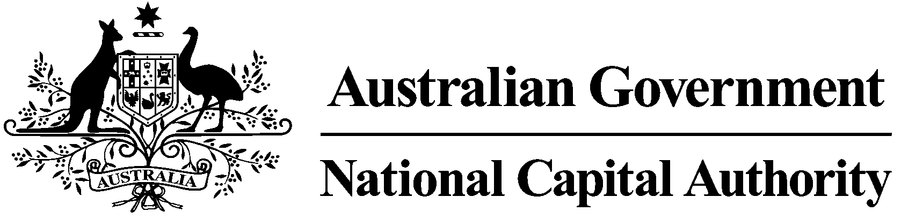

**CONSULTATION REPORT**

**DRAFT AMENDMENT 90**

**Mint Administration Building**

July 2018

**Table of** Contents

1 Introduction 3

1.1 Purpose and background 3

2 Consultation 3

3 Key issues 3

3.1 Heritage 3

3.2 Land Use 4

4 Recommended changes 4

5 Conclusion 4

6 Attachments 4

Attachment 1 – Canberra Times notice 5

Attachment 2 – Government Notices Gazette notice 6

Attachment 3 – Summary of submissions 7

# 1 Introduction

## Purpose and background

The National Capital Plan (the Plan) sets out general planning policies and principles for overall development of the Australian Capital Territory (ACT). One of the functions of the National Capital Authority (NCA) is to keep the Plan under constant review and propose amendments to it when necessary.

This report summarises the issues raised during the public consultation process undertaken by the NCA on Draft Amendment 90 – Mint Administration Building (DA90) to the Plan.

DA90 proposed to vary the land use policy for the Mint Administration Building from ‘National Capital Use’ to ‘National Capital Use’ and ‘Mixed Use’ policy allowing for consulting rooms (*veterinary services restricted to small/domestic animals only), Health Centre and Office*.

# Consultation

On 2 June 2018, DA90 was released for public comment. A public notice was published in *The Canberra Times* on this day (Attachment 1). On 4 June 2018, a notice was published in the *Government Notices Gazette* (Attachment 2).

In accordance with the NCA’s ‘Commitment to Community Engagement (August 2015)’ the period for public comment ran for 30 business days, concluding on 16 July 2018. DA90 was available on the NCA’s website, and hard copies were available on request.

Key activities during the consultation period for DA90 included:

# On 2 June 2018, the NCA published a public notice in *The Canberra Times*.

* On 4 June 2018, notice appear in the *Commonwealth Notices Gazette*.
* From 2 June to 16 July 2018, the NCA published the draft amendment on the NCA’s website.
* The NCA wrote to key stakeholders and community groups advising of the consultation process and inviting comments.
* On 20 June 2018 NCA held an information session. No members of the public attended.

# Key issues

The NCA received three written submissions in response to DA90. The key issues raised in submissions are identified below. Full details of submissions are available in Attachment 3.

## Heritage

***Comments***

Three submitters raised issues and/or expressed interest in relation to the ongoing heritage management of the Mint Administration Building. In general, support was expressed for the preparation of the Heritage Management Plan (HMP). The following more particular matters were raised:

* the heritage Management Plan (HMP) should be updated every five years and endorsed by the Department of Environment and Energy
* concern was raised about the potential changes to how the building is viewed from Yarra Glen. One submitter suggested that the current HMP is weak and would like to see a review of the HMP prior to sale.

***NCA response***

The Plan does not operate in isolation. There are other Commonwealth heritage protections in place, including through the *Environment Protection and Biodiversity Conservation Act 1999.*

The draft Crown Lease for the Mint Administration Building also addresses heritage matters. The draft Crown Lease includes the requirement for the Lessee to provide to the Department of the Environment and Energy a review of the HMP within the first 12 months of the Lease and every five years thereafter and that the review, including any updates to the HMP, be to the satisfaction of the Department of the Environment and Energy. The Lessee is required to not contravene the HMP and is to occupy, use and manage the place to protect and conserve its heritage value.

## Land Use

***Comments***

One submitter stated that they did not support the removal of the *National Capital Use* land use policy for the site.The submitter requested that the site be identified as both *National Capital Use* in addition to the other proposed uses to ensure that the Department of Industry, Innovation and Science (DIIS) can continue to use the site.

***NCA response***

The proposed amendment will be varied to include National Capital Use, in addition to Consulting Rooms, Health Centre, and Office as permitted uses on the site. This is consistent with the draft Crown Lease that has been prepared by the Department of Finance.

# Recommended changes

DA90 will be amended to remove any ambiguity regarding land use, and clarify that permitted used on site includes *National Capital Use*, in addition to Consulting Rooms, Health Centre, and Office.

# Conclusion

On 2 June 2018, DA90 was released for public consultation. The public consultation period ran for six weeks in accordance with the NCA’s ‘*Commitment to Community Engagement*’ (August 2015), concluding on 16 July 2018.

Three written submissions were received in response to DA90. Clarification regarding land use, as noted in sections 3.2 and 4 above, is the only change to DA90.

# Attachments

1. Notice of release of Draft Amendment 90 for public comment published in *The Canberra Times*.
2. Notice of release of Draft Amendment 90 for public comment published in the *Commonwealth Notices Gazette*.
3. Summary of submissions and NCA response.

### Attachment 1 – Canberra Times notice

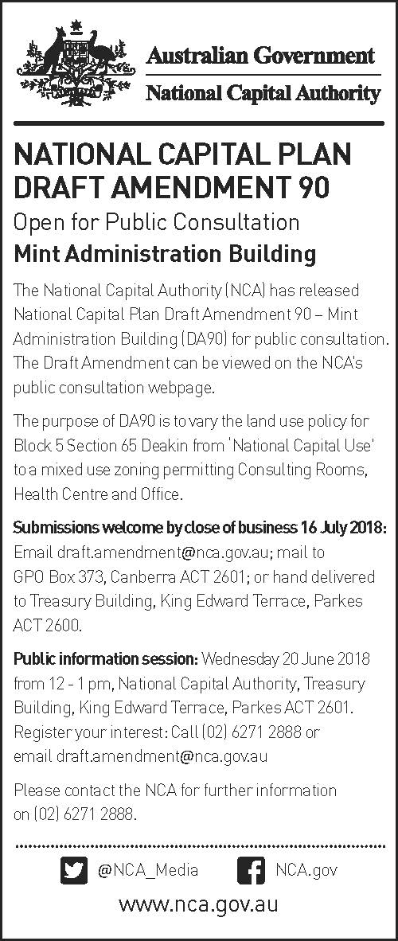

### Attachment 2 – Government Notices Gazette notice

### Attachment 3 – Summary of submissions

| **No.** | **Details of submitter** | **Details of submission** | **NCA consideration** |
| --- | --- | --- | --- |
| 1 | Submission 1 | The submitter raised concerns about the ongoing heritage conservation of the Mint Administration Building. The submitter has noted that they are pleased to see a Heritage Management Plan in place but would like to see it updated every five years and endorsed by the Department of Environment and Energy.  The submitter also stated that they would like to see public consultation conducted about any potential use and building changes. | Noted. In addition to the existing Heritage Management Plan, further heritage requirements are included in the draft Crown Lease. The draft Crown Lease includes the requirement for the Lessee to provide to the Department of the Environment and Energy a review of the HMP within the first 12 months of the Lease and every five years thereafter and that the review, including any updates to the HMP, be to the satisfaction of the Department of the Environment and Energy.  Where required the NCA will conduct public notification for changes to the Mint Administration Building in accordance with the NCA’s *Commitment to Community Engagement* (August 2015). |
| 2 | Sam White, Acting Chief Financial Officer, Department of Industry, Innovation and Science | The submitter raised concerns about the change of use for the block and has concerns that Questacon will not be able to operate as normal under the new land use propose by DA90.  The submitter also raised concerns that the new landlord might seek to reduce or extinguish Questacon’s current rights in order to receive a greater return on the investment. The submitter would like to see the site to remain *National Capital Use* and missed useaddedto specifically permit Questacon’s current activities.  The submitter has concerns about the ongoing heritage management of the Mint Administration Building. In particular, the submitter has concerns about the potential changes to how the building is viewed from Yarra Glen. The submitter believes that the current Heritage Management Plan is weak and would like to see a review of the Heritage Management Plan prior to sale. | The proposed amendment includes the retention of the *National Capital Use* as well as the addition of other uses allowing a mixed use site.  In addition to the existing Heritage Management Plan (HMP), further heritage requirements are included in the draft Crown Lease. These include the requirement for a review of the HMP within the first 12 months of the Lease and every five years thereafter.  The Lessee is required to not contravene the HMP and is also required to occupy, use and manage the place to protect and conserve its heritage value. |
| 3 | Ben Ponton, Director-General of Environment, Planning and Sustainable Development Directorate | The submitter is supportive of the proposed amendment and welcomes the preparation of a Heritage Management Plan by the Department of Finance.  The submitter is also pleased that relevant covenants and provisions will be included in the Crown Lease and sale documentation to ensure the heritage values are protected. | Noted. |