National Capital Plan – Amendment 90 – Block 5 Section 65 Deakin¹
Australian Capital Territory (Planning and Land Management) Act 1988
I, JOHN McVEIGH, Minister for Regional Development, Territories and Local Government, approve this amendment of the National Capital Plan under section 19(1)(a) of the Australian Capital Territory (Planning and Land Management) Act 1988.
Dated 24 August 2018
JOHN McVEIGH
Minister for Regional Development, Territories and Local Government

1 Name of instrument
This instrument is the National Capital Plan – Amendment 90 – Block 5 Section 65 Deakin.
2 Commencement
This instrument commences on the date of its registration.
3 Amendment of National Capital Plan
Schedule 1 amends the National Capital Plan.

Schedule 1 Amendment
(section 3)

[1] Section 4.14.4 Land Use for the Diplomatic Precinct (Yarralumla, Deakin and O’Malley
Delete Figure 122 ‘Land use for the Yarralumla and Deakin Diplomatic Precinct’, and replace with the following figure:

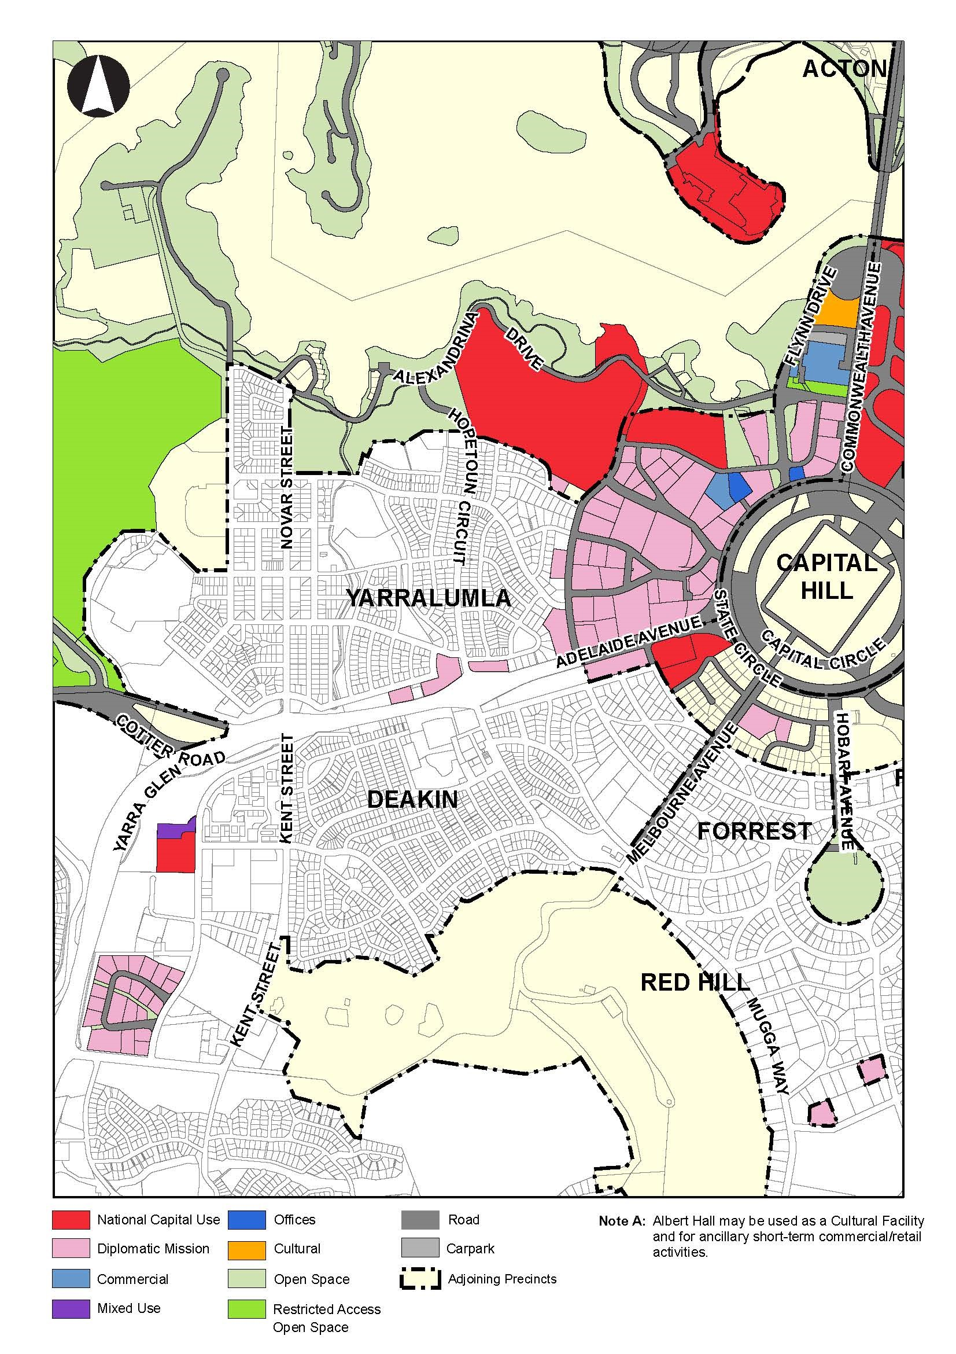

- Insert the following paragraph below Figure 122:
Permitted land uses on sites identified for ‘Mixed Use’ are:
- National Capital Use
- Consulting Rooms (veterinary services restricted to small/domestic animals only)
- Health Centre
- Office.
Note
1. All legislative instruments and compilations are registered on the Federal Register of Legislation kept under the Legislative Instruments Act 2003. See http://www.frli.gov.au.

