

National Capital Plan Amendment (No. 95 – North Curtin Diplomatic Estate and Urban Area) Amending Instrument 2020

I, Nola Marino, Assistant Minister for Regional Development and Territories, make the following instrument.

Dated 19 October 2020

Nola Marino

Assistant Minister for Regional Development and Territories

Contents

1 Name 1

2 Commencement 1

3 Authority 1

4 Schedules 1

Schedule 1—Amendments 2

National Capital Plan 2

1 Name

This instrument is the *National Capital Plan Amendment (No. 95 – North Curtin Diplomatic Estate and Urban Area) Amending Instrument 2020*.

2 Commencement

(1) Each provision of this instrument specified in column 1 of the table commences, or is taken to have commenced, in accordance with column 2 of the table. Any other statement in column 2 has effect according to its terms.

| Commencement information | | |
| --- | --- | --- |
| Column 1 | Column 2 | Column 3 |
| Provisions | Commencement | Date/Details |
| 1. The whole of this instrument | The day after this instrument is registered. |  |

Note: This table relates only to the provisions of this instrument as originally made. It will not be amended to deal with any later amendments of this instrument.

(2) Any information in column 3 of the table is not part of this instrument. Information may be inserted in this column, or information in it may be edited, in any published version of this instrument.

3 Authority

This instrument is made under paragraph 19(1)(a) of the *Australian Capital Territory (Planning and Land Management) Act 1988*.

4 Schedules

Each instrument that is specified in a Schedule to this instrument is amended or repealed as set out in the applicable items in the Schedule concerned, and any other item in a Schedule to this instrument has effect according to its terms.

Schedule 1—Amendments

National Capital Plan

1 Part One – The National Significance of Canberra and the Territory

Repeal ‘Figure 1: Designated Areas’ and substitute with the following:

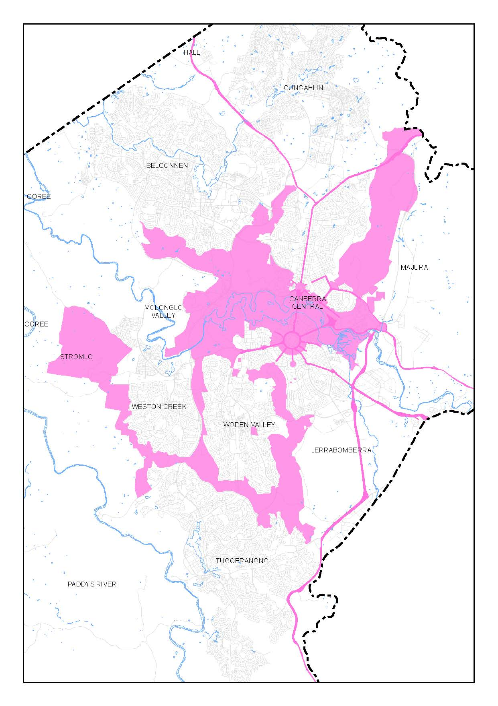

2 Part Three – Land Use Plans and General Land Use Controls

Repeal ‘Figure 2: General Policy Plan – Metropolitan Canberra’ and substitute with the following:

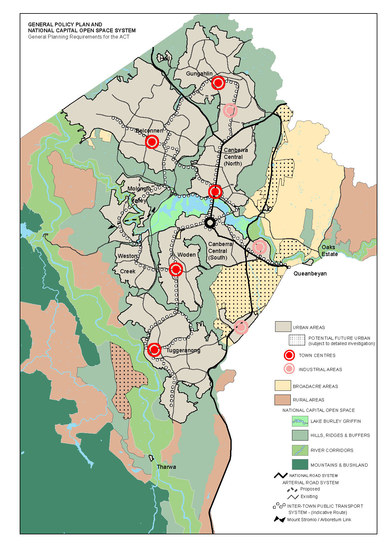

3 Part Four(A) – Principles and Policies for Designated Areas and Special Requirements for National Land outside Designated Areas

Repeal ‘Figure 12: Designated Areas precincts’ and substitute with the following:

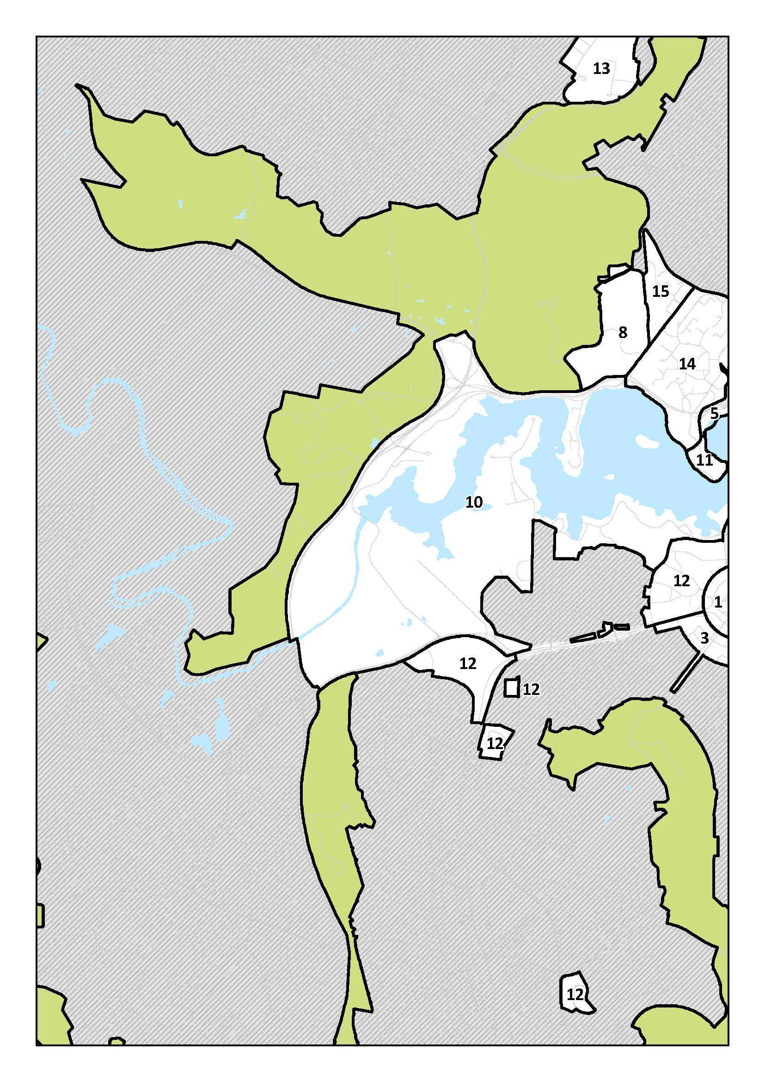

4 Section 4.1 The Central National Area

Omit:

* Diplomatic Precinct (Yarralumla, Deakin and O’Malley)

Substitute:

* Diplomatic Precinct (Yarralumla, Deakin, O’Malley and Curtin)’.

5 Section 4.12.1 Lake Burley Griffin and Foreshores Precinct Code

Repeal ‘Figure 113: Lake Burley Griffin and Foreshores Precinct location’ and substitute with the following:

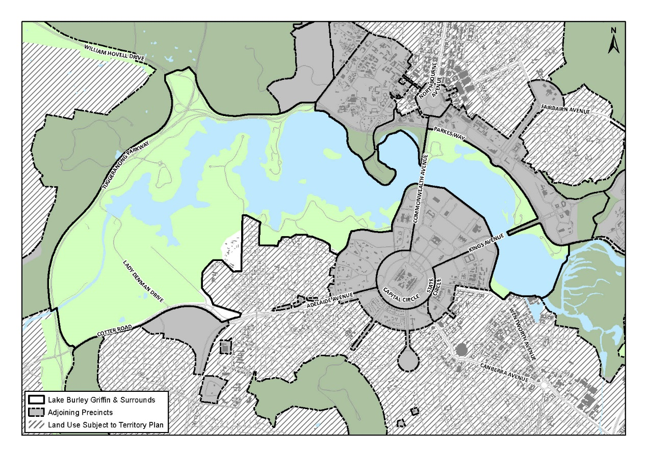

6 Section 4.12.4 Lake Burley Griffin and Foreshores Precinct Code – Land use for Lake Burley Griffin and Foreshores

Repeal ‘Figure 114: Land use for the Lake Burley Griffin and Foreshores Precinct’ and substitute with the following:

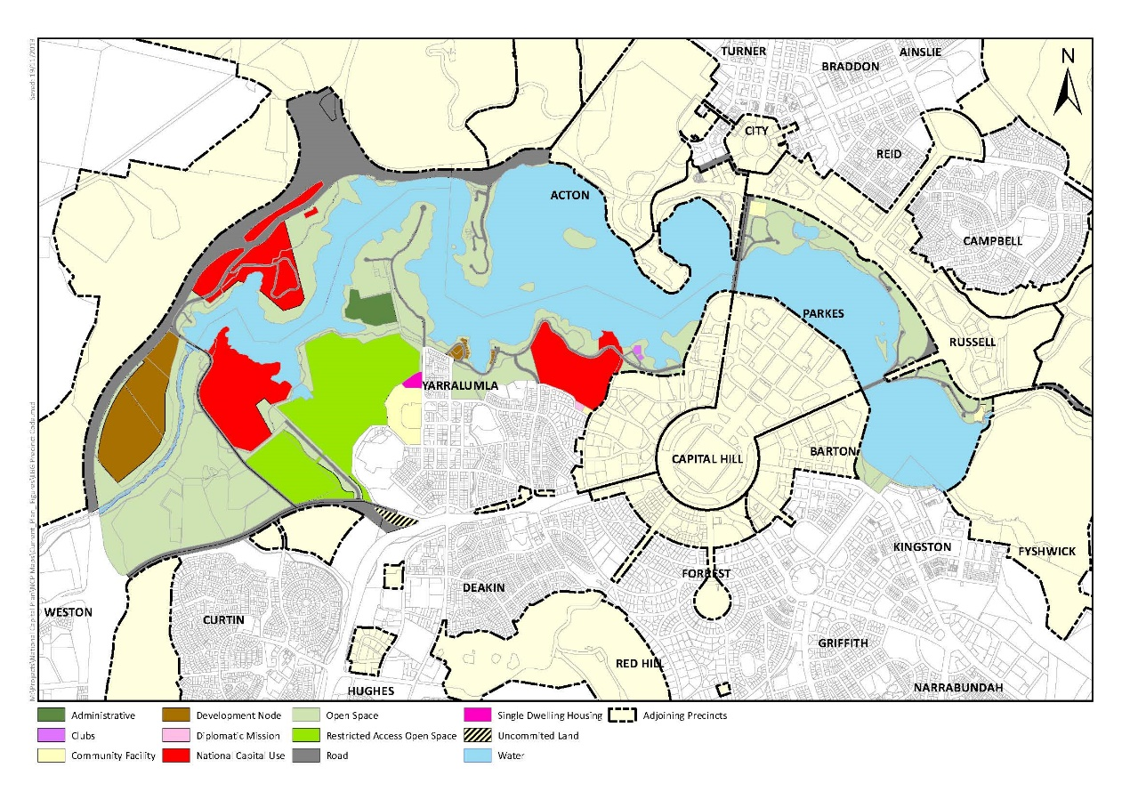

7 Section 4.14 Diplomatic Precinct (Yarralumla, Deakin and O’Malley)

Omit:

* Diplomatic Precinct (Yarralumla, Deakin and O’Malley) Code

Substitute:

* Diplomatic Precinct (Yarralumla, Deakin, O’Malley and Curtin) Code

8 Section 4.14.1 Diplomatic Precinct (Yarralumla, Deakin and O’Malley)

Repeal ‘Figure 122: Yarralumla and Deakin Diplomatic Precinct location’ and substitute with the following:

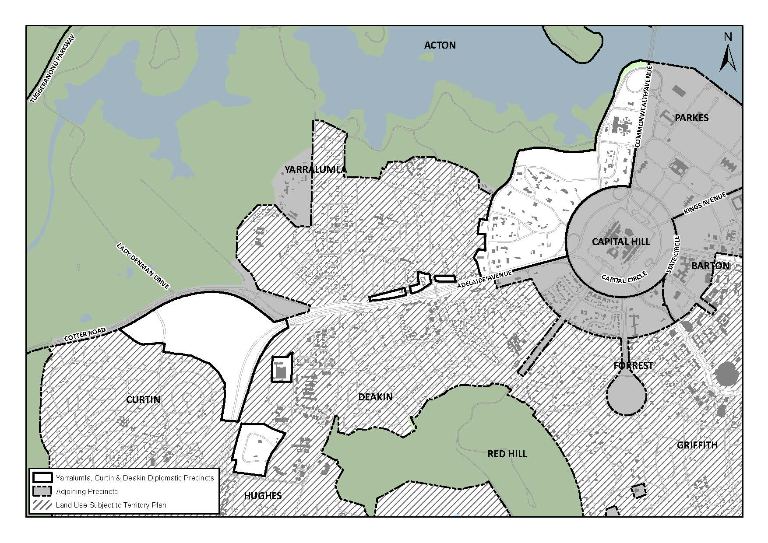

9 Section 4.14.1 Diplomatic Precinct (Yarralumla, Deakin and O’Malley)

Omit:

* Figure 122: Yarralumla and Deakin Diplomatic Precinct location

Substitute:

* Figure 122: Yarralumla, Deakin and Curtin Diplomatic Precinct location

10 Section 4.14.1 Diplomatic Precinct (Yarralumla, Deakin and O’Malley)

Omit:

* The Diplomatic Precinct is comprised of three separate areas:
  + Yarralumla
  + Deakin
  + O’Malley.

Substitute:

* The Diplomatic Precinct is comprised of four separate areas:
  + Yarralumla
  + Deakin
  + O’Malley
  + Curtin.

11 Section 4.14.3 Objectives for the Diplomatic Precinct (Yarralumla, Deakin, O’Malley and Curtin)

Omit:

* Objectives for the Diplomatic Precinct (Yarralumla, Deakin and O’Malley)

Substitute:

* Objectives for the Diplomatic Precinct (Yarralumla, Deakin, O’Malley and Curtin)

12 Section 4.14.4 Land use for the Diplomatic Precinct (Yarralumla, Deakin, O’Malley and Curtin)

Omit:

* Land use for the Diplomatic Precinct (Yarralumla, Deakin and O’Malley)

Substitute:

* Land use for the Diplomatic Precinct (Yarralumla, Deakin, O’Malley and Curtin)

13 Section 4.14.4 Land use for the Diplomatic Precinct (Yarralumla, Deakin, O’Malley and Curtin)

Omit:

* Land use for the Diplomatic Precinct (Yarralumla, Deakin and O’Malley) should be in accordance with Figure 125, Figure 126 and Figure 127.

Substitute:

* Land use for the Diplomatic Precinct (Yarralumla, Deakin, O’Malley and Curtin) should be in accordance with Figure 125, Figure 126 and Figure 127.

‘Road’ is a permitted use within the Curtin diplomatic estate, the location of which is to be determined at the time of estate development planning.

14 Section 4.14.4 Land use for the Diplomatic Precinct (Yarralumla, Deakin, O’Malley and Curtin)

Repeal Figure 124 ‘Land use for the Yarralumla and Deakin Diplomatic Precinct’ and substitute with the following:

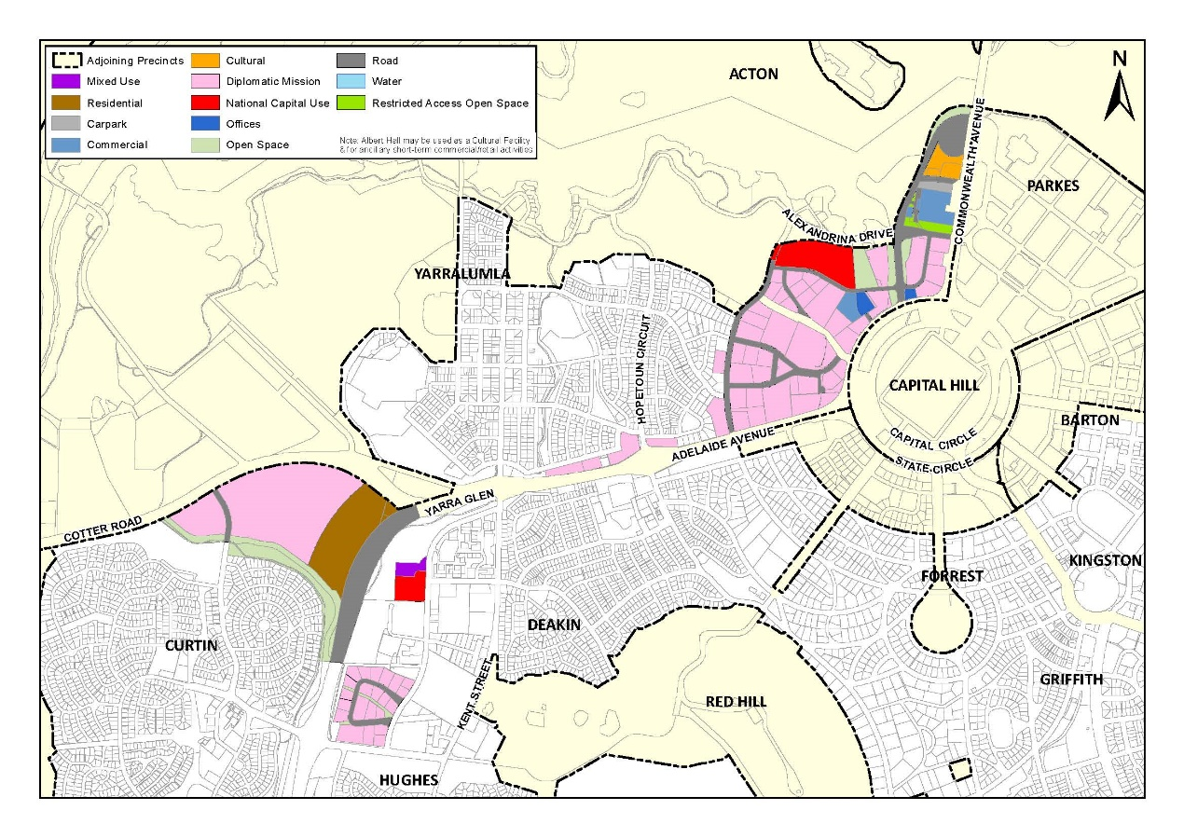

15 Section 4.14.4 Land use for the Diplomatic Precinct (Yarralumla, Deakin, O’Malley and Curtin)

Omit:

* Figure 124: Land use for the Yarralumla and Deakin Diplomatic Precinct

Substitute:

* Figure 124: Land use for the Yarralumla, Deakin and Curtin Diplomatic Precinct

16 Section 4.14.5 Detailed conditions of planning, design and development for the Diplomatic Precinct (Yarralumla, Deakin, O’Malley and Curtin)

Omit:

* Large bulky building form is to be avoided. The building by its form should follow the slope of the land, rather than contrasting with it.

The height of any building should not exceed two storeys above natural ground level.

The plot ratio should not exceed 0.35.

Externally exposed plumbing and mechanical plant including duct work will not be permitted. All mechanical plant and equipment should be contained within buildings or service yards and should be suitably screened from public view.

The design, material and colour of building roofs are of particular importance and should be sympathetic with that of surrounding development.

Substitute:

* Large bulky building form is to be avoided. The building by its form should follow the slope of the land, rather than contrasting with it.

The height of any building should not exceed three storeys above natural ground level.

Basements are permitted in addition to the number of storeys above natural ground level. Basements must be predominantly below natural ground level. Where the finished floor level of the storey immediately above the basement is greater than one metre above natural ground level, a basement will be considered a storey above natural ground level.

Plant and equipment should be contained within the roof form, in basements, or otherwise incorporated into building design and screened from view. Minor building elements for roof top plant are permitted where they do not increase the building height as it presents to public street frontages or other public places. Solar panels on roofs are permitted.

Buildings must be setback a minimum of 10 metres from street frontages. Side and rear setbacks are to be in accordance with Conditions of Lease and Development. With the exception of buildings associated with security measures, such as guard houses, all buildings must be set back in accordance with the above.

The plot ratio should not exceed 0.35.

Externally exposed plumbing and mechanical plant including duct work will not be permitted. All mechanical plant and equipment should be contained within buildings or service yards and should be suitably screened from public view.

The design, material and colour of building roofs are of particular importance and should be sympathetic with that of surrounding development.

17 Section 4.14.5 Detailed conditions of planning, design and development for the Diplomatic Precinct (Yarralumla, Deakin, O’Malley and Curtin)

Omit:

* Landscape design for individual blocks should seek to enhance the visual quality of the area and integrate the building with its landscape setting.

Landscaping should only be carried out in accordance with a Landscape Plan approved by the National Capital Authority.

Substitute:

* Landscape design for individual blocks should seek to enhance the visual quality of the area and integrate the building with its landscape setting.

Not less than 40% of total site area should be for soft planting area. Soft planting area means an area of permeable land within a block covered by trees, grass or lawn (not including synthetic turf), garden bed, shrubs (including hedges) and the like. Soft planting area does not include any area covered by buildings (including basement), swimming pools, vehicle parking or manoeuvring areas (whether permeable or not), or any other form of impermeable surface.

Mature trees should be retained to the maximum extent possible and integrated into landscape design. Where tree removal occurs, this must be compensated for by planting elsewhere on site.

A Tree Management Plan is to accompany landscape plans, outlining tree protection measures during construction activity for existing trees proposed for retention.

Landscape design must enhance environmental performance and microclimate. This could be achieved by planting appropriate trees near eastern and western façades for shade, planting a mix of evergreen and deciduous trees to provide shade in summer and allow sunlight access in winter, and incorporating green walls and roofs into building design.

Landscaping must only be carried out in accordance with a Landscape Plan approved by the National Capital Authority.

18 Section 4.14.5 Detailed conditions of planning, design and development for the Diplomatic Precinct (Yarralumla, Deakin, O’Malley and Curtin)

Omit:

* All car parking for staff and visitors should be accommodated wholly within the site.

Car parking areas should be landscaped to minimise their visual impact. The layout of proposed parking areas should be included in the Landscape Plan.

Garages and car ports will not be permitted forward of the building lines established along the frontage of individual blocks. All covered vehicle parking must be consistent in character with the architectural style of the main building, matching materials and finishes.

Substitute:

* All car parking for staff and day-to-day visitors must be accommodated wholly within the site. A parking report must be provided to demonstrate that adequate parking will be provided on site for all staff and day-to-day visitors.

A minimum 50 per cent of required car parking must be accommodated in basements to minimise visual impact and ensure that parking does not dominate site design.

On-grade parking is discouraged and will only be permitted if the following criteria are met:

* parking is located away from road frontages and other public places
* cars are screened from view to the maximum extent possible of streets, buildings, communal and private open space areas
* parking is incorporated into the landscape design of the site, by extending planting and materials into car parking space
* light coloured paving materials or permeable paving systems are used and shade trees are planted between every 4-5 parking spaces to reduce increased surface temperatures from large areas of paving.

The layout of proposed parking areas must be included in the Landscape Plan.

Garages and car ports will not be permitted forward of the building lines established along the frontage of individual blocks. All covered vehicle parking must be consistent in character with the architectural style of the main building, matching materials and finishes.

19 Section 4.14.5 Detailed conditions of planning, design and development for the Diplomatic Precinct (Yarralumla, Deakin, O’Malley and Curtin)

* Add a new section titled ‘Signs, lighting and other structures’ as follows:

Flagpoles, wireless masts, signs, security fencing, flood lighting, special security lighting and other like elements may be permitted between the site boundary and building setback. Where proposed, such elements must be complementary to architectural and landscape design, and demonstrate a consistency in design detail such as colour, materials and quality.

20 Section 4.14.5 Detailed conditions of planning, design and development for the Diplomatic Precinct (Yarralumla, Deakin, O’Malley and Curtin)

* Add a new section titled ‘Environmentally sustainable design’ as follows:

The NCA encourages environmentally sustainable design through the use of innovative technology, design and ongoing building operation. Development must seek to:

* reduce energy consumption, reduce total operating greenhouse gas emissions, and reduce peak demand through particular design measures such as appropriate building orientation, space allocation for solar panels, and shading to glazed surfaces
* improve water efficiency, reduce total operating potable water use, collect and reuse stormwater, use alternative water sources (such as greywater)
* provide a healthy indoor environment including the provisions of fresh air, cross ventilation and natural daylight, reduce reliance on mechanical heating, ventilation, lighting and cooling
* minimise noise levels and noise transfer within and between buildings and associated external areas
* incorporate the use of water sensitive urban design, including stormwater collection and reuse.

As a minimum:

Development should incorporate passive solar design to optimise heat storage in winter and reduce heat transfer in summer. Potential design options include the use of smart glass or other technologies (particularly on north and west elevations), maximising thermal mass in the floors and walls of north facing rooms, overhangs and shading devices such as awnings, blinds and screens.

Operable screening such as louvres, sliding, folding or retractable elements should be designed to provide shade and protection from natural elements. Operable screening elements must be integrated with building design.

Building design must incorporate shading and glare control, particularly to manage sun penetration in warmer months. Design features could include:

* balconies or sun shading that extend far enough to shade summer sun, but allow winter sun to penetrate living areas
* shading devices such as eaves, awnings, balconies, pergolas, external louvres
* horizontal shading to north facing window
* vertical shading to east and particularly west facing windows
* operable shading to allow adjustment.

21 Section 4.14.5 Detailed conditions of planning, design and development for the Diplomatic Precinct (Yarralumla, Deakin, O’Malley and Curtin)

* Add a new section titled ‘Site specific’ as follows:

Buildings and major structures on land identified for Residential use must be set back a minimum of 15 metres from Yarra Glen road reserve boundary.

No access to Residential land is permitted from Yarra Glen.

For Residential land, detailed conditions of planning, design and development must be approved by the National Capital Authority prior to development. Detailed conditions of planning, design and development must address (at a minimum):

* refined land uses
* building heights and setbacks to roads and boundaries other than those already identified in the National Capital Plan
* impact on, and interface with, the diplomatic estate
* subdivision
* access, road layout and car parking
* building form
* landscape structure and open space
* streetscape
* lighting
* design quality.

Detailed conditions of planning, design and development must be prepared in the context of a strategic planning exercise for the Adelaide Avenue/Yarra Glen corridor, and are subject to public consultation.

22 Section 4.19.1 Design and Siting General Code – Application

Omit:

* Yarralumla, Deakin, Red Hill and O’Malley Diplomatic Precincts

Substitute:

* Yarralumla, Deakin, Red Hill, O’Malley and Curtin Diplomatic Precincts