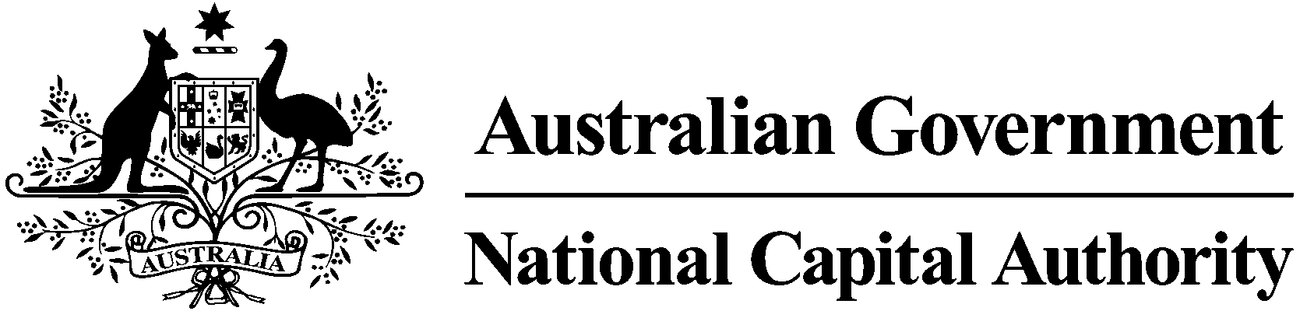

**CONSULTATION REPORT**

**National Capital Plan Draft Amendment 94 – National Arboretum Commercial Accommodation**

April 2020

**Contents**

Contents

1 Introduction 3

1.1 Background 3

1.3 Draft Amendment 94 3

2 Consultation 4

2.1 Consultation activities 4

2.2 Submissions received 4

3 Key Issues 4

3.1 Additional matters requiring clarification 4

4 Changes to the draft amendment 4

5 Conclusion 4

6 Attachments 4

Attachment A – Public notice in *The Canberra Times* 6

Attachment B – Government Gazette notice 7

Attachment C – Submissions received in response to Draft Amendment 94 8

# 1 Introduction

## 1.1 Background

Following the 2003 bushfires in Canberra, the ACT Government dedicated an area of burnt-out pine forest as the new site for a national arboretum. In 2004, a national design competition for the new arboretum was launched and in 2005, Taylor Cullity Lethlean Landscape Architects and Tonkin Zulaikha Greer Architects were announced winners with their joint proposal *'100 Forests and 100 Gardens*'.

The winningproposal focused on the establishment of 100 forests of rare, threatened and symbolic trees from Australia and around the world, and provided the foundation for a master plan for the National Arboretum Canberra (NAC). Work on the arboretum commenced in 2005. The Village Centre, Margaret Whitlam Pavilion, Pod Playground and Discovery Garden have all been completed. Substantial progress has been achieved in road, track, signage and car park improvements and in lighting, water harvesting and recycling, irrigation and water storage.

The NAC currently features 94 forests, with the remaining six forests still to be planted. Over 44,000 trees from over 100 countries are growing across the 250 hectare (618 acre) site, making it one of the world's largest living collections of rare, endangered and significant trees.

The NAC is currently managed by the ACT Government through the Chief Minister, Treasury and Economic Development Directorate (CMTEDD).

Hotel accommodation was included on the NAC’s original competition brief and master plan. The 2006 Master Plan Report identified a hotel, conference centre and carpark on the southern side of Dairy Farmers Hill.

The master plan was updated in 2018 and the hotel remains in the plan. The ACT Government’s CMTEDD requested an amendment to the National Capital Plan (the Plan) to facilitate the proposal.

## 1.3 Draft Amendment 94

DA94 proposed two key changes to the Plan:

1. Add ‘Commercial Accommodation’ and ‘Personal Service Establishment’ as permitted uses within the Hills, Ridges and Buffer Spaces land use policy area (for defined forests within the NAC only).

Commercial Accommodation as defined under the Plan means *‘a building or place used for the purpose of providing temporary accommodation and includes a hotel, motel, guest house, caravan park/camping ground, serviced apartment, serviced house and the like’*. Given the sensitive nature of the site, it is proposed to restrict land use to hotel accommodation only. Motels, guest houses, caravan park/camping ground, serviced apartment, serviced houses will not be permitted.

1. Introduce detailed conditions of planning, design and development to guide the design and siting of commercial accommodation facilities on the site. These conditions set out requirements pertaining to such matters as built form, architectural and landscape quality, parking and movement, lighting, and signage.

DA94 was released for public consultation between 1 February and 16 March 2020. This report summarises the issues raised during the public consultation process undertaken by the NCA on DA94 to the Plan.

# 2 Consultation

## 2.1 Consultation activities

On 1 February 2020, the NCA released DA94 for public consultation. The public consultation period ran for six weeks in accordance with the NCA’s ‘Commitment to Community Engagement (August 2015)’, concluding on 16 March 2020. DA94 was available of the NCA’s website, and hard copies were available on request.

Key activities during the public consultation period included:

* On 1 February 2020, a public notice was published in *The Canberra Times* (Attachment A).
* On 3 February, the NCA referred DA94 to the ACT Government’s Environment, Planning and Sustainable Development Directorate (EPSDD) in accordance with section 15(1) of the *Australian Capital Territory (Planning and Land Management) Act 1988*.
* On 4 February 2020, a notice was published in the *Government Notices Gazette* (Attachment B).
* During the consultation period, social media was utilised to advertise DA94.
* On 10 February 2020, the Office of Best Practice Regulation advised that no Regulation Impact Statement would be required for DA94.
* On 13 February 2020, the NCA hosted a public information session at the National Capital Exhibition. Seven members of the public attended. A representative from the NAC was also in attendance.
* On 12 March 2020, EPSDD advised the NCA that it had no objection to DA94.

## 2.2 Submissions received

Seven submissions were received in response to DA94, with submissions provided by individuals, community groups, and the ACT Government.

The key issues raised during the public consultation period are summarised in section 3 of this report. Details of submissions are available in Attachment C.

## 2.3 Social and other media

Articles about DA94 appeared in the Canberra Times, the Riot Act, and the NCA’s Chief Executive participated in a radio interview. Public comment was made on the Canberra Times and Riot Act articles, with many issues raised also reflected in formal submissions received by the NCA.

# 3 Key Issues

## 3.1 Hotel concept

***Comments received***

Support was received for the concept of a hotel. One submitter noted the opportunity for the resort and wellness centre to cater and provide bursary programs to patients of the Canberra Region Cancer Centre as part of a referral system for their patients. Such an arrangement could help provide respite for patients and their families, and allied health services could be co-located on site. Funding potentially form public donors to the existing cancer centre, or possibly the National Disability Insurance Scheme (NDIS).

Objections to the hotel concept generally centred on additional commercial uses at the arboretum (refer section 3.4 of this report).

***NCA response***

Comments concerning the use of the accommodation and associated facilities in providing bursary support to patients of the Canberra Region Cancer Centre were provided to the National Arboretum Canberra for their consideration. The operation and management of the accommodation facilities is a matter for decision by a future operator.

The NCA’s response to objections concerning the hotel concept is provided in section 3.4 of this report.

## 3.2 Scale of development

***Comments received***

Comment was received that the proposed footprint of the accommodation is so large that it would ultimately change the entire character of the arboretum. The buildings will also replace tree plantings, notably two of the planned forest, thus reducing the number of forests.

Buildings on the site proposed will interrupt vistas and detract from existing views, a key attraction of the arboretum.

***NCA response***

The drawing in the draft amendment identifying the restricted location for ‘Commercial Accommodation’ and ‘Personal Services Establishment’ does not illustrate the building footprint. This drawing effectively contains the area is which buildings must be located (that is, no buildings must be constructed outside the envelope provided), however written policies further restrict the nature of the built form. For example, built form is to consist of a series of buildings within a generous landscape setting.

While new buildings will remove the capacity for some future tree plantings, trees planted as part of landscape works for new development must be predominantly those species identified on the arboretum master plan for each respective forest.

Amendment 94 contains provisions to ensure that new buildings do not detract from existing views and vistas. These provisions include:

* Landscape design must ensure that when trees are mature, development of the site does not significantly detract from the view from Dairy Farmers Hills.
* Planting on buildings and structures is encouraged as a way of enhancing the integration between built form and landscape.
* A visual analysis must be undertaken to demonstrate the impact of development from key vantage points such as Lake Burley Griffin and the Governor-General’s residence.

The NCA is confident that new buildings can be sensitively placed on the site whilst upholding the landscape character of the inner hills and the national arboretum.

## 3.3 Movement, parking and access

***Comments received***

Submitters raised concern that commercial accommodation will cause increases in traffic and change the character of what at the moment is a low key road which is of low risk to foot traffic of visitors to the arboretum.

The ACT Government raised the following matters for the NCA’s consideration:

1. As part of the NAC Trails Concept Plan, recreational trails for walking and cycling have been recently constructed at the arboretum. These could be considered as part of the design and siting of accommodation facilities. Forest Drive is a designated cycling route and the design of the proposed vehicle access could take this into consideration.
2. The Molonglo Valley Stage 3 Planning and Design Framework identifies the possibility of a future road between the NAC and Molonglo Stage 3. DA94 refers to a secondary and emergency vehicle access. It is unclear where DA94 is referring to this future road or another connection for the proposed development. If it is referring to the same future road identified in the Molonglo Valley Stage 3 Planning and Design Framework, it should be noted that the suburban road network is not expected to be available until approximately 2030.

***NCA response***

Small increases in traffic are expected as part of the development of accommodation and supporting facilities. The NCA’s works application process requires the submission of a traffic and parking assessment report which considers the potential impact on the area, vehicle access and egress, parking arrangements and road capacity. Amendment 94 also specifically requires that proposed access arrangements demonstrate consideration of increased traffic on Forest Road as visitation to the NAC increases.

Reference in Amendment 94 to secondary/emergency vehicle access is not a reference to the future road between the NCA and Molonglo Stage 3. It is a recognition that a second access point directly associated with the hotel and associated facilities will be required in the short term. A future road between the NAC and Molonglo Stage 3 may provide a permanent, long term solution.

The NCA agrees that existing recreational trails could be taken into consideration during detailed planning and design of accommodation and associated facilities, and that access to the site should consider the role of Forest Drive as a designated cycling route.

Two changes have been made to ‘Access, parking and movement’ provisions:

1. A new provision has been added that path networks across the site must:

*Demonstrate consideration of existing recreation trails and how these integrate with new facilities and infrastructure.*

1. The provision requiring consideration of increased traffic on Forest Drive has been amended to read:

*Access arrangements must demonstrate consideration of increased traffic on Forest Road as visitation to the National Arboretum Canberra increases, and the role of Forest Drive as a designated cycling route. The design of access arrangements should be designed to ensure pedestrian and cycle priority, and that conflict between vehicles, and cyclists and pedestrians, is minimised.*

## 3.4 Commercialisation of the arboretum

***Comments received***

Strong concerns were expressed by the Weston Creek Community Council and two individuals about the commercialisation of the NAC. This concern was in regard to both commercial accommodation and ‘wellness’ facilities. The NAC is viewed as a public asset, and the introduction of commercial businesses into the precinct will detrimentally impact public use and amenity of the NAC generally. The proposed facilities have been described as ‘boutique’ and ‘bespoke’, which suggests a high end facility out of reach of many people. The arboretum should be open and accessible to all member of the community, however the proposed facilities are likely to be accessible to only a few. This is not consistent with the vision, mission and objectives of the NAC.

Concern was also expressed that allowing commercial uses will set a precedent, and that operators will likely want to expand facilities in the future. A suggestion was made that if the ACT wishes to have accommodation facilities connected with the arboretum, land could be made available nearby, but outside the boundaries of the arboretum.

***NCA response***

Hotel accommodation at the NAC has been envisaged from inception of the arboretum in 2003. Hotel accommodation was included on the NAC original competition brief in 2004, subsequent master plan prepared in 2006, and latest version of the master plan dated 2018.

The NAC will remain a public facility, with the vast majority of land and facilities available for general public use. The additional of commercial accommodation and associated facilities will not alter the visitor experience, activities or programs provided by the NAC. Public events, guided talks, recreational trails, as well as the capacity for the arboretum to host public and private events (for example, weddings) will not be diminished.

The NCA Board has supported commercial accommodation and associated facilities with the requirement that new development is modest in scale, sits within the landscape and does not significantly detract from views to the arboretum or from within the arboretum (such as from Dairy Farmers Hill). Amendment 94 was drafted explicitly to limit the nature and extent of development that can occur.

Further amendment to the Plan would be required to facilitate an expansion of the facilities beyond that permitted by Amendment 94. Provisions of Amendment 94 will result in development that does not compromise principles and policies of the Plan. Whilst these principles and policies of the Plan remain in place, further development is unlikely to be supported.

## 3.5 Principles of the National Capital Plan

***Comments received***

One submitter noted that a key principle of the Plan is to ‘protect the undeveloped hill tops and the open spaces which divide and give form to Canberra’s urban areas’. The Inner Hills provide the scenic backdrop and natural setting for the city, and the proposed hotel location is visible from a number of vantage points, potentially narrowing the divide between urban and non-urban areas.

Proposed landscape plantings are unlikely to provide the screening necessary to give the illusion of an undeveloped hill top or provide adequate screening. Light spill from any commercial accommodation or wellness facilities may also impact the division between urban and non-urban areas.

***NCA response***

In supporting the proposed location of the hotel, the NCA considered all relevant objectives, principles, and policies of the Plan. The NCA has taken the view that ‘protect the undeveloped hill tops and open spaces’ does not mean that no development can occur, but that those buildings and structures placed into the landscape must be sympathetic to their surroundings and that the essential landscape and environmental character of the hill areas is retained.

## 3.6 Heritage

***Comments received***

The ACT Heritage Council advised that the area subject to the draft amendment does not contain any registered or recorded heritage places or objects subject to the provisions of the ACT *Heritage Act 2004*.

The ACT Heritage Council did however, note that a heritage assessment was completed in 2006, and a salvage program undertake in 2006, covering the subject area. It was advised that section 4 of the 2008 report dealing with the discovery of Aboriginal heritage is no longer current and that any new discoveries will require all works within 20 metres to cease until advice from the Council to proceed is provided. Provisions of the *Heritage Act 2004* for reporting the discovery of Aboriginal places or objects must be adhered to.

The Weston Creek Community Council (WCCC) noted that the Australian Government is currently considering a nomination of Canberra to the National Heritage List. An identified value of the proposed listing in the setting of Canberra within the Inner Hills with an unbroken skyline. The WCCC suggested deferring a decision on the draft amendment until a determination has been made on the Canberra National Heritage listing.

***NCA response***

The NCA notes the comments from the ACT Heritage Council. The discovery of Aboriginal heritage will be managed in accordance with the provisions of the *Heritage Act 2004* during the construction phase.

## 3.7 Sustainability

***Comments received***

DA94 could also include provisions requiring consideration of resilience to extreme weather events and their impacts, including bushfire protection measures and smoke mitigation.

Development within the Molonglo Valley will ultimately be at an approximate distance of 200 metres from the proposed development. Provision could be made to ensure that future residents are not adversely impacted by noise from the commercial accommodation use.

***NCA response***

The NCA agrees that the addition of provisions concerning resilience to extreme weather events would be valuable. The relevant design and siting conditions have been amended to read:

*Development must demonstrate consideration of climatic conditions, including wind and heat. Proposals must also demonstrate consideration of resilience to extreme weather events, such as bushfire, and the measures proposed to manage the impacts from such events.*

The NCA’s view is that the greatest potential noise source associated with the accommodation facilities will be from the common areas of the accommodation facilities (for example, a restaurant). These are located at sufficient distance, and with significant existing plantings in between, that noise is unlikely to be an issue. Future development will need to consider all noise sources as detailed planning and design is undertaken.

## 3.8 Design and siting conditions

***Comments received***

EPSDD noted that residential development within the Molonglo Valley will ultimately be located approximately 200 metres from the proposed accommodation facilities. The NCA may wish to reflect this in DA94, for example by recognising that the views to the west, towards the Brindabella ranges, is likely to change.

The Weston Creek Community Council supported the general design principles should ‘Commercial Accommodation’ and ‘Personal Services Establishment’ should these land uses be approved for the site. In particular, the preservation of the landscape needs to take precedence over all other considerations, and that landscaping and the built environment need to complement the existing nature and slope of the proposed sites. Principles of the draft amendment are supported in their intent to preserve the landscape of the site.

Whilst the community council supported the majority of the design and siting provisions, several suggestions were made:

* All buildings should be limited to a single storey to limit the visual impact of development on the landscape.
* Additional provision could be included to address alternative vehicle access arrangements when events occur.
* Lighting should meet or exceed the National Light Pollution Guidelines for Wildlife recently distributed by the Department of Agriculture, Water and the Environment.

***NCA response***

The NCA acknowledges that future development within the Molonglo Valley will alter both distant and more immediate views from Forests 69 and 76. The intent is that development takes advantage of distant views where possible, rather than more immediate views in the Molonglo Valley. Views in all directions will change over time, however the NCA considers that it is not necessary to include this in policy.

The NCA notes support for many of the design and siting provisions. These were drafted with the intent of upholding principles and policies of the Plan concerning the Inner Hills and the function of the landscape. In response to those matters raised by the Weston Creek Community Council:

* The NCA is of the view that two storey buildings are suitable in some locations. Provisions of Amendment 94 require a visual analysis to be undertaken to demonstrate the impact of development from the Central National Area and key vantage points such as Lake Burley Griffin, the Governor-General’s residence and Parliament House. This analysis will need to demonstrate that any two storey buildings achieve the objectives for buildings to site within the landscape setting of the Inner Hills and for the landscape to remain the dominant feature.
* The NCA’s works application process requires the submission of a traffic and parking assessment report which considers the potential impact on the area, vehicle access and egress, parking arrangements and road capacity. The NCA will request that this addresses traffic impacts at peak or event times. Any traffic and parking assessment report will form part of documentation notified as part of the public consultation process on development proposals.
* The NCA’s Outdoor Lighting Policy is applicable to proposals at the NAC. Provisions of this policy include minimising the impact of lighting on wildlife, and ensuring that the design and operation of lighting does not cause wildlife (including avifauna) disorientation, injury or death.

## 3.9 Other matters

***Comments received***

Other matters raised included:

1. One submitter suggested that the proposed amendment amounts to unlawful racial discrimination under the *Racial Discrimination Act 1975*. The submitter’s view is that Aboriginal interests in the land are being ignored to allow for commercial opportunities. The draft amendment ignores local Aboriginal land interests as if the Mabo case in 1992 and subsequent Native Title legislation does not affect any government.
2. The NCA and ACT Government should prioritise stakeholder consultation at all stages of the development.
3. In regard to built form, the draft amendment requires that buildings on the southern slope of the site, within Forest 76, must be not more than seven metres above datum ground level in height and two storeys. The NAC suggested that this is achievable provided that the measurement is taken at the intersection of the highest point of built form with the natural ground level (ie up the slope not down the slope). Clarification was requested that this is the intent of this clause.
4. The NAC raised concern that the statement that additional amenities such as a restaurant and supporting back of house facilities are permitted within the hotel where is can be demonstrated that they are necessary for the successful operation of the hotel may be restrictive. The NAC suggested that small meeting spaces in addition to restaurant facilities are required, and requested that the statement could be broadened to include ‘additional guest facilities or similar’.

***NCA response***

1. The issue of Aboriginal land ownership and title is addressed through the *Native Title Act 1993* (Native Title Act). The Native Title Act recognises and protects native title. Native title describes the recognition by the Australian legal system of rights and interests of Aboriginal and Torres Strait Islander peoples to land and waters according to their traditional laws and customs.

The Native Title Act was a result of the historic Mabo decision by the High Court of Australia in 1992. This decision resulted in the High Court:

* rejecting the doctrine that Australia was *terra nullius* at the time of European settlement
* holding that the common law of Australia recognises a form of native title that reflects the entitlement of the indigenous inhabitants of Australia, in accordance with their laws and customs, to their traditional lands
* holding that native title is extinguished by valid government acts that are inconsistent with the continued existence of native title rights and interests, such as the grant of freehold or leasehold estates.

Special procedures for the just and proper ascertainment of native title rights and interests are established under this legislation. A search of the National Native Title Register indicates that that there have been no attempts to establish native title over land within the ACT.

1. The NCA will undertake public notification and consultation for all major proposals at the NAC, including proposals for accommodation and associated facilities.
2. In regard to building height for buildings two storeys in height, the NCA confirms that is that the maximum of seven metres is measured at the intersection of the highest point of built form with the natural ground level (ie up the slope not down the slope). This provisions has been amended to read:

*Buildings on the southern slope of the site, within Forest 76, must be no more than seven metres above datum ground level in height and two storeys. The maximum height of seven metres is to be measured at the intersection of the highest point of built form with the natural ground level.*

1. The intent of the reference to ‘supporting back of house facilities’ is to permit those facilities typically required for the general operation of a hotel. This includes staff meeting rooms and the like, but not include conference rooms for hotel occupants or those external to the hotel. The NCA does not support a change to this clause.

# 4 Changes to the draft amendment

Three changes to DA94 as release for public consultation have been made:

1. In addition to climatic conditions such as wind and heat, proposals must also demonstrate resilience to extreme weather events such as bushfire and how impacts will be mitigated.
2. In addition to the requirement for access arrangements to demonstrate consideration of increased traffic on Forest Road as visitation to the National Arboretum Canberra increases, proposals must also consider the role of Forest Drive as a designated cycling route. Access arrangements must provide priority to pedestrians and cyclist and be designed to minimise conflict.
3. The point at which the height of two storey buildings are measured has been clarified.

# 5 Conclusion

On 1 February 2020, the NCA released DA94 for public consultation. The public consultation period ran for six weeks in accordance with the NCA’s ‘Commitment to Community Engagement (August 2015)’, concluding on 16 March 2020.

Seven written submissions were received in response to DA94.

# 6 Attachments

1. Notice of release of DA94 for public consultation published in *The Canberra Times*
2. Notice of release of DA94 for public consultation published in the *Commonwealth Notices Gazette*
3. Submissions received

## Attachment A – Public notice in *The Canberra Times*

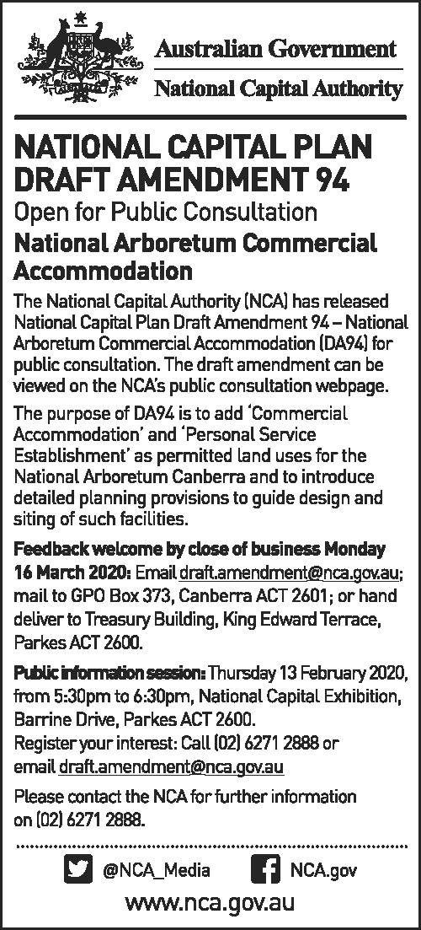

## Attachment B – Government Gazette notice

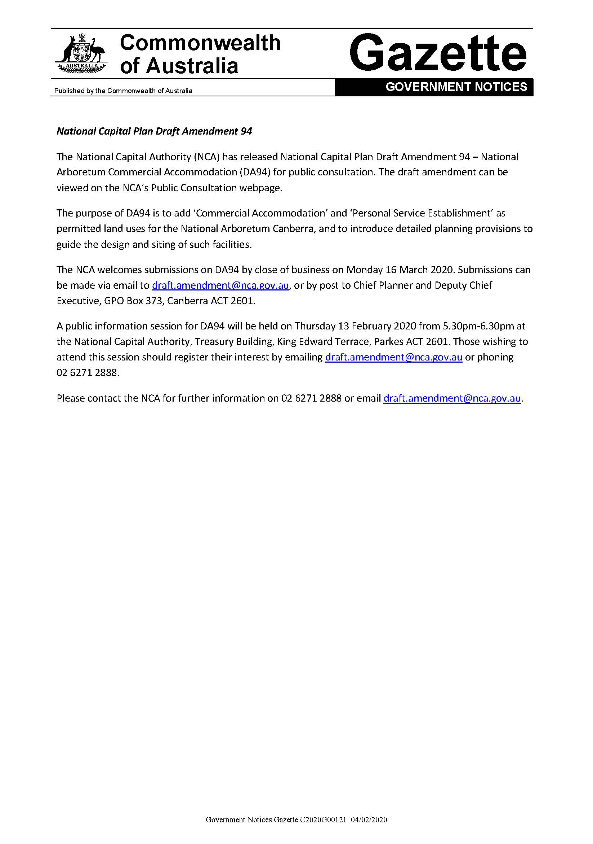

## Attachment C – Submissions received in response to Draft Amendment 94

The text provided below largely reflects the full submission received. Personal details or identifying information (where people have requested anonymity) have been removed. Some minor changes have been made (for example, to correct spelling or to provide consistency of terms used in this report).

As noted in the draft amendment documentation, the NCA seeks and open and transparent draft amendment process. The name of each person has been published, except where requests for confidentiality were made through submissions or in discussions with officers of the National Capital Authority.

|  |  |  |
| --- | --- | --- |
| ***No*** | ***Submitter name*** | ***Submission*** |
| 1 | Elizabeth Pickworth | I am a resident of the Molonglo Valley and I am in support of the proposed development of an eco-wellness resort at the National Arboretum.  I would like to further endorse the idea of the resort to cater and provide bursary programs to patients of the Canberra Region Cancer Centre as part of a referral system for their patients.  I am a rare cancer patient that has been helped tremendously by ACT Health and the Canberra Region Cancer Centre and I truly believe a resort in the ACT would help patients and their families get some much needed respite.  Along with a holiday, there could be allied health services such as a Psychologist and an Oncology Chef on site and yoga/healthy eating program where guests can learn to cook healthy meals with their health requirements at the forefront of their meal planning. There wouldn't need to be any other health services on site but it would allow for on demand or group therapy in the form of psychological support for patients and their families.  Funding could come from public donors to the Canberra Region Cancer Centre, possible support from the NDIS (if it includes the scope of cancer patients) and along with horse-riding already at the Arboretum, it could also provide hippotherapy to guests as part of their treatment/recovery.  As a passionate resident of the Molonglo Valley with a lived experience of cancer and its effects on one's own family, I believe many other people in the same boat would also welcome this idea.  Originally I was going to try and raise funds for this to be established in the NSW South Coast for residents of the ACT and Regional NSW, however, it would require significant capital and with an eco-wellness resort already (possibly) planned for the ACT, I think this would be a much more suitable option. |
| 2 | Ruth Palavestra | Having reviewed the proposed plan to develop commercial accommodation at the National Arboretum, I wish to place my strong objection.  My objections are based on the following grounds:  1) The proposed footprint of the accommodation is so large that it would ultimately change the entire character of the arboretum.  2) Introduction of a commercial precinct into the publicly owned precinct will require change to many of the operating processes in order to ensure the commercial venture makes maximum profit, and these changes must necessarily reduce access and amenity for the general public.  3) Having a commercial accommodation will cause increases in commercial traffic and change the character of what at the moment is a low key road which is of low risk to foot traffic of visitors to the arboretum.  4) The actual footprint of the proposed development will replace arboreal plantings, specifically 2 of the planned forests, to the detriment of the arboretum. 100 Forests means 100 forests, not 99 or 98.  5) Introduction of a commercial venture however small is always the thin end of the wedge. Operators would eventually always push for more space and more development.  6) A part of the attraction of the arboretum is the serenity and the long uninterrupted panoramic vistas. Building into that vista will detract from those views.  I visit the arboretum at least once per month as a minimum, usually more often. I will be very disappointed if the Government capitulates to commercial opportunity pressures at the expense of the actual owners of this facility, the taxpayer.  If the government sees a need for accommodation close to the arboretum, then please allocate space outside and adjacent to the arboretum precinct. And make the developers pay a commercial price for that land. |
| 3 | ACT Heritage Council | Thank you for seeking ACT Heritage Council (the Council) comment on the draft amendment to the National Capital Plan for Block 74 Molonglo Valley (DA94).  The Council understands that DA94 proposes to vary the land use policy of the block to add ‘Commercial Accommodation’ and ‘Personal Service Establishment’ as permitted land uses for a small section of the National Arboretum Canberra (NAC), within Forests 69 and 76, and to introduce detailed planning provisions to guide the design and siting of such facilities.  Review of the ACT Heritage Register identifies that the subject area does not contain any registered or recorded heritage places or objects subject to *Heritage Act 2004* provisions.  The Council understands that a heritage assessment was completed, AASC 2006 *Canberra International Arboretum and Gardens Heritage Survey*, and a salvage program undertaken, AASC & CHMA 2008 *Canberra International Arboretum and Gardens Cultural Heritage Salvage Program*, covering the subject area.  The Council also notes that Section 4 of the 2008 report dealing with the discovery of Aboriginal heritage is no longer current and that any new discoveries will require all works within 20m to cease until advice from the Council to proceed is provided and that provisions of the *Heritage Act 2004* for reporting the discovery of Aboriginal places or objects within five working days after the day of the discovery must be adhered to. |
| 4 | National Arboretum Canberra | I am writing to you in relation to the National Capital Plan Draft Amendment 94 – National Arboretum Commercial Accommodation (DA94) which is currently out for public consultation.  After consulting with Tonkin Zulaika Greer (TZG), responsible for the Concept Design Package, Dain Simpson and AHS, the authors of the Feasibility Study, the National Arboretum Canberra (NAC) would like to provide the following written comments on DA94 as part of the public consultation process.   1. Part 2 of Draft Amendment 94: Built Form   States that *“Buildings on the southern slope of the site, within Forest 76, must be no more than seven metres above datum ground level in height and two storeys”.*  TZG believes that this is achievable provided that the measurement is taken at the intersection of the highest point of built form with the natural ground level – i.e. up the slope, not down the slope – please see Attachment A.  The NAC would appreciate clarification of this statement.   1. Part 2 of Daft Amendment 94: Design and Siting   States that *“Additional amenities such as a restaurant and supporting back of house facilities are permitted within the hotel where it can be demonstrated that they are necessary for the successful operation of the hotel”.*  There is some concern that these stipulations could be restrictive to a potential operator. With the room limit set at 40, it is imperative that the facility be able to host small residential retreats as identified in the Feasibility Study. This would require flexible spaces including small meeting spaces in additional to restaurant facilities.  The NAC would appreciate a broadening of this statement to include ‘additional guest facilities’ or similar.  I appreciate the work you and the NCA Board have provided into Draft Amendment 94 and look forward to continuing to work with you in this exciting NAC project. |
| 5 | Weston Creek Community Council | The Weston Creek Community Council (WCCC) welcomes the opportunity to comment on *Draft Amendment 94 – National Arboretum Commercial Accommodation*. WCCC notes the purpose of the amendment is to facilitate the development of commercial accommodation on the grounds of the National Arboretum Canberra and introduce detailed planning provisions to guide the design and siting of such facilities.  WCCC **does not support** *Draft Amendment 94 – National Arboretum Centre* in its current form.  WCCC does not believe that the proposed development of commercial accommodation on the site is in line with the Objectives of the National Capital Plan. Nor is the development of commercial accommodation in line with the Vision, Mission and Objectives of the National Arboretum Centre. Further, we recognise the importance of the National Arboretum Centre as a place for all Canberrans to enjoy, and express concern that the proposed accommodation will only be accessible to more wealthy visitors and community members.  **Part 1: Context**   1. **Consistency With the Objectives of the National Capital Plan**   WCCC notes that a key objective of the National Capital Plan is the ‘protection of undeveloped hill tops and the open spaces which divide and give form to Canberra’s urban area’. Draft Amendment 94 notes that the National Arboretum Centre site forms part of the Inner Hills, and is therefore afforded special protections under Canberra’s planning laws (in line with the objective above).  WCCC notes the importance of Inner Hills in providing a scenic backdrop and natural setting within Canberra’s urban areas. We further note that the Arboretum’s designation as a ‘Park’ is a key reason preventing the development of commercial accommodation on the site, as the ‘Park’ designation limits the types of facilities that can be built.  WCCC is of the view that any change to the defined land use within the Plan for the National Arboretum Centre site needs to take into consideration consistency with the objectives of the Plan, namely those noted above relating to the protection of undeveloped hill tops. WCCC questions whether a strong case has been made to warrant a change to the defined land use that, in our view, would not be consistent with the objectives of the National Capital Plan to protect undeveloped hill tops and open spaces.  WCCC notes that the location of the proposed sites for commercial accommodation (Forest 69 and Forest 76) will be visible from a range of vantage points, potentially narrowing the divide between Canberra’s urban and protected areas. We note that this is also not consistent with the objective outlined above. We note the plantation of Radiata Pine and Chinese Golden Larch are unlikely to provide adequate screening. WCCC further notes that light illumination from the facility will further narrow the divide between Canberra’s urban and protected areas.  Given these considerations, WCCC is not confident that the construction of commercial buildings on the proposed site is consistent with the objectives of the National Capital Plan.   1. **Canberra As A Heritage Site**   WCCC notes that the Commonwealth Government is currently considering the possible inclusion of Canberra in the Commonwealth Heritage List. We note that the National Capital Authority supports inclusion, as the Australian Heritage Council has found that Canberra meets the National Heritage Criteria. We also note that the setting of Canberra within the natural appearance of the Inner Hills (of which the Arboretum is a part) with an unbroken skyline of ridges is an important aspect of the proposed heritage listing.  Given the importance of the Inner Hills to the Commonwealth Heritage Listing consideration, WCCC supports deferring a decision on this amendment to the National Capital Plan until a determination has been made by the Commonwealth Minister for Environment.   1. **Other Considerations**   ***Consistency with Vision, Mission and Objectives of National Arboretum Canberra***  WCCC notes that the Vision for the National Arboretum Canberra is to be an internationally recognised arboretum with outstanding beauty, community amenity and scientific value. WCCC notes that the Mission of the National Arboretum Centre is to create and nurture a living collection of forests of international significance for recreation, education and conservation. WCCC notes that objectives of the National Arboretum Canberra are to foster an ongoing relationship with local, national, international, government, community and corporate interests; engage visitors in stimulating, enjoyable experiences that build community engagement and increase their understanding of the Arboretum and its role; and ensure that the living collection is guided by a well-defined curatorial approach and managed to ensure high quality standards.  WCCC questions if the construction of commercial accommodation is in line with the Vision, Mission and Objectives of the National Arboretum Canberra, and we strongly encourage the National Capital Authority to consider this in its decision. While we note that commercial accommodation may have a community amenity benefit for the small group of people who are expected to stay at the planned boutique accommodation, we are unsure if this benefit extends to other users of the National Arboretum Canberra. Further, we are concerned about the impact of commercial accommodation on the living collection and do not consider the provision of accommodation to be in line with the ‘creating and nurturing’ mission.  ***Equity Considerations***  WCCC notes the inclusion of construction of commercial accommodation at the National Arboretum Centre in the *National Arboretum Canberra Master Plan 2018*, and that the Master Plan describes the planned accommodation as ‘boutique’ and ‘bespoke’ with a range of facilities. Further, WCCC notes recent media on the planned development has described the facility as an ‘eco lodge and luxury wellness retreat’ and a ‘six or seven star hotel’. WCCC also notes that the design principles outlined in Part 2 of the Draft Amendment lend themselves to the development of a ‘high end’ luxury facility.  WCCC notes that the National Arboretum Canberra is a facility that should be open and accessible to all members of our community, regardless of their income status. We note the inherent inequity of developing an accommodation facility that will be only accessible to those with significant financial resources . We also note that this is not in line with the Vision, Mission and Objectives of the National Arboretum Centre as outlined above.  **Part 2: General Principles and Policies**  ***Amendments to the National Capital Plan***  As noted in our Submission, WCCC **does not support** amendments to the National Capital Plan to provide for commercial accommodation on Forest 69 and Forest 76. Nor do we support amendments to provide for personal services establishments on Forest 76.  ***General Principles and Policies***  While WCCC does not support the development of commercial accommodation on the National Arboretum Centre, should such a development be approved, we **support** the general design principles outlined in the Draft Amendment.  First and foremost, WCCC believes that the preservation of the landscape needs to take precedence over all other considerations, and that landscaping and build environments need to complement the existing nature and slope of the proposed sites. We believe that principles (i), (iii) and (iv) go to the intent of preserving the landscape of the site.  WCCC notes the importance of adhering to the design principles that have been outlined and encourages the National Capital Authority to strictly enforce these design principles.  WCCC notes that it will be important that the public is consulted on the design of the commercial accommodation at all stages of the development, and we encourage both the National Capital Authority and the ACT Government to prioritise strong stakeholder consultation.  ***Location***  Should the National Capital Plan be amended to support commercial accommodation, WCCC strongly supports the restriction of commercial accommodation to Forest 69 and 76.  ***Built Form***  Should the National Capital Plan be amended to support commercial accommodation, WCCC does not support buildings of two storeys and recommends that all buildings be restricted to a single story to limit the visual impact of the development on the landscape. We support the requirement that buildings be visually recessive and sit within the landscape.  WCCC strongly supports the requirement that a visual analysis be undertake to demonstrate the impact of the development from the Central National Area and key vantage points.  ***Design and Siting***  Should the National Capital Plan be amended to support commercial accommodation, WCCC supports the requirement for any design of commercial accommodation to demonstrate excellent in architecture, landscape architecture and urban design. WE further support best practice environmental design.  ***Landscape***  Should the National Capital Plan be amended to support commercial accommodation, WCCC supports the landscaping requirements outlined in the Draft Amendment.  ***Access Parking and Movement***  Should the National Capital Plan be amended to support commercial accommodation, WCCC supports parking being incorporated into the landscape design of the site. Further, WCCC strongly supports the provision of adequate disability parking and path networks that can accommodate wheelchairs.  WCCC expresses concern over the increased flow of vehicles and its impact on the National Arboretum Canberra and their impact on other users of the precinct, especially walkers, runners and cyclists. We note that increased car and bus traffic will create increased risks for other users and we encourage other users to be given priority in terms of traffic flow.  WCCC notes the pressure the single access point to the site is under at peak times or when a special event is conducted. We suggest the draft amendment could be enhanced by clearly specifying the proposed alternative vehicle access arrangements to the site rather than leaving it to further consultation, presumably outside the approval process.  ***Signage***  Should the National Capital Plan be amended to support commercial accommodation, WCCC supports the signage requirements outlined in the Draft Amendment.  ***Lighting***  Should the National Capital Plan be amended to support commercial accommodation, WCCC supports the lighting requirements outlined in the Draft Amendment. We note that the lighting requirements should have particular regard to any adverse impacts on the amenity of the Weston Creek and Molonglo Valley residential areas. In addition, the lighting should meet or exceed the National Light Pollution Guidelines for Wildlife recently distributed by the Department of Agriculture, Water and the Environment. |
| 6 | Environment Planning & Sustainable Development Directorate | Thank you for your letter of 3 February 2020 providing the ACT Government with the opportunity to comment on the Draft National Capital Plan Amendment (DA94). The proposed changes to the plan include adding ‘Commercial Accommodation’ and ‘Personal Service Establishment’, specifically hotel accommodation and associated facilities, as permitted land uses and introducing detailed planning provisions to guide the design and siting of such facilities. The Environment, Planning and Sustainable Development Directorate has coordinated comments on DA94 on behalf of the ACT Government agencies.  DA94 is supported with the following comments provided for consideration:  **Molonglo Stage 3 Development**   * DA94 notes that ‘any design will want to take advantage of views across Lake Burley Griffin to the city as well as to the Brindabella mountain ranges to the west’. The land to the west and south of the National Arboretum forms part of the future suburban area of Molonglo Valley (i.e. Molonglo Valley Stage 3), which is already zoned by the National Capital Plan and the Territory Plan for future urban redevelopment. * By approximately 2030, urban development is expected to be occurring in the immediate vicinity of the proposed development, refer to Figure 1 in the Molonglo Valley Stage 3 Planning and Design Framework ([www.planning.act.gov.au/__data/assets/pdf_file/0003/1348005/Molonglo-Planning-and-Design-Framework-Stage3-ACCESS.pdf](http://www.planning.act.gov.au/__data/assets/pdf_file/0003/1348005/Molonglo-Planning-and-Design-Framework-Stage3-ACCESS.pdf)). Future suburban development could potentially be within approximately 200m of the proposed development. As such, the setting and backdrop will significantly change and the NCA may wish to acknowledge this future development in DA94.   **Sustainable Development**   * DA94 notes that any development should demonstrate consideration of climatic conditions, including wind and heat. The NCA may wish to consider extending the policies to include resilience to extreme weather events and their ancillary impacts, including bushfire protection measures and smoke mitigation * With suburban development potentially being within approximately 200m of the proposed development, the NCA may wish to expand dot point four under the ‘Design and Siting’ heading to include making sure that future residents are not adversely impacted by noise from the commercial accommodation use.   **Access and Movement**   * As part of the National Arboretum Canberra Trails Concept Plan, recreational trails for walking and cycling have been recently constructed within the arboretum. The NCA may wish to consider these trails in the ‘design and siting’ requirements (e.g., integrate the existing recreational trails into the provision). It is considered particularly important for the arboretum and the proposed development because there are no footpaths on Forest Drive. In addition, Forrest Drive is a designed cycling route and the design for the proposed vehicle access may also take this into consideration * The Molonglo Valley Stage 3 Planning and Design Framework nominates the possibility of a future road between the Arboretum and Molonglo Stage 3, in the vicinity of Quarry Road. There is a reference in DA94 to a secondary and emergency vehicle access. It is unclear whether DA94 is referring to this future road or another connection to the proposed development. If it is referring to the same future road identified in Figure 2 of the Molonglo Valley Stage 3 Planning and Design Framework, it should be noted that the suburban road network is not expected to be available until approximately 2030 and would be associated with residential development. |
| 7 | Dean Bell, on behalf of the Ngunawal Peoples | On behalf of the Ngunawal Peoples, Traditional Owners of the Australian Capital Territory (ACT) and surrounding area, we oppose this proposed amendment on questions of law as being another ongoing example of encouraged unlawful racial discrimination conduct under s10 of the Racial Discrimination Act 1975 (Cth).  Our ancient and modern land and water interests that exist, according to law and subject to the Australian Constitution, are being deliberately ignored.  They are ignored for mere convenience of what is thought to be advantageous unique commercial opportunities in the ACT because of there being no current challenges with any native title issue that government is required to take into account.  The ACT government as we understand it, is just an “agent of the Commonwealth” and can only exercise rights and responsibilities over the land and waters of the ACT that the Commonwealth hold and exercise and deal with those rights on behalf of the Commonwealth.  If the ACT government acts in any unlawful racial discriminatory way, they do it on behalf of the Commonwealth.  It is deliberately unconscionable that any government or its agent would disregard and unlawful behaviour because of race, by ignoring local Aboriginal land interests as if the Mabo case in 1992 or the later NTA did not affect any government.  It is our understanding that there does not need to be a formal native title claim of our existing rights to land and waters under the NTA before government must address our existing Aboriginal interest over the entire, but not restricted to, the Australian Capital Territory.  When our ownership of our lands, or having to even acknowledge them, and can be conveniently ignored, as in this opposed proposal, no tenure in Australia is safe.  The National Capital Authority (NCA) National Capital Plan Draft Amendment 94 – National Arboretum Commercial Accommodation (DA94) and its stated purposes as currently submitted suffers unlawful racial discrimination and needs to be rejected by the Commonwealth. |