National Capital Authority

Gungahlin Drive Extension Review

Traffic & Transport Planning Assessment

Report
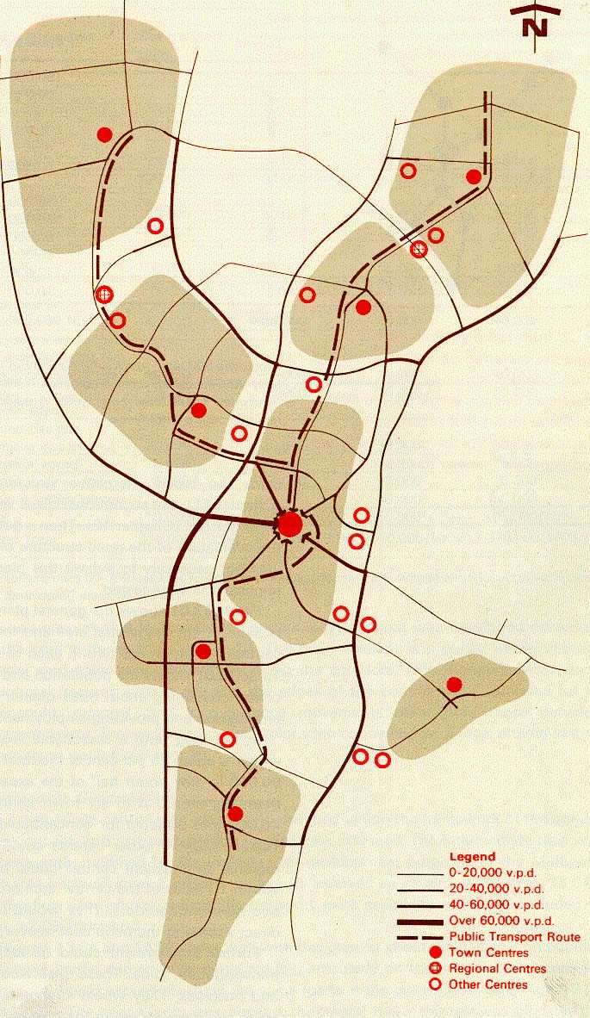

Scott Wilson Nairn Pty Ltd
Young Consulting Engineers
December 2002



Gungahlin Drive Extension Review

Traffic & Transport Planning Assessment

CONTENTS
1. Introduction 1
1.1 Background 1
1.2 Objectives of the Report 1
1.3 Acknowledgements 1
2. The Gungahlin Drive Proposal 2
2.1 The Current ACT Government Position 2
2.2 History 2
2.3 The Alternative Alignments at AIS 4
2.4 The need for an Updated Evaluation 5
3. Methodology 6
3.1 Introduction 6
3.2 Data and Information Sources 6
3.2.1 The 2001 ABS Census 6
3.2.2 The 1997 Canberra / Queanbeyan Household Interview Travel Survey 6
3.2.3 The ACT Department of Urban Services 6
3.2.4 ACTION 7
3.3 The modelling Process 7
3.3.1 The Overall Modelling Sequence 7
3.3.2 The Network 8
3.3.3 Population Distribution 8
3. 4 Calibration 9
3.4.1 Introduction 9
3.4.2 Trip Costs 9
3.4.3 Mode Choice 9
3.4.4 Assigned Traffic 10
3.4.5 Traffic Speed 11
3.5 Influences on Future Travel Demand 11
3.5.1 Introduction 11
3.5.2 Trip Costs 12
3.5.3 Self Containment 12
3.5.4 Ageing Demographic Influences 13
3.5.5 Income Influences 14
3.5.6 Mode Choice 14
3.5.7 Car Occupancy 15
3.6 Assumptions 16
3.6.1 Population Growth and Distribution 16
3.6.2 Mode Choice 17

4. Results 18
4.1 Traffic Forecasts on Gungahlin Drive Extension 18
4.1.1 Introduction 18
4.1.2 Predicted Traffic Growth 18
4.1.3 Predicted Future Congestion 18
4.2 Sensitivity Tests 19
4.2.1 Effect of Higher Public Transport Mode Choice 19
4.2.2 Effect of Crace Arterial and Monash Drive 19
4.2.3 Both Higher Public Transport Mode Choice and Crace Arterial/Monash Drive 19
4.3 The Standards for Gungahlin Drive Extension 20
4.4 The Timing of Gungahlin Drive Extension 20
4.4.1 Regional Congestion 20
4.4.2 Traffic Flows on GDE 21
4.4.3 Analysis of Intersections 21
4.5 The Western and Eastern Alignments 22
4.6 Connection to Caswell Drive 23
5. Other Travel Impacts 24
5.1 Effects on Overall Travel in Canberra 24
5.1.1 Travel Costs 24
5.1.2 Trip Generation Rates 25
5.1.3 Mode Split by Public Transport 25
5.2 Effects on Transport Emissions 26
5.2.1 Introduction 26
5.2.2 Methodology 26
5.2.3 The Overall Quantity of Emissions in Canberra 28
5.2.4 Emission Intensities 29
5.2.5 The Distribution of Emission Intensities 29
5.2.6 Emission Intensities near AIS 30
5.3 Economic Impacts 30
6. Conclusions 33

Scott Wilson Nairn Pty Ltd

Young Consulting Engineers
December 2002

Executive Summary
This review is primarily aimed to provide answers, from a traffic and transport perspective, to the following questions:-
- Is the Gungahlin Drive Extension (GDE) necessary?;
- Which alignment is preferred?;
- What standard should GDE be?;
- What assumptions are made in the traffic and transport analysis?; and
- What other impacts and effects will GDE produce?.
In answer to the question “Is GDE necessary?” the following points apply:-
- All roads leading to and from Gungahlin will be badly congested without GDE;
- Travel times and costs to Gungahlin are higher than all other areas except Queanbeyan now but will become higher than Queanbeyan by 2031 without GDE;
- There are existing unwanted traffic routes through residential areas in Belconnen and Lyneham, which are mainly due to Gungahlin traffic and these will get worse without GDE;
- Even increased self-containment cannot reduce the traffic flow sufficiently to avoid building GDE;
- Even the Inter-town LRT and other public transport initiatives cannot reduce the traffic flow sufficiently to avoid GDE; and
- Building the Crace Arterial / Monash Drive will not reduce the traffic flow sufficiently to avoid GDE and this is the only other proposed arterial on the General Policy Plan that will effect GDE.
The question “Which alignment is preferred?” cannot be answered effectively by this traffic and transport analysis as there is negligible difference between the traffic flows on the two alignments. The option to provide a full diamond interchange at Belconnen Way and allow Caswell Drive to be downgraded to a collector road, thus diverting heavy traffic away from residential streets in Aranda, is preferred.
The question “what standard should GDE be?” is answered that it should be of parkway standard. A Parkway has continuous grade separation, low grades, long curves and restricted side access throughout – all more or less continuous that allow noise barriers and landscaped treatment in the design. It needs to be a Parkway because of the following:-
- It requires two lanes in each direction to accommodate the traffic demand;
- Grade separation is necessary throughout as at-grade intersections would be intolerably congested with excessive delays;
- A 4-lane Parkway has more capacity than a 6-lane Arterial;
- Parkway standards are much safer than arterial standards, having accident rates as low as one third those of arterial roads carrying the same traffic;

- A Parkway has smooth flows without stops, rather than stop-start conditions experienced on arterials, and the traveling speeds of traffic are close to those, which produce the least individual vehicle fuel consumption;
- Parkway speeds help divert traffic away from congested arterials such as Northbourne Avenue; and
- A corridor has been set aside which was always intended for a Parkway.

The following fundamental assumptions have been made in the traffic and transport analysis:-
- Population
  - Existing Population of Canberra is based on the 2001 Census; and
  - The future population is based on Gungahlin growing to its capacity of 100,000 (from ACT Government sources), which is assumed to occur by 2031. In addition, tests have been made with Gungahlin populations of 80,000 in 2021 and 46,000 in 2011. These tests show that GDE is needed well before the year 2011 and the section near Belconnen Way needs to be built before 2006;
- Mode Split
  - Mode Split (the motorized share taken by public transport) has been predicted in detail at the zone level (not a blanket assumption as in previous studies); and
  - An option of 20% average Mode Split has been modelled, including an Inter-town LRT and other supporting policies. They do not make sufficient difference to GDE traffic to avoid building the Parkway.
- Other Road Options
  - The effect of the Crace Arterial and Monash Drive has been tested. Their inclusion does not make sufficient difference to GDE traffic to avoid building the Parkway.

Some of the other impacts and effects predicted to be produced by GDE include:-
- Travel Costs – GDE is predicted to produce longer trips but of shorter duration, leading to significant decreases in perceived average travel costs in Canberra;
- Trip Generation Rates – GDE is forecast to slightly increase daily person trip making rates by all modes;
- Mode Split – GDE is expected to slightly reduce mode split by public transport, but this is offset by increased trip making so that public transport ridership is not expected to be reduced;
- Emissions – GDE will have little effect on the growth or savings of total pollutant emissions in Canberra. GDE will increase emissions near the AIS but reduce emissions in the locations in Canberra where they are most intense. However, it has not been possible in this study to fully relate these emission intensities to ACT Government air quality goals nor to any especially pertaining to athletes in training. Nevertheless, emission intensities near AIS with GDE are only a fraction of those in Civic (ranging from 4% to 37%); and

- Economics – An economic evaluation shows that GDE would be economically well worthwhile, achieving a Benefit-to-Cost Ration of 2.7 when discounted at 8%.

1. Introduction

1.1 Background
This report is prepared for Young Consulting Engineers, consultants to the National Planning Authority, and provides an assessment of traffic and transport issues relevant to the proposed Gungahlin Drive Extension.
While the question of whether an alignment east or west of the Australian Institute of Sport (AIS) is foremost in this review, the overall questions of the need for GDE, the standard to which it should be built and the value of other proposals, also have to be fully addressed so that questions are answered in a full strategic and policy context.

1.2 Objectives of the Report
This report on traffic and transport issues is aimed at answering the following questions;-
- Is the Gungahlin Drive Extension (GDE) necessary?
- If so, what standard should it be?
- Are there significant Canberra-wide traffic and transport advantages of one alignment over the other – The Eastern or Western alignment?
- What traffic and transport effect will GDE have on travel and the environment in Canberra?
It is intended that this report should comprehensively cover all relevant land-use and transport issues and take into account the work being done on the current Canberra Public Transport study and other studies being conducted by the ACT Government within its sustainability policies and plans.

1.3 Acknowledgements
Scott Wilson Nairn gratefully acknowledges the willing assistance and co-operation provided by officers of the ACT Government, the National Capital Authority, Young Consulting Engineers and Professor John Black in his role in peer review.

2. The Gungahlin Drive Proposal

2.1 The Current ACT Government Position
Following an election promise, the ACT Government announced that the Gungahlin Drive Extension (GDE) would be located on an alignment west of the Australian Institute of Sport (AIS) subject to further studies.

2.2 History
In 1965, A M Voorhees and Associates prepared a Metropolitan Structure Plan, subsequently called the ‘Y Plan’, which provided a land-use and transport plan for the long-term growth of Canberra. The basic concept of the plan is that the primary and central transport spine would be a public transport service linking the town centres and that parkways, running peripheral to the separate towns in reserved corridors, would be linked to the town centers by arterial roads to serve the private travel demand.
The National Capital Development Commission confirmed the concepts of the ‘Y Plan’ in 1970 in its publication ‘Tomorrow’s Canberra’, including separation between the satellite towns and the peripheral parkway system of which the GDE is a key component.

Tomorrow’s Canberra - 1970
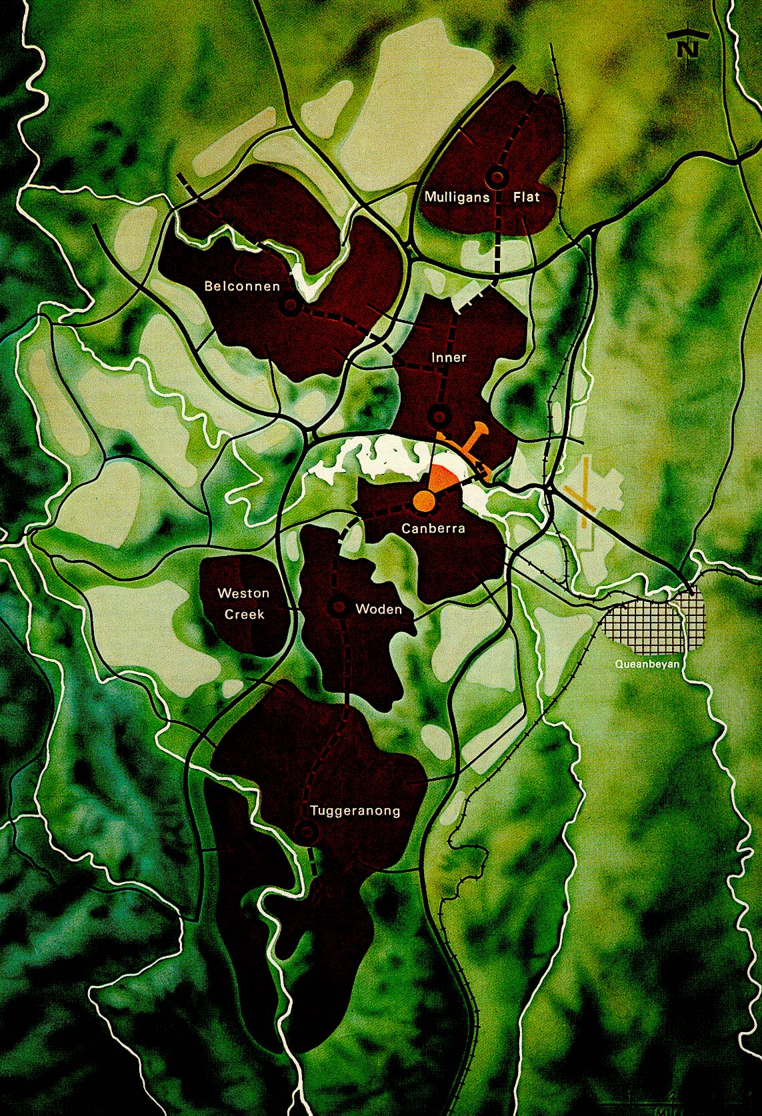

Gungahlin Drive Extension

The Metropolitan Policy Plan, guiding development up to a population level of 400,000, re-confirmed the ‘Y Plan’ in 1984 including the peripheral parkway principle. It identified John Dedman Drive (now GDE) and Monash Drive as key components of the road network.

The Metropolitan Policy Plan - 1984
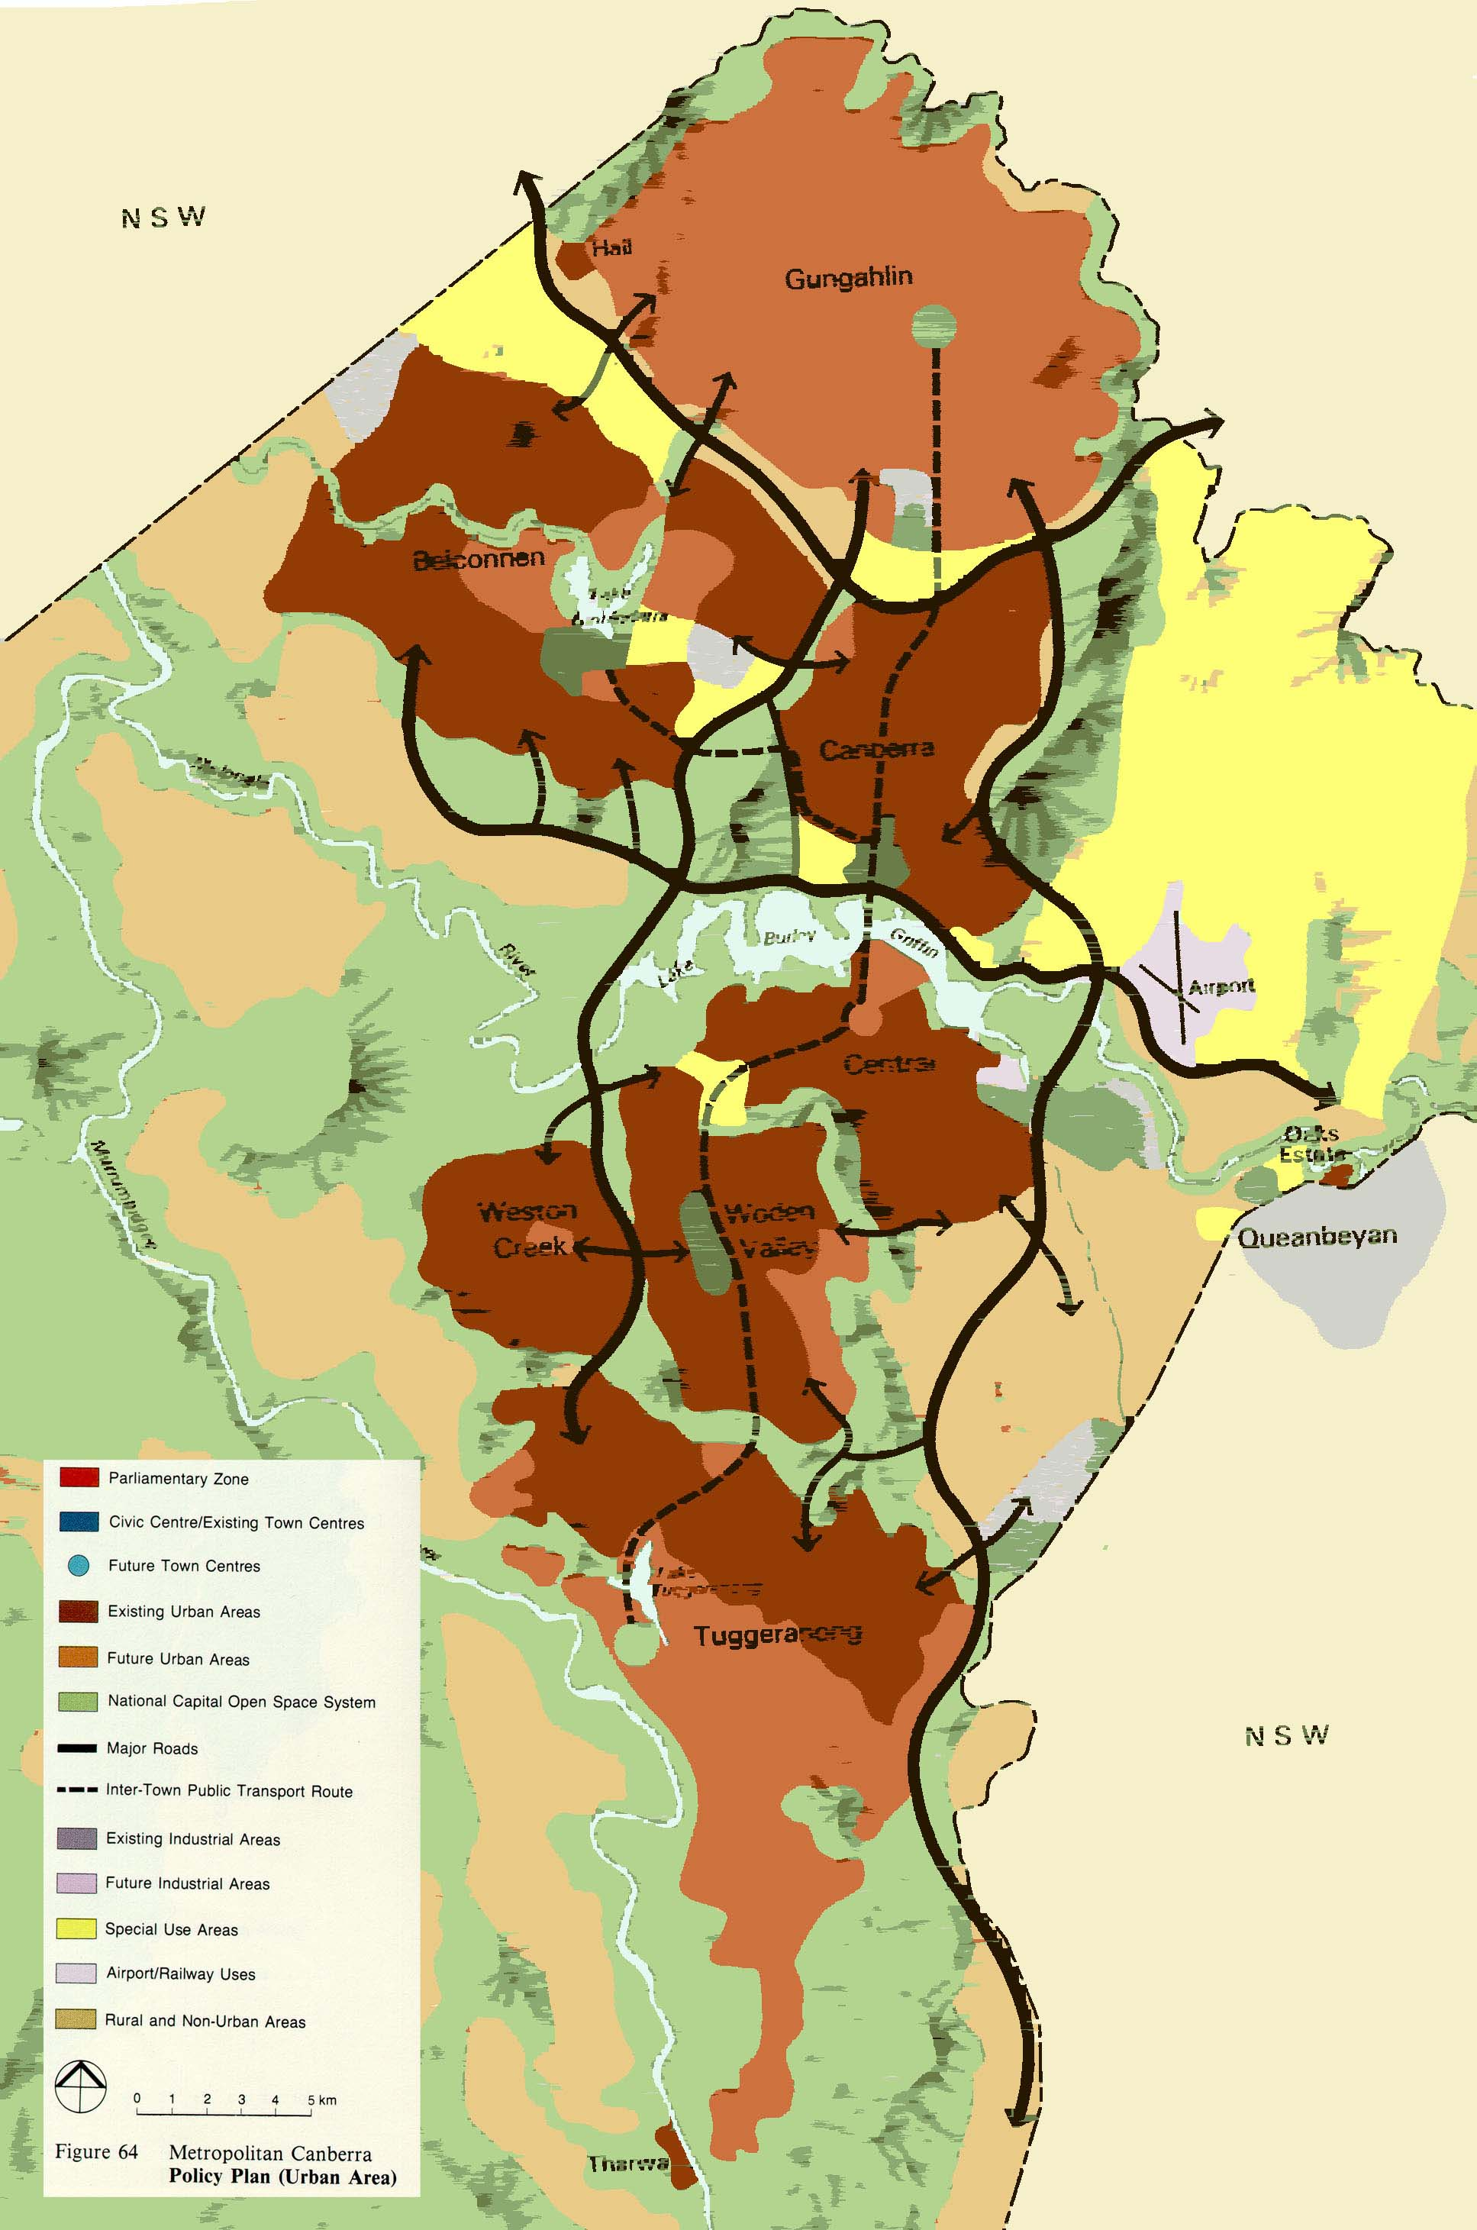

Gungahlin Drive Extension

In 1988-1990 the Gungahlin External Travel Study, an extensive land-use/transport assessment involving major public consultation recommended John Dedman Drive (GDE) together with Monash Drive and an extensive public transport system as the preferred transport development option serving Gungahlin.
The National Capital Plan (NCP) of 1990 set out policies for land-use, National and Arterial Roads, Inter-town Public Transport, Town Centres and showed GDE as an arterial road.
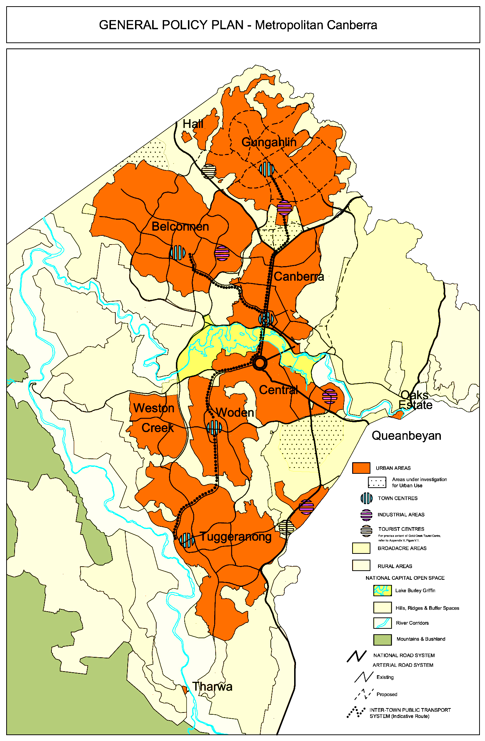
The National Capital Plan - 1990

A Parliamentary Joint Committee enquiry in 1991 recommended the link road over O’Connor Ridge (east road) be deleted from NCP and recommended an environmental assessment of two other options for John Dedman Parkway - east and west of AIS with both connecting to Caswell Drive. The Government Response to this was that the final alignment would be determined as a consequence of outcomes from further studies including Future Public Transport Options for Canberra and the inquiry into the Canberra Open Space System. The findings were that open space could be used for roads and services where the impact is minimal.
In 1997, a ‘Preliminary Assessment’ Report for the John Dedman Parkway (GDE), between the Barton Highway and Belconnen Way, was prepared for ACT Government by Maunsell Pty Ltd and recommended an alignment east of AIS.
In 1999 a Legislative Assembly Inquiry was held. A majority of the Standing Committee on Planning and Urban Services supported GDE east of AIS, while a minority report supported a road west. A Draft Amendment 41/DTPV 138 was put on exhibition in July 2001, which proposed to remove Barry Drive link and deleted the western alignment. In Sept 2001 the ACT Government gazetted Variation 138.

2.3 The Alternative Alignments at AIS
The two alternative alignments for GDE near AIS are shown in the following diagram.
The Eastern and Western Alignments
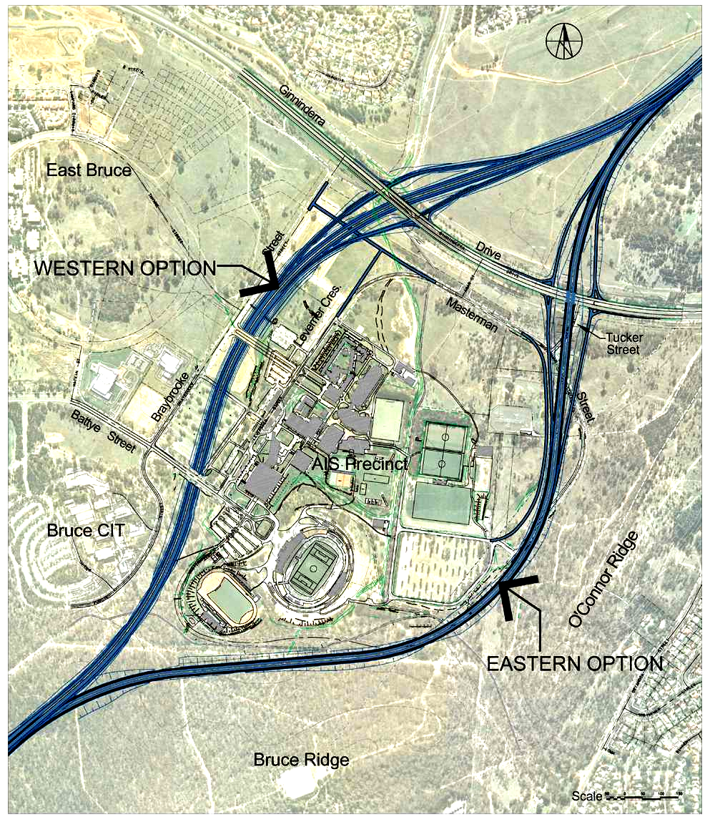

2.4 The need for an Updated Evaluation
The original study, on which the proposal for the Gungahlin Drive Extension is based, was the Gungahlin Extension Transport Study (GETS) carried out in 1988-90. The two most recent studies are the “Preliminary Assessment” completed by Maunsell Pty., Ltd. (Maunsell report) in October 1997 and those carried out by Snowy Mountains Engineering Corporation in June 2002 (SMEC report). Both of these studies recommended that GDE be built and to Parkway standards.
Both of these latter studies have been reviewed to establish whether they adequately reflected the strategic intentions of the GETS study. This review concluded that the traffic modelling work in both previous studies was insufficiently documented in technical detail to allow any revision in the light of new input data. Since the GETS study and these two later traffic studies were published there have been a number of changes in policy, planning or development, which have the ability to influence the strategy inherent in the study. They include the following:-
- Increased emphasis on Civic as an employment centre relative to the town centers;
- An emphasis on in-fill development;
- Higher density residential development in Civic and other locations in Canberra;
- The development of Jerrabomberra;
- More rapid development in Queanbeyan;
- New development near the airport; and
- Continued reduction in mode choice.
The combination of all of these issues is capable of influencing the outcomes of the GETS study and, as it was also established that highly relevant recent information was now available and following the review of the two recent reports, it was decided that it was necessary to carry out an updated and independent re-evaluation of GDE. Recognizing the need for a fully comprehensive land-use/transport evaluation, the TRANSTEP model was selected for this review as it has been widely applied in many previous transport studies of the type relevant to the GDE assessment.
The recent data on which this updated re-evaluation was based, but which was not available at the time of the Maunsell or SMEC studies, includes:
- Population and other demographic data from the 2001 ABS Census;
- Data from the 1997 Canberra / Queanbeyan Household Interview Travel Survey;
- 2002 Vehicle Registration data from the Department of Urban Services (DUS);
- 2001 DUS data on employment and retail surveys and recent school enrolments;
- ACT Environment data on transport emissions prepared for the National Pollutant Inventory 1997;
- 2001 DUS traffic count and speed data; and
- Material from the current Canberra Public Transport Futures Feasibility Study.

3. Methodology

3.1 Introduction
This chapter describes the modelling and simulation process used in the review and its data sources, assumptions and calibration.
The traffic forecasts have been derived using a computerised travel simulation model, which has been developed for Canberra and including Queanbeyan. The model consists of:
- a suite of software that controls operations of the model and performs calculations;
- a network database, describing the road and public transport infrastructure;
- land-use files, containing forecasts of travel-related land use variables; and,
- a set of files describing the travel characteristics of Canberra residents.
The model is developed within the format of Scott Wilson’s TRANSTEP suite of travel models.

3.2 Data and Information Sources

3.2.1 The 2001 ABS Census
The ACT Department of Urban Services provided ABS census data for the use of this review. It included the following:-
- Population by Suburb, with average suburban personal income and age, and the proportion of this population aged under 14 and 65 and over; and
- Journey to work data by mode and suburb.

3.2.2 The 1997 Canberra / Queanbeyan Household Interview Travel Survey
Scott Wilson Nairn retains copies of data provided to the ACT Department of Urban Services from the Canberra / Queanbeyan Household Interview Travel Survey 1997 and has used this data to research the travel behavioural relationships built into the travel simulation model.

3.2.3 The ACT Department of Urban Services
The ACT Department of Urban Services also provided the following data:-
- Land-use Data – The Department provided the latest data on employment, retail floor-space and educational enrolments for use in the travel simulation model;
- Traffic counts – The latest traffic counts on Canberra’s streets. This information was used in calibrating the travel simulation model;
- Street speed measurements – Observed peak hour travel speeds on Canberra’s streets. This information was used in calibrating the travel simulation model; and
- Motor Vehicle Registration Data – This data were used in the vehicle emissions model.

3.2.4 ACTION
The Canberra bus service operator, ACTION, provided bus route and schedule data for use in the mode split and public transport models.

3.3 The modelling Process

3.3.1 The Overall Modelling Sequence
The computer modelling process is an iterative one, in which street congestion alters travel costs, and this in turn is fed back into the trip generation, trip distribution and mode choice computations. This ensures that the travel costs effectively influence the whole travel simulation process and is illustrated in the following diagram.
Overall Modelling Sequence
Trip Generation and Distribution to produce trip matrix
Road Network Data-base
Zone Land-use Data-base
Process Control Files
Travel Characteristics
Calculate Travel Costs
Split trip matrix into car and bus modes
Travel Cost Factors
Assign car trip matrix to highway network to produce traffic volumes and speeds on each link
Add external road trips
External Traffic Database
Pre-load Buses and Trucks
Truck Trip Matrix
Congested Road Travel Cost File
Build Public Transport Costs and Paths
Transit Service Data-base
Assign passenger trip matrix to transit network to produce passenger loads and service frequencies
Resulting passenger loads and highway traffic volumes

The travel simulation model is comprehensive, embracing the latest land-use data, full public transport services and the latest research into travel behavioural relationships.

3.3.2 The Network
The network for this study consists of an inventory of major roads and streets in Canberra and Queanbeyan, including their number of lanes, length, their speed and their capacity/delay characteristics. The Canberra network is illustrated in the following Diagram.
The Canberra Street Network

3.3.3 Population Distribution
Canberra’s existing population distribution is shown graphically in the following diagram, where each circle represents a zone’s population.
Canberra’s Population Distribution

3. 4 Calibration

3.4.1 Introduction
The travel simulation model has been calibrated to reproduce peak hour observed data for the following information for the year 2001, the last year for which consistent data were available:-
- Trip Costs;
- Mode Choice;
- Street Traffic Volumes; and
- Street traffic speeds.
As the travel simulation model employs an iterative procedure, then all of these sub-models must be calibrated simultaneously.

3.4.2 Trip Costs
Predicted average zonal trip costs were calibrated against those derived from the 1997 Canberra / Queanbeyan Household Interview Travel Survey. The following diagram shows the result of this comparison. Ideally all of the points plotted in the diagram should fall on or near the red line. Given the overall imperfections of this type of modeling, the calibration is considered satisfactory.

3.4.3 Mode Choice
Similarly, the predicted average zonal mode split were calibrated against those derived from the 1997 Canberra / Queanbeyan Household Interview Travel Survey.
The following diagram shows the result of this comparison. Again, ideally all of the points plotted should be on or near the red line. This calibration is also considered satisfactory.

3.4.4 Assigned Traffic
The assigned traffic predicted by the travel simulation model was checked against observed traffic counts provided by the ACT Department of Urban Services. The sample covered several different types of roads. The calibration result is shown in the following table:-
Average Traffic Calibration Error by Road Type
Road Type | Error | Sample
Streets in Central Areas | 0.60% | 38
Arterials in Central Areas | 15.10% | 47
Arterials | 4.20% | 55
Major Arterials | 8.00% | 20
Restricted Access Roads | 11.60% | 34
Rural Arterials | 1.80% | 6
Tuggeranong Parkway | 1.80% | 4
The following diagram shows the comparison for all of the sample. The scatter of points around the red line is satisfactory.

3.4.5 Traffic Speed
A sample of peak hour speeds on Canberra roads were provided by the Department of Urban Services. The average error for the different road types is shown in the following table.
Average Speed Calibration Error by Road Type
Road Type | Error | Sample
CBD Streets | 2.80% | 20
CBD Arterials | 0.60% | 2
Collectors | 12.40% | 26
Streets in Central Areas | 6.30% | 24
Arterials in Central Areas | 9.60% | 18
Arterials | 6.60% | 11
Major Arterials | 4.10% | 6
The following diagram shows how well the predicted road speeds compared with these observations as they are all quite close to the red line.
In most cases the available sample is sufficient to ascribe 90% confidence levels to the speed forecasts and 85% confidence levels to the traffic forecasts..

3.5 Influences on Future Travel Demand

3.5.1 Introduction
Trip generation per head of population is influenced by a number of factors including the following:-
- Trip cost – Average daily trip rates tend to fall where trip lengths or durations are long;
- Self-containment – Good planning and urban management can achieve higher levels of self-containment, which result in lower trip costs and higher trip rates;
- Population ageing – The ageing of Canberra’s population has an effect on trip rates; and
- Income levels – Disposable income has an effect on trip rates.
Each of these factors are built into the travel simulation model.

3.5.2 Trip Costs
The effect of increasing average zonal trip lengths on daily personal trip making, by all modes and for all purposes, is shown in the following diagram.

3.5.3 Self Containment
One of the principles of good town planning is to attempt to achieve high self-containment. That is, to provide adequate jobs, schools and shopping opportunities within the same town or suburb, for those living within its boundaries. Research confirms that, as expected, higher levels of self-containment equate to lower travel costs.
The measure of self-containment in the table below is the proportion of trips, which originate in each district, and which find a destination in the same district. These results are derived from the travel simulation models, not from the ABS Journey-to-work data, and include travel by all modes and for all purposes. Clearly, as the districts vary in size and population, they will not have the same levels of self-containment.
District Self-Containment (All travel)
District/Year | 2001 | 2006 | 2011 | 2021 | 2031
Belconnen | 23.0% | 23.0% | 23.1% | 23.5% | 23.8%
Gungahlin | 7.8% | 9.3% | 10.8% | 22.5% | 22.8%
North Canberra | 41.5% | 40.6% | 39.9% | 32.6% | 32.6%
South Canberra | 21.0% | 21.7% | 22.1% | 22.6% | 23.6%
Woden | 17.6% | 16.4% | 15.7% | 15.0% | 14.9%
Weston Creek | 55.6% | 55.5% | 56.3% | 55.2% | 54.8%
Tuggeranong | 20.2% | 20.7% | 21.1% | 21.2% | 21.8%
Jerrabomberra | 1.2% | 1.1% | 1.0% | 6.3% | 6.1%
Queanbeyan | 9.9% | 12.6% | 19.6% | 28.3% | 31.6%
The prediction that the levels of self-containment in Gungahlin, which is very low now at 8%, will increase by 2021 to about the same as those in Belconnen and Tuggeranong is of particular significance to this review.

3.5.4 Ageing Demographic Influences
The average age of Canberra residents increased by about two years in the 1996 to 2001 inter-census period. The proportion of those under 14 decreased by 7% and that for those aged over 65 increased by 17%. In particular, the average age of Canberra suburbs varied between 26 and 43 and the proportion of those aged less than 14 varied between 1.2% and 15.4%. It is obvious that different suburbs generate different travel demands for school, however the pattern of ageing influences on travel demand is more complex and the following influences have been researched in Canberra:-
- Daily trip by all modes making varies between different age groups as illustrated in the diagram below;
- Mode choice is high for school-aged persons, decreases quickly for working people and then rises again for those in the older age groups;
- The reasons why people make trips varies with age, school travel being dominant with younger people, then work travel becomes dominant and, finally, shopping, personal business and recreational travel becomes dominant for those over 60.
- The proportion of travel during the peak hours is less for older age groups.
The review examined the rate at which Canberra suburbs were ageing and then predicted the proportion of different age groups in future years. These predictions were then used in the trip generation, trip distribution and mode split models to reflect the influences on travel discussed above.

3.5.5 Income Influences
Personal income also has an effect of daily trip making as illustrated in the following diagram. Income levels were obtained from the 2001 Census and used to predict trip generation and mode split.

3.5.6 Mode Choice
Many factors influence users choice for public transport. They include the following:-
- Personal Income levels, which are usually taken as a surrogate for car ownership levels;
- The average age of the suburb and its distribution;
- The relative perceived travel cost between public transport and private car travel;
- The development density at the origin of the trip; and
- The overall travel cost to the destination, which appears to be one of the strongest influences as illustrated in the diagram below.
All of these issues were included in the mode split simulation model.
While increasing transit choice is a worthwhile ACT planning and policy objective, the current trend shows that transit choice has been falling. Comparisons between the Household Interview travel Surveys of 1976 and 1997, provided in the following table, show the degree to which transit choice has fallen during this period.
Change in Public Transport Choice 1976-97
Survey Year | All Day |  | Morning Peak
Survey Year | Region | Civic | Region | Civic
1976 | 9.0% | 14.7% | 19.9% | 23.2%
1997 | 6.0% | 11.6% | 8.0% | 15.0%
% Change 1976-97 | -33% | -21% | -60% | -35%
Although transit choice to Civic has not fallen as much as that throughout the whole Canberra region, the overall choice for public transport has fallen substantially throughout this period. This does not necessarily mean that the influence exerted by transit choice on GDE is small, since there are several reasons why transit choice in Gungahlin will be quite strong. Transit choice needs to be modelled zone-by-zone to establish its true effect.
The following table, which is derived from the same survey data, shows that the average time taken when travelling by bus is not only about twice the time taken when travelling by car but that average bus travel times have increased more quickly than those for cars.
Change in Factors influencing Public Transport Choice 1976-97
Trip Characteristic | Survey Year | All Day |  | Morning Peak
Trip Characteristic | Survey Year | Region | Civic | Region | Civic
Av Car Trip Time (Min) | 1976 | 12.08 | 13.17 | 15.14 | 15.57
Av Car Trip Time (Min) | 1997 | 15.53 | 15.48 | 16.99 | 16.89
% Increase 1976-97 |  | 28.5% | 17.6% | 12.3% | 8.5%
Av Bus Trip Time (Min) | 1976 | 26.5 | 24.1 | 29.4 | 34.8
Av Bus Trip Time (Min) | 1997 | 37.4 | 38.6 | 37.4 | 43.4
% Increase 1976-97 |  | 41.1% | 60.2% | 27.2% | 24.7%
Source: Canberra/Queanbeyan Household Interview Travel Survey 1997 and Canberra Survey 1976
This does not indicate that bus speeds are slower but that passengers are only taking longer trips by bus, but the table does show that public transport has a considerable time disadvantage over the private car.

3.5.7 Car Occupancy
Car-occupancy levels were obtained from the 1997 survey and are shown in the table below.
Car-Occupancy for Different Times and Locations
Time of day | All Canberra | Civic | Woden Centre
All day | 1.36 | 1.21 | 1.35
AM Peak hour | 1.41 | 1.19 | 1.33
PM Peak hour | 1.36 | 1.27 | 1.32
Source: Canberra/Queanbeyan Household Interview Travel Survey 1997

Car occupancy levels for the journey to work were reported at 1.11 in 1995 (Maunsell). The results from the 2001 census Journey to Work analysis show car-occupancy for this purpose at 1.13. Apart from this, there is no direct evidence that car-occupancy levels have increased in the past but it is reasonable to infer that car-occupancy will increase in future because, as Canberra’s population ages, travel for social and recreational travel will be more dominant and these travel purposes at present have higher car-occupancies then those for work, employer’s business or even school, as illustrated in the following table.
Car-Occupancy by Purpose
Trip Purpose | Car Occupancy
Work | 1.09
School | 1.46
Shopping | 1.55
Sport/recreation | 1.47
Visit friends/relatives | 1.53
Personal business | 1.44
Employers business | 1.30
Visit Club | 1.50
Restaurant/takeout | 1.97
Cinema | 1.89
Source: Canberra/Queanbeyan Household Interview Travel Survey 1997

3.6 Assumptions

3.6.1 Population Growth and Distribution
While the ABS Census was used as the source for zonal population for 2001, population data for future years must be regarded as an assumption in the travel simulation model. Recent forecasts for the the year 2011 were obtained from the ACT Department of Urban Services but later years relied on data from earlier planning studies.
The following table summarizes the growth and distribution of Canberra’s population as used in the travel simulation model.
District Population Growth Assumption
 | 2001 | 2006 | 2011 | 2021 | 2031
Belconnen | 78,300 | 81,500 | 84,600 | 90,200 | 95,400
Gungahlin | 27,000 | 36,700 | 46,300 | 79,800 | 98,700
North Canberra | 41,600 | 43,900 | 46,200 | 52,200 | 61,900
South Canberra | 28,000 | 28,300 | 28,700 | 30,300 | 31,500
Woden | 31,200 | 31,500 | 31,700 | 32,400 | 32,800
Weston Creek | 28,500 | 27,700 | 26,900 | 27,000 | 28,200
Tuggeranong | 85,600 | 86,700 | 87,700 | 90,900 | 103,700
Jerrabomberra | 5,000 | 7,200 | 12,500 | 22,000 | 36,000
Queanbeyan | 27,700 | 35,500 | 43,400 | 50,500 | 58,500
Gooramon/Hall/etc | 1,100 | 1,200 | 1,400 | 2,000 | 3,800
Total | 354,000 | 380,200 | 409,400 | 477,300 | 550,500

3.6.2 Mode Choice
Mode split has been predicted on a zonal basis for this review. The prediction takes into account recent and planned short-term initiatives by ACTION. However, the ACT Government has commissioned a Canberra Public Transport Futures Feasibility Study to investigate a range of transport policies and projects, including a Light Rail option, and including a variety of means to improve public patronage in future, in an expression of its Sustainability Policies.
These measures include new and higher car-parking charges at town centers and a variety of operating initiatives to achieve an higher mode split. Accordingly, an higher mode split simulation has been carried out to test its effect on GDE. As the full extent of these initiatives is unknown at this time, the higher resulting mode split must be regarded as an assumption rather than a prediction.
The predicted mode split and the higher mode split are shown in the following table.
Mode Split Forecasts
Year | Predicted | Higher
2001 | 8.0% | n.a.
2006 | 8.2% | 13.4%
2011 | 9.0% | 14.7%
2021 | 9.9% | 17.5%
2031 | 10.9% | 20.3%
It is worth noting that, the Maunsell report referred to work by Newman and Kenworthy (1991) showing the purported relationship between city size and Mode Split in Australia. On this basis an average mode split of 20% could be expected with a Canberra population of about 1.8 millions. While little reliance should be placed on this relationship, nevertheless it does illustrate that the higher mode split assumption should be regarded simply as a worth-while political and social goal, rather than a prediction.
Even though the higher mode split forecast is an assumption, it has nevertheless been modelled on a zonal basis consistent with the remainder of the travel simulation process.

4. Results

4.1 Traffic Forecasts on Gungahlin Drive Extension

4.1.1 Introduction
The traffic simulation model, after being calibrated for the year 2001, was used to prepare traffic forecasts for the years 2006, 2011, 2021 and 2031 based on land-use forecasts prepared with the co-operation of DUS and the various proposals for transport policy and operations listed in this review.

4.1.2 Predicted Traffic Growth
The predicted traffic growth on various sections of GDE is shown in the following table.
Growth of Daily Traffic on Gungahlin Drive Extension
Section | 2006 | 2011 | 2021 | 2031
North of Barton Highway | 19,500 | 33,150 | 43,875 | 48,263
Barton Highway to Ginnindarra Drive | 18,525 | 33,638 | 44,363 | 49,725
Ginnenderra Drive to Belconnen Way | 21,938 | 34,125 | 38,025 | 42,413
Caswell Drive South | 33,638 | 36,075 | 39,488 | 41,925

4.1.3 Predicted Future Congestion
Road congestion slows traffic, adds to travel costs and creates greater levels of accidents and emissions. The degree to which Gungahlin Drive Extension relieves congestion in the Canberra network, particularly in Belconnen and North Canberra, is graphically shown in the diagrams below, in which the shaded roads have high volume-to-capacity ratios in excess of 0.85.
Congested Roads without GDE in 2031 Congested Roads with GDE in 2031
The diagrams show how traffic to and from Gungahlin has to wend its way through Belconnen and North Canberra creating congested arterials and high volumes on quiet residential streets. GDE diverts traffic away from residential areas and from many of the congested roads.

4.2 Sensitivity Tests

4.2.1 Effect of Higher Public Transport Mode Choice
A test to determine whether GDE could be avoided if mode split reached the higher levels previously explained, gave the following long-term traffic forecasts.
Effect of Higher Public Transport Mode Split (20%) on GDE (2031)
Section | Predicted | Higher | Reduction
North of Barton Highway | 48,263 | 46,800 | 3.03%
Barton Highway to Ginnindarra Drive | 49,725 | 47,775 | 3.92%
Ginnenderra Drive to Belconnen Way | 42,413 | 40,950 | 3.45%
Caswell Drive South | 41,925 | 40,463 | 3.49%
The effect of the higher mode split simulation was to reduce traffic flows on GDE by 4%.

4.2.2 Effect of Crace Arterial and Monash Drive
The following table shows the effect of constructing the Crace Arterial and Monash Drive on the predicted long-term traffic forecasts for GDE.
Effect of Crace / Monash Drive on GDE (2031)
Section | GDE | Crace/Monash | Reduction
North of Barton Highway | 48,263 | 44,363 | 8.08%
Barton Highway to Ginnindarra Drive | 49,725 | 44,850 | 9.80%
Ginnenderra Drive to Belconnen Way | 42,413 | 38,513 | 9.20%
Caswell Drive South | 41,925 | 40,950 | 2.33%
The effect of the construction of the Crace Arterial and Monash Drive would be to reduce traffic flows on GDE by almost 10%. These two major roads are the only planned arterials, which are likely to effect traffic on GDE to any significant extent.

4.2.3 Both Higher Public Transport Mode Choice and Crace Arterial/Monash Drive
If the Crace Arterial / Monash Drive proposal is built and, in addition, mode split reaches the higher levels, then the GDE traffic will be affected as shown in the table below.
Effect of both Higher Mode Choice & Crace / Monash Drive on GDE (2031)
Section | GDE | Both | Reduction
North of Barton Highway | 48,263 | 40,950 | 15.15%
Barton Highway to Ginninderra Drive | 49,725 | 43,875 | 11.76%
Ginnenderra Drive to Belconnen Way | 42,413 | 37,538 | 11.49%
Caswell Drive South | 41,925 | 39,975 | 4.65%

These influences will have little effect on the Caswell Drive section of GDE but reduce traffic on other sections by from 12% to 15%. This is insufficient to change the requirements for GDE, which would still have to be a grade-separated, four-lane road, even with the lower volume demand.

4.3 The Standards for Gungahlin Drive Extension
As GDE needs to be a four-lane, grade-separated road, the standards to which it should be constructed should follow Parkway standards. That is, the road should have restricted access. It should have a separated median, with 80 KpH design standards and full landscape and environmental treatments. The reasons in support of this standard are as follows:-
- Roads built to these standards are much safer than normal arterial roads with accident rates up to one third as frequent;
- A parkway standard will have the full effect of diverting as much traffic as possible from residential streets and congested arterials; and
- The reserved corridor, which is a part of the town articulation system, needs full landscape and noise amelioration treatment to properly protect the adjacent parkland and other land-uses.

4.4 The Timing of Gungahlin Drive Extension

4.4.1 Regional Congestion
The following diagrams show the roads that are forecast as congested with volume-to-capacity ratios in excess of 0.85 in Belconnen and North Canberra by the year 2006 and the effect that GDE is expected to have in reducing this congestion.
Congested Roads without GDE in 2006 Congested Roads with GDE in 2006
While congestion in Belconnen will not be as bad as that forecast for 2031, nevertheless many streets, including streets in residential areas, will be quite congested in 2006.

4.4.2 Traffic Flows on GDE
The predicted morning peak hour volumes by direction on various sections of GDE in the year 2006 are shown in the following table:-

AM Peak Hour Flows in the year 2006 on Gungahlin Drive Extension
Section | Northbound | Southbound
North of Barton Highway | 700 | 1,300
Barton Highway to Ginnindarra Drive | 500 | 1,400
Ginnenderra Drive to Belconnen Way | 750 | 1,500
Caswell Drive South | 1,800 | 1,650
These flows in 2006 could just be accommodated within a two-lane arterial road provided that the intersection configuration was adequate.
The predicted morning peak hour volumes in the year 2011, five years later, are shown in the following table:-
AM Peak Hour Flows in 2011 on Gungahlin Drive Extension
Section | Northbound | Southbound
North of Barton Highway | 1,500 | 1,900
Barton Highway to Ginnindarra Drive | 900 | 2,550
Ginnenderra Drive to Belconnen Way | 1,100 | 2,400
Caswell Drive South | 1,700 | 2,000
The Southbound flows cannot be accommodated in 2011 within a two-lane arterial road but require a four-lane road.

4.4.3 Analysis of Intersections
An analysis of the intersection at Belconnen Way with an at-grade arterial with the above volumes (and turning volumes) shows that such an intersection would have a level-of-service ‘F’ and long delays. However, an at-grade intersection with Ginninderra Drive would operate successfully in 2006. By 2011 an analysis of an at-grade intersection at Ginninderra Drive shows that this intersection would also have long delays.
An analysis of the intersections of GDE with Belconnen Way and Ginninderra Drive shows that they cannot be designed at grade so GDE will need to be grade-separated. A further analysis of the intersections of the ramps with Bellconnen Way and Ginninderra Drive shows that these intersections with the ramps can be designed, under the eventual traffic demand, to operate under linked signal control but that, even with grade separation, there would be some considerable delays at the Belconnen Way intersections.
GDE will relieve congestion at several critical intersections in Canberra. The following table shows how the performance criteria for two typical intersections has been poor and is expected to continue to fall if nothing is done. GDE will relieve this problem.

Typical Intersection Performance Indicators with and without GDE
Intersection | Year | Degree of  saturation | Average  delay (sec) | Level of  Service
Belconnen Way / Caswell Drive | 1999 | 0.82 | 32 | A
Belconnen Way / Caswell Drive | 2006 with GDE | 0.95 | 53 | B
Belconnen Way / Caswell Drive | 2006 without GDE | 1.07 | 85 | F
Northbourne Ave / Mouat St | 1999 | 0.69 | 17 | A
Northbourne Ave / Mouat St | 2006 with GDE | 0.93 | 30 | B
Northbourne Ave / Mouat St | 2006 without GDE | 1.22 | 93 | F
The table shows that both of these typical intersections will have long delays by 2006 if GDE is not built. The degree of saturation is defined as the ratio of arrival flow to the capacity of the approach. The average delay is the delay when stopped experienced by all vehicles passing through the intersection. Level of service F describes forced flow, where flow breakdown occurs, and queuing and delays result.
This analysis indicates that GDE should be commenced before 2006 in the area near Belconnen Way, which would need to be grade separated immediately. The section over Ginninderra Drive would need to be constructed as a grade separated four-lane road well before 2011.

4.5 The Western and Eastern Alignments
Both the proposed Western and Eastern alignments have been tested with the traffic simulation model and, as shown in the table below, there is negligible difference between their traffic assignments.
Traffic Comparison between the Western and Eastern Alignments
Eastern Alignment
Section | AM Peak Traffic |  |  | Daily  Traffic
Section | Northbound | Southbound | Total | Daily  Traffic
North of Barton Highway | 2,100 | 2,850 | 4,950 | 48,263
Barton Highway to Ginnindarra Drive | 1,300 | 3,800 | 5,100 | 49,725
Ginnenderra Drive to Belconnen Way | 1,200 | 3,150 | 4,350 | 42,413
Caswell Drive South | 1,900 | 2,400 | 4,300 | 41,925

Western Alignment
Section | AM Peak Traffic |  |  | Daily  Traffic
Section | Northbound | Southbound | Total | Daily  Traffic
North of Barton Highway | 2,200 | 2,900 | 5,100 | 49,725
Barton Highway to Ginnindarra Drive | 1,400 | 3,800 | 5,200 | 50,700
Ginnenderra Drive to Belconnen Way | 1,200 | 3,100 | 4,300 | 41,925
Caswell Drive South | 1,900 | 2,400 | 4,300 | 41,925

4.6 Connection to Caswell Drive
The above analysis has been based on a design, which provides a diamond interchange at Belconnen Way and downgrades the function of Caswell Drive to that of a residential collector. The following table shows the traffic estimates for the original design.
Traffic Estimates for Original Caswell Drive Connection
Original Connection to Caswell Drive
 | AM Peak Traffic |  |  | Daily
Section | Northbound | Southbound | Total | Traffic
North of Barton Highway | 2,200 | 3,050 | 5,250 | 51,188
Barton Highway to Ginnindarra Drive | 1,400 | 4,050 | 5,450 | 53,138
Ginnenderra Drive to Belconnen Way | 1,400 | 3,250 | 4,650 | 45,338
Caswell Drive South | 2,900 | 2,900 | 5,800 | 56,550
For most of the length of GDE, the difference in daily traffic flows with the improved design is less than about 3,000 vehicles per day. However, the above table shows that the original design would carry about 15,000 more vehicles per day on the Caswell Drive South section.
This traffic enters GDE from Caswell Drive and much of it accesses Caswell Drive through Aranda residential streets. The improved design reduces this traffic through residential areas in Aranda.

5. Other Travel Impacts

5.1 Effects on Overall Travel in Canberra

5.1.1 Travel Costs
As Canberra grows, travel costs will gradually increase due to greater distances and road congestion. The following table shows average trip costs for all types of peak hour travel for residents of Canberra’s different towns and districts.
Predicted Average Peak Hour District Trip Costs
District/Year | 2001 | 2011 | 2021 | 2031
Belconnen | $4.10 | $4.21 | $4.34 | $4.50
Gungahlin | $5.15 | $5.31 | $6.87 | $8.52
North Canberra | $2.94 | $3.01 | $3.13 | $3.33
South Canberra | $3.10 | $3.10 | $3.32 | $3.45
Woden | $3.46 | $3.54 | $3.83 | $3.86
Weston Creek | $3.97 | $4.01 | $4.17 | $4.38
Tuggeranong | $4.85 | $5.29 | $5.38 | $5.77
Jerrabomberra | $3.72 | $3.90 | $5.37 | $5.49
Queanbeyan | $6.45 | $7.32 | $7.57 | $7.64
Of particular interest is the relatively high costs in Gungahlin now and the fact that they will grow to be more than any other Canberra district, including Queanbeyan. This is because of its remoteness and local congestion and the fact that Gungahlin traffic has to pass through Belconnen and North Canberra, where some congestion already exists.
GDE will have an effect on travel costs. It is predicted to encourage motorists to travel a little further but will save them time. The table below shows the effect of GDE on the growth of travel distances, times and costs.
Effect of GDE on Road-based Canberra-wide Travel Costs
Year | Without GDE | With GDE | Without GDE | With GDE | Without GDE | With GDE
Year | Length Km | Length Km | Duration Min | Duration Min | Costs  $ | Costs  $
2001 | 13.41 | n.a. | 17.5 | n.a. | $3.48 | n.a.
2006 | 13.45 | 13.51 | 18.0 | 17.5 | $3.55 | $3.47
2011 | 13.96 | 14.22 | 21.6 | 21.1 | $4.11 | $4.03
2021 | 14.14 | 14.24 | 24.7 | 24.1 | $4.53 | $4.45
2031 | 14.46 | 14.49 | 28.7 | 28.2 | $5.16 | $5.07
Implementing GDE will have the effect of increasing travel distances but reducing trip durations. The net effect will be a significant reduction in perceived travel costs Canberra-wide.

5.1.2 Trip Generation Rates
Increasing trip costs and the effect of population ageing is predicted to have an effect of trip generation rates. Daily trip rates have been slowly increasing in the past and it is anticipated that this trend will continue at first. However, the ageing population will tend to make fewer trips each day and eventually the current trend in trip rates is expected to reverse.
The construction of GDE will have the effect of reducing future congestion and therefore of slowing the reduction of trip generation rates. The following table shows the expected future changes in trip generation rates compared with the current rates. It also shows the expected effect on trip rates caused by GDE.
Rate of Change in Trip Generation Rates and the Effect of GDE
Year | Without GDE | With GDE
2006 | 0.8% | 1.1%
2011 | 0.0% | 0.6%
2021 | -1.4% | 0.2%
2031 | -5.7% | -3.7%

5.1.3 Mode Split by Public Transport
The travel simulation model predicted mode split for every zone, not just a blanket assumption. The estimated average mode split for residents of different districts in Canberra is shown in the following table.
Predicted Public Transport Mode Split by District
District | 2011 | 2021 | 2031
Belconnen | 6.8% | 6.9% | 7.0%
Gungahlin | 12.6% | 13.2% | 19.0%
Canberra Nth | 9.4% | 8.8% | 8.5%
Canberra Sth | 11.7% | 9.9% | 9.5%
Woden | 9.7% | 8.7% | 7.6%
Weston Creek | 6.5% | 6.2% | 6.0%
Tuggeranong | 10.1% | 10.0% | 10.0%
Jerrabomberra | 13.5% | 14.4% | 16.9%
Queanbeyan | 11.2% | 13.7% | 15.7%
Overall | 9.0% | 9.9% | 10.9%
As travel costs are generally higher in Gungahlin than in other districts, mode split is also likely to be higher as is shown in the above table.
The construction of GDE would have a small impact on predicted mode split as shown in the following table.

The Impact of GDE on Mode Split
Year | Without GDE | With GDE
2001 | 8.0% | n.a.
2006 | 8.0% | 7.9%
2011 | 9.1% | 9.0%
2021 | 10.1% | 9.9%
2031 | 11.2% | 10.9%

5.2 Effects on Transport Emissions

5.2.1 Introduction
Construction of transport infrastructure has an effect on the total Canberra-wide emissions of greenhouse gases.
However, emissions of different pollutants are also important for health reasons. In this context it is the intensity of pollutant emissions, particularly near AIS and in Civic, which are of special interest.

5.2.2 Methodology
The model developed for the ACT National Pollutant Inventory was used for the following transport emission forecasts. This model is designed to estimate the annual volume of a variety of pollutants for the whole of Canberra derived from moving transport sources. The area is specified in grid squares, which was set to be of one Kilometre square in Canberra.
The estimate is based on a peak hour traffic assignment, which contains link lengths, car and bus volumes, volume-to-capacity ratios and speeds for each link in the transport network. The effect on emissions of traffic congestion is fully expressed in the model as are the effects of public transport choices.

The emission model estimates the total daily production of the following pollutant types:-
- Hydro-Carbons 10 Benzene
- Carbon Monoxide 11 Butadiene
- Carbon Dioxide 12 Ethylbenzene
- Nitrogen Oxides 13 Formaldehyde
- Sulphur Dioxide 14 Hexane
- Particulate Matter (10um) (PM10) 15 Polycyclic Aromatic Hydrocarbons
- Lead 16 Toluene
- Acetaldehyde 17 Xylene
- Acetone
For each pollutant the emission model takes into account the following variables:-

- Vehicle type – Five different vehicle types were defined as Motorcycle (M/Cycle), Car, Light Commercial (Licom), Bus and Truck. The data for vehicles on the ACT register have been compressed into these five types.
- Travel speed – One of the most significant variables in estimating the extent of pollutant emissions is the effect of vehicle speeds. For each vehicle type, vehicle age group and for each emission type, formulae were developed to express the volume of each emission per Kilometre as speed varies.
- Vehicle Age - The age of motor vehicles is an important variable in estimating emissions and the emission equation is modified for vehicles of different age. Age has been classified as those vehicles registered for the first time before 1986, the year that it became necessary for all new vehicles to use unleaded petrol, between 1986 and 1995, the year catalytic converters were introduced, and after 1995. The proportions of different vehicles in the above three age groups in 2001 and predicted for 2016, which have been forecast based on changes in registrations 1997 to 2001, is shown in the following table:-

Proportions of Vehicles by Type and Age
Vehicle Type  First registered | Before 1986 | 1986-95 | After 1995 | Before 1986 | 1986-95 | After 1995
Year of data | Actual 2001 |  |  | Predicted 2016
Motorcycle | 23.1% | 28.7% | 48.2% | 0.0% | 3.2% | 96.8%
Car | 19.5% | 41.5% | 39.0% | 0.0% | 17.2% | 82.8%
Light Commercial | 26.2% | 36.3% | 37.5% | 0.0% | 14.5% | 85.5%
Bus | 16.7% | 59.0% | 24.3% | 0.0% | 10.0% | 90.0%
Truck | 28.6% | 40.3% | 31.1% | 0.0% | 10.0% | 90.0%
Source: 2001 from ACT Department of Urban Services, Road Transport Section
Vehicle age has also been shown (using ABS data) to be important in that owners tend to accrue more annual vehicle kilometres on newer vehicles..
- The type of fuel used – The fuel type used by different vehicles is also an important variable in estimating emissions. The proportions of different fuel types used by different vehicles was also obtained from the ACT Department of Motor Vehicles, and forecast based on recent changes, is shown in the following table:-

Proportions of Vehicles by Type and Fuel Used
Vehicle  Type | Actual 2001 |  |  | Predicted 2016
Vehicle  Type | Leaded | Unleaded | Deisel | Leaded |  | Unleaded |  | Deisel
Motorcycle | 23.1% | 76.9% | 0.0% | 0.0% | 100.0% |  | 0.0%
Car | 19.2% | 79.2% | 1.6% | 0.0% | 97.1% |  | 2.9%
Light Commercial | 21.4% | 60.4% | 18.2% | 0.0% | 72.9% |  | 27.1%
Bus | 5.4% | 26.8% | 67.9% | 0.0% | 0.0% |  | 100.0%
Truck | 1.1% | 2.7% | 96.3% | 0.0% | 0.0% |  | 100.0%
Source: 2001 from ACT Department of Urban Services, Road Transport Section
As less than one half of one percent of vehicles registered in the ACT at present use CNG or LPG fuels, these have been omitted from the emission simulation.

5.2.3 The Overall Quantity of Emissions in Canberra
The predicted total daily emission of various pollutants in Canberra is shown in the following table.
Total Hourly Emissions in Canberra (Grams)
Emission Type | 2001 | 2011 | 2021 | 2031
HydroCarbons | 19,817.51 | 13,421.01 | 15,687.11 | 17,328.80
Carbon Monoxide | 108,901.10 | 79,946.91 | 90,426.25 | 104,472.90
Nitrigen Oxides | 26,050.58 | 25,823.62 | 29,863.15 | 31,375.24
Sulphur Dioxide | 362.01 | 475.36 | 597.45 | 653.25
Particlulate Matter (PM10) | 440.05 | 469.63 | 550.86 | 601.09
Acetaldhyde | 14.63 | 12.12 | 13.63 | 15.12
Benzene | 57.19 | 34.65 | 39.50 | 45.50
Butadyene | 5.66 | 3.83 | 4.34 | 4.93
Ethylbenzene | 46.61 | 27.76 | 31.67 | 36.56
Formaldehyde | 40.64 | 31.93 | 36.00 | 40.16
Hexane | 10.42 | 6.21 | 7.09 | 8.19
Toluene | 125.20 | 74.63 | 85.12 | 98.29
Xylene | 61.79 | 36.80 | 41.98 | 48.48
Changes in the age (and consequent technology) of the vehicle fleet are largely responsible for the predicted reductions in Canberra-wide pollutant emissions shown in the above table at least up tp 2011. As no new inventions have been taken into account, then the predicted emissions are expected to increase again due to increased travel.
The following table shows the effect of building GDE on emissions for the whole of Canberra in the year 2011.
Effect of GDE on Total Canberra Emissions in 2011 (% change)
Emission | Effect of GDE
HydroCarbons | 0.000%
Carbon Monoxide | -0.203%
Nitrigen Oxides | 1.308%
Sulphur Dioxide | 1.525%
Particlulates PM10 | 1.522%
Acetaldhyde | 1.508%
Benzene | -0.144%
Butadyene | 0.525%
Ethylbenzene | -0.216%
Formaldehyde | 1.269%
Hexane | -0.321%
Toluene | -0.227%
Xylene | -0.244%
Building GDE has little effect on the growth or savings in emissions in Canberra.

5.2.4 Emission Intensities
The predicted maximum daily emission intensities in Canberra (usually in or near Civic) are shown in the following table.
Maximum Daily Emission Intensities in Canberra
Emission Type | 2001 | 2011 | 2021 | 2031 | Units
HydroCarbons | 229,702 | 144,892 | 153,974 | 184,235 | Grams/Km2
Carbon Monoxide | 1,523,659 | 995,629 | 1,199,897 | 1,254,061 | Grams/Km2
Nitrogen Oxides | 304,780 | 285,620 | 304,674 | 307,668 | Grams/Km2
Carbon Dioxide | 2,523 | 2,604 | 3,171 | 3,526 | Kilograms/Km2
Sulphur Dioxide | 4,452 | 5,396 | 6,236 | 6,423 | Mlgrams/Km2
Particulates PM10 | 5,393 | 5,325 | 5,747 | 5,867 | Mlgrams/Km2
Lead | 606 | 13 | 0 | 0 | Mlgrams/Km2

The predicted effect of building GDE is to reduce the emission intensity in their worst locations in Canberra as shown in the following table.
Reduction in Maximum Emission Intensities in Canberra with GDE -2031
Emission Type | Without GDE | With GDE | Reduction | Units
HydroCarbons | 184,235 | 179,268 | 2.70% | Grams/Km2
Carbon Monoxide | 1,254,061 | 1,224,936 | 2.32% | Grams/Km2
Nitrogen Oxides | 307,668 | 306,298 | 0.45% | Grams/Km2
Carbon Dioxide | 3,526 | 3,363 | 4.62% | Kilograms/Km2
Sulphur Dioxide | 6,423 | 6,302 | 1.88% | Mlgrams/Km2
Particulates PM10 | 5,867 | 5,799 | 1.16% | Mlgrams/Km2

5.2.5 The Distribution of Emission Intensities
An example (using NO_{x}) of the distribution of emission intensities in Canberra (part), with and without GDE, is shown in the following diagrams. The darker colours show the greater emission intensities.
NO_{X} Intensities in 2031 without GDE NO_{X} Intensities in 2031 with GDE & Monash
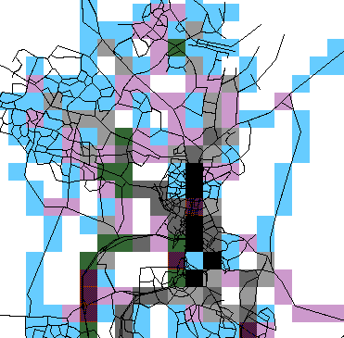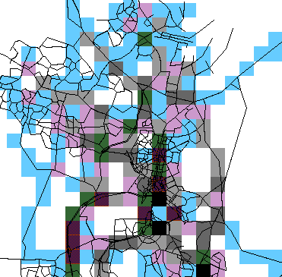
Emission intensities are, of course, increased along the route of GDE. However, intensities are reduced in many other areas in Belconnen and in some locations in North Canberra.

5.2.6 Emission Intensities near AIS
While the emission intensities do not adequately portray emission concentrations, their effect of health and particularly their effect on athletes involved in vigorous aerobic exercises, it is at least possible to assess the growth of pollutant emissions near AIS and compare them with the emission intensities in Civic, which is usually amongst the highest intensities.
The following table compares the emission intensities near AIS, with and without GDE, and Civic with GDE, against those in Civic without GDE in the year 2031 and in 2001.
Emission Intensities in 2031 compared with Civic without GDE
Emission | AIS Without GDE | AIS With GDE | Civic with GDE | Civic now
HydroCarbons | 5.18% | 22.55% | 95.55% | 122.44%
Carbon Monoxide | 4.91% | 26.71% | 95.26% | 117.08%
Nitrigen Oxides | 5.60% | 37.30% | 95.99% | 87.55%
Sulphur Dioxide | 5.25% | 33.84% | 95.77% | 60.14%
Particulates PM10 | 4.99% | 33.95% | 95.61% | 78.44%
Acetaldhyde | 3.32% | 4.33% | 94.46% | 100.74%
Benzene | 2.10% | 4.16% | 90.78% | 115.29%
Butadyene | 3.34% | 4.22% | 92.08% | 119.90%
Ethylbenzene | 3.35% | 4.15% | 90.58% | 113.27%
Formaldehyde | 3.33% | 4.31% | 93.94% | 105.53%
Hexane | 3.21% | 4.15% | 90.51% | 106.60%
Toluene | 3.35% | 4.15% | 90.56% | 110.86%
Xylene | 3.35% | 4.15% | 90.57% | 103.19%
The table shows that, although emission intensities will increase near AIS with the construction of GDE, they are still only a fraction (between 4% and 37%) of those in Civic today or in the future.

5.3 Economic Impacts
The economic evaluation aims to assess all impacts created by the introduction of the proposed road, which have a bearing on the economic well-being of the entire Canberra urban area and which can be credibly enumerated. The GDE has not been assessed in isolation, but as a part of the whole city's transport and travel environment.
The evaluation compares the situation where GDE is not constructed with the opposite where it is implemented, all other things being equal. The evaluation uses data from the travel simulation model in three years – 2001, 2011 and 2021, intermediate years being interpolated.
It generates benefit-to-cost ratios and net present values at different discount rates with which to assess the economic viability of the project and its economic merit.

The economic assessment removes the effect of taxes, subsidies and other transfer payments, such as fares, from the analysis. The list of economic benefits and costs, to be enumerated includes the following items:-
- Capital costs of GDE;
- Personal travel or activity benefits valued in perceived travel prices,
- Changes in economic resources consumed in achieving the benefits, classified as:-
- changes in annual road maintenance;
- changes in annual accident costs;
- changes in highway vehicle operating costs; and
- changes in drivers' and passengers time.
The economic evaluation has been based on a construction cost estimate of $54 millions in the year 2004. The present value in 2001, excluding tax effects, reduces this figure to the $41.3 million shown in the table below, which summarizes the costs and benefit items.
Summary of Canberra-wide Benefits and Costs from GDE
Benefit or Cost Item | Present Value Millions @ 8%
Construction Costs | $41.3
Maintenance Costs | $1.7
Accident Costs | -$0.4
Vehicle Operating Costs | $41.0
User Time Costs | -$96.4
Total Costs | -$12.7
User Travel Benefits | $54.3
Net Present Value | $67.0
Additional benefits arising from reduced operating and fleet replacement costs for public transport have not been included.
The Benefit-to-Cost Ratio and Net Present Value available from implementing GDE is shown in the following table.
Benefit to Cost Ratio & Net Present Value of GDE
Discount Rate | B/C Ratio | Net Present Value (Mill)
6% | 3.2 | $92.8
8% | 2.7 | $67.0
10% | 2.3 | $48.0
While it is not normal for all projects with a Benefit-to-Cost Ratio exceeding 1.0 to be implemented, a project with a ratio as high as 2.7 is well worth-while.
The estimated annual flows of costs and benefits from implementing GDE are as shown in the table below.

Annual Flow of Canberra-wide Costs & Benefits from GDE
Year | Const.  costs | Maint.  costs | Accident  costs | Veh Op Costs | User Time  Costs | User Benefits | Net Flow
2004 | 27,000,000 | 0 | 0 | 0 | 0 | 0 | -27,000,000
2005 | 27,000,000 | 44,640 | -9,880 | 1,380,642 | -1,490,689 | 1,193,737 | -25,730,976
2006 | 0 | 229,000 | -50,000 | 6,740,535 | -8,748,285 | 6,217,315 | 8,046,065
2007 | 0 | 234,800 | -50,600 | 6,577,856 | -10,043,124 | 6,465,944 | 9,747,012
2008 | 0 | 240,600 | -51,200 | 6,415,177 | -11,337,963 | 6,714,573 | 11,447,960
2009 | 0 | 246,400 | -51,800 | 6,252,498 | -12,632,802 | 6,963,202 | 13,148,906
2010 | 0 | 252,200 | -52,400 | 6,089,819 | -13,927,641 | 7,211,831 | 14,849,854
2011 | 0 | 258,000 | -53,000 | 5,927,140 | -15,222,480 | 7,460,459 | 16,550,798
2012 | 0 | 261,500 | -53,500 | 5,923,487 | -15,767,798 | 7,934,625 | 17,570,936
2013 | 0 | 265,000 | -54,000 | 5,919,833 | -16,313,116 | 8,408,791 | 18,591,074
2014 | 0 | 268,500 | -54,500 | 5,916,180 | -16,858,434 | 8,882,957 | 19,611,212
2015 | 0 | 272,000 | -55,000 | 5,912,526 | -17,403,752 | 9,357,123 | 20,631,348
2016 | 0 | 275,500 | -55,500 | 5,908,873 | -17,949,070 | 9,831,289 | 21,651,486
2017 | 0 | 279,000 | -56,000 | 5,905,219 | -18,494,388 | 10,305,455 | 22,671,624
2018 | 0 | 282,500 | -56,500 | 5,901,566 | -19,039,706 | 10,779,621 | 23,691,760
2019 | 0 | 286,000 | -57,000 | 5,897,912 | -19,585,024 | 11,253,787 | 24,711,898
2020 | 0 | 289,500 | -57,500 | 5,894,259 | -20,130,342 | 11,727,953 | 25,732,036
2021 | 0 | 293,000 | -58,000 | 5,890,606 | -20,675,656 | 12,202,117 | 26,752,166
The following abbreviations apply
- Const. Refers to Construction costs
- Maint. Refers to Maintenance Costs
- Veh Op refers to vehicle Operating Costs

6. Conclusions
This review is primarily aimed to provide answers, from a traffic and transport perspective, to the following questions:-
- Is the Gungahlin Drive Extension (GDE) necessary?;
- Which alignment is preferred?;
- What standard should GDE be?;
- What assumptions are made in the traffic and transport analysis?; and
- What other impacts and effects will GDE produce?.
To address these questions the review re-modelled the proposal using the TRANSTEP suite of travel simulation models. The review has been comprehensive, taking into account all land-use, public transport and other policy or operation factors including social and demographic issues. This re-model was considered necessary because the recent studies into GDE did not fully explain all of the issues leading to their conclusions.
Traffic to and from Gungahlin has to wend its way through Belconnen and North Canberra creating congested arterials and high volumes on quiet residential streets. GDE diverts traffic away from residential areas and from many of the congested roads. GDE is necessary to avoid congestion on residential streets and arterials in Belconnen and North Canberra.
Testing a higher mode split assumption and the construction of the Crace Arterial and Monash Drive showed that:-
- The effect of the higher mode split simulation was to reduce traffic flows on GDE by 4%.
- The effect of the construction of the Crace Arterial and Monash Drive would be to reduce traffic flows on GDE by almost 10%. These two major roads are the only planned arterials, which are likely to effect traffic on GDE to any significant extent.
- Both a higher mode split and constructing the Crace / Monash proposal will have little effect on the Caswell Drive section of GDE but reduce traffic on other sections by from 12% to 15%. This is insufficient to change the requirements for GDE, which would still have to be a grade-separated, four-lane road, even with the lower volume demand.
As GDE needs to be a four-lane, grade-separated road, the standards to which it should be constructed should follow Parkway standards. That is, the road should have restricted access. It should have a separated median, with 80 KpH design standards and full landscape and environmental treatments. The reasons in support of this standard are as follows:-
- Roads built to these standards are much safer than normal arterial roads with accident rates up to one third as frequent;
- A parkway standard will have the full effect of diverting as much traffic as possible from residential streets and congested arterials; and
- The reserved corridor, which is a part of the town articulation system, needs full landscape and environmental treatment to properly protect the adjacent parkland and other land-uses.
- An analysis of the intersections of GDE with Belconnen Way and Ginninderra Drive shows that they cannot be designed at grade so GDE will need to be grade-separated. A further analysis of the intersections of the ramps with Bellconnen Way and Ginninderra Drive shows that these intersections with the ramps can be designed, under the eventual traffic demand, to operate under linked signal control.
While congestion in Belconnen will not be as bad as that forecast for 2031, nevertheless many streets, including streets in residential areas, will be quite congested in 2006. The traffic flows in 2006 could just be accommodated within a two-lane arterial road provided that the intersection configuration was adequate. However, an analysis of the intersection at Bellconnen Way with an at-grade arterial with these volumes (and turning volumes) shows that such an intersection would have a level-of-service ‘F’ and intolerable delays. However, an at-grade intersection with Ginninderra Drive would operate tolerably in 2006.
By 2011, the Southbound flows cannot be accommodated within a two-lane arterial road but require a four-lane road. Further, an analysis of an at-grade intersection at Ginninderra Drive shows that this intersection would also have intolerable delays by 2011.
The review concludes that GDE should be commenced before 2006 in the area near Belconnen Way, which would need to be grade separated immediately. The section over Ginninderra Drive would need to be constructed as a grade separated four-lane road well before 2011.
There is negligible difference between the proposed Western and Eastern alignments from the traffic and transport perspective. The improved design, which has a diamond interchange at Belconnen Way and downgrades Caswell Drive to a collector, reduces traffic through residential areas in Aranda and, although it attracts less traffic, this improved design is preferred.

Some of the other impacts and effects predicted to be produced by GDE include:-
- Travel Costs – GDE is predicted to produce longer trips but of shorter duration, leading to some decreases in average travel costs in Canberra;
- Trip Generation Rates – GDE is forecast to slightly increase daily trip making rates;
- Mode Split – GDE is expected to slightly reduce mode split, but this is offset by increased trip making so that public transport ridership is not expected to be reduced;
- Emissions – GDE will have little effect on the growth or savings of total pollutant emissions in Canberra. GDE will increase emissions near the AIS but reduce emissions in the locations in Canberra where they are most intense and more likely to be dangerous to health. Emission intensities near AIS with GDE are only a fraction of those in Civic; and
- Economics – A preliminary economic evaluation shows that GDE would be economically well worthwhile.

