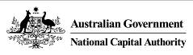

Australian Capital Territory (Planning and Land Management) Act 1988

Draft Amendment 94

National Arboretum Commercial Accommodation
February 2020

Introduction
The National Capital Authority (NCA) is established under the Australian Capital Territory (Planning and Land Management) Act 1988 (the Act). The National Capital Plan (the Plan) came into effect on 21 January 1990. In accordance with the Act, the NCA is required to keep the Plan under constant review and to propose amendments to it where necessary. The object of the Plan is ‘to ensure that Canberra and the Territory are planned and developed in accordance with their national significance’.
The Plan identifies matters of national significance in the planning and development of Canberra and the Territory. These are:
- The pre-eminence of the role of Canberra and the Territory as the centre of National Capital functions, and as the symbol of Australian national life and values.
- Conservation and enhancement of the landscape features which give the National Capital its character and setting, and which contribute to the integration of natural and urban environments.
- Respect for the key elements of the Griffins’ formally adopted plan for Canberra.
- Creation, conservation and enhancement of fitting sites, approaches and backdrops for national institutions and ceremonies as well as National Capital uses.
- The development of a city which both respects environmental values and reflects national concerns with the sustainability of Australia’s urban areas.
Within the framework of this legislative object or goal, key objectives of the Plan are to:
- Recognise the pre-eminence of the role of Canberra and the Territory as Australia’s National Capital.
- Further develop and enhance the Central National Area which includes the Parliamentary Zone and its setting and the main diplomatic sites and national institutions, as the heart of the National Capital.
- Emphasise the national significance of the main avenues and approach routes.
- Respect the geometry and intent of Walter Burley Griffin’s formally adopted plan for Canberra.
- Maintain and enhance the landscape character of Canberra and the Territory as the setting for the National Capital.
- Protect the undeveloped hill tops and the open spaces which divide and give form to Canberra’s urban area.
- Provide a plan offering flexibility and choice to enable the Territory government properly to fulfil its functions.
- Support and promote environmentally responsible urban development practices.
The purpose of Draft Amendment 94 – National Arboretum Commercial Accommodation (DA94) is to add ‘Commercial Accommodation’ and ‘Personal Service Establishment’ as permitted land uses for the National Arboretum Canberra (NAC), and to introduce detailed planning provisions to guide the design and siting of such facilities.
DA94 to the Plan (set out in Part 2: National Capital Plan Draft Amendment 94 – National Arboretum Commercial Accommodation) has been prepared in accordance with section 23 of the Act.

Part 1: Context

Introduction
Following the 2003 bushfires in Canberra, the ACT Government dedicated an area of burnt-out pine forest as the new site for a national arboretum. In 2004, a national design competition for the new arboretum was launched and in 2005, Taylor Cullity Lethlean Landscape Architects and Tonkin Zulaikha Greer Architects were announced winners with their joint proposal '100 Forests and 100 Gardens'.
The winning proposal focused on the establishment of 100 forests of rare, threatened and symbolic trees from Australia and around the world, and provided the foundation for a master plan for the National Arboretum Canberra (NAC). Work on the arboretum commenced in 2005. The Village Centre, Margaret Whitlam Pavilion, Pod Playground and Discovery Garden have all been completed. Substantial progress has been achieved in road, track, signage and car park improvements and in lighting, water harvesting and recycling, irrigation and water storage.
The NAC currently features 94 forests, with the remaining six forests still to be planted. Over 44,000 trees from over 100 countries are growing across the 250 hectare (618 acre) site, making it one of the world's largest living collections of rare, endangered and significant trees. The location of the NAC is illustrated in Figure 1.
The NAC is currently managed by the ACT Government through the Chief Minister, Treasury and Economic Development Directorate (CMTEDD).
Hotel accommodation was included on the NAC’s original competition brief and master plan. The 2006 Master Plan Report identified a hotel, conference centre and carpark on the southern side of Dairy Farmers Hill.
The master plan was updated in 2018 and the hotel remains in the plan. The ACT Government’s CMTEDD has requested an amendment to the National Capital Plan (the Plan) to facilitate the proposal.
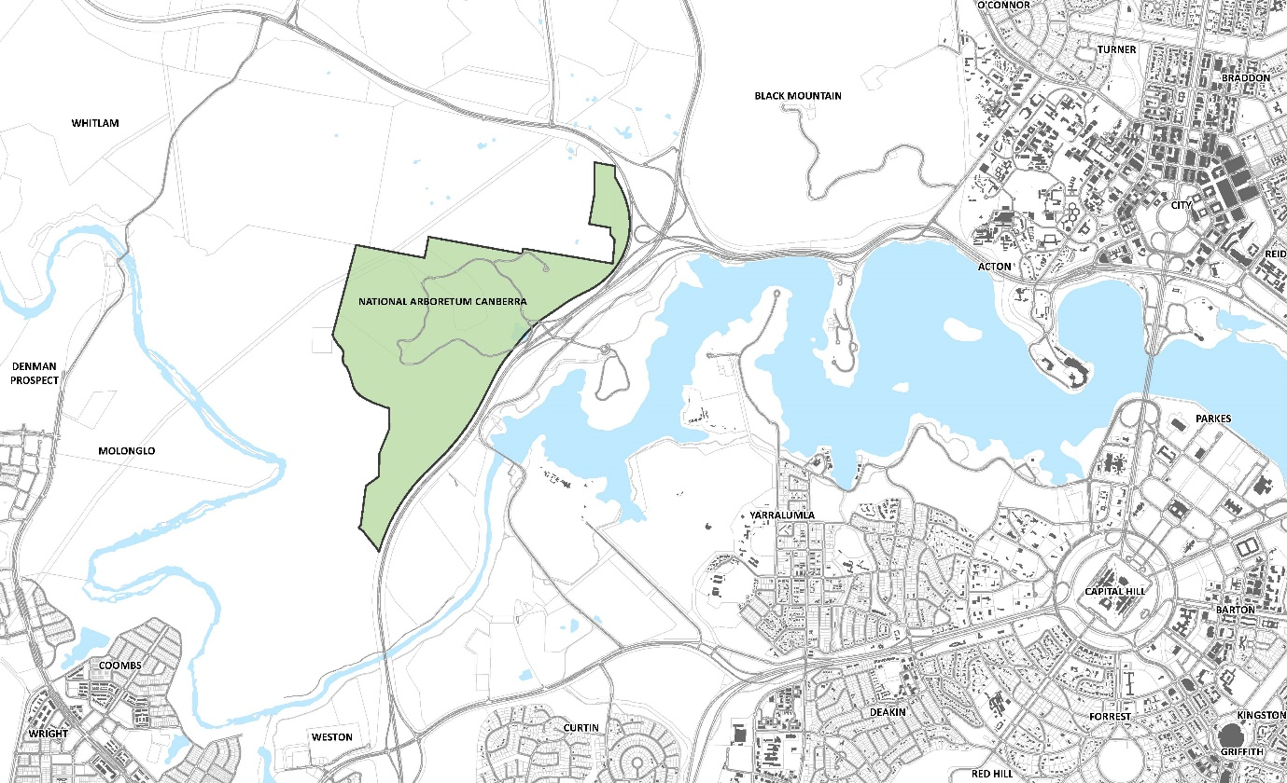
Figure 1: National Arboretum Canberra locality map

The site
The site for the hotel as identified in the master plan is located on the south-western side of Dairy Farmers Hill (refer Figure 2). The site includes Forests 69 and 76 under the National Arboretum Canberra Master Plan. Forest 69 is yet to be planted, but is planned as a forest of Pseudolarix amabilis (Chinese golden larch), within which accommodation and associated facilities will sit. Forest 76 was planted in 2004, and consists of Pinus radiata (Radiata or Monterey pine). Accommodation and associated facilities are also intended to be planted within the Radiata pine forest.
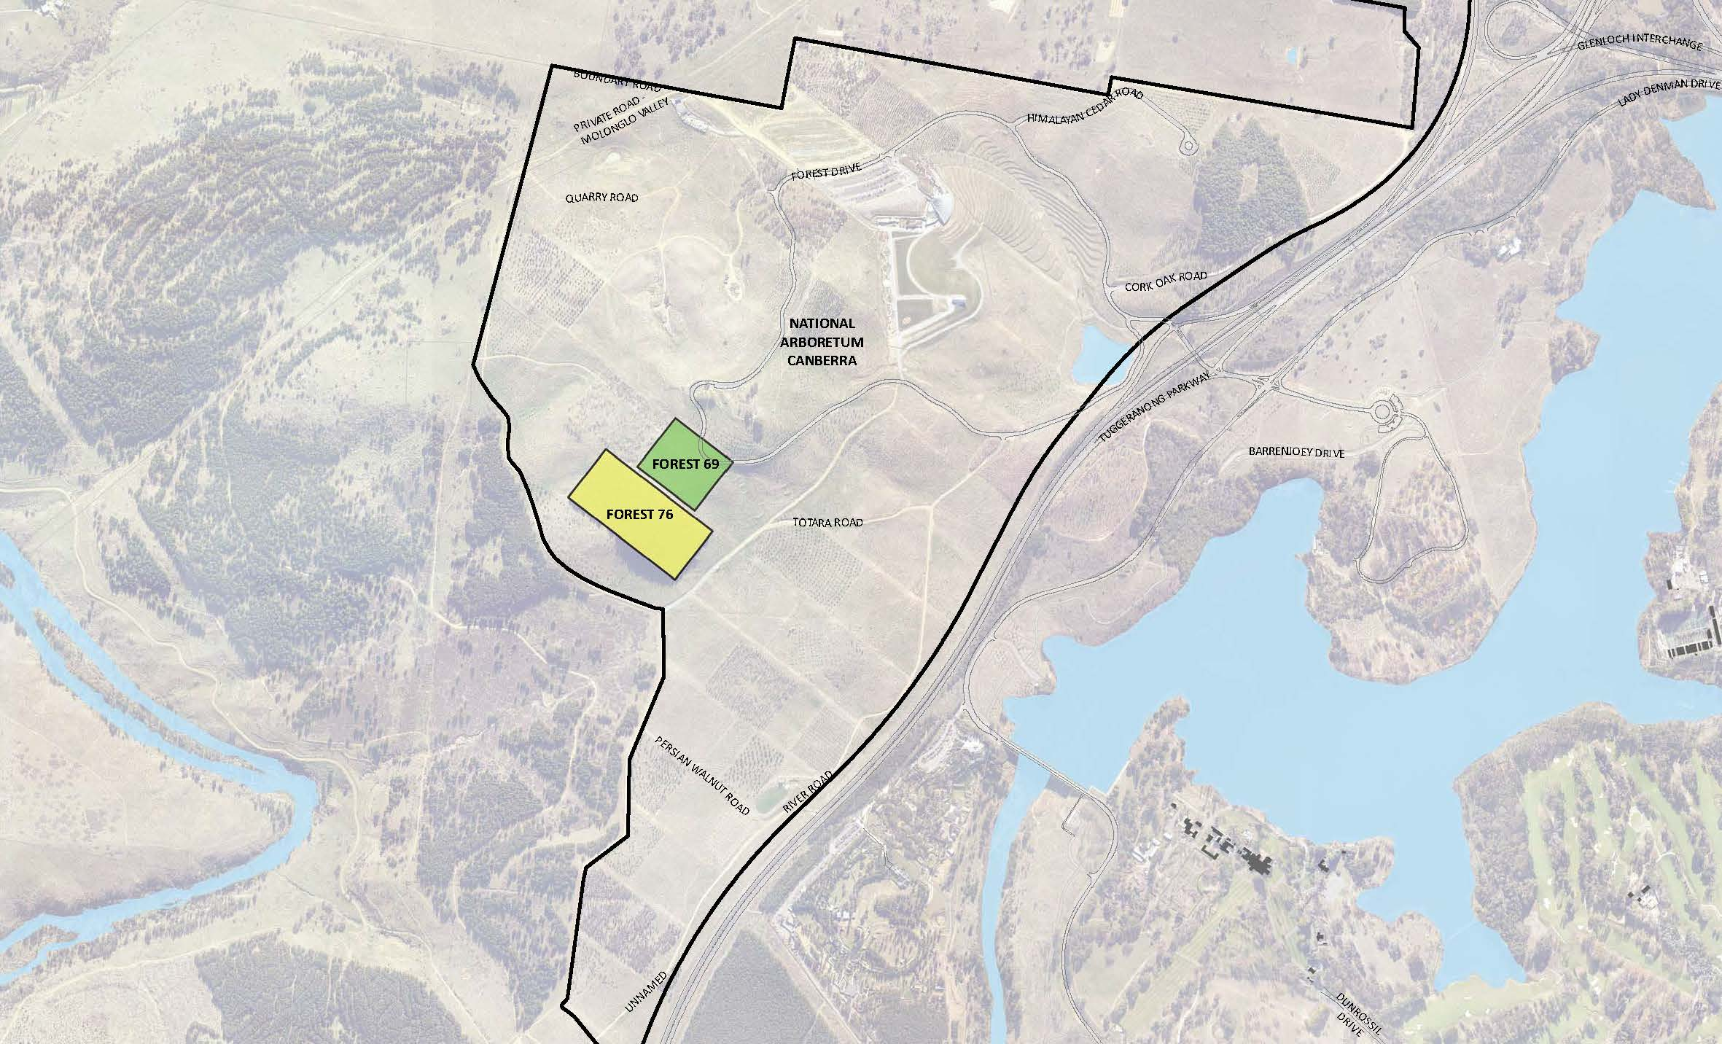
Figure 2: Site of proposed commercial accommodation facilities

Planning, design and heritage considerations

Land use
The NAC is located in the Hills, Ridges and Buffer Spaces land use policy area under the General Policy Plan of the Plan and the entire arboretum site forms part of the Inner Hills. The Inner Hills are within Designated Areas and the NCA is therefore responsible for setting detailed planning policy and approving works at the NAC. The importance of the Inner Hills and the protections afforded to them have consistently been recognised in Canberra’s planning, including most recently in the 2016 legislative remake of the Plan.
The Inner Hills provide a multiplicity of roles within the Central National Area. Most readily identifiable is their role in providing the scenic backdrop and natural setting for Canberra’s urban areas. Their planning, design and development as open space areas are central to the maintenance and enhancement of the character of the National Capital. Key principles and policies for Hills, Ridges and Buffer Spaces seek to ensure that the hill areas are preserved from urban development and that their essential landscape/environmental character is retained and reinforced to provide the unified background and landscape setting for the National Capital.
Hills, Ridges and Buffer Spaces are not however, intended to serve only as a visual backdrop to the city. They are intended to provide for a range of nature based activities, with appropriate support amenities. This includes their continued use for recreation, tourism and appropriate urban services in a manner consistent with the maintenance of their environmental qualities. A range of land uses are permitted within the Hills, Ridges and Buffer Spaces, primarily those associated with agriculture, landscape, and recreation uses. More intense uses are permitted within specific locations, such a tourist facility at Stromlo Forest Park.
The arboretum falls under the land use definition of a ‘Park’, which is a permitted use in the Hills, Ridges and Buffer Spaces. The term ‘Park’ includes facilities provided for the enjoyment or convenience of the public, for example kiosks, amphitheatres, shelters, and lookouts. Existing supporting facilities such as the visitor centre and Margaret Whitlam Pavilion have contributed to the arboretum’s success as a popular visitor destination in Canberra and are considered complementary to the primary use of the site as an arboretum.
Commercial accommodation and personal services establishment are defined land uses within the Plan and not permitted under the current land use policies in place for the NAC. An amendment to the Plan is therefore required to facilitate this development at the NAC.

Visual impact
The subject site is visually prominent from a number of viewpoints including the Tuggeranong Parkway and has a direct line of sight to Government House. It is anticipated that any design will want to take advantage of views across Lake Burley Griffin to the city as well as to the Brindabella mountain ranges to the west. A building at this location is likely to be visible from a number of vantage points.
The forest that sits on the eastern slope below the site is expected to grow to a height of around 10 metres, and is therefore unlikely to provide any screening to the site in the future. The established Radiata pine forest to the south and forest to the west will provide a landscape screen so long as the built form remains below the tree lines.
The design, height and built form of the proposed accommodation and associated facilities will be critical in determining the impact of the development on the Inner Hills. The importance of any development sitting within the landscape and not dominating its surroundings, particularly when viewed from a distance, is also a critical matter.
It is expected that a hotel development and associated facilities would generate a reasonable amount of night time illumination and this issue also requires consideration in the context of the site location, and the potential for further development in this locality to illuminate the Inners Hills.
The NCA is of the view that suitably designed and sited small scale accommodation facilities can provide a favourable outcome for the site. Achieving this outcome is dependent on the application of appropriate planning and design provisions specific to the site and its context.

Heritage and environment
The subject site is not listed on the National, Commonwealth or ACT heritage lists however is in close proximity to a number of places that have heritage values. This includes Government House, which is listed on the Commonwealth Heritage List. The Official Secretary of Government House will be consulted as part of the draft amendment process.
‘Canberra the Planned National Capital’ as a place area has been assessed by the Australian Heritage Council and found to meet the National Heritage Criteria. A National Heritage listing for part of Canberra is currently being considered by the Commonwealth Minister for the Environment.
The NCA supports the proposed National Heritage listing of parts of Canberra and has endorsed the proposed ‘place’ boundary that had been determined by the Department of the Environment and Energy (DEE) in collaboration with the NCA and the ACT Government. The arboretum is located within the place area boundaries.
The setting of Canberra within the natural appearance of the Inner Hills with an unbroken skyline of ridges is an important aspect of the proposed listing. The guidelines indicate that major alienation of nature reserves should be avoided, and the construction of some small ancillary buildings may be acceptable if they are designed in sympathy with National Heritage values. Whilst the listing currently has no formal status, the NCA must be cognisant of the implications of a National Heritage listing on future works within the place area and appropriate planning and design measures will be incorporated to protect heritage values.

Explanatory statement
DA94 proposes two key changes to the Plan:
- Adding ‘Commercial Accommodation’ and ‘Personal Service Establishment’ as permitted uses within the Hills, Ridges and Buffer Spaces land use policy area (for defined forests within the NAC only).

Commercial Accommodation as defined under the Plan means ‘a building or place used for the purpose of providing temporary accommodation and includes a hotel, motel, guest house, caravan park/camping ground, serviced apartment, serviced house and the like’. Given the sensitive nature of the site, it is proposed to restrict land use to hotel accommodation only. Motels, guest houses, caravan park/camping ground, serviced apartment, serviced houses will not be permitted.
- Introducing detailed conditions of planning, design and development to guide the design and siting of commercial accommodation facilities on the site. These conditions set out requirements pertaining to such matters as built form, architectural and landscape quality, parking and movement, lighting, and signage.

Draft Amendment process
The process for making an amendment to the Plan is outlined in Figure 2.
Figure 2: Outline of the National Capital Plan draft amendment process
WHAT HAS BEEN DONE
Proposal by the NCA of a Draft Amendment to the Plan
❑
CURRENT STATUS
Public consultation on a Draft Amendment
❑
WHAT IS NEXT
Submission to Minister
Action by Minister
Parliamentary scrutiny
Expiration of disallowance period

Public consultation
The NCA welcomes written comments on DA94 from interested parties as part of the consultation process. All responses received will be considered before DA94 is submitted to the Assistant Minister for Regional Development and Territories in accordance with the provisions of the Act.
Hard copies of DA94 are available on request by contacting:
National Capital Authority
Ground Floor, Treasury Building
King Edward Terrace
PARKES ACT 2600
02 6271 2888
Between 9am and 5pm Monday to Friday

Public information session
A public information session will be held on Thursday 13 February 2020, from 5.30pm to 6.30pm at the National Capital Exhibition, Barrine Drive, Regatta Point, Commonwealth Park, Parkes AC T 2600. The NCA invites interested parties to register their interest in attending by email draft.amendment@nca.gov.au.
Submissions to DA94 can be:
- emailed to draft.amendment@nca.gov.au
- mailed to Chief Planner, National Capital Authority, GPO Box 373, Canberra, ACT 2601
- delivered to National Capital Authority, Ground Floor Treasury Building, King Edward Terrace, Parkes ACT 2600.
Submissions are invited until close of business on 16 March 2020.
Further information on DA94 is available by telephone on 02 6271 2888 or email draft.amendment@nca.gov.au.

Permission to disclose name and address
The NCA seeks an open and transparent draft amendment process. Following public consultation on the draft amendment, the NCA will prepare a Consultation Report which will be published on the NCA website. This report will include a summary of each submission. The NCA intends to publish the name of each person making the submission, but will not publish contact details (such as physical address, email or phone number).
If you have a concern about having your name published on the internet or wish to make a confidential submission, you must make this clear when submitting your comments. Say why you want your submission to be kept confidential.
The NCA will consider requests for confidentiality, but cannot make promises in advance. If you have concerns about confidentiality, please contact the NCA to discuss before making a submission.

Part 2: National Capital Plan Amendment 94 – National Arboretum Commercial Accommodation
The National Capital Plan is amended by the following:
- Under section 3.2.4.4, add the following to the range of permitted uses in the Hills, Ridges and Buffers Spaces part of the National Capital Open Space System (NCOSS):

- Commercial Accommodation, not including a motel, guest house, caravan park/camping ground, serviced apartment, serviced house (Forest 69 and 76, National Arboretum - only)
- Personal Services Establishment (Forest 76, National Arboretum only)

- Add a new section 3.2.4.4 titled ‘Detailed conditions of planning, design and development – Commercial Accommodation at the National Arboretum Canberra’ as follows:

General principles and policies
- Built form must sit within the landscape setting of the Inner Hills, with the landscape to remain the dominant feature.
- Buildings and landscape must exhibit design excellence in recognition of the site’s visual prominence from the Central National Area, Governor-General’s residence, and its location within the Inner Hills.
- Buildings must explicitly adopt a similar materials palette to existing buildings at the arboretum so as to create an identifiable family of arboretum buildings.
- Landscaping must be complementary to the existing and intended design themes of the arboretum.

Location
Commercial Accommodation is restricted to Forests 69 and 76 of the National Arboretum Canberra, as identified in Figure 8. Personal Service Establishment is restricted to Forest 76 of the National Arboretum Canberra.
Figure 8: Permitted location of commercial accommodation at the National Arboretum Canberra (Forests 69 and 76)

Built form
Buildings on the eastern slope of Forest 69 must be no more than a single storey or seven metres above datum ground level in height. Buildings on the western slope of Forest 69 must be no more than two storeys in height and must not exceed the maximum RL of the top of any building located on the eastern slope. Buildings on the southern slope of the site, within Forest 76, must be no more than seven metres above datum ground level in height and two storeys.
Buildings must be designed and sited to be visually recessive and sit within the landscape when viewed from the Central National Area. Built form should consist of a series of buildings within a generous landscape and forest setting. The materials palette for new buildings must explicitly adopt similar materials to those used for existing buildings at the arboretum.
A visual analysis must be undertaken to demonstrate the impact of development from the Central National Area and key vantage points such as Lake Burley Griffin, the Governor-General’s residence, and Parliament House.
Service areas and facilities such as loading zones, water tanks, waste enclosures must be incorporated into the building form.
Requirements for built form, and design and siting of development are shown in Figure 9.
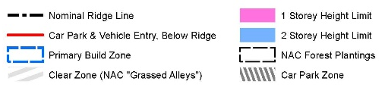
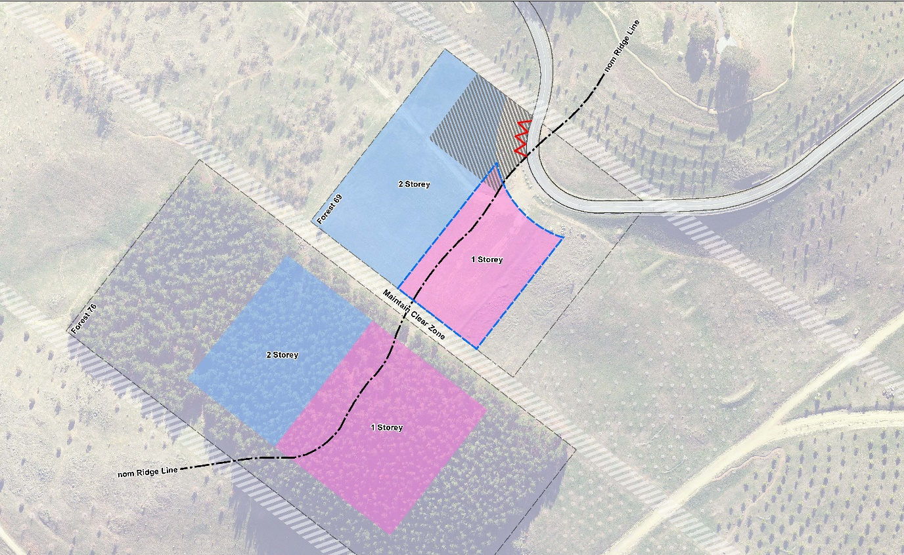Figure 9: Site layout and built form requirements for commercial accommodation at the National Arboretum Canberra (Forests 69 and 76)

Design and siting
Development must demonstrate excellence in architecture, landscape architecture and urban design, including through the use of high quality and durable materials.
The total footprint of all buildings must not occupy more than ten per cent of the total site area.
A maximum of 40 guest rooms is permitted. Guest rooms are not permitted in the single storey precinct of Forrest 69.
Additional amenities such as a restaurant and supporting back of house facilities are permitted within the hotel where it can be demonstrated that they are necessary for the successful operation of the hotel.
Development should achieve best practice in environmentally sustainable design through the use of innovative technology, design and ongoing building operation. Development should be designed to:
- reduce energy consumption, reduce total operating greenhouse gas emissions, and reduce peak demand through particular design measures such as appropriate building orientation, space allocation for solar panels, and shading to glazed surfaces
- improve water efficiency, reduce total operating potable water use, collect and reuse stormwater, use alternative water sources (such as greywater)
- provide a healthy indoor environment including the provisions of fresh air, cross ventilation and natural daylight, reduce reliance on mechanical heating, ventilation, lighting and cooling
- minimise noise levels and noise transfer within and between buildings and associated external areas
- incorporate the use of water sensitive urban design, including stormwater collection and reuse.
Building and landscape design should incorporate biophilic design patterns that enhance connectivity with nature, and contribute to the health and well-being of visitors. Examples of how this may be achieved include:
- using the site’s location within the arboretum to create opportunities for direct visual connections to nature, living systems and natural processes
- designing buildings that allow natural fluctuations in temperature, airflow, and humidity to mimic natural environments
- providing opportunities to experience the place through the seeing, hearing or touching of water
- the use of biomorphic forms and patterns in building materials and landscape design, including contoured, patterned, textured or numerical arrangements that persist in nature
- landscape design that entices people to travel deeper into the environment
- the use of materials or landscape elements from nature that, through minimal processing, reflect the local ecology or geology and create a distinct sense of place.
Building and landscape design must consider the privacy and security of guests. Fencing is not permitted. Landscape should be used to delineate between the public and private realms.
Buildings should be sited to take advantage of views and vistas to the Brindabella Ranges to the west and north-west, and to the Central National Area in the east.
Development must demonstrate consideration of climatic conditions, including wind and heat.
Development proposals must incorporate measures to address noise generated from external sources, including from the Tuggeranong Parkway. Measures may include the use of building materials to reduce noise levels in building interiors, the use of landscape, and the siting and orientation of the residential components away from noise sources.

Landscape
Soft landscaping around buildings should incorporate a range of planting types of varying scales, including trees, shrubs and ground-covers to create a rich, diverse garden setting.
Buildings and landscape design must reflect the original design intent of the arboretum masterplan. Tree plantings should act as an extension of the planted forests of the arboretum. Within Forest 69, tree plantings must predominantly be Chinese Golden Larch. New tree plantings within Forest 76 must predominantly be Radiata Pine.
As far as practicable, Radiata Pine plantings in Forest 76 should be retained to protect the site from southerly winds. New tree plantings and landscape design should afford protection from other predominant winds.
Landscape design should ensure that when trees are mature, development of the site does not significantly detract from the view from Dairy Farmer’s Hill.
Planting on buildings and structures is encouraged as a way of enhancing the integration between built form and landscape, and to provide amenity, improve air quality and microclimate, and reduce direct energy use and stormwater runoff. Where planting on buildings and structures is proposed, landscape materials should respond to local context and complement arboretum species.

Access, parking, and movement
Primary vehicle access to the site is to be from Forest Drive. Secondary access, including for emergency vehicles, must be provided and agreed by the relevant authorities.
Car parking must be screened from view to the maximum extent possible from Forest Drive, Dairy Farmers Hill, and the Central National Area. Parking provision shall be in accordance with the following:
- 1 space per guest room, plus
- 10 spaces per 100m² GFA of bars, restaurant, function rooms and supporting back of house facilities, plus
- 3 spaces per 5 employees
Parking must be incorporated into the landscape design of the site, by extending planting and materials into car parking spaces. Parking must be located on the western side of the ridge. Shade trees should be planted between every 4 car parking spaces to reduce increased surface temperatures from large areas of paving.
Access arrangements must demonstrate consideration of increased traffic on Forest Road as visitation to the National Arboretum Canberra increases.
Path networks across the site must:
- Accommodate the needs of people with a wide range of abilities, including:
  - ensuring that access arrangements and public spaces are appealing for all users, and avoids segregating or stigmatizing any users
  - providing equitable privacy, security and safety for all users
  - minimizing hazards and the adverse consequences of accidental or unintended actions.
- Provide a visually engaging experience, for example through landscape design and public art.
- Be of sufficient width to accommodate all intended users, including pedestrians and vehicles associated with the movement of people and goods between commercial accommodation facilities. Where possible, separate path networks should be constructed to improve safety and amenity.

Signage
A cohesive and co-ordinated signage suite must be developed that:
- responds to the scale, proportion and detailing of the development
- utilises wayfinding markers, both integrated with the built form and within the landscape to identify destinations and points of reference
- includes parking and other regulatory signage integrated with the public realm design and complementary to signage used throughout the arboretum
Illuminated signage must not be visible from the Central National Area.
No animated or flashing signage is permitted.

Lighting
All outdoor lighting, including security and car park lighting, must be designed and sited to minimise light pollution. Lighting solutions must carefully consider any impact on Mount Stromlo Observatory, and views to the site from the Central National Area.
All outdoor lighting (including lighting fixed to structures) must use full cut-off light fittings. Any up-lighting of buildings should be carefully designed to keep night time overspill and glare to a minimum.

Part 3: Consequential changes
The Draft Amendment will recognise consequential changes to page numbers, figure numbers and text references, and contents page.

