

*Australian Capital Territory (Planning and Land Management) Act 1988*

Draft Amendment 89

Deakin/Forrest Residential Precinct

February 2018

# Introduction

The National Capital Authority (NCA) is established under the *Australian Capital Territory (Planning and Land Management) Act 1988* (the Act). The National Capital Plan (the Plan) came into effect on 21 January 1990. In accordance with the Act, the NCA is required to keep the Plan under constant review and to propose amendments to it where necessary. The object of the Plan is *‘to ensure that Canberra and the Territory are planned and developed in accordance with their national significance’*.

The Plan identifies matters of national significance in the planning and development of Canberra and the Territory. These are:

* The pre-eminence of the role of Canberra and the Territory as the centre of National Capital functions, and as the symbol of Australian national life and values.
* Conservation and enhancement of the landscape features which give the National Capital its character and setting, and which contribute to the integration of natural and urban environments.
* Respect for the key elements of the Griffins’ formally adopted plan for Canberra.
* Creation, conservation and enhancement of fitting sites, approaches and backdrops for national institutions and ceremonies as well as National Capital uses.
* The development of a city which both respects environmental values and reflects national concerns with the sustainability of Australia’s urban areas.

Within the framework of this legislative object or goal, key objectives of the Plan are to:

* Recognise the pre-eminence of the role of Canberra and the Territory as Australia’s National Capital.
* Further develop and enhance the Central National Area which includes the Parliamentary Zone and its setting and the main diplomatic sites and national institutions, as the heart of the National Capital.
* Emphasise the national significance of the main avenues and approach routes.
* Respect the geometry and intent of Walter Burley Griffin’s formally adopted plan for Canberra.
* Maintain and enhance the landscape character of Canberra and the Territory as the setting for the National Capital.
* Protect the undeveloped hill tops and the open spaces which divide and give form to Canberra’s urban area.
* Provide a plan offering flexibility and choice to enable the Territory government properly to fulfil its functions.
* Support and promote environmentally responsible urban development practices.

The purpose of Draft Amendment 89 – Deakin/Forrest Residential Precinct (DA89) is to clarify the intended outcomes for the precinct. DA89 proposes that for all sites, other than those fronting State Circle, a single dwelling only is permitted.

DA89 to the Plan (set out in Part 2: National Capital Plan Draft Amendment 89 – Deakin/Forrest Residential Precinct) has been prepared in accordance with section 23 of the Act.

# Part 1: Context

## Background

The Plan identifies areas of land that have the special characteristics of the National Capital to be Designated Areas. The Deakin/Forrest Residential Precinct is one such Precinct within Designated Areas due to its frontage to the Main Avenue of State Circle, its location within the Griffins’ land axis, and from its close proximity and relationship to Parliament House. The residential area is also an example of the twentieth century ‘Garden City’ planning concepts that the Griffins’ adopted in their design for Canberra.

In late 2016, the NCA embarked on a review of the Deakin/Forrest Residential Precinct and relevant provisions of the Plan. The intent of the review is to ascertain whether current planning and design controls are still adequate to guide the outcomes expected for the Precinct. The NCA released an Issues Paper for public consultation in April 2017, which identified a range of local and strategic issues relevant to the Precinct.

Thirty-seven submissions were received by the NCA in response to the Issues Paper, from community groups, industry, government, and individuals. Submitters provided comment on a range of matters including landscape, setbacks, building height, the public domain, environmental sustainability, density and dwelling type, architecture, plot ratio and site coverage. The planning and design policy proposed in DA89 addresses a number of these matters and reflects concerns raised by many submitters.

## The Precinct

The Deakin/Forrest Residential Precinct comprises the area bound by State Circle, Canberra Avenue, National Circuit and Adelaide Avenue. The Precinct also encompasses the site of St Andrew’s Church, the Embassy of Italy, Collins Park, and diplomatic missions in Red Hill.

DA89 focusses on residential blocks in that part of the precinct bound by Hobart Avenue, National Circuit, Canterbury Crescent, and blocks fronting State Circle. The blocks subject to DA89 are identified in Figure 1.

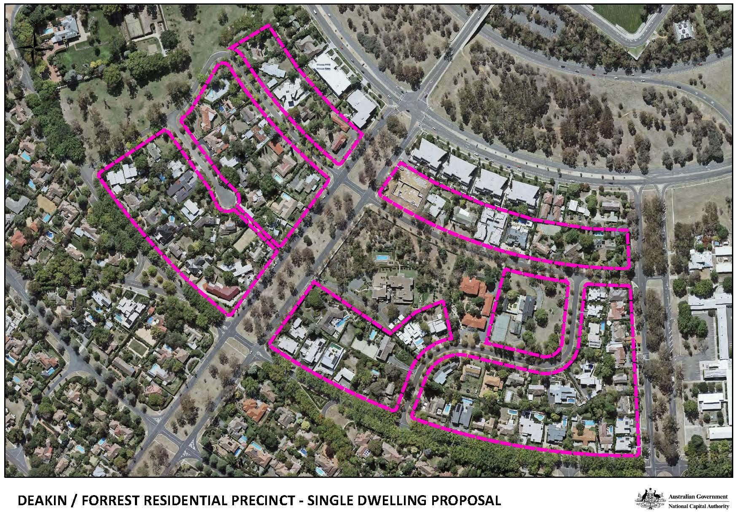

Figure 1: Area of the Deakin/Forrest Residential Precinct subject to Draft Amendment 89

## 1.3 Explanatory statement

The Deakin/Forrest Residential Precinct has been within Designated Areas since inception of the Plan in 1990, and was originally identified as part of the ‘Parliamentary Zone and its Setting’. The area so designated ensures that the essential relationships between Parliament and its setting are planned and developed in an integrated way, with the Commonwealth providing the requisite leadership and expectations for the highest standards of planning and design.

The nature and extent of Designated Areas has been examined on multiple occasions through inquiries by the Joint Standing Committee on the National Capital and External Territories (JSCNCET) and examination of the roles and responsibilities of the NCA. Notably this has included consideration of the national significance of the Deakin/Forrest Residential Precinct by the JSCNCET in the context of their inquiry into National Capital Plan Amendment 39. In each case, it was concluded that the location of the Deakin/Forrest Precinct warrants inclusion within Designated Areas.

The NCA supports continued inclusion of the Precinct within Designated Area. The NCA is best placed to ensure that planning policy, and subsequent works, demonstrate the highest standards of planning, design and development.

Over the past 10-15 years, redevelopment of the area has seen changes to the form and scale of development, with an increase in multi-dwelling units such as duplexes, townhouses and apartments facing State Circle. New dwellings are typically larger, with increased hardscape and subsequently decreased soft landscaping.

The cumulative impacts have been such that the NCA is concerned that key characteristics of the Precinct may be lost without changes to existing planning policy. The NCA is committed to ensuring that the Precinct continues to exhibit the ‘Garden City’ and ‘City beautiful’ principles on which the Precinct was originally based.

The NCA has considered the changing nature of the Precinct and feedback on the Issues Paper. The NCA is of the view that in order to uphold the national significance of the Precinct and the reasons for its inclusion within Designated Areas, development should be restricted to a single dwelling per block. This excludes blocks fronting State Circle, which the NCA recognises can appropriately accommodate multi-dwelling development given their context. Complementary provisions addressing landscape character and retention of existing trees are also required.

The NCA believes the proposed policy will uphold the characteristics of the neighbourhood valued by a significant proportion of the community, and result in a nationally significant area of which Canberrans can be proud.

## Effect of the draft amendment

DA89 proposes to introduce specific requirements for those residential blocks in the Deakin/Forrest Residential Precinct bound by Hobart Avenue, National Circuit, Canterbury Crescent, and blocks fronting State Circle. Key proposed requirements for these blocks include:

* a single dwelling only per block
* new and existing trees to be capable of providing at least 15% canopy coverage of a site when trees are mature
* not less 35% of total site are to be for planting area (meaning an area of land covered by trees, grass or lawn, garden beds, shrubs, and the like.

Existing provisions of the Plan concerning building height and plot ration are not proposed to change. This includes a maximum building height of two storeys and eight metres above ground level, and a maximum plot ratio of 0.4.

DA89 also proposes to introduce definitions of ‘Basement’ and ‘Corner block’, and to amend the definition of ‘Height of building’. This will assist with interpretation of the Plan.

## 1.5 Draft Amendment process

The process for making an amendment to the Plan is outlined in Figure 2.

Figure 2: Outline of the National Capital Plan draft amendment process

|  |
| --- |
| **WHAT HAS BEEN DONE** |
| Proposal by the NCA of a Draft Amendment to the Plan   |
| **CURRENT STATUS** |
| Public consultation on a Draft Amendment   |
| **WHAT IS NEXT** |
| Submission to Minister |
| Action by Minister |
| Parliamentary scrutiny |
| Expiration of disallowance period |

## Public consultation

The NCA welcomes written comments on DA89 from interested parties as part of the consultation process. All responses received will be considered before DA89 is submitted to the Minister for Local Government and Territories in accordance with the provisions of the Act.

Hard copies of DA89 are available on request by contacting:

National Capital Authority  
Ground Floor, Treasury Building  
King Edward Terrace  
PARKES ACT 2600

02 6271 2888

Between 9am and 5pm Monday to Friday

draft.amendment@natcap.gov.au

### Public information session

A public information session will be held on Tuesday 13 March 2018, from 5pm to 6pm at the National Capital Authority, Griffin Room, Ground Floor, Treasury Building, King Edward Terrace, PARKES, ACT 2600. The NCA invites interested parties to register their interest in attending by email [draft.amendment@natcap.gov.au](mailto:draft.amendment@natcap.gov.au).

Submissions to DA89 can be:

* emailed to [draft.amendment@natcap.gov.au](mailto:draft.amendment@natcap.gov.au)
* mailed to Chief Planner, National Capital Authority, GPO Box 373, Canberra, ACT 2601
* delivered to National Capital Authority, Ground Floor Treasury Building, King Edward Terrace, Parkes ACT 2600.

**Submissions are invited until close of business on 16 April 2018**.

Further information on DA89 is available by telephone on 02 6271 2888 or email draft.amendment@natcap.gov.au.

### Permission to disclose name and address

The NCA seeks an open and transparent draft amendment process. Following public consultation on the draft amendment, the NCA will prepare a Consultation Report which will be published on the NCA website. This report will include a summary of each submission. The NCA intends to publish the name of each person making the submission, but will not publish contact details (such as physical address, email or phone number).

If you have a concern about having your name published on the internet or wish to make a confidential submission, you must make this clear when submitting your comments. Say why you want your submission to be kept confidential.

The NCA will consider requests for confidentiality, but cannot make promises in advance. If you have concerns about confidentiality, please contact the NCA to discuss before making a submission

# Part 2: National Capital Plan Amendment 89 – Deakin/Forrest Residential Precinct

The National Capital Plan is amended by the following:

1. Delete section 4.5 Deakin/Forrest Residential Area Precinct Code and replace with the following:

## 4.5.1 Precinct location

The Deakin/Forrest Residential Area Precinct comprises the area bounded by State Circle, Canberra Avenue, National Circuit and Adelaide Avenue. The Precinct also encompasses the site of St Andrew’s Church, the Embassy of Italy, Collins Park and diplomatic missions in Red Hill. Figure 27 illustrates the location of the Deakin/ Forrest Residential Area Precinct.

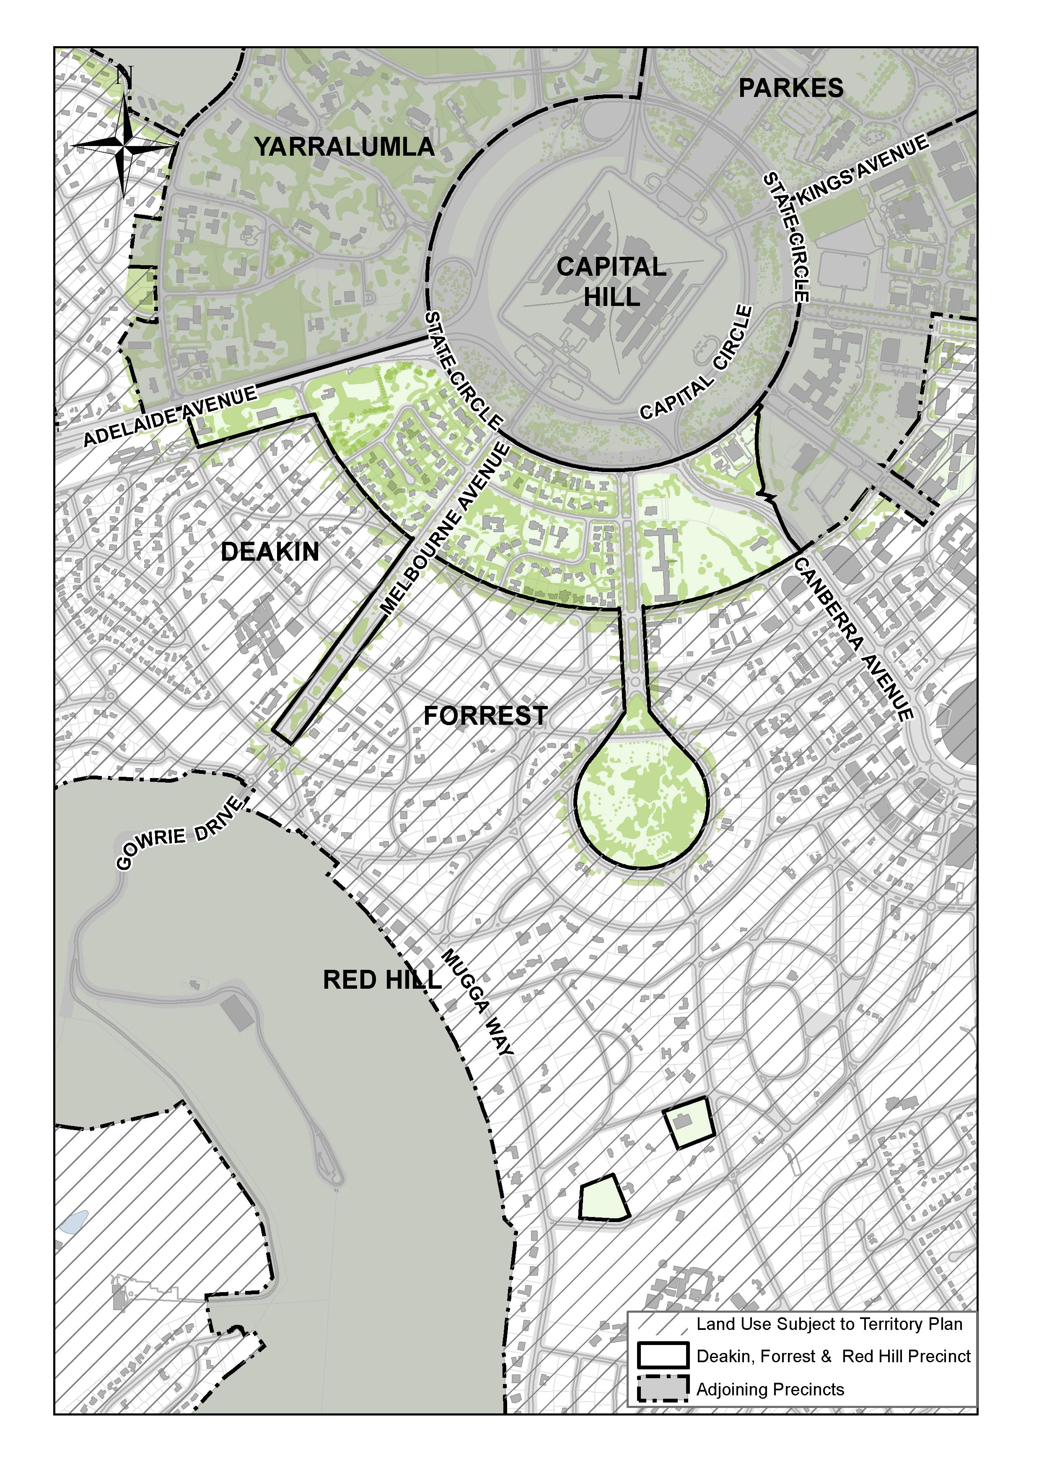

Figure 27: Deakin Forrest Residential Precinct location

## 4.5.2 Background

The importance of the Deakin/Forrest residential area stems from its frontage to the Main Avenue of State Circle, its location within the Griffins’ Land Axis, and from its close proximity and relationship to Parliament House. The residential area is an example of the twentieth century ‘Garden City’ planning concepts that the Griffin’s adopted in their designs for Canberra.

ThThere is a National Capital interest in ensuring that development surrounding, and in close proximity to, Parliament House is of the highest design quality.

## 4.5.3 Desired character statement

Development will be predominantly residential in nature, except where other uses are specified.

Since Canberra’s inception the garden city concept has been an integral part of the residential environment. This will continue to be a relevant concept, and the precinct will be characterised by large areas of soft landscaping around dwellings, with either no front fence or a front fence combined with hedging. Car parking and structures are not permitted in the front setback of properties in order to maximise space for landscaping and enhance the streetscape.

Development is to be typically no more than two storeys in height (except where specifically provided for), with the aim of achieving a scale that is not assertive. It is envisaged that a mix of building materials will be retained, however brickwork or painted render should dominate. Colours should be generally muted and drawn from the orange-brown and white-grey ranges.

## 4.5.4 Land use for the Deakin/Forrest Residential Area Precinct

Land use for the Deakin/Forrest Residential Area Precinct should be in accordance with Figure 28.

Commercial accommodation including serviced apartments is not permitted on ‘Residential’ or ‘Single Dwelling Housing’ blocks.

Permitted land uses for ‘Land Use A’ are:

* Residential
* Diplomatic Mission
* Commercial Accommodation (Hotel and Serviced Apartment only).

## 

Figure 28: Land use for the Deakin Forrest Residential Precinct

## 4.5.5 Detailed conditions of planning, design and development

### General

To ensure excellent urban design for this important residential precinct adjacent to Parliament House, the quantitative standards, with the exception of building height and plot ratio, may be varied where it can be demonstrated that this would result in an excellent urban design outcome. All residential development proposals are subject to public notiﬁcation and consultation with lessees and residents in the Deakin/ Forrest residential area.

The general development conditions include:

* Development throughout the area, except for sites fronting State Circle, should not be more than two storeys in height and generally no more than eight metres above the natural ground level.
* Development throughout the area, except for sites fronting State Circle, should have a maximum plot ratio of 0.4.
* Design of buildings in proximity to the Prime Minister’s Lodge should reﬂect the dominant urban design character of the locality.
* Roof mounted aerials, masts and satellite dishes should be located to have a low visual impact.

### Location specific – Residential sites fronting State Circle between Hobart and Adelaide Avenues

The following conditions apply to residential sites fronting State Circle between Hobart and Adelaide Avenues.

The objectives of these development conditions are to:

* Provide for high quality residential development of a scale and character appropriate to the setting of Parliament House and the Main Avenue role of State Circle.
* Protect the residential amenity of rear neighbours in terms of privacy, sunlight access and provision of a landscape buffer.
* Reduce traffic access from residences to State Circle.
* Provide for a variety of housing types and sizes.

#### Block amalgamation

Block amalgamation may involve more than two blocks.

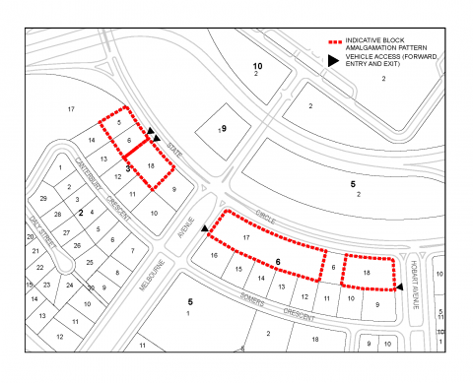

Figure 29: Deakin Forrest Residential Precinct - Indicative block amalgamation and access

#### Building height

Any redevelopment of blocks will result in buildings that address State Circle and should be two storeys in height. If blocks are amalgamated three storeys is permissible. If a block is isolated by amalgamation three storeys may be permissible.

#### Plot ratio

The plot ratio for residential redevelopment of existing blocks is 0.4. If sites are amalgamated the plot ratio may be up to 0.8. An exception applies to blocks flanking Melbourne Avenue (Block 1 Section 6 Forrest and Block 9 Section 3 Deakin) which are permitted to develop to a plot ratio of 0.8 without amalgamation. For other blocks, including blocks isolated by amalgamation, a plot ratio higher than 0.4 and up to a maximum of 0.8 may also be permissible (where it can be demonstrated that this would result in an excellent urban design outcome).

#### Architecture

Architectural treatment should be of the highest quality, reflecting the prestigious character of the area. The provision of legible entries, accessible from the street, is encouraged as a means of enriching the streetscape. Buildings should be modulated and provided with articulation elements such as porches, balconies, bay window and shade devices, to provide visual interest to the streetscape. Balconies off living areas should generally have a minimum dimension of 2.5 metres.

Due consideration should be given to the roof form and roofscape of buildings. Roof top plant and equipment, if required, should be carefully integrated with the roof form and design of the building and screened from public view from the street. Internal floor to ceiling dimensions should generally be a minimum of 2.7 metres to promote natural lighting and cross-ventilation, consistent with energy efficiency objectives and creation of generously scaled façades.

#### Vehicle access

Vehicle access should be consistent with the principle shown in Figure 29. Blocks, including amalgamated blocks, with a frontage to a road other than State Circle may have access to that road. Site planning should ensure that vehicles are able to enter and leave the site in a forward direction.

The number of vehicular access points to and from State Circle should be minimised in the interests of traffic safety, convenience and streetscape quality.

#### Building envelopes

Buildings should generally be contained within the building envelopes depicted in Figure 30.

#### Setbacks

Setback from State Circle should be 10 metres. Building articulation elements such as balconies, entries and shading devices may be permitted forward of the primary setback.

The minimum setback of buildings from side boundaries for three storey development is six metres. For two storey development, the minimum side boundary set back may be less than six metres provided it is generally in accordance with the building envelope depicted in Figure 30.

The minimum set back for buildings from rear boundaries for three storey development is generally 18 metres. Lower scale development may occur within the rear landscape zone subject to the protection of privacy, the avoidance of overshadowing and the retention of existing substantial trees.

#### Car parking

Where the plot ratio exceeds 0.4, car parking other than parking for visitors, should be in a basement. If car parking is in a basement it will not be considered to be part of the Gross Floor Area (GFA) of the building. The basement level is also not considered to be a storey.

The finished floor level of the floor above the basement should not exceed one metre above natural ground level. Vent openings are to be integrated with landscape and architectural elements, and generally concealed from public view.

Undercroft parking, carports, and free standing garages are to be avoided.

#### Landscape

The front landscape zone to State Circle should be developed to provide a high quality landscape setting with space for planting medium to large trees.

The rear landscape zone is to provide for a substantial landscape buffer that will afford privacy to rear neighbours and maintain winter sunlight to those properties.

The use of hedges is encouraged in lieu of, or combined with, garden walls when forward of the building line. Any front retaining or garden wall should be integrated with the landscape treatments. Garden walls forward of the building line should generally be transparent in character. The maximum average height of fencing should be 1500mm.

Large expanses of exposed paved surfaces except for necessary vehicle driveways, should be avoided.

#### Off-site works

Off-site works to be provided by the proponent, may be required as part of the approval for development.

#### 

Figure 30: Deakin Forrest Residential Precinct - Building envelopes and setbacks

#### Indicative development plan, section and elevation

Development of amalgamated blocks is to be guided by the indicative development plan, section and elevation at Figure 31, Figure 32 and Figure 33 respectively.

### 

Figure 31: Deakin Forrest Residential Precinct - Indicative development plan for State Circle

### 

Figure 32: Deakin Forrest Residential Precinct - Indicative elevation for State Circle

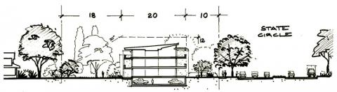

Figure 33: Deakin Forrest Residential Precinct - Indicative cross section for State Circle

### Location specific – Single Dwelling Housing sites bound by Canterbury Crescent, Somers Crescent, Hobart Avenue and National Circuit, and on the north eastern side of Canterbury and Somers Crescents

#### Introduction

Proponents must demonstrate that new development is not inconsistent with the following policies.

Both quantitative and qualitative standards are provided in the conditions below. The quantitative standards are objective guides to the performance standards.

Compliance with the quantitative standards will therefore not necessarily result in works approval unless the performance standards have, in the opinion of the National Capital Authority, also been achieved.

On the other hand, works approval may be given under special circumstances when the performance standards can be achieved without complete compliance with the quantitative standards.

#### Block amalgamation

In order to maintain subdivision patterns, block amalgamation is not permitted.

#### Building height

The maximum height of buildings is two storeys, and no more than eight metres above natural ground level.

#### Plot ratio

Plot ratio must not be greater than 0.4.

#### Number of dwellings

A single dwelling only is permitted on each block.

#### Architecture

Architectural treatment must be of the highest quality, reflecting the prestigious character of the area, including proximity to Parliament House and The Lodge. Buildings should be modulated and provided with articulation elements to provide visual interest to the streetscape.

Internal floor to ceiling dimensions should be a minimum of 2.7 metres to promote natural lighting and cross-ventilation. A lower ceiling height is permissible in storerooms, bathrooms laundries and toilets.

Every habitable room should have a window in an external wall with a total minimum glass area of not less than 15% of the floor area of the room. No part of a habitable room should be more than 8 metres from a window.

The design of buildings should demonstrate a high standard of sustainable design. Design responses could include:

* living areas oriented to the north
* design eaves and awnings to provide shade for window during summer
* select building materials and colours which absorb less heat in summer
* insulate walls, ceilings, floors and roof spaces
* use smart glass or other technologies on north and west elevations
* install photovoltaics on buildings to generate electricity.

Proposals must demonstrate consideration of overshadowing and privacy of neighbouring properties, including both dwellings and open space.

New development must be located and oriented to maximize visual privacy between buildings on site and for neighbouring properties.

New development must ensure that building separation does not impact on the solar access of neighbouring properties.

#### Setbacks

***Performance standards***

The planning objectives in requiring buildings to be set back given distances from front property boundaries are:

1. to enable a building to be sited so that its occupants can, as far as possible, be assured of an outlook that will not be obstructed by neighbouring buildings that might otherwise be erected closer to the front property boundary
2. to provide an area adjacent to the street or open space for landscape treatment so that the garden character which is a major environmental feature of suburban Canberra can be preserved and maintained
3. in certain circumstances, to protect the sight lines of drivers of motor vehicles.

Requirements for side distances are intended to achieve the following objectives:

* to allow adequate light and ventilation and to preserve the privacy of neighbours
* in some cases to provide a space wide enough for vehicles to pass by the house on one side at least
* to provide access for fire control and to inhibit the easy escape of fire
* to create a spatial separation between detached buildings for reasons of civic design.

Requirements for read distances are intended to allow adequate light and ventilation to preserve the privacy of neighbours and to ensure the provision of a service yard.

***Quantitative standards***

Side set backs should be a minimum of 2.4 metres for single storey buildings. Side set backs for the ground floor components of buildings of more than one storey should be a minimum of 2.4 metres. Second storey components of buildings of more than one storey should be set back a minimum of 3.6 metres.

Front set backs should be a minimum of six metres for single storey buildings. Front set backs for the ground floor components of buildings of more than one storey should be a minimum of six metres. Second storey components of buildings of more than one storey should be set back a minimum of 7.5 metres.

Where sited on a corner block, building set backs to the major frontage should be a minimum of six metres for single storey buildings and 7.5 metres for buildings of more than one storey. Set backs to minor frontages should be a minimum of 4.5 metres for a single storey building and a minimum of six metres for buildings of more than one storey.

Rear set backs should be a minimum of four metres for single storey buildings. Rear set backs for the ground floor component of buildings of more than one storey should be set back a minimum of four metres. Second storey components of buildings of more than one storey should be set back a minimum of 7.5 metres.

Regardless of the above, all buildings must be set back a minimum of 10 metres from any property boundary adjacent to a Main Avenue.

Where structures are provided as part of private open space (such as alfresco dining areas, pergolas, swimming pools and the like), these should be set back in accordance with the set back provisions for buildings. The NCA may consider alternative set backs where is can be demonstrated that the privacy of neighbouring dwellings is maintained.

#### Landscape

Proposals for redevelopment of a block must be accompanied by a landscape plan prepared by a Registered Landscape Architect.

A composition of soft landscaping must be provided between the building line and the front property boundary (or boundaries in the case of corner blocks). Soft landscaping may include trees, shrubs, grass and garden beds. Hard surfacing, other than for pathways and driveways, should be avoided.

Established trees should be retained where possible and information submitted to the National Capital Authority demonstrating that construction activities will not result in significant adverse impacts to those trees. The National Capital Authority will consider tree removal where an arborist report demonstrates that:

* a tree is in ill health or in decline;
* a tree poses a threat to resident or public safety;
* a tree is pest species or unsuitable for the Canberra climate;
* a tree is restricting the growth of other vegetation; and/or
* site and building design can be optimized by the removal of trees.

In these circumstances, the National Capital Authority’s preference is for new trees to be planted elsewhere on site. The combination of new and existing trees should be capable of providing at least 15% canopy coverage of a site when trees are mature.

Trees should be chosen to contribute to energy efficiency by providing substantial shade in summer, especially to west facing windows, and admitting winter sunlight to outdoor and indoor living areas, especially to the north.

Not less than 35% of total site area should be for planting area. Planting area means an area of land within a block covered by trees, grass or lawn (not including synthetic turf), garden bed, shrubs (including hedges) and the like. Planting area does not include any area covered by buildings (including basement), swimming pools, vehicle parking or manoeuvring areas (whether permeable or not), or any other form of impermeable surface.

#### Vehicle access and car parking

No increase in the number or width of verge crossings is generally permitted. The exception to this is for corner blocks where individual access may be provided to each dwelling.

Driveways should integrate with front garden planting to reduce the visibility of the driveway from the street.

Driveways should be a single-vehicle width (<3.6m) between the front boundary and building line and have a uniform surface of subdued charcoal or earthen tones. Gravel, brick, clay or concrete pavers or bitumen are preferred surface finishes.

Verge crossings should have a bitumen surface. Where existing verge crossings are surfaced in a material other than bitumen, consideration should be given to replacement. Where required, the replacement of existing bitumen verge crossings with new bitumen is encouraged.

A minimum of two off-street car parking spaces must be provided for all new dwellings.

To avoid parking dominating the streetscape, garages and carports should be located behind the main building façade. Other elements of the dwelling design should dominate the streetscape.

#### Hedges and fences

The planting of hedges along front boundaries and along side boundaries forward of the building line, to separate the public and private domains, and which ‘frame’ views to dwellings and front gardens, are encouraged.

Replacement or new hedge species should be evergreen and of appropriate scale and shape to form a border of typically not more than 1200mm in height.

Retaining walls or earth mounding visible to the street should only occur where they will not have an adverse impact on the streetscape character.

Fences and courtyard walls are generally not permitted closer to the street than the building line.

Sheet metal fencing is not permitted between buildings and side boundaries or at any location visible to the street or adjacent public domain.

Fences and gates between buildings and side boundaries should be:

* set at least 0.6 metres behind the building line
* a maximum of 1.8 metres in height above natural ground level
* timber paling, timber lattice, brush, open mesh or metal railing.

Side and rear boundary fences and gates should:

* not extend forward of the building line
* be a maximum of 1.8 metres above ground level
* be timber paling, timber lattice, brush or open mesh metal railing.

Proposals for fences and gates along side and rear boundaries in excess of 1.8 metres in height will be subject to special consideration by the National Capital Authority.

### Location specific – Blocks 13 and 14 Section 13 Forrest

The following conditions apply to Blocks 13 and 14 Section 13 Forrest.

The objectives of these development conditions are to:

* Ensure excellent urban design for this important precinct on the final approach to the Parliamentary Zone.
* Provide an opportunity for the development of mixed use facilities, including ‘Residential’, Diplomatic Mission’, and ‘Commercial Accommodation (Hotel and Serviced Apartments only)’.
* Achieve a built form for the Canberra Avenue frontage similar to other sites adjacent to the final approach to the Parliamentary Zone.
* Achieve a built form for the State Circle frontage similar to that of the sites fronting State Circle in the Deakin/Forrest residential area.

#### Building height

Buildings fronting Canberra Avenue are to be a maximum height of RL594. Buildings fronting State Circle are to be a maximum height of RL591.

#### Plot ratio

The plot ratio for development on Blocks and 14 Section 13 Forrest is 0.8.

#### Architecture

Architectural treatment must exhibit design excellence, reflecting the prestige of the site location. Buildings must be designed to ensure protection of the amenity of surrounding buildings and public spaces, including privacy and overlooking.

Modulation of facades, sun shading and balconies, and clear articulation of building elements, textures and materials, should be employed to provide interest and variety to the streetscape.

Development must be contained by the Development Zone indicated at Figure 34. An articulation zone to the block boundary is permitted for the State Circle frontage. Articulation elements permitted in the articulation zone are awnings, shade devices, dwelling entries and roof elements. Balconies are not permitted forward of the primary building setbacks.

Legible entries are to be provided from Canberra Avenue and State Circle. Balconies off living areas should be a minimum dimension of 2.5 metres. Balcony balustrades should be solid to optimise privacy.

Rooftop plant and equipment, if required, should be carefully integrated with the roof form and design of the building and screened from public view from the street and Parliament House. Internal floor to ceiling dimensions should generally be a minimum of 2.7 metres to promote natural lighting and cross-ventilation, consistent with energy efficiency objectives and creation of generously scaled façades. Ground floor level must be equal to or greater than the existing adjacent kerb level.

#### Setbacks

Building setbacks should address the geometries of Canberra Avenue, Hobart Avenue and State Circle. This will result in a variable boundary setback to the State Circle frontage, and in this case setback to road geometry will be given precedence over the setback to the site boundary. Building setbacks from Canberra Avenue and State Circle and rear and side setbacks are indicated in Figure 34.

#### Access

Vehicular access arrangements will be agreed by the relevant approval authorities, but will reflect the indicative vehicular and pedestrian access in Figure 34.

Vehicular access from Canberra Avenue should provide opportunity for landscape treatments commensurate with the primacy of the location. Access from Canberra Avenue should have minimal impact to the indicative verge planting pattern. The access layout should minimise traffic impact, with site planning to ensure vehicles are able to enter and leave the site in a forward direction.

A vehicular access point from Hobart Avenue should provide for main residential access to parking, visitor access to parking, as well as facilitating all waste and servicing vehicle access. Vehicular access from State Circle is not permitted.

The main pedestrian address frontages for development are to be oriented to Canberra Avenue and State Circle to reinforce the prestige and visual interest of the main avenues. Pedestrian access should connect with existing footpaths.

#### Car parking

Onsite parking must not be located within the Canberra Avenue and State Circle front landscape zones. All car parking other than parking for visitors, should be in a basement.

Traffic and parking assessments should accompany development proposals for the site, and this will be determined in consultation with the approving authority.

Secure parking entry/exit points should be located to take advantage of the natural fall of the site to avoid external ramps and to maximize the opportunity for ‘at grade’ entry into undercover parking zones under the building footprints.

Parking basements and ventilation openings are to be concealed from public view. Ventilation openings will be configured to minimise light spill and noise from the basements. Basement car parking within the setback areas on Canberra Avenue and State Circle will only be permitted where it cannot be seen from Canberra Avenue and State Circle and where it does not affect the planting of trees and shrubs.

The visual impact of surface car parking must be minimised through adequate screening and landscape treatment that appropriately considers view lines and safety.

Undercroft parking, carports and free standing garages are not permitted. Refer to ‘Design and Siting General Code’ for parking provision requirements.

#### Landscape

Landscaping should be consistent with Figure 34 and employ a formal character to Canberra Avenue and State Circle appropriate to the sites prestigious location.

The front and offsite landscape zones to Canberra Avenue and State Circle must be developed to provide a high quality landscape setting with space for planting shrubs and medium to large trees. The front and offsite landscape zones must be filled to ensure fall away from the ground level of buildings.

The Canberra Avenue verge will have interplantings of Eucalyptus mannifera and Prunus species consistent with nearby plantings along Canberra Avenue, and the indicative planting pattern shown in Figure 34. The State Circle verge will have Quercus species plantings consistent with verge trees along State Circle, and the indicative planting pattern shown in Figure 34.

Landscaping should soften built mass presented to Canberra Avenue and State Circle.

Wide building entrances marked with considered landscaping should be used to create formal and legible address frontages to Canberra Avenue and State Circle. These entrances should be integrated with existing footpaths.

A publically accessible, high quality landscaping treatment, reflecting the indigenous landscape character of the land between State Circle and Capital Circle is to be provided at the corner of Canberra Avenue and State Circle to increase the amenity and visual quality for the site.

Letter box pillars, utility meters and minor service structures located in the landscape zone should be harmoniously integrated with the landscape design.

The rear landscape zone is to provide for a substantial landscape buffer that will afford privacy to rear neighbours and maintain winter sunlight to those properties.

Existing trees to the western boundary of Block 13 Section 13 Barton should be maintained where possible to ensure visual privacy between new development and the existing childcare centre. Additional planting to the rear of the site should be used to enhance privacy to the childcare centre without compromising solar gain.

#### Off-site works

Off-site landscape works, as indicated in Figure 34, consistent with landscaping for the subject site, may be required as part of the approval for development.

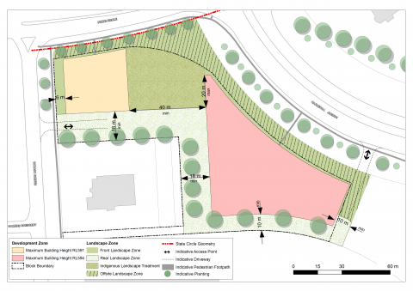

Figure 34: Block 10 Section 13 Forrest - Indicative edge cross sections

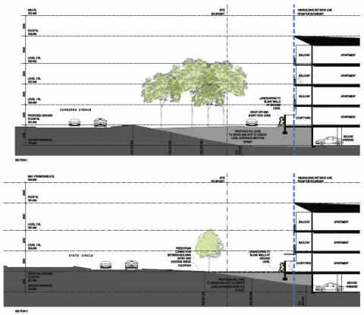

Figure 35: Block 10 Section 13 Forrest - Indicative edge cross sections

1. Amend the definition of ‘Height of building at Appendix B – General definitions, to read:

***Height of building*** means the vertical distance between ground level to the highest point or points of the building.

1. Add the following definitions to Appendix B – General definitions:

***Basement*** means a space within a building where the floor level of the space is predominantly below ground level and where the finished floor level of the level immediately above the space is less than one metre above ground level.

***Corner block***means a block which has more than one street frontage. In relation to a corner block, the major frontage shall be taken to be the frontage with the longest dimension.