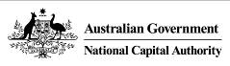

*Australian Capital Territory (Planning and Land Management) Act 1988*

Draft Amendment 90

Mint Administration Building

June 2018

# Introduction

The National Capital Authority (NCA) is established under the *Australian Capital Territory (Planning and Land Management) Act 1988* (the Act). The National Capital Plan (the Plan) came into effect on 21 January 1990. In accordance with the Act, the NCA is required to keep the Plan under constant review and to propose amendments to it where necessary. The object of the Plan is *‘to ensure that Canberra and the Territory are planned and developed in accordance with their national significance’*.

The Plan identifies matters of national significance in the planning and development of Canberra and the Territory. These are:

* The pre-eminence of the role of Canberra and the Territory as the centre of National Capital functions, and as the symbol of Australian national life and values.
* Conservation and enhancement of the landscape features which give the National Capital its character and setting, and which contribute to the integration of natural and urban environments.
* Respect for the key elements of the Griffins’ formally adopted plan for Canberra.
* Creation, conservation and enhancement of fitting sites, approaches and backdrops for national institutions and ceremonies as well as National Capital uses.
* The development of a city which both respects environmental values and reflects national concerns with the sustainability of Australia’s urban areas.

Within the framework of this legislative object or goal, key objectives of the Plan are to:

* Recognise the pre-eminence of the role of Canberra and the Territory as Australia’s National Capital.
* Further develop and enhance the Central National Area which includes the Parliamentary Zone and its setting and the main diplomatic sites and national institutions, as the heart of the National Capital.
* Emphasise the national significance of the main avenues and approach routes.
* Respect the geometry and intent of Walter Burley Griffin’s formally adopted plan for Canberra.
* Maintain and enhance the landscape character of Canberra and the Territory as the setting for the National Capital.
* Protect the undeveloped hill tops and the open spaces which divide and give form to Canberra’s urban area.
* Provide a plan offering flexibility and choice to enable the Territory government properly to fulfil its functions.
* Support and promote environmentally responsible urban development practices.

The purpose of Draft Amendment 90 – Mint Administration Building (DA90) is to vary the land use policy for Block 5 Section 65 Deakin from ‘National Capital Use’ to a mixed use zoning permitting Consulting Rooms, Health Centre, and Office.

DA90 to the Plan (set out in Part 2: National Capital Plan Draft Amendment 90 – Mint Administration Building) has been prepared in accordance with section 23 of the Act.

# Part 1: Context

## Introduction

The Department of Finance (Finance) has requested an amendment to the National Capital Plan (the Plan) to change the land use policy of Block 5 Section 65 Deakin, from ‘National Capital Use’ to a mixed use policy permitting Consulting Rooms, Health Centre, and Office.

Finance intends to sell Block 5 Section 65 Deakin through a competitive tender process, which is expected to commence in 2018. The sale of the building reflects the Australian Government’s Property Divestment program announced in the 2015-16 Budget, the objective of which is to rationalise the Commonwealth’s property holdings to reflect current and future needs.

Blocks 5 and 6 Section 65 Deakin are unleased National Land managed by Finance. The blocks currently contain ‘The Royal Australian Mint’, which consists of two physically separate buildings – the Mint Process Building and the former Mint Administration Building. The buildings are surrounded by open space to the north, south and west. The West Deakin employment area is located to the east, comprising primarily commercial offices and medical facilities.

The Mint Process Building continues to mint coins and is the sole supplier of Australia’s circulating coinage. As well as the Mint’s functions to produce Australia’s coinage, it produces coins for other countries, along with medals, medallions, tokens and seals for private clients, both national and international. The former Mint Administration Building is currently occupied by the Department of Industry, Innovation and Science (Questacon).

The subject site is identified in Figure 1.

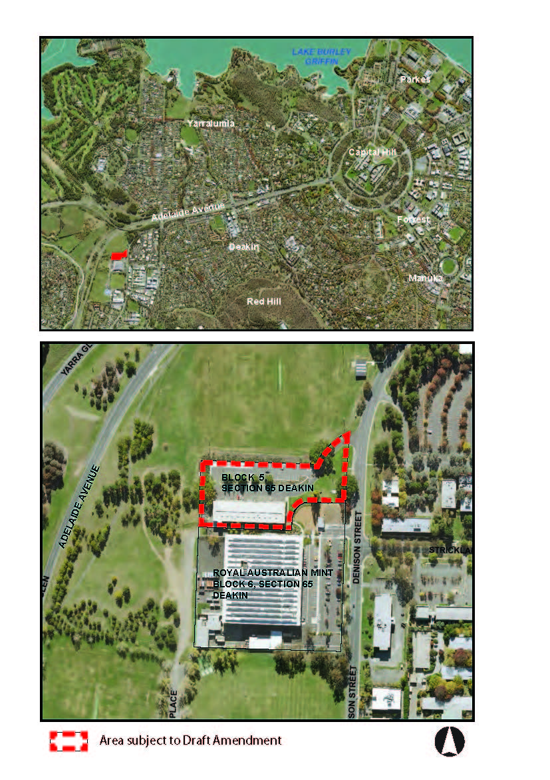

Figure : Block 1 Section 65 locality map

## Historical background

The Mint is located in the suburb of Deakin. The suburb was first settled in 1928, although significant parts of the suburb were developed after 1945. Land uses are predominantly low scale residential, although multiple-dwelling units are becoming more common where planning rules permit, such as along Adelaide Avenue, at the local centre, and opposite the West Deakin employment area. There is a small local shopping centre providing amenities such as a chemist, supermarket, sports and medical facilities, a petrol station, and community clubs.

West Deakin forms a distinctly separate portion of the suburb and was established in the 1970s. Land was released in West Deakin to attract the headquarters for national associations, with land granted initially through concessional leases.

The Australian Government approved the construction of the Mint in 1962, with construction commencing in 1963. His Royal Highness, the Duke of Edinburgh, officially opened the Mint on 22 February 1965. The first task of the Mint was to produce new coins for the introduction of decimal currency on 14 February 1966. Since then it has produced more than fifteen billion circulating coins, and has the capacity to produce two million coins per day.

The site for the Mint was in part selected in order to distribute Government employment throughout Central Canberra. Initial propositions were to locate the Mint near the present National between Old Parliament House and Capital Hill. Other examples of the trend to distribute employment include Campbell Park offices north of the Royal Military College Duntroon, and the old CSIRO headquarters in Campbell.

Refurbishments to the Mint have occurred on a number of occasions, in the mid-1980s and again commencing in 2006. The latter refurbishment was referred to the Public Works Committee for consideration and report to Parliament. On 11 October 2005, the Public Works Committee tabled their report titled ‘Refurbishment of the Royal Australian Mint Building, Canberra, ACT’, recommending that the proposed refurbishment proceed.

The 2006 refurbishment included both the Process and Administration Buildings. Works to the Administration Building included internal demolition to create an open floor plate and support modern office requirements. Completion of refurbishment works resulted in the Mint’s administrative, business and retail operations relocating from the administration building to the process building in 2009.

During 2009-10 Finance carried out refurbishment of key building services including mechanical, electrical, and hydraulic systems. The internal fabric of the building was also altered in preparation for a new tenant.

Following a lease agreement between Finance and the Department of Innovation, Industry, Science and Research represented by the National Science and Technology Centre (Questacon), during 2011 the internal fabric of the building was further altered with dedicated and client specific fit out to meet Questacon’s requirements. Internally this refurbishment involved the removal of almost all original partition walls except those directly adjacent to the main entrance and the stairwells. Original windows have been refurbished and the steel security grilles have been removed from all openings except the front entrance. The marble lined walls and floors of the building’s original entrance have been substantially retained as have the original stainless steel panelled entrance doors.

Externally, a goods lift, loading dock and dock leveller were installed to accommodate Questacon’s delivery requirements, and reconfigured the car park to accommodate visitors. Questacon commenced its tenancy of the building in late 2012.

## 1.3 Heritage

‘The Royal Australian Mint’ is listed on the Commonwealth Heritage List. The listing includes both the Mint Process Building, as well as the former Mint Administration Building. The summary statement of significance of the heritage citation states:

*‘The Royal Australian Mint in Canberra is significant as Australia’s sole production facility of circulating coinage and the only Australian Mint to be established independently of the London Royal Mint. Historically, The Royal Australian Mint played a crucial role in Australia’s conversion to decimal currency…The Royal Australian Mint is constructed in the ‘stripped classical’ architectural style which demonstrates its important public institutional role beyond its functional purpose as a factory. Today, The Royal Australian Mint has a special association with coin collectors/numismatists as the place where commemorative coins are produced, reflecting a worldwide passion and the role that coinage has played in human culture for more than two millennia’*.

A Heritage Management Plan (HMP) has been prepared by Finance to protect the heritage values of the site. Finance is currently in the process of preparing a HMP for the Mint Administration Building only.

The proposed land use change will not impact on the heritage values of the Mint Administration Building. The *Environment Protection and Biodiversity Conservation Act 1999* (EPBC Act) provides a comprehensive framework for the protection of heritage values, including protections for the Mint Administration Building. Finance is not required to undertake a heritage referral, but will protect the heritage values of the building by including covenants and provisions in the Crown Lease and sale documentation.

## 1.4 Explanatory statement

Block 1 Section 65 Deakin is within the Diplomatic Precinct (Yarralumla, Deakin and O’Malley) under the Plan, and subject to the provisions of the relevant Precinct Code.

### Land use

The land use for Block 1 Section 65 Deakin, as identified in Figure 122 of the Plan, is currently ‘National Capital Use’, which is defined under the Plan as:

*the use of any land, building or structure for the purpose of a work of special status and national interest. This includes the National Library, the National Gallery, the High Court, the National Archives, the National Museum of Australia, the Australian War Memorial, the Prime Minister’s Residence, the Governor-General’s Residence, the Australian National University, the Australian National Botanic Gardens, Commonwealth offices needing prestigious locations, national memorials, National Association Offices [as herein defined], a hospitality house or a Commonwealth Government conference centre and the like.*

The draft amendment proposes to add the following permitted uses for the northern part of Block 1 Section 65 Deakin:

* Consulting Rooms – defined as *‘a building or place used for the provision of health care services (including dental, optical and veterinary services) to members of the public’*. Veterinary services will be limited to small/domestic animals only.
* Health Centre – defined as *‘a building or place used for the medical care (including diagnosis, preventative care and counselling) of out-patients only and may include medical or dental clinics, family planning clinics, first aid station or other professional or paramedical health care services’*.
* Office – defined as *‘any premise used for the purpose of administration (including commercial and public administration), clerical, technical, professional or like business services’*.

The land use policy for the remaining portion of Block 1 Section 65 Deakin will continue to be ‘National Capital Use’.

### Other provisions

There are no other detailed conditions of planning, design and development in the Precinct Code that are relevant to the site. Development is however, subject to the general principles and policies of the Plan, and the Design and Siting General Code. Specific planning and design conditions for the site are not proposed to be introduced due to existing heritage requirements and protections, and general principles and policies of the Plan.

## Draft Amendment process

The process for making an amendment to the Plan is outlined in Figure 2.

Figure 2: Outline of the National Capital Plan draft amendment process

|  |
| --- |
| **WHAT HAS BEEN DONE** |
| Proposal by the NCA of a Draft Amendment to the Plan   |
| **CURRENT STATUS** |
| Public consultation on a Draft Amendment   |
| **WHAT IS NEXT** |
| Submission to Minister |
| Action by Minister |
| Parliamentary scrutiny |
| Expiration of disallowance period |

## Public consultation

The NCA welcomes written comments on DA90 from interested parties as part of the consultation process. All responses received will be considered before DA90 is submitted to the Minister for Local Government and Territories in accordance with the provisions of the Act.

Hard copies of DA90 are available on request by contacting:

National Capital Authority  
Ground Floor, Treasury Building  
King Edward Terrace  
PARKES ACT 2600

02 6271 2888

Between 9am and 5pm Monday to Friday

draft.amendment@natcap.gov.au

### Public information session

A public information session will be held on Wednesday 20 June 2018, from 12pm to 1pm at the National Capital Authority, Griffin Room, Ground Floor, Treasury Building, King Edward Terrace, PARKES, ACT 2600. The NCA invites interested parties to register their interest in attending by email [draft.amendment@natcap.gov.au](mailto:draft.amendment@natcap.gov.au).

Submissions to DA90 can be:

* emailed to [draft.amendment@natcap.gov.au](mailto:draft.amendment@natcap.gov.au)
* mailed to Chief Planner, National Capital Authority, GPO Box 373, Canberra, ACT 2601
* delivered to National Capital Authority, Ground Floor Treasury Building, King Edward Terrace, Parkes ACT 2600.

**Submissions are invited until close of business on 16 July 2018**.

Further information on DA90 is available by telephone on 02 6271 2888 or email draft.amendment@natcap.gov.au.

### Permission to disclose name and address

The NCA seeks an open and transparent draft amendment process. Following public consultation on the draft amendment, the NCA will prepare a Consultation Report which will be published on the NCA website. This report will include a summary of each submission. The NCA intends to publish the name of each person making the submission, but will not publish contact details (such as physical address, email or phone number).

If you have a concern about having your name published on the internet or wish to make a confidential submission, you must make this clear when submitting your comments. Say why you want your submission to be kept confidential.

The NCA will consider requests for confidentiality, but cannot make promises in advance. If you have concerns about confidentiality, please contact the NCA to discuss before making a submission.

# Part 2: National Capital Plan Amendment 90 – Mint Administration Building

The National Capital Plan is amended by the following:

## Section 4.14.4 Land use for the Diplomatic Precinct (Yarralumla, Deakin and O’Malley

1. Delete Figure 122 ‘Land use for the Yarralumla and Deakin Diplomatic Precinct’, and replace with the following figure:

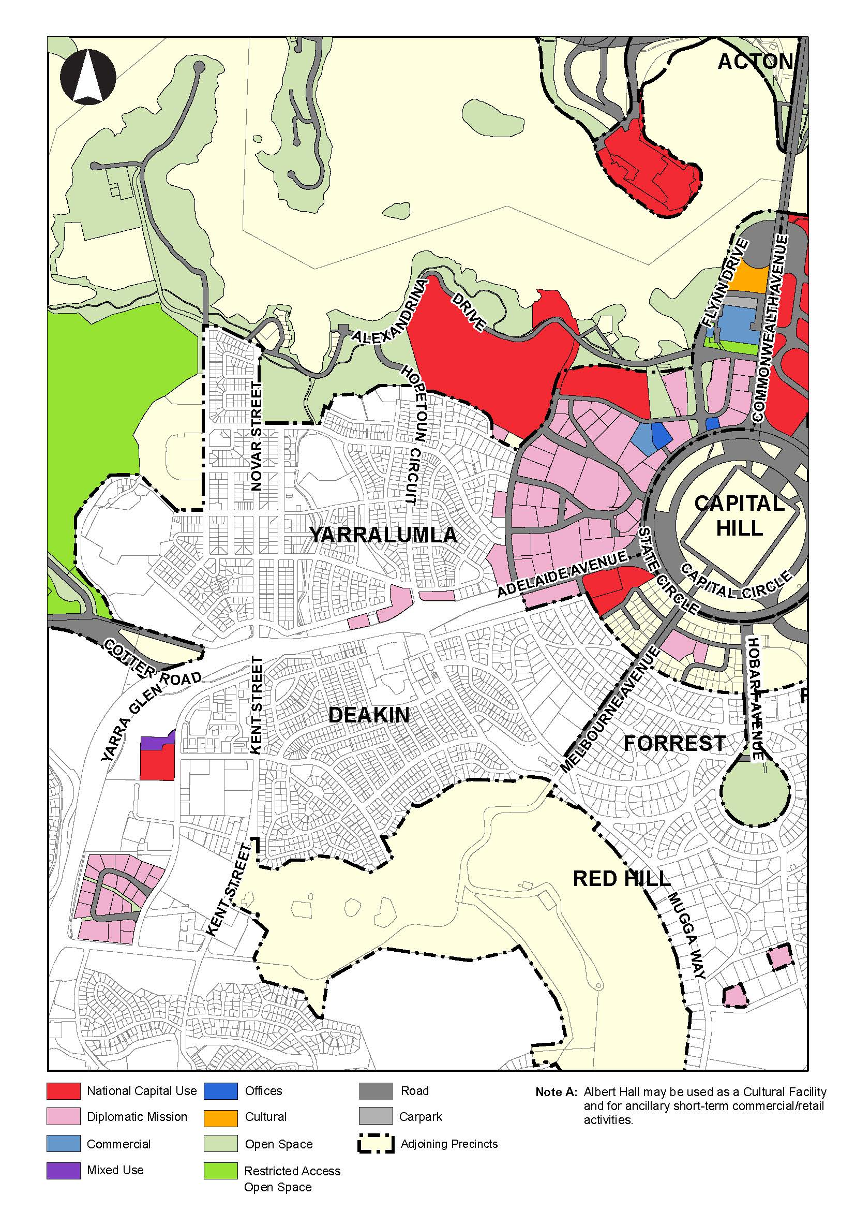

1. Insert the following paragraph below Figure 122:

*Permitted land uses on sites identified for ‘Mixed Use’ are:*

* *Consulting Rooms (veterinary services restricted to small/domestic animals only)*
* *Health Centre*
* *Office.*