Barton Land Use Policy Analysis

Background
Barton has long been recognised as a prestigious office location, and is characterised by a series of large buildings set in a generous landscape setting. A number of key government agencies are located in the area, including the Department of Foreign Affairs and Trade, Australian Federal Police, Australian National Audit Office, Department of the Prime Minister and Cabinet and the Attorney-General’s Department. Smaller Australian Government agencies, and private sector offices (often providing services to government) have also established in Barton.
The suburb has been subject of significant redevelopment over the past few years. It can be expected that, despite the current lull in commercial development, future development pressures will arise over the coming 5 to 10 years as existing tenancies expire and many of the smaller buildings in Barton come to the end of their useful life.
A land use planning analysis is proposed to ensure that the planning framework in place reflects contemporary planning values to accommodate this next phase of growth.

Study Area
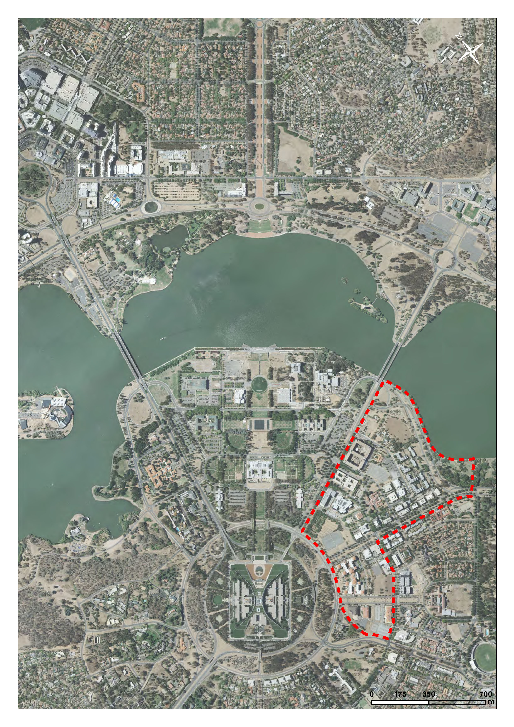
The Barton Land Use Policy Analysis (the Analysis) is an investigation that will focus on the part of Barton that is south of Lake Burley Griffin and within Designated Areas. The study area includes a small portion of the suburb of Forrest which geographically forms part of the Barton office precinct.
The study area is identified in the National Capital Plan (the Plan) as one part of the Parliamentary Zone and its setting. Principles and policies of the Plan describe the Parliamentary Zone and its setting as the ‘heart of the National Capital’.
The Parliamentary Zone and its setting is intended to be the centre for all nationally significant activities of Parliament, the Judiciary and government and the focal point of visitor interest in the National Capital. The Plan suggests that major national functions and activities that are closely connected with the workings of Parliament be located in or adjacent to the National Triangle.
The study area has a small residential population and a number of other uses such as St Marks National Theological Centre, Australian Centre for Christianity and Culture, the Ottoman Restaurant, ACT Rugby Union Club and the Kurrajong Hotel.

Existing Planning Framework and Project Purpose
Figure 8 The Central National Area (Barton) of the Plan identifies the current land use policies for the study area. National Capital Use and Offices are the dominant land use policies. Other permitted uses include:
- Residential (Landmark Apartments);
- Community Facility (Australian Centre for Christianity and Culture and St. Mark’s National Theological Centre);
- Commercial (the Kurrajong Hotel, the Ottoman Restaurant, and the current surface car park on Block 13 Section 9 Barton);
- Open Space (Windsor Walk and York Park);
- Communications Facility; and
- Ancillary uses such as retail, café, bar, restaurant, personal services establishment, child care centre, commercial accommodation, consulting rooms, and co-operative society (for some sites only).
A number of recent Amendments to the Plan have introduced a broader range of permitted uses for some sites to allow for mixed use development. These typically have been done on a site by site and to some degree ad hoc basis. A comprehensive analysis of land use and supporting policy has not been undertaken since the early 1990s.
In some circumstances, the policy approach to particular issues is inconsistent (for example, prescribing permitted building heights). In other cases, current policy is very much ‘performance based’ and difficult to interpret.
The purpose of the project is to develop a planning framework for the study area that:
- Provides for an appropriate mix of land uses which will support development and redevelopment of the area during the next phase of development (5-10 years) and beyond;
- Encourages development which will support the needs of the existing office population and residents;
- Introduces more objective planning and design policy which will provide the necessary balance between certainty and flexibility in outcomes;
- Clarifies the role of Barton in the hierarchy of commercial centres and office employment locations across the ACT; and
- Clarifies the relationship between Barton and surrounding areas, notably the Parliamentary Zone.

Next Steps
The NCA will commence engagement with key stakeholders and the community in early 2012.
The NCA has also resolved to undertake a review of the National Capital Open Space System and Building Heights in the Central National Area (CNA).
Any recommendations arising from the Barton Land Use Policy Analysis will both draw on the work of related projects being undertaken by the NCA and inform other work.
The Hawke Review into the NCA makes a number of recommendations to address the broader planning framework of the ACT. A number of these, if agreed by the Government, will impact on the timing and character of any recommendations arising from the Barton Land Use Policy Analysis.

